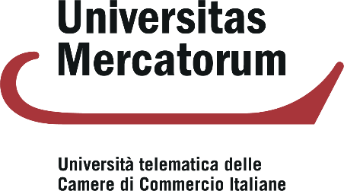

The PhD scholarship co-funded with resources from the European Union – NextGeneration EU
National Recovery and Resilience Plan (PNRR), Mission 4, Component 2 “From Research to Business” – Investment 3.3 “Introduction of innovative PhD programmes that meet the innovation needs of enterprises and promote the recruitment of researchers by companies” – CUP D83C22001880003

