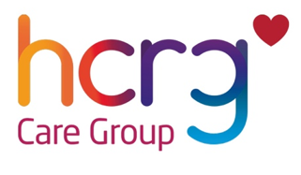


Sexual Health Outreach Referral Form

This form is for professionals to refer people into our service.

Please complete all fields and return this form via secure email to:
outreach.cheshirewest@hcrgcaregroup.com

If you would like to speak to a member of the team regarding your referral, please contact,
01244 271131. If we are unavailable to take your call, please leave a voicemail and we will get back to you.

Patient details

First name |  | Last name
Sex |  | DOB
Gender Identity |  | Ethnicity
Address |  | School name/address
Young person’s contact number |  | Country of Birth
Emergency contact name |  | Relationship to the young person
Emergency contact number |  | Is the emergency contact aware of the referral

Do we have permission to contact the emergency contact? | Yes |  | No |  | Only in an emergency
Do we have permission to write to the young person’s home address? | Yes |  | No |  | Only in an emergency
Do we have permission to contact the young person via the contact telephone number? | Yes |  | No |  | Only in an emergency

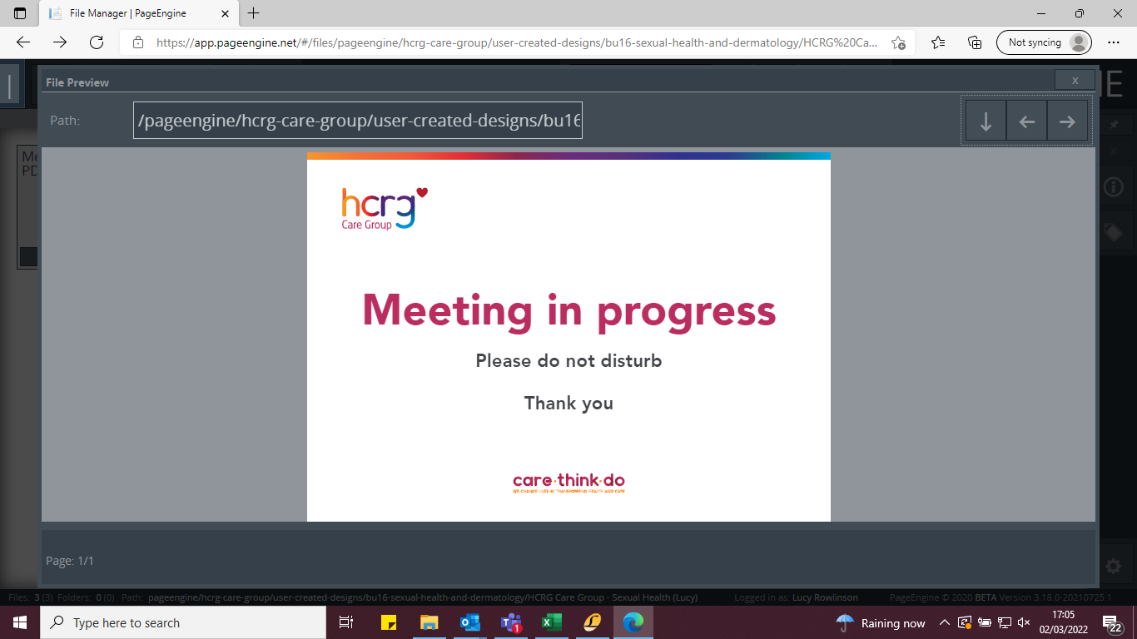

Involvement from social care

Is the young person known to social care? | Yes |  | No
Is there an open case with social services? | Yes |  | No

If yes, please provide more information

Does the young person have a social worker? | Yes |  | No

Name of the designated social worker
Contact Number (if known)

Involvement from other agencies

Is the young person involved with any other agencies? | Yes |  | No

If yes, please provide more information

Vulnerabilities

Does the young person display or discuss any of the following vulnerabilities? This may be current or historic. Please tick if appropriate

Coercion | Historic |  | Current
Grooming | Perpetrator |  | Victim
Power imbalance in relationship | Historic |  | Current
Any type of violence or abuse | Historic |  | Current
Self-harm | Historic |  | Current
Being paid for sex | Yes |  | No
Paying for sex | Yes |  | No
Exploitation | Perpetrator |  | Victim
LGBTQIA+ | Yes |  | No
(For education solely on gender/sexual orientation/transition please refer to the proud trust)

High-risk groups

Do you consider the young person to be one or more of the high-risk groups?

Drug and alcohol issues | Yes |  | No
Mental health | Yes |  | No
Learning difficulties or disabilities | Yes |  | No
Missing from home | Yes |  | No
Looked after child | Yes |  | No
Refugee/Asylum seeker/ Unaccompanied child/ Newly arrived in the UK | Yes |  | No

Referral information

Does the young person have any significant issues? | Yes |  | No
Is the person subject to Deprivation of Liberty Safeguards (DoLS or Liberty Protection Safeguards (LPS)? | Yes |  | Yes
Does the young person have an increased supervision ratio ie 2:1 ratio? | Yes |  | No

What are your specific concerns regarding the young person? Your referral cannot be processed without completion of this question)

Are there any known risk-taking behaviors? | Yes |  | No

If yes, please provide more information below:

Referrer information

Contact name |  | Organisation
Email address |  | Telephone number
Date of referral

Have you discussed your concerns with the young person? | Yes |  | No
Have you discussed the referral with the young person? | Yes |  | No
Has the young person consented to the referral? | Yes |  | No

What’s next?

Please return completed referral forms to: outreach.cheshirewest@hcrgcaregroup.com

- Referrals will be assessed and responded to within 5 days.

