Enact Volunteer Application Form 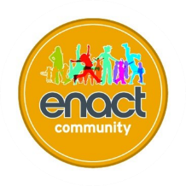

Your Details
First Name: |  |  | Date of Birth:
Surname: |  |  | Ethnicity
Address:

Postcode:

Phone Number:

Email:

Emergency Contact Information

Full Name of Contact:

Address

Phone Number:

Relationship to you:

About You:
Tell us why you want to volunteer at enact and what you hope to get out of volunteering:

Your Experience:
Use this space to tell us of your past/present work experience including volunteering:

References
All volunteers at enact will be required to provide someone who can give a reference. The referee will be contacted in writing and may be followed up with a phone call. (Please note that we cannot accept references from relatives)

Full Name:

Address:

Phone Number:

Email:

Relationship To You:

DBS Checks
All volunteers working at enact will be required to complete an Enhanced DBS application form prior to starting at enact.

Please circle:

I agree I disagree

Training and continued professional development.
As part of your volunteering role at enact you will be required to participate in Induction/training and opportunities to develop your knowledge and skills:

Declaration:

I declare that to the best of my knowledge the information in this Application Form is true and correct.

Signature: …………………… Date:…

Please return to:
Unit 52 Island Centre Way,
Enfield, EN3 6GS
Tel: 07917724860
Email: info@enact.community

FOR OFFICE USE ONLY:

Information checked by: …… ................................Date.…......................

