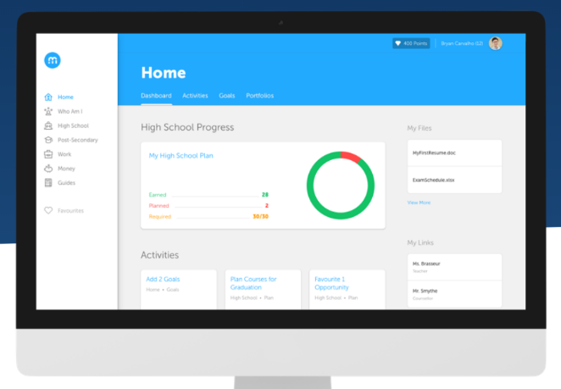
myBlueprint Ambassadors Program
What is myBlueprint Education Planner?
myBlueprint Education Planner is an interactive, mobile-friendly education, career, and life planning resource that supports self-discovery, informed decision making, and student success.
Students have access to a number of features in myBlueprint Education Planner, such as:
- Comprehensive Self-Assessments called Who Am I? where students can learn more about themselves (learning style, personality type, interests, knowledge, and motivations) and find occupation, post-secondary, and course matches based on their results.
- Occupation and Post-Secondary databases where students can easily explore and compare over 12 000 opportunities to determine which program or occupation is the best match.
- Resume and Cover Letter Builders where students can easily record experiences, certifications, and important dates.
- Multiple Portfolios allow students to collate subject-specific information, self-report on the core competencies, build applications for scholarships and post-secondary, reflect on their growth and progress over time, or even create career portfolios. They can easily upload pictures, videos, files, and links from their device, Google Drive, and from their favourite sites.
- Goal Setting provides students with a template to create S.M.A.R.T. goals and action plans.
- Money is an interactive budgeting tool where students can create multiple budgets and learn about how to finance their post-secondary education and futures.
- High School allows students to easily plan ahead to ensure that they are meeting graduation requirements, and to explore post-secondary opportunities in Canada that are available to them.
What is the myBlueprint Ambassador Program?
The myBlueprint Ambassadors Program is a great way for students to develop leadership skills while supporting younger students to learn more about themselves and plan for their futures. To use the myBlueprint Ambassadors program, you will follow the myBlueprint Ambassadors Program Checklist for Staff (on page 2-3) to introduce students to myBlueprint Education Planner, have them explore their own myBlueprint account using a checklist, and evaluate their ‘myBlueprint Ambassador’ portfolio and/or short quiz to showcase their knowledge. Once completed, you will print the certification and present it to your myBlueprint Student Ambassadors.
What are the benefits of the Ambassador Program?
There are numerous benefits for students to become a myBlueprint Ambassador at your school:
- Develop leadership skills
- Teach new technology skills to all students
- Promote peer mentorship
- Provide more student-centered support when leading full-class or small-group lessons

myBlueprint Ambassadors Program Checklist for Staff
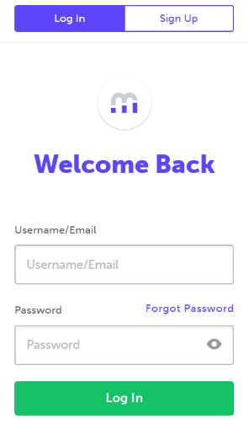
- Familiarize yourself with myBlueprint Education Planner by logging in to your account and completing the ‘Student Account Exploration’ checklist below.

LOG IN TO YOUR ACCOUNT
- Visit www.myBlueprint.ca
- Click Log In at the top right hand corner
- Enter username and password
- Click Login

STUDENT ACCOUNT EXPLORATION CHECKLIST
- Click Go to Student View in the top right corner of your account
- Complete the five (5) Who Am I surveys
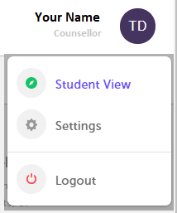
- Go to Match Results tab > Complete two (2) Compatibility Surveys
- Go to Home > Goals > Add a goal
- Go to Post-Secondary > Select a Pathway (e.g., College & University) > Favourite one (1) program
- Go to Work > Occupations > Favourite two (2) occupations
- Go to Work > Job Search > Look up and favourite a job posting in your area
- Go to Home > Portfolios > Add a Portfolio > Name your portfolio
- Add an Avatar and a Banner image
- + Add Box > Add Media > Upload a picture/image that represents who you are
    - + Reflection > Give an explanation of how the image represents who you are
- + Add Box > Add Recent > Favourites > An occupation that you favourited
- + Add Box > Add Recent > Favourites > A post-secondary program related to the occupation you favourited

- Decide how you will implement the myBlueprint Ambassador Program and who will be accountable for the ambassadors at your school, including:
- Who will be responsible for training the myBlueprint Ambassadors?
- How will they train Ambassadors (i.e. in small groups at lunchtime, during leadership)?
- How will teachers/students request the Ambassadors’ support in the classroom?
- Decide which students at the school will be the myBlueprint Ambassadors. Consider selecting students in Grade 10-12 to support students in Grade 7-9.

- Decide how the myBlueprint Ambassadors will connect with other students
- Will Ambassadors work with younger students during class time?
- Will one Ambassador show a group of students how to use the program?
- Will a group of students work one-on-one with a younger group of students?
- Will a group of Ambassadors present their Portfolios at a school assembly?
- Introduce the myBlueprint Education Planner to students
OPTION 1 (Teacher-Led): Do a live demo using your Student View and/or use the myBlueprint PPT to walk students through the following process to ensure they are competent ambassadors and are aware of the rationale behind becoming an ambassador.
OPTION 2 (Student-Driven): Share the myBlueprint Ambassadors Program Information for Students (on page 4) to have students independently explore myBlueprint and complete the Ambassadors Checklist and Quiz. Please print:
- myBlueprint Ambassador Checklist
- myBlueprint Ambassadors Quiz (with answer key for peer evaluation)

OPTION 1 (Teacher-Led)

- Teacher Demo Checklist
- Show students how to login to their own myBlueprint Account
- Show students how to add a link (to parents and teachers)
- Show students how to navigate their grade-specific activities (explain that they will differ from the younger year’s students and share the myBlueprint Activities Chart)
- Show students how to create a portfolio and:
  - upload a picture
  - embed a video link
  - add work they completed in their account (i.e., Who Am I? survey results)
- Show students how to view and compare occupations
- Show students how to plan for high school and introduce some important questions that younger students may ask about high school (around which courses to select, variation/options for courses, what they need to graduate, etc.)
- Print the myBlueprint Ambassador Checklist for each student and have students work through the tasks listed in the checklist (i.e., Have students create a ‘myBlueprint Ambassador’ portfolio in their myBlueprint account with each artifact from the checklist)
- Evaluate each student’s portfolio to determine whether they have satisfied the requirements on the ‘myBlueprint Ambassadors Checklist’ and would be able to help others do the same AND/OR have students complete the myBlueprint Ambassadors Quiz.
- Walk students through the Transitioning to High School, Goal Setting, and Who Am I learning styles activities. Students could then use these suggested activities when supporting younger students with myBlueprint.
- Print the myBlueprint Ambassadors Certificate (with Principal Signature) OR the myBlueprint Ambassadors Certificate (with Teacher Signature), fill in the student’s name, and give a certificate to each myBlueprint Ambassador.
- Have students take a picture of their certificate and upload it to their ‘myBlueprint Ambassador’ portfolio, including a reflection on the importance of being a school leader and helper for younger students. Students can keep building their portfolio to reflect on their experience as a myBlueprint Ambassador throughout the school year!

Great work! You have facilitated the myBlueprint Ambassadors Program. Your students can now support other kids with myBlueprint.
myBlueprint Ambassadors Program - Information for Students
What is myBlueprint Education Planner?
myBlueprint Education Planner is an interactive, mobile-friendly education and life planning resource to assist you in your career journey. This program can help you learn more about yourself, reflect on your interests, discover opportunities available to you, and make a plan to achieve your goals.

Explore some of the tools listed below to help you prepare for a successful future:
- Comprehensive Self-Assessments called Who Am I? where you can learn more about yourself (learning style, personality type, interests, knowledge, and motivations) and find occupation, post-secondary, and course matches based on your results.
- Occupation and Post-Secondary databases where you can easily explore and compare over 12 000 opportunities to determine which program or occupation is the best match for you.
- Resume and Cover Letter Builders where you can easily record experiences, certifications, and important dates.
- Multiple Portfolios allow you to collate subject-specific information, self-report on the core competencies, build applications for scholarships and post-secondary, reflect on your growth and progress over time, or even create career portfolios. You can easily upload pictures, videos, files, and links from their device, Google Drive, and from your favourite sites (Facebook and Instagram).
- Goal Setting provides you with a template to create S.M.A.R.T. goals and action plans.
- Money is an interactive budgeting tool where you can create multiple budgets and learn about how to finance your post-secondary education and future.
- High School allows you to easily plan ahead to ensure that you are meeting graduation requirements, and to explore post-secondary opportunities in Canada that are available to you.
What is the myBlueprint Ambassador Program?
The myBlueprint Ambassadors Program is a great way to develop leadership skills while supporting younger students at your school to learn more about themselves and plan for their futures. As an ambassador, you will go through a short training program, build your own myBlueprint account, and write a short quiz to be certified.
What are the benefits of the Ambassador Program?
There are numerous benefits for students to become a myBlueprint Ambassador at your school:
- Develop leadership skills
- Teach new technology skills to all students
- Promote peer mentorship
- Provide more student-centered support when leading full-class or small-group lessons
What are the steps in becoming an Ambassador?

STEP 1:
- Print the myBlueprint Ambassador Checklist and work through the tasks listed (i.e., Create a ‘myBlueprint Ambassador’ portfolio in your myBlueprint account with each artifact from the checklist)
STEP 2:
- Complete the myBlueprint Ambassadors Quiz.
STEP 3:
- OPTIONAL: Evaluate a peer’s myBlueprint Ambassadors Quiz with the myBlueprint Ambassadors Answer Key (ask a teacher for the key)
STEP 4:
- Read through the Transitioning to High School, Goal Setting, and Who Am I learning styles activities. You can use these suggested activities when supporting younger students with myBlueprint.
STEP 5:
- Add a journal entry to your myBlueprint Ambassadors Portfolio outlining your favourite lesson (from step 4) and how you will support younger students with myBlueprint.
STEP 6:
- Print the myBlueprint Ambassadors Certificate (with Principal Signature) OR the myBlueprint Ambassadors Certificate (with Teacher Signature), fill in your name, and get it signed by your teacher or principal.
STEP 7:
- Take a picture of your signed certificate and upload it to your ‘myBlueprint Ambassador’ portfolio, including a reflection on the importance of being a school leader and helper for younger students.
STEP 8:
- Continue to build your portfolio to reflect on your leadership experience as a myBlueprint Ambassador throughout the school year!

Congrats! You are now a myBlueprint Ambassador. Great work!

