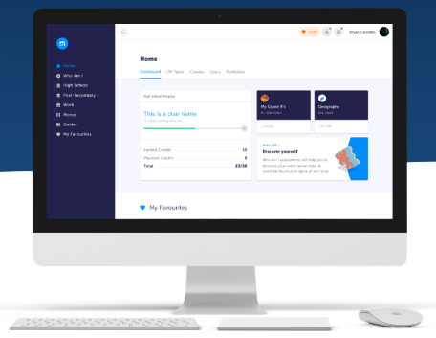
What is the myBlueprint Education Planner?

The myBlueprint Education Planner is a student-friendly, interactive education and career/life planning resource that allows Gr. 7-12 students to reflect on their learning, showcase their growth, and share their achievements.

Want to learn more? Watch the Student Introduction video tutorial at myBlueprint.ca/support/videos

As a parent/guardian, can I access myBlueprint Education Planner?

Yes! You can create an account and link to your child(ren) by following the steps below.

Why would I want access to myBlueprint Education Planner?

The family account allows you to view student artifacts and reflections, including the goals they are setting, occupations they are interested in, and what they are learning in school.
You can log in to your account to comment on your child’s work or receive messages from their teacher(s).
Want to watch a video tutorial about the Family Account? Visit myBlueprint.ca/support/videos

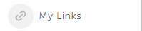
Options for creating your Family Account
Option #1: Request an invitation from a Student
Have the student log in to their myBlueprint account, then:
- Click their Name in the top-right corner
- Select My Links
- Click Add Link
- Enter your name and email address
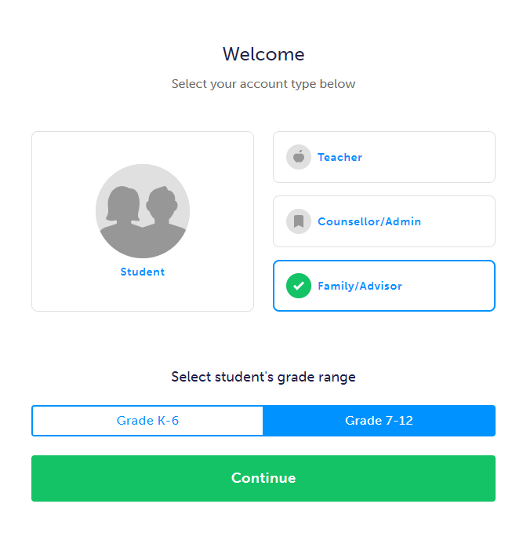
- Click the Create Account button in the email you received and follow the sign-up steps
Option #2: Sign up with school’s Activation Key or District Landing Page
- Visit www.myBlueprint.ca/
- Click Sign Up in the top right corner
- Enter your child’s school Activation Key and click Create Account
- Select Family/Advisor, and your child’s grade range (7-12)
- Click Continue and fill out the sign up form
- Click Create My Account
- Enter your child’s email address that they use to log in to their myBlueprint account, and click Add Student (note: your child will have to approve your link request)
- Click Continue
*Don’t have your school activation key or District Landing page? Request this information from your child’s Guidance Counsellor or Teacher.
Engaging with your child’s work

Once you have linked with your child, click on the Student Feed option in the left-hand menu. From here, you will see your child’s most recent work that they have added to their portfolios.

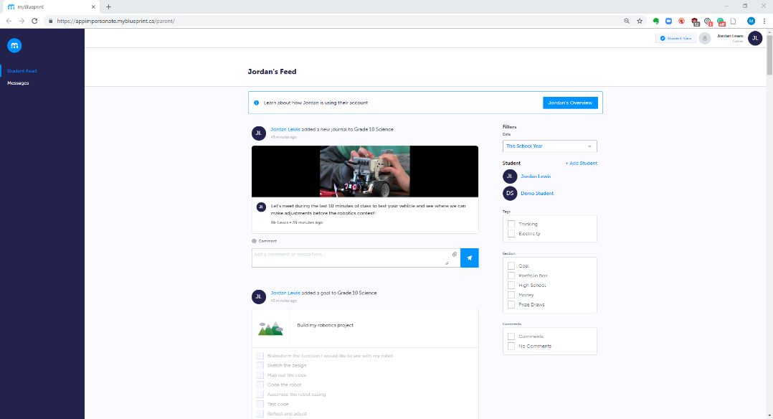

Providing comments and feedback
For tips on how to provide feedback on your child’s learning and sample conversation prompts, click here!

Want to provide comments and feedback on your child’s work? Enter your feedback in the comment box below an artifact, and click the blue button to post it.

You can also include media with your comments in the form of audio or video recordings, images, or files! Simply click the paper clip icon and select one of the media attachment options.
View your child’s full account
- Click on the Overview button at the top of the student feed
- Click on the Eye Icon in the top-right corner
- This will open your child’s account in a new tab
- From here, you will be able to explore your child’s account and view all of the work they have done, including survey results, favourite occupations and post-secondary programs, portfolios, and more!

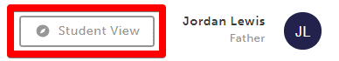
What’s the Student View button?
From your Dashboard, click the Student View button to access a demo student account and explore and familiarize yourself with the features of myBlueprint student account.

Try it out for yourself! Follow the steps below to complete similar tasks to what your child may be working on at school to help plan for their future.

- Click Student View in the top right corner of your account
- Complete the five (5) Who Am I surveys
- Go to Match Results tab > Complete two (2) Compatibility Surveys
- Go to Home > Goals > Add a goal
- Go to Post-Secondary > Select a Pathway (e.g., College & University) > Favourite a program
- Go to Work > Occupations > Favourite two (2) occupations
- Go to Work > Job Search > Look up and favourite a job posting in your area
- Go to Home > Portfolios > Add a Portfolio > Name your portfolio
- Add an Avatar and a Banner image
- + Add Box > Add Media > Upload a picture/image that represents who you are
    - + Reflection > Give an explanation of how the image represents who you are
- + Add Box > Add from myBlueprint > Favourites > An occupation that you favourited
- + Add Box > Add from myBlueprint > Favourites > A post-secondary program related to the occupation you favourited

Document student learning on the go! Download the myBlueprint Class Pass App.

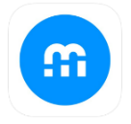
Class Pass App is an easy-to-use companion app, which allows for students to easily post artifacts, media, and evidence of learning to their portfolios. This app is compatible with both iOS and Android.

Helpful Hints
Looking for some more helpful resources to support your child in the documentation of their learning? Check out these resources below:
- Browse exemplar portfolios
- Video Tutorials
- Top 4 Reasons to Implement Digital Portfolios in the Classroom
Need more support?
