The person who is giving the power of attorney logs in to the Ísland.is
- Choose Access Control
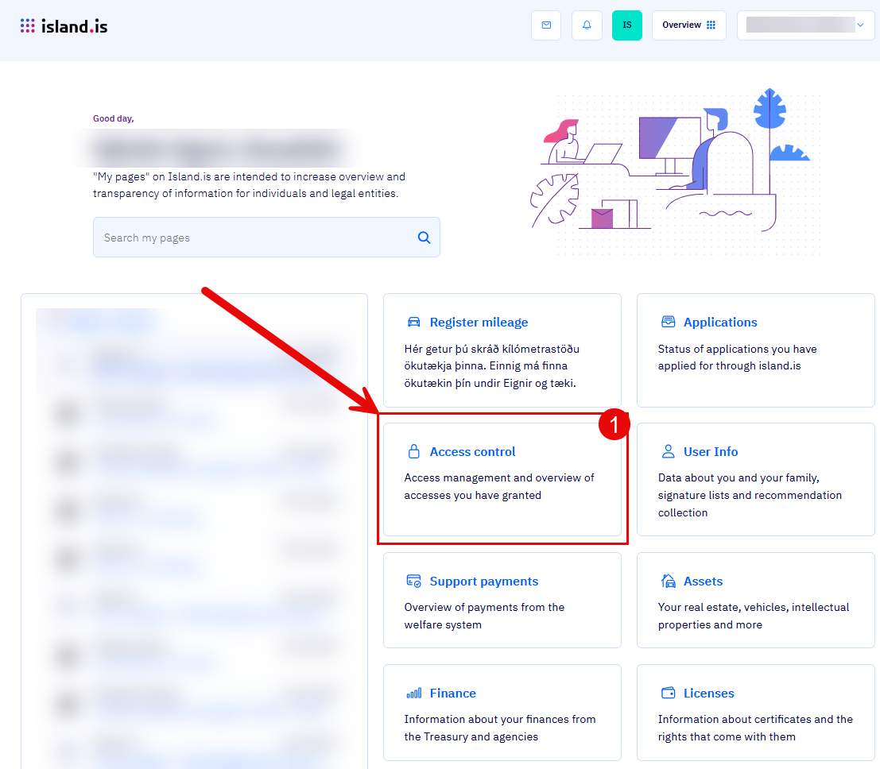

- Select a mandate
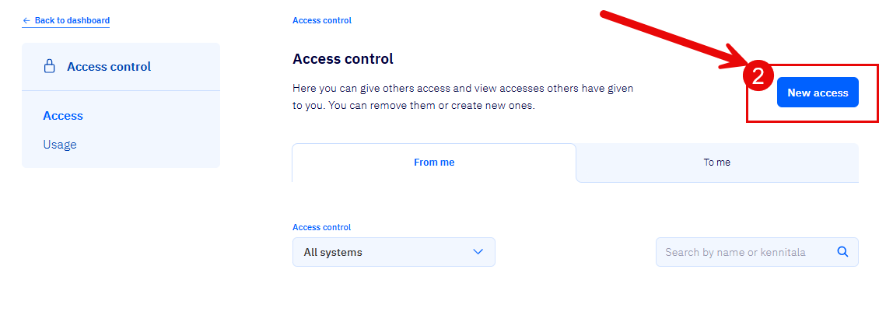

- Enter the ID number of the person who is to have the power of attorney
- In Access control choose „Mínar síður á Ísland.is
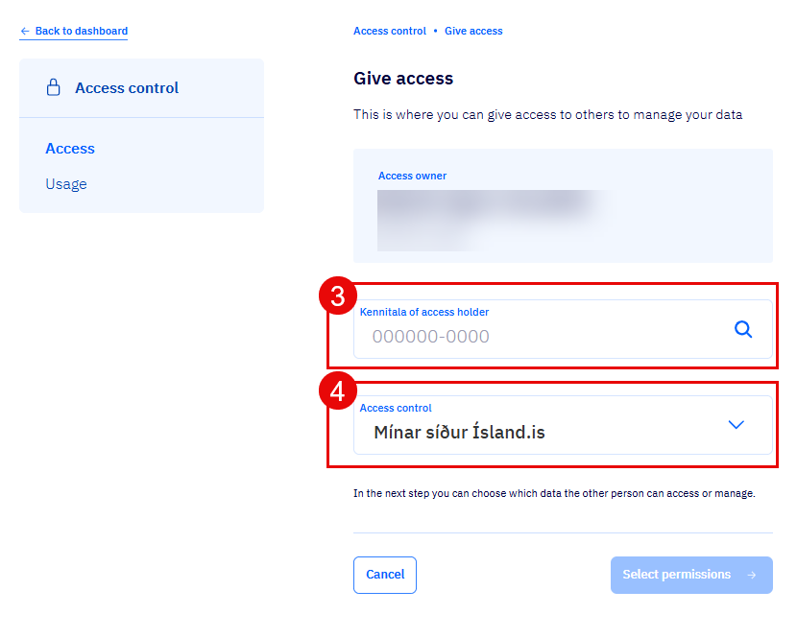
- Select what you are giving a mandate for.
Note that you have to scroll down on the page to see this option.
- Select a mandate expiration date

- 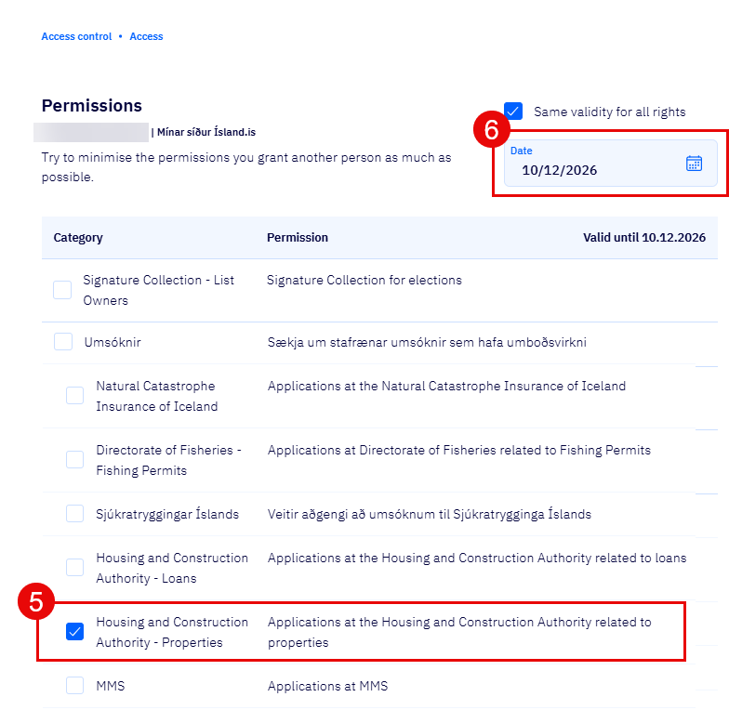
- Before proceeding, please take to read over all the information and confirm.
