Introduction
National Apprenticeship Week provides a fantastic opportunity to help students to think about their future careers and to raise awareness of apprenticeships, exploring the benefits of apprenticeships and how they might be a suitable option for your students when leaving school. We have put together a useful Student Apprenticeship Activity Pack with 10 different apprenticeship activity ideas for your students, which is available to download at www.apprenticeships.gov.uk/influencers/naw-2022-toolkit.
- The Student Apprenticeship Activity Pack has been designed so that it can be completed individually, or in groups both in the classroom and remotely.

- This pack for teachers contains the answers that you will need to help your students to mark/score their work.

- Please note that Activity 6, Activity 8, and Activity 9 will capture the students’ thoughts and ideas rather than require specific answers, so answers will not be included in this pack, but may benefit from follow up discussion.

Please note that some tasks will require access to a computer and the internet.
Stay up to date with the latest news from National Apprenticeship Week:
Social media: @Apprenticeships Hashtag: #NAW2022
For questions about using these resources or to share any feedback, please contact Amazing Apprenticeships at hello@amazingapprenticeships.com.
_____________________________________________________________________________
Contents
Answer sheet 1: What are apprenticeships? 4
Answer sheet 2: Discover apprenticeships 5
Answer sheet 3: Apprentices in Action 6
Answer sheet 4: Mind the gap 8
Answer sheet 5: Meet apprentice employers 9
Answer sheet 6: The Big Assembly 10
Answer sheet 7: Linking your subjects to apprenticeships 11
Answer sheet 8: Ask an apprentice or employer 12
Answer sheet 9: ‘Build the Future’ 12
Answer sheet 10: Apprenticeship crossword 13

Apprenticeship support for schools
To find out more about apprenticeships and how you can support your students with apprenticeships information, visit: www.apprenticeships.gov.uk
You can also access free apprenticeship support for your school by booking in with the Apprenticeship Support & Knowledge for schools and colleges (ASK) programme. The programme provides free digital or in-person support to educational establishments across England (this includes schools, colleges and training providers) to better inform students about their career options and transform the way they think about apprenticeships, traineeships and T Levels.
The programme is funded by the Department for Education.
Types of support
The support that ASK provides will depend on the size, requirements and focus of the school or colleges. All support is delivered in-person or virtually, depending on the needs of the school/college.
Examples of support include:
- An inspiring awareness assembly
- An apprenticeship application workshop
- Careers fair attendance
- Free resources
- A teacher CPD session

Click the link above or scan the QR code to visit now.

Answers

TASK 1: What are apprenticeships?
- What is an apprenticeship?

Answer: B – A real job where you learn at the same time

- As an apprentice, do you have a specific job?

Answer: A – Yes, you have a specific job role

- Can I still get a degree whilst doing an apprenticeship?

Answer: B – Yes, degree apprenticeships allow you to work and study for a degree at the same time

- Will I get paid in an apprenticeship?

Answer: B – Yes, you will get paid a salary

- Where would I study if I were an apprentice?

Answer: B – At a college, University, or a training provider

- How long does an apprenticeship take?

Answer: B – It can take up to 6 years depending on the role and apprenticeship level

- Do apprentices have to pay for their apprenticeship?

Answer: B – No, the apprenticeship will be paid for by the employer and the government

- What age can apprentices be?

Answer: A – 16 or over
TASK 2: Discover apprenticeships

 | 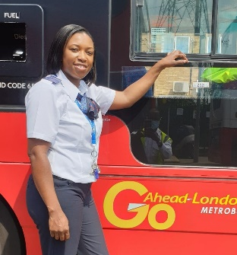
Estimator Apprentice | Bus Driver Apprentice
Quality Control Laboratory Technician | HR Apprentice
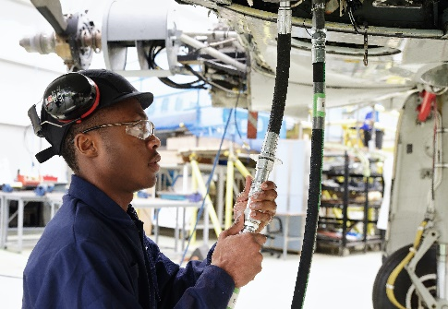 | 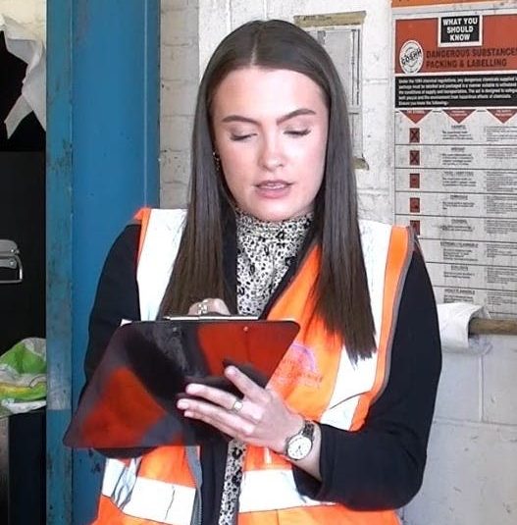
Aircraft Maintenance Technician | Safety, Health and Environment Technician

TASK 3: Apprentices in Action

Why does Sophie feel it is beneficial to be an apprentice?
- You’re into the place that you want to work
- You get to work alongside the people you aspire to be

What did Laurence think apprentices brought to the team?
- Come with an open mind
- Embed themselves into the team really well
- Bring the passion and drive to the team
- And a new way of looking at things

What benefits did Claire give for doing an apprenticeship?
- At work day to day
- Part of a team
- Putting skills into practise as you learn them
- Employed and accruing your skills as you go

Through her apprenticeship, how does Zahra hope to inspire others?
- Having the team and support that Zahra had
- The enzyme department were very welcoming when Zahra joined

What was Farzin’s advice for future apprentices?
- Be patient with your time (before understanding your role) and use that time well

TASK 4: Mind the gap

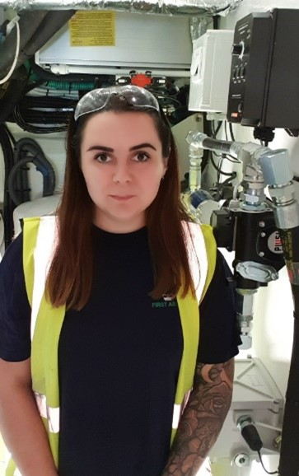
I chose the apprenticeship route as I had already spent a year at college studying engineering and I decided that University was not for me. I found that apprenticeships worked best for my style of learning. I’ve never been very good at exams so learning on the job and getting the chance to be hands on, whilst gaining skills, experience and earning money meant that an apprenticeship was the best route for me.

I am currently a grade 7 engineer, section lead, and I am also a first aider with Princess Yachts. My day-to day tasks are really varied but can include meetings with my team and assisting them with any queries that they may have and building the yachts’ engine room, which includes installing and testing the engines. I am also first aid trained and trained in mental health first aid so must make sure that I am available should there be any issues.

I never thought that I would be working on the building of the new X95 Princess Yacht. It was my first time working on a development boat and having the opportunity to work on a project that is completely new to the company was incredibly exciting.

I am so proud of myself for finishing my level 3 apprenticeship in Marine Engineering. After this, I got the opportunity to take part in the Queens Silver Medal Award. I was also proud to be accepted to continue my learning and do a level 4 apprenticeship, including an HNC. I’m really proud of the progress I’ve made since starting my career.

My advice to you is to not put anything off, take every opportunity you get and try something different. Be open to new ideas and have the drive to succeed.

TASK 5: Meet apprentice employers

Designs and provides water, waste and energy management solutions

Leading supplier of materials and equipment to the building, construction and home improvement industry
Provide smart, technology-enabled advice to the property development industry
Provides Cloud IT services to the UK legal and accounting sectors
TASK 6: The Big Assembly
- This activity will need to be completed after 12pm on Tuesday 8th February
- Students will be asked to watch The Big Assembly 2022 here: www.workpays.co.uk/bigassembly/
- This broadcast is scheduled to be 30 minutes
- Students will then be asked questions to help them to reflect on the broadcast and what they have learnt

TASK 7: Linking your subjects to apprenticeships

Subject | Apprenticeship
Business Studies | - Project Manager  - Human Resources (HR) Assistant
Drama and Music | - Creative Venue Technician  - Live Event Rigger
English | - Junior Journalist  - Public Relations (PR) Assistant
Maths | - Aerospace Engineer  - Professional Economist
ICT | - Software Developer  - Cyber Security Technologist
Food Technology | - Food and Drink Engineer  - Chef de Parties
Languages | - Cabin Crew  - Transport Planner
PE | - Physiotherapist  - Personal Trainer
Art and Design | - Junior 2D Artist  - Product Design Engineer

TASK 8: Ask an apprentice or employer
- Students will be asked to think of some useful questions that they could ask an apprentice or an employer at an event or on social media to find out more about their apprenticeship(s)
- We have given some example questions to get them started
- You could then submit some of their questions to apprentices and employers be getting involved in #AskAnApprentice and #AskAnEmployer on Twitter – please see the details below

#AskAnEmployer

Use the #AskAnEmployer hashtag during 12pm – 2pm on Tuesday 8th February to find employers participating in #AskAnEmployer on Twitter. Submit your students’ questions to employers to find out more about their schemes and why they employ apprentices.

#AskAnApprentice

Use the #AskAnApprentice hashtag during 12pm – 2pm on Wednesday 9th February to find apprentices participating in #AskAnApprentice on Twitter. Submit your students’ questions to apprentices to find out more about their experiences as an apprentice, their role and why they would recommend doing an apprenticeship.

TASK 9: ‘Build the Future’
- Students have been asked to create a poster that you could use at school to celebrate National Apprenticeship Week
- We’ve included some questions that may give them ideas of what to include
- We would love to see the designs in and around your school
- Please share them with us by posting pictures on social media and tagging in @Apprenticeships and #BuildTheFuture

TASK 10: Apprenticeship crossword

 |  |  |  |  |  |  | 1 F
 |  |  |  |  | 2 S | T | U | D | Y
 |  |  |  |  |  |  | T
 |  |  | 3 A |  |  |  | U
 |  |  | 4 P | R | O | G | R | E | S | S | I | 5 O | N
 |  |  | P |  |  |  | E |  |  |  |  | F
 |  |  | R |  |  |  |  |  |  |  |  | F
 |  | 6 B | E | N | E | F | I | T | S |  |  | T
 |  |  | N |  |  |  |  |  |  |  |  | H
 |  |  | 7 T | R | A | I | N | I | N | G |  | E
 |  |  | I |  |  |  |  |  |  |  |  | J
 | 8 S | E | C | T | O | R |  |  |  |  |  | O
 |  |  | E |  |  |  |  |  |  |  |  | B
 |  |  | 9 S | A | L | A | R | Y
 |  |  | H
 |  |  | I
 | 10 E | M | P | L | O | Y | E | R

Across | Down
2. In an apprenticeship, you work and …… at  the same time  4. Moving up through the organisation  6. You receive the same as any other employee  7. Your employer and provider will give you this  to help you to learn how to do your role  8. An area where industries and businesses  share the same related activities or subject  area  9. Apprentices get paid this  10. The organisation that you work for | 1.The theme for National Apprenticeship Week  this year is ‘Build the …….?’  3. A real job where you learn and earn at the  same time  5. You spend 20% of your time in an apprenticeship

