Apprenticeship Ambassador Handbook



Contents
Subject | Page
Contents | 2
AAN Strategy and Objectives | 3
AAN Structure | 4
Role of the ambassador | 5
AAN Key partners | 6
AAN priorities | 7
Social media | 8
Code of Conduct | 9
AAN Portal | 10
Useful information | 11

AAN Strategy and Objectives
The Apprenticeship Ambassador Network is a group of employers and past and current apprentice ambassadors. These ambassadors work together to promote the diversity and benefits of apprenticeships at all levels and across all sectors.

The government is committed to supporting high quality apprenticeships to boost the country’s skills, growth, and productivity. The Apprenticeship Ambassador Network has aligned with the government's priorities. By March 2026, the objectives of the AAN are to have:

- Ambassadors engaged with the +3,500 secondary schools and colleges in England.
- Ambassadors buddy with small business employers, starting with the 3,000 recruited through the new piloted Apprenticeship Growth Partners work.

Our Vision and Mission for the AAN

Every individual and employer will understand the value of apprenticeships as a route to opportunity and economic success.

Ambassadors will influence, advocate and have a passion for apprenticeships. This is so that more individuals, employers, and local communities understand and value the role apprenticeships play in igniting business productivity and social prosperity.

The network grows and becomes more inclusive and diverse. This paves the way for future apprentices by creating more opportunities for individuals to thrive.

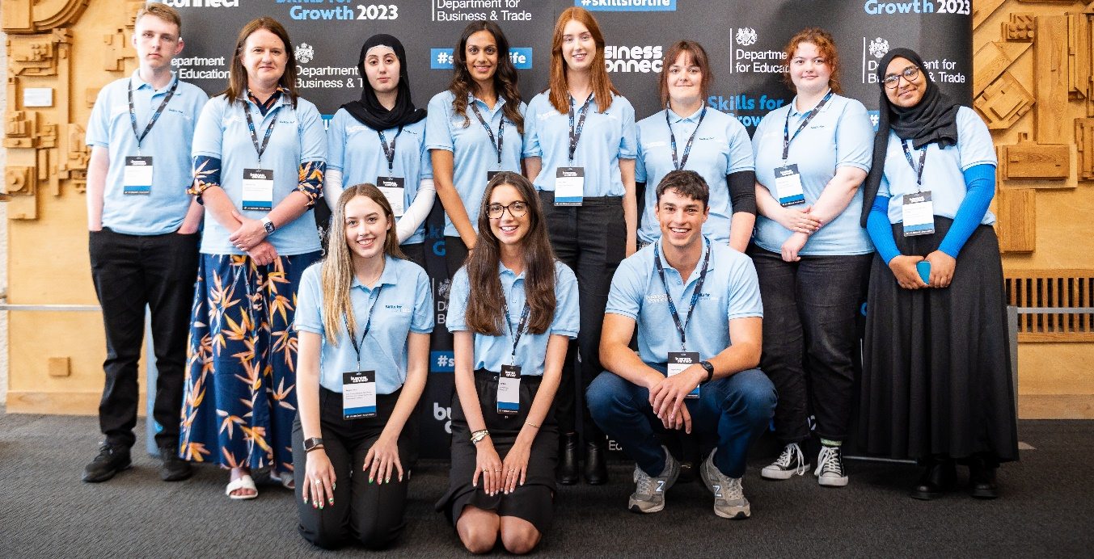
Ambassadors joined an event in London

The AAN Structure

The Apprenticeship Ambassador Network operates across England. It includes both apprentice and employer apprenticeship ambassadors.

The strategic direction of the AAN is overseen by the national leadership team, which is led by Anthony Impey, MBE and supported by the Department for Education.

It comprises an employer led multi-regional group and 9 regional networks. Each of the regions has its own employer and apprentice Chair(s) supported by a coordinator. The contact details can be found below.
Anthony Impey, MBE
National Chair

Regional Apprentice Chairs
Tom Culley,
National Co-Vice Chair
(apprentices)
Kathryn Marshall,
National Co-Vice Chair (Multi Regions)
Regional Employer Chairs

Regional ambassadors
Multi Regional Ambassadors

Region | Employer Chair/Co-Chair | Regional Co-ordinator | Apprentice Chair
Yorkshire and Humber | Jill Coyle  Jill.coyle@nestle.com  Katie Rankin  Katie.rankin@jet2.com | Craig Watson  Chair@yhaan.co.uk | Bradley Longford blongford@henryboot.co.uk  Tegan Hinch  tegan.hinch@santander.co.uk
North West | Tom Russell  chair@nwaan.co.uk | Craig Watson  chair@nwaan.co.uk | Sara McGinlay  Sara.Mcginlay@bbc.com
North East | Ian Green  mrigreen@sky.com  Jenienne Hinchcliffe Jenienne.hinchcliffe@northumberland.gov.uk | Alan Wallace Wallacealan10@gmail.com | Jess Duff  Jessica.Duff@newcastle.co.uk
West Midlands | Saima Yaqub Saima.Yaqub@midlandheart.org.uk  Jenny Johnston  j.johnston@kmf.co.uk | Caitlin O'Sullivan  c.osullivan@kmf.co.uk | Tino Mumvuri tino.mumvuri@icloud.com
East Midlands | Charlotte Nicholls  charlottenicholls@eastmidsaan.onmicrosoft.com | Bobby Ramsay  bobbyramsay@lumiandlumiere.com | Charlie Gresswell  CharlieGresswell@eastmidsaan.onmicrosoft.com
London | Neil Weller  n.weller@tbanda.com | Amber Price  a.price@tbanda.com | Leora Wilson  leora.wilson@mottmac.com  Naomi Ogun  naomiogun2@gmail.com
East of England | Matt O’Conner  matt@johnoconner.co.uk | Karen Kelly  eoeaan@gmail.com | Kieren Buxton  Kieren@tracweb.co.uk
South East | Elizabeth Flegg Elizabeth.flegg@westsussex.gov.uk | Phil Golding  info@seaan.org.uk | Max McGarvie  max@zenopa.com
South West | Nigel Fenn  nfenn@southwestwater.co.uk | Debbie Passmore  dpassmor@southwestwater.co.uk | Jordan Keen jordankeen@southdevon.ac.uk  Rebecca Ridler  rridler@synoptix.co.uk
The Role of an Ambassador
The role of an apprenticeship ambassador is to champion apprenticeships by:

- sharing success stories that demonstrate the impact apprenticeships have on individual careers and business success, such as improved productivity
- providing insight to the government to continue to develop and grow the apprenticeship landscape

Employer Ambassadors
- are committed to spearheading the drive to engage new employers to deliver apprenticeships in England
- interact with other employers to highlight the impact an apprentice can have on a business
- share their experience of recruiting and upskilling staff through an apprenticeship programme
- provide information, guidance and mentoring to employers looking to introduce apprentices to their business
- attend regional meetings to stay up to date with the network
- volunteer for approximately 1 day every 3 months
- use business or personal social media channels to share the benefits of apprenticeships

Apprentice Ambassadors
- Raise the profile of apprenticeships by sharing their personal apprenticeship story
- use social media, write case studies, and record your apprenticeship experiences
- volunteer for events and remain as part of the network for at least one year
- share their experience of the network with others and invite them to become a member of the AAN
- join and participate in AAN training sessions to support their professional and personal development
- attend regional meetings to stay up-to-date

Benefits of being an ambassador

- Being part of a trusted and influential network
- attending annual and regional conferences to share good practices and meet other members
- receiving the most up-to-date information and guidance on apprenticeships
- opportunities to attend high profile events
- sharing your views
- joining regional social events and getting to know other members of the network
- access to live and pre-recorded training sessions delivered by the Department for Education.
- building your network and having access to peer-to-peer support opportunities.
- developing personal and professional skills.
- being invited to join exciting campaigns.

AAN Priorities

School engagement

One of the AAN strategic objectives is that by March 2026, an ambassador will be connected to every secondary school and college in England. That’s an ambitious target as there are over 3,500 of them across the country!

The aim is that ambassadors will inspire the next generation of apprentices by telling compelling stories as someone who “has been in their shoes”. Ambassadors will be able to take part in assemblies and workshops to champion technical education options. These sessions will be delivered in conjunction with The Careers and Enterprise Company.

This will also serve to ensure school leaders and teachers understand and value the opportunities and benefits of apprenticeships.

Supporting SMEs

SMEs play a pivotal role in creating apprenticeship opportunities – particularly for younger people and those in disadvantaged areas.

There has been a drop in the number of new SME apprenticeship starters. SMEs cite specific barriers to connecting with apprenticeships, including a lack of awareness of the programme and challenges around recruitment and mentoring.

All of these barriers can be overcome. The AAN has set itself a target to ‘buddy’ with 3,000 SMEs by March 2026 to support them with their apprenticeship engagement. This buddying will involve linking up with and supporting the employers to recruit and employ apprentices.

We are working with the SME Apprenticeship Brokerage pilots across the country; as well as connecting with SMEs and the intermediary bodies they trust, such as the Institute of Directors and the Federation of Small Businesses.

The AAN’s multi region ambassadors are also supporting this as they work in partnership with SMEs in their supply chains - as well as with some levy transfers.

Social Media
Apprenticeship ambassadors are encouraged to use social media as a platform to highlight the benefits of apprenticeships to employers and individuals. This can be done by sharing an apprenticeship journey, celebrating achievements, promoting apprenticeship events or sharing useful resources.

When using social media, the messaging must be positive, exciting and motivating and not contain any derogatory terminology.

Please find below the regional websites and social media handles. We encourage members to follow and share information.

Region | Website | LinkedIn
Yorkshire and Humber | www.yorkandhumberportal.com/ | Yorkshire and Humber Apprenticeship Ambassador Network
North West | www.nwaan.co.uk/ | North West Apprenticeship Ambassador Network
North East | www. neaan.org.uk/ | North East Apprenticeship Ambassador Network
West Midlands |  | West Midlands Apprenticeship Ambassador Network
East Midlands | www.emaan.org/ | East Midlands Apprenticeship Ambassador Network
London | www.londonaan.com/ | London Apprenticeship Ambassador Network
East of England | www.eastofenglandaan.co.uk/ | East of England
South East | www.seaan.org.uk/ | South East Apprenticeship Ambassador Network
South West | www.southwestaan.com/ | South West Apprenticeship Ambassador Network
Apprenticeship.gov.uk | www.apprenticeships.gov.uk/influencers/become-an-ambassador | Apprenticeships.gov.uk

Region |   X (Twitter) |   Instagram |   TikTok
Yorkshire and Humber | @YHAANetwork | YH.AAN | @yorkandhumberann
North West | @NWAANetwork
North East | @AANNorthEast | aannortheast
West Midlands | @WMAANetwork | aanwestmids
East Midlands |  | eastmidsaan | @EastMidsAAN
London | @AanLondon | aanlondon
East of England | @EofEAAN
South East | @NetworkSeaa
South West | @SouthWestAAN | SouthWestAAN | @SouthWestAAN
Apprenticeship.gov.uk | @Apprenticeships | Gov.apprenticeships

Code of Conduct

The huge contribution and brilliant work apprenticeship ambassadors do across the county to champion apprenticeships is critical to the success, growth and reputation of the network.

The Code of Conduct sets out behavioural expectations and ensures all ambassadors maintain a level of professional conduct that is acceptable to other ambassadors, employers and key stakeholders. .

As an ambassador, you will be expected to:

- be friendly and welcoming to all.
- be supportive of and committed to other ambassadors.
- respect the rights, dignity and worth of all participants, regardless of age, gender, ability, race, cultural background, religious beliefs, or sexual identity.
- be aware when using social media that offensive content such as racial, ethnic, sexual, religious, or physical disability slurs will not be tolerated.
- report inappropriate behaviour to AAN.ENQUIRIES@education.gov.uk
- keep yourself safe.
- not consume alcohol or drugs of any kind on any premises whilst representing your regional or national network.

AAN Portal

The AAN portal has been created to allow employer and apprentice ambassadors to find and participate in regional and national activities that support the network mission and connect with other ambassadors.

How the portal helps ambassadors

- View the interactive calendar to see the full list of events available to ambassadors.
- Sign up for events.
- Update the ambassador profile page.
- Use the network directory to connect with the regional Chairs and other ambassadors.
- View the list of resources.

Ambassador user guide

A user guide to help ambassadors navigate and use the portal has been created to help users get the most out of the platform. The guide covers:

- accessing the portal
- managing user profiles
- using the network directory
- searching for events
- signing up for events
- leaving the network

A range of resources are available on the portal to provide top tips and guidance to ambassadors and to promote the AAN to colleagues. The full library of resources can be found on the resources hub.

Useful Information

Please find below a list of website ambassadors may find useful to support presentations, apprenticeship ambassador knowledge or for signposting.

Become an apprentice - https://www.apprenticeships.gov.uk/apprentices
Browse apprenticeships - https://www.apprenticeships.gov.uk/apprentices/browse-apprenticeships
Find an apprenticeship - GOV.UK - Find an apprenticeship - GOV.UK
Find apprenticeship training- https://www.gov.uk/employers-find-apprenticeship-training
Employer guides- https://www.apprenticeships.gov.uk/employers/employer-guides

Key Apprenticeship Events

There are some key events in the apprenticeship ambassador calendar for you to be aware of and to look out for the dates of when the events are happening.

National Apprenticeship Week – 9th – 15th February 2026
A full week of celebrations across the country to showcase the positive impact apprenticeships have on businesses and individuals.

The National Apprenticeship and Skills Awards
The annual awards ceremony recognises the hard work and commitment of apprentices and employers in a brilliant celebration.

The National Apprenticeship Ambassador Network Conference
The Annual conference is an amazing opportunity to inspire, reflect and plan for the year ahead.

Top Apprenticeship Employers
Celebrating England’s top 100 employers and top 50 SMEs and their outstanding apprenticeship programme.

