Welcome to Eli Lilly’s IIR Portal for Trial Management
Welcome to the Eli Lilly’s IIR Portal where you will be able to manage your trial communication with Lilly. The portal is Lilly’s preferred method for Investigator Sponsored Trial management. Below are detailed instructions to help you understand and navigate the portal.
https://www.lillyinvestigatorresearch.com/
First things first
The first action Lilly requires you to take is to review your milestones from First Patient Visit (FPV) to Final Study Report (FSR). If these dates are acceptable, please inform Lilly that these dates are acceptable. If the dates need to be adjusted, please reforecast trial dates. The dates you provide for FPV through FSR will be baselined by Lilly to for trial management.
Investigator Trial Management Overview
Step 1: Investigator or delegate logs into IIR portal
Step 2: Navigate to the appropriate IIT Study (as there may be multiple trials) and click on the study to expand the trial details.
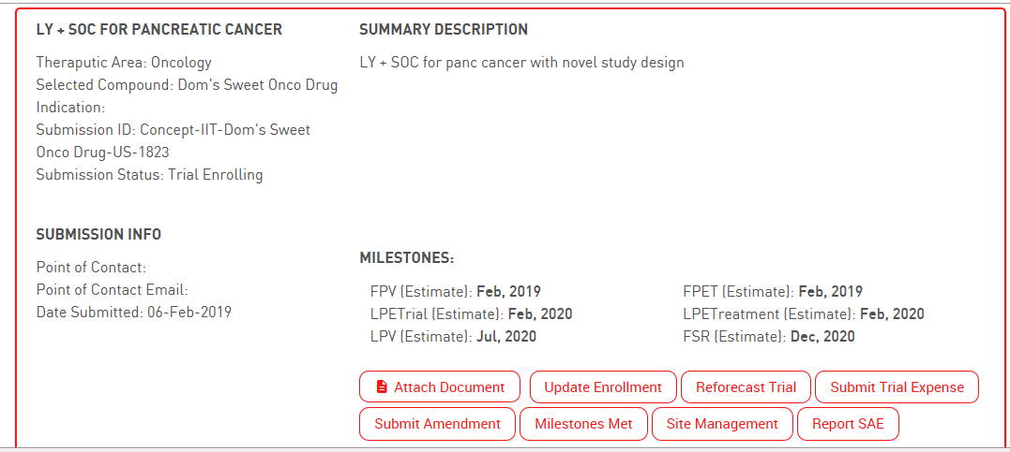

Milestones: This section highlights the current milestones for quick understanding. To change the milestone (forecasts), click “Reforecast Trial.” To actualize the milestones, click “milestones met.
Each section below highlights the critical points per section (Attach Doc, Update Enrollment, Reforecast Trial, etc).

Attaching a document:
  - Attach appropriate documents

Update Enrollment:
Purpose: Site to update Lilly on quarterly enrollment actuals (compared to expected)
Click “Update Enrollment” and select a Quarter/Year from the drop down, then click “Next”.
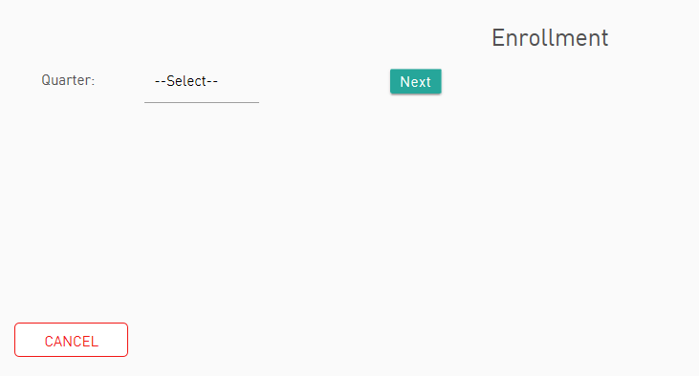

Current Pts Entered Treatment Estimate cannot be changed and is based on the site enrollment predictions. This tells HOW many pts should be enrolled up to this time (quarter) total.

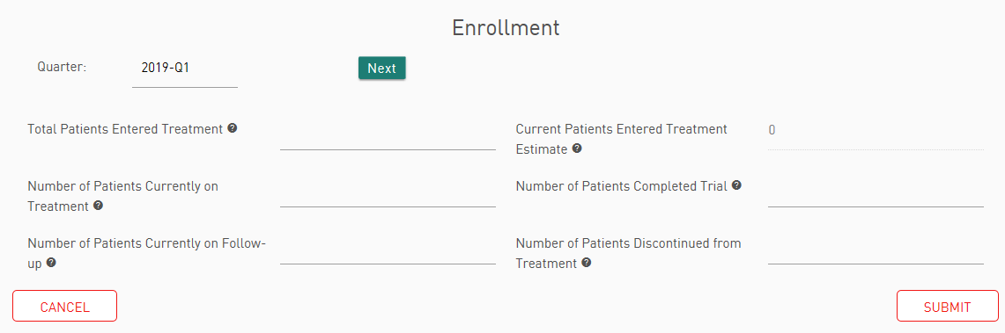
Note: Total Patients Entered Treatment: Total number of pts consented and treated (does not include screen failures).

Reforecast Trial:

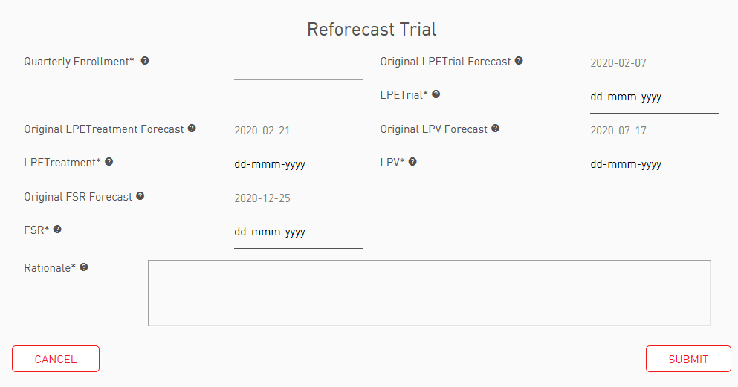
This page is for reforecasting:
- quarterly enrollment (i.e. from 10 pts/quarter to 5 pts/quarter)
- Milestones
Enrollment is not tied to the milestones in the portal. If enrollment rates are changed (per quarter), please ensure that the milestones align to the enrollment. They are independent in the portal. Same applies to milestone changes and need to adjust enrollment rates.
  - Milestones achieved will not show up. Only future estimated milestones.
  - Rationale examples could be: Landscape changes reducing eligible patients, not seeing pts who meet criteria, but screening is good, etc.

Submit Trial Expenses:
This allows for submission of any invoicing for payments. Please note that enrollment does not need to included as this will be captured from the enrollment section. Only non-enrollment expenses should be submitted.
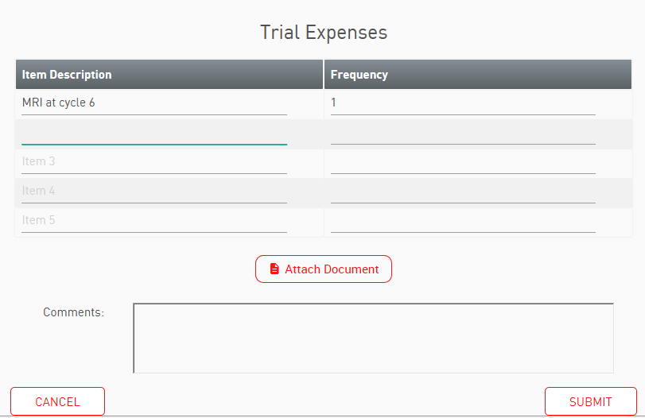
Trial Expenses include:
- Items per contract are to be invoiced such as:
  - procedures outside SOC and not included in the cost per patient.
  - IRB renewal

Submit Amendment:
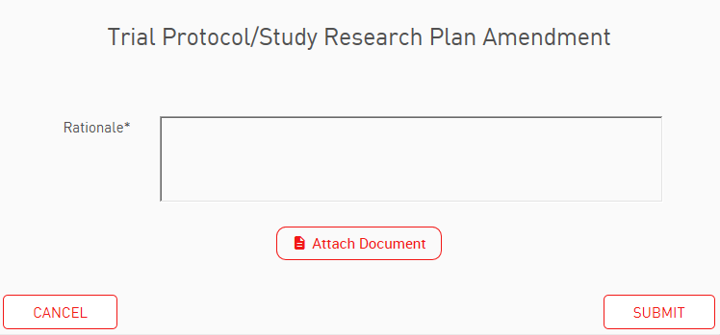
Please include a rationale for amending the protocol.
Protocol and Summary of Changes should be uploaded into the portal via “attach document.”

Milestones Met:
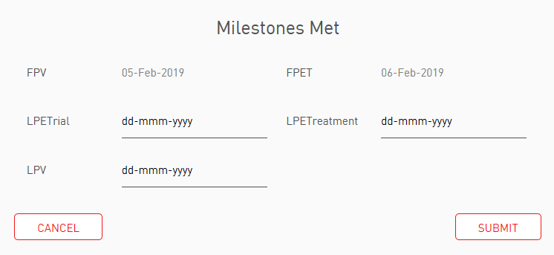
This section allow the site to update Lilly on milestones met. Please note that actualized milestones will be greyed out.

Below is a description for each milestone:
First Patient Visit (FPV): date first patient is consented
First Patient Enters Treatment (FPET): date first patient is treated
Last Patient Enters Trial (LPETrial): date last patient is enrolled into the trial.
Last Patient Enters Treatment (LPETreatment): date last patient is treated in the trial
Last Patient Visit (LPV): date last patient completes trial protocol objectives (all pts off study)
Final Study Report (FSR): date Eli Lilly will receive the final report on the study

Site Management:
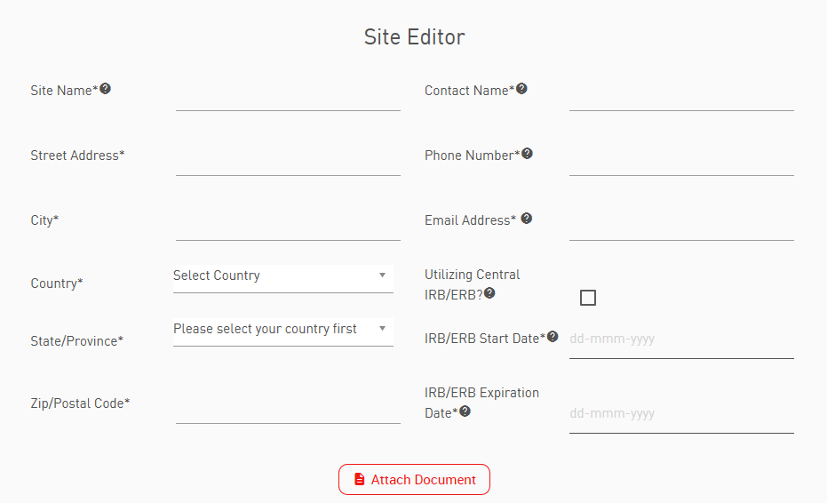

Ability to add site information for single or multi-site trial.

Report SAE: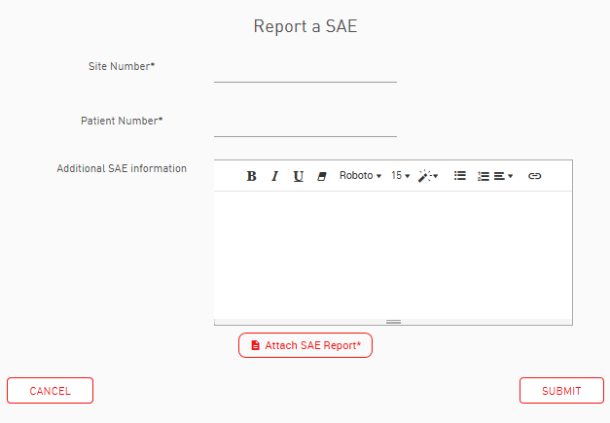

Site number (site defined) and patient number (site defined) are required when submitting an SAE, along with the ATTACHED SAE report. Lilly does NOT provide the SAE report form (site to use their own template).

