Nib Adviser 2 Months Free Offer Social Media Tile & Copy

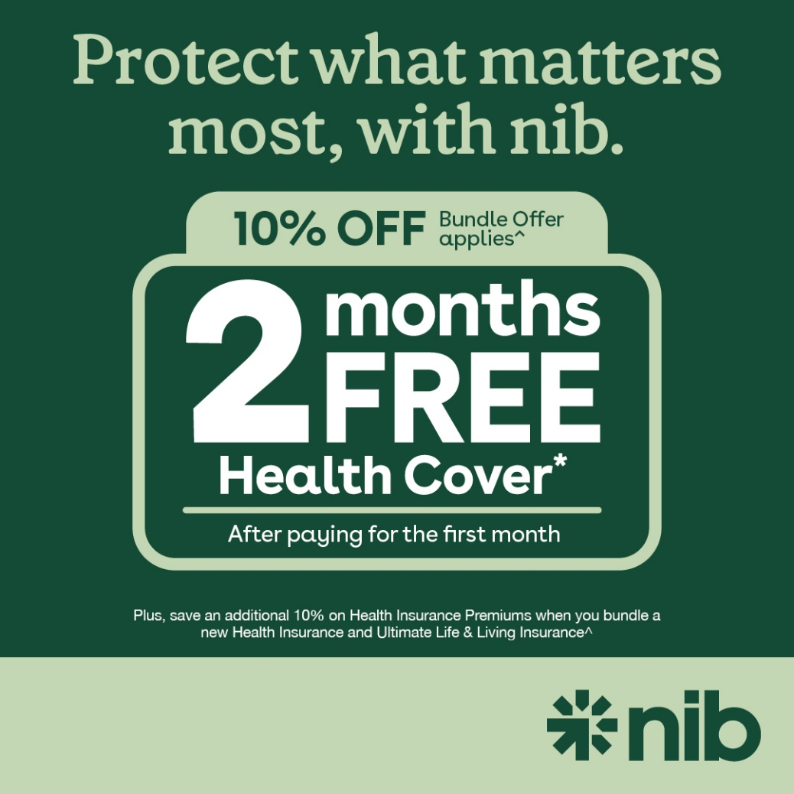

Social Caption:
With nib, you can protect your family’s health and future — and for a limited time, get 2 months free when you sign up for a new Health Insurance policy*. Even better? Bundle your health and life cover together and you’ll receive an exclusive 10% discount on your health insurance. *
Don’t wait — offer ends 30 April 2026. Contact your adviser today. Contact ^10% off Health Insurance Premiums when bundled with any new Health Insurance and Ultimate Life & Living Insurance.
*Credit for 2 months free premiums is applied to the policy in the 2nd month after the policy is issued. New policies only. Offer available exclusively through nibAPPLY. Ends 30 April 26’. T&C’s, eligibility criteria & exclusions apply

