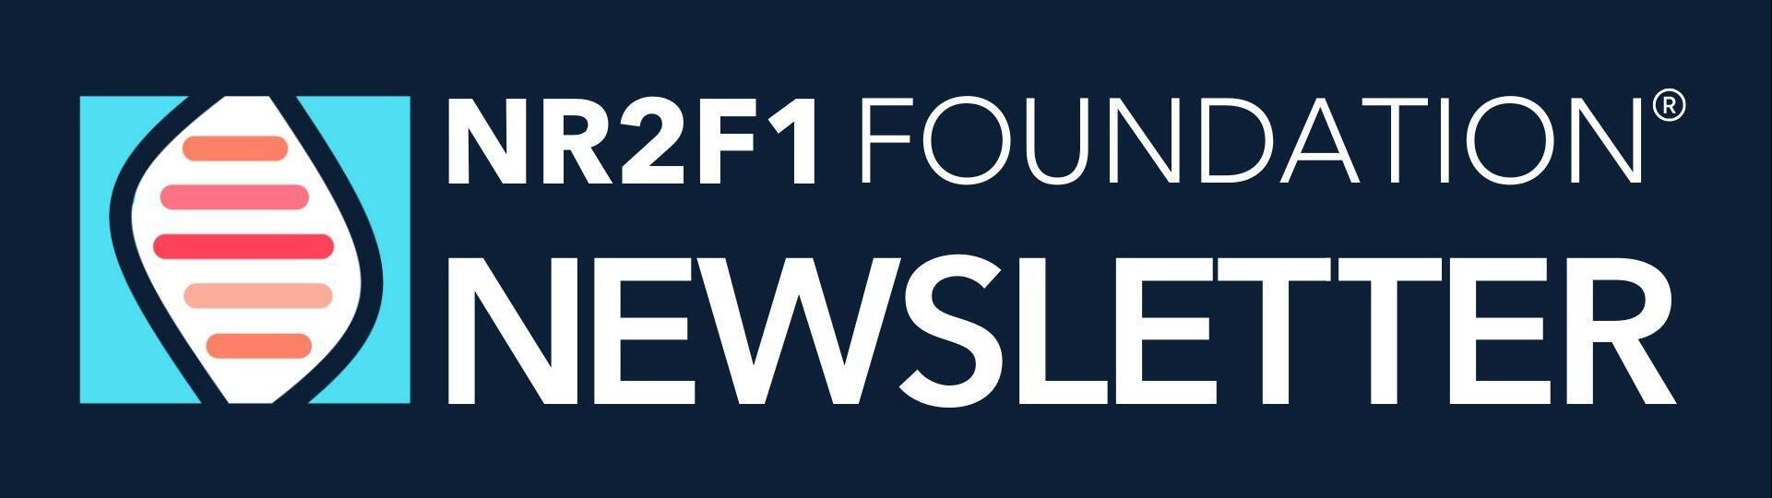
Dear {{contact.first_name}}
As ever, it’s been an action-packed few months! We’ve been incredibly grateful for the amazing fundraisers supporting our work, including a powerful (and moving) Sibling Month campaign, two UK events (I was lucky enough to cheer on one in person!), and our third consecutive year riding in the Million Dollar Bike Ride in Philadelphia—despite a last-minute scramble to get a team together!
We're are excited about the next steps with Dr. Chow and our drug repurposing study—more on that soon.
This summer, we have focused on Patient Registry. Wherever you are in the world, it’s the easiest way to contribute to research—straight from your sofa—and it’s vital that you're registered if our drug repurposing work progresses to clinical trials. We have also completed a Patient Count...how many diagnosed cases around the world do you think we have? Read on to find out!
We have launched ticket sales for our 2026 BBSOAS Family & Scientific Conference. Join us in person or online and our amazing line up of speakers (including the one and only Dr Schaaf - the ‘S’ in BBSOAS!)
A personal highlight for me came in May, when I finally (at long last!) had the chance to take my daughter, Edith, to the BBSOAS Clinic at Cincinnati Children’s Hospital with Dr. Shah. Having worked with Dr. Shah over the past few years, I already knew how dedicated and knowledgeable he is. But seeing him in action at the clinic was truly something else. In just four hours, I learned more about Edith’s vision than I have in the past four years.
Whether you're wrapping up your summer or just beginning, we’re wishing you joy, rest, and meaningful time with your loved ones.
Thank you so much for your ongoing support and commitment. Without you, we can’t do this!
Best,
Jennifer
NR2F1 Foundation President, and most importantly, Edith’s Mum

BBSOAS PATIENT COUNT
For the first time since the Foundation launched (2018) we have a patient count!
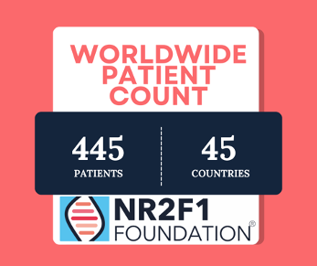
A quick note: This count isn’t complete yet — some information is still missing. If you received an email from Abigayle Nafus or were tagged in a post in our BBSOAS Parent Support Facebook Group, please respond so we can make sure your diagnosis is included.

Research Corner
Dr Chow and the Fruit Fly Drug Repurposing study
It’s taken a little longer than we hoped, but we’ve almost got the first round of results in from our fruit fly drug repurposing project and it’s looking promising. We have an update with Dr Chow in the coming weeks to determine next steps. We will share more as soon as we have it.
If you missed our last update from Dr Chow, you can watch here.
**NEW ** NR2F1 Research Advisory Council
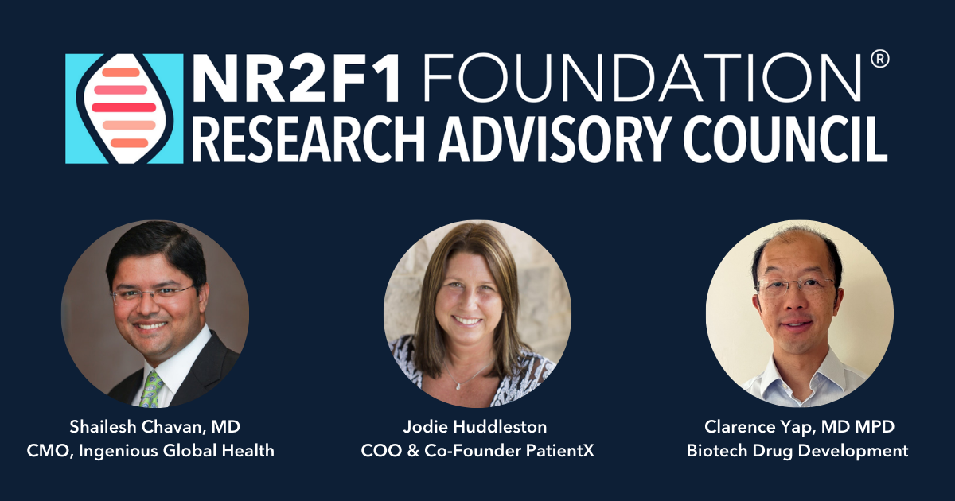
We are delighted to announce the formation of a new Research Advisory Council. The council will provide expert guidance and strategic insight to help steer the foundation’s research priorities and initiatives. By bridging the gap between academic research, scientific innovation and patient needs, the council ensures that the NR2F1 Foundations research efforts are impactful, patient-centered, and focused on accelerating the development of effective treatments
How does this differ from the Scientific Advisory Board?
The Scientific Advisory Board is composed of our leading BBSOAS researchers who are not only advising the foundation, but actively driving the science forward in their own laboratories. These experts are deeply involved in the day-to-day work of uncovering how the gene functions and are systematically building the knowledge and tools needed to move toward clinical trial readiness.
October 2025 Strategic Research Meeting
We are delighted that our October meeting will include both our Scientific Advisory Board (eg Dr Schaaf, Dr Shah, Dr Wassmer) as well as our new Research Advisory Council members. Our ambition is to create a Research Roadmap for the next few years with a clear pathway to our ambition of finding treatment.
Read more about our Research Advisory Council members in this blog post

Get involved in Research - BBSOAS families
Join or Update the NR2F1 Patient Registry
We’re asking all BBSOAS families worldwide to take part in the NR2F1 Patient Registry. Whether you’re new or returning, your information is vital for research, future treatments, and clinical trials.
Already registered? Complete your surveys by September 1, 2025 to be included in this year’s findings.
Why it matters:
- Help doctors and researchers understand BBSOAS symptoms and progression
- Support treatment development and clinical trial readiness
- See anonymous summaries from other families once you've completed your surveys
Available in 7 languages — just change language via the globe icon after logging in.
How to take part:
- Register or log in to the NR2F1 Patient Registry (Matrix)
- Complete all surveys in your dashboard
- Upload your child’s genetic report

The Biorepository on the Road continues
We need participants with BBSOAS to contribute to the Biorepository by donating blood, urine, and nasal swab samples at one of our designated locations. We have two chances left this year:
Philadelphia, PA Sept 24 - 27
Atlanta, GA December 4 - 5
Click HERE for more info and FAQ. To participate email jennifer.coughlin@nr2f1.org

Fundraising Update
Year to date we have raised $80,000 towards our annual target of $205,000 based on our current committed projects.
April - Thanks to our amazing board member, Brian. Brian created a fantastic matching offer where he shared anincredibly moving story about his sister, Stephanie, for Sibling month. Stephanies impact on this campaign was incredible raising over $10,000
May 17 - BBSOAS friend, Sarah, made 10 miles meaningful and exceeded her fundraising target!
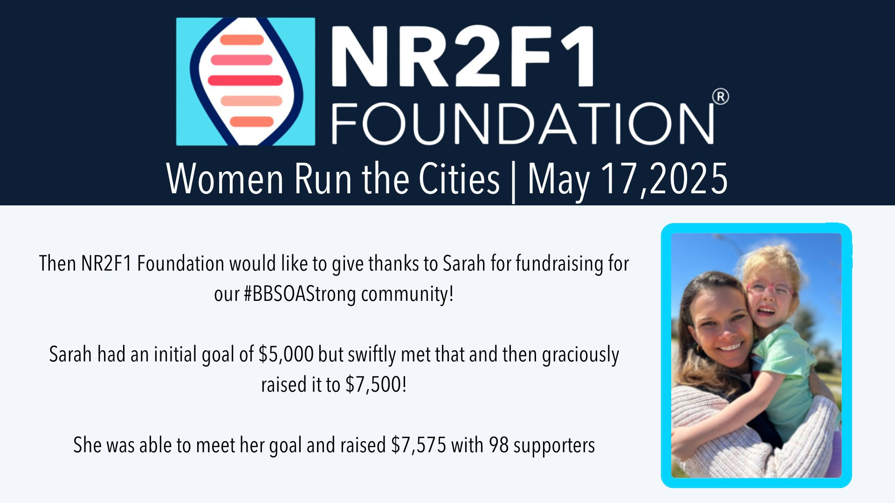
June 14 - Thanks to our amazing BBSOAS families - the Fales and Coughlins. Despite an emergency hospital admission, Dad Ross showed up and rode for our BBSOAStrong
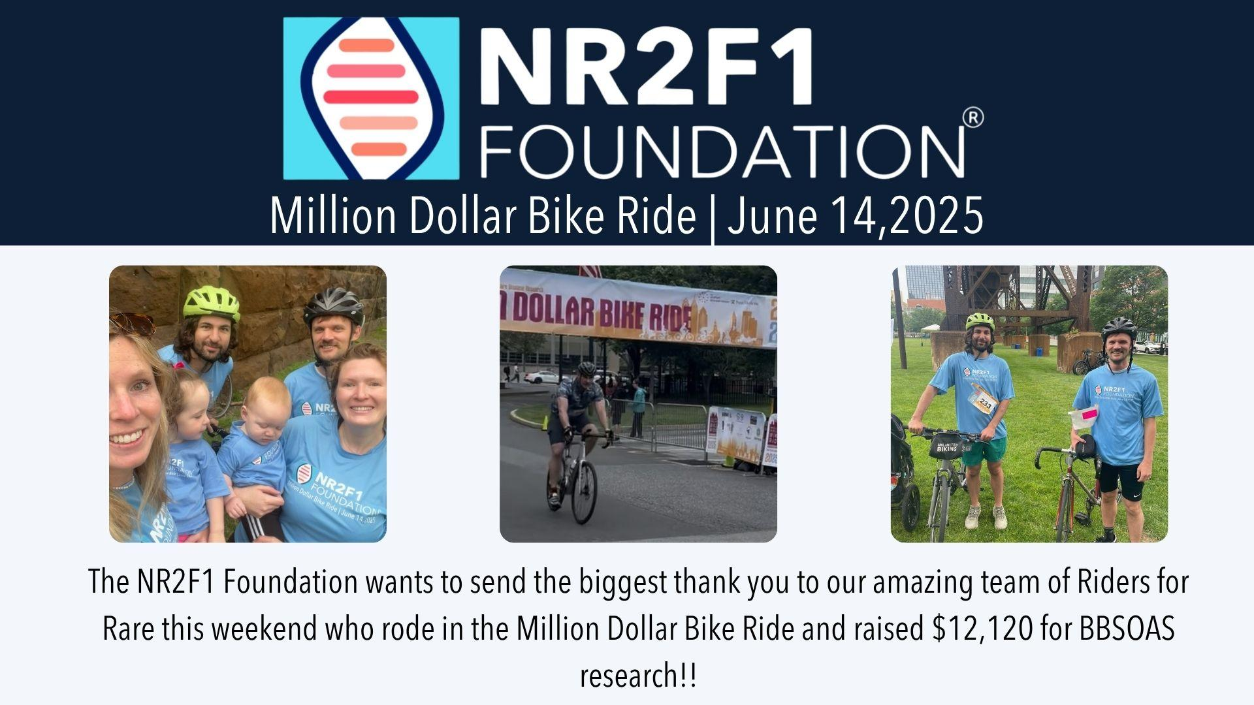
June 15 - Thanks to Edith's dear friends, Conor, Simon and Brian. Conor rustled up a team with short notice and I was delighted to be there and witness the kindness of others to support both my daughter, Edith, and all our BBSOAStrong
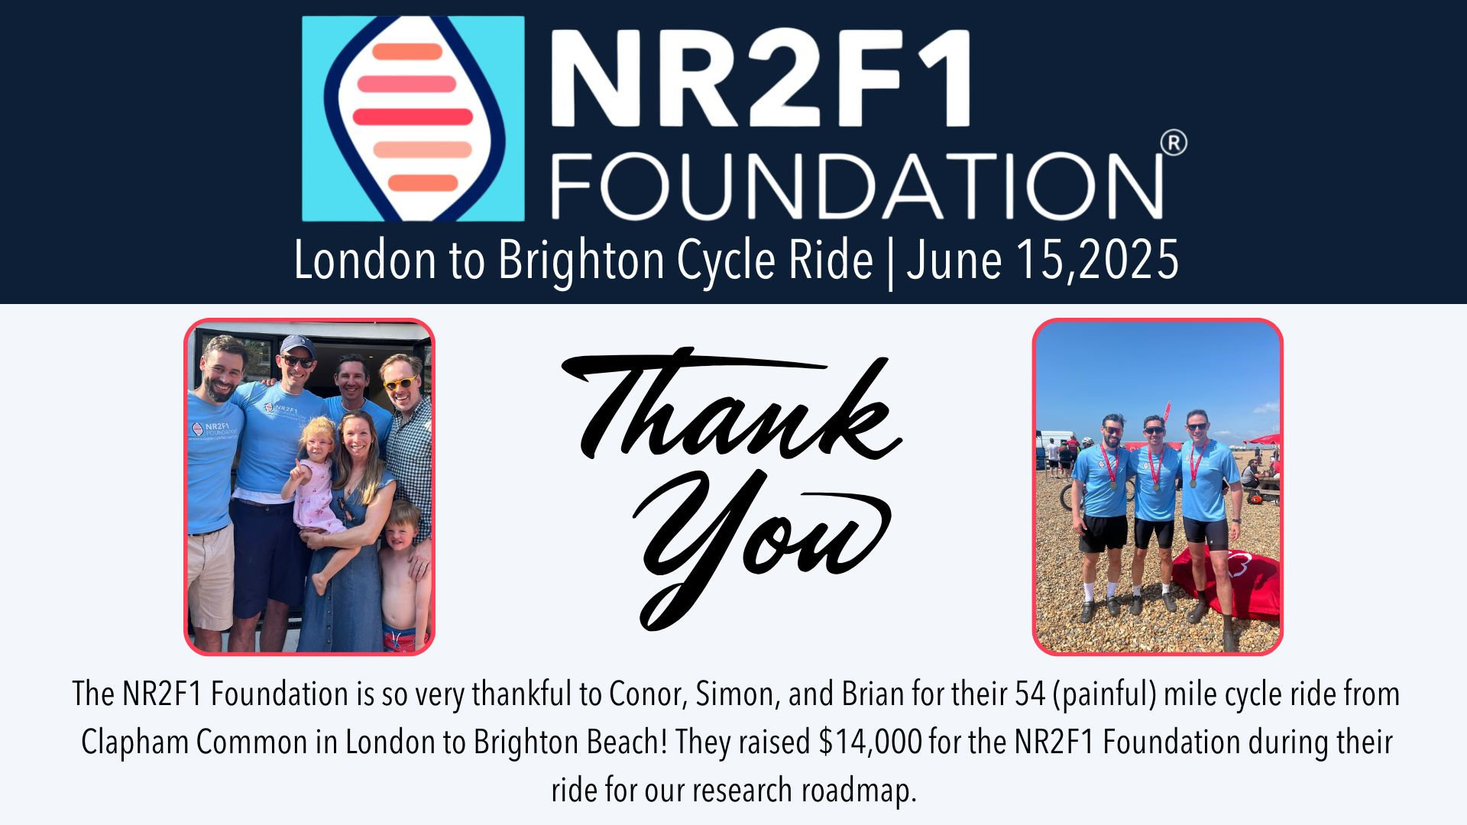
July 6 2025 - Devon, UK. BBSOAS Dad, Sean, and a team of family and friends competed in a Triathlon in honor of son Albert. But they didn’t stop there - Alberts Grandparents also did Europes longest zip wire!! Read all about it in our latest blog post
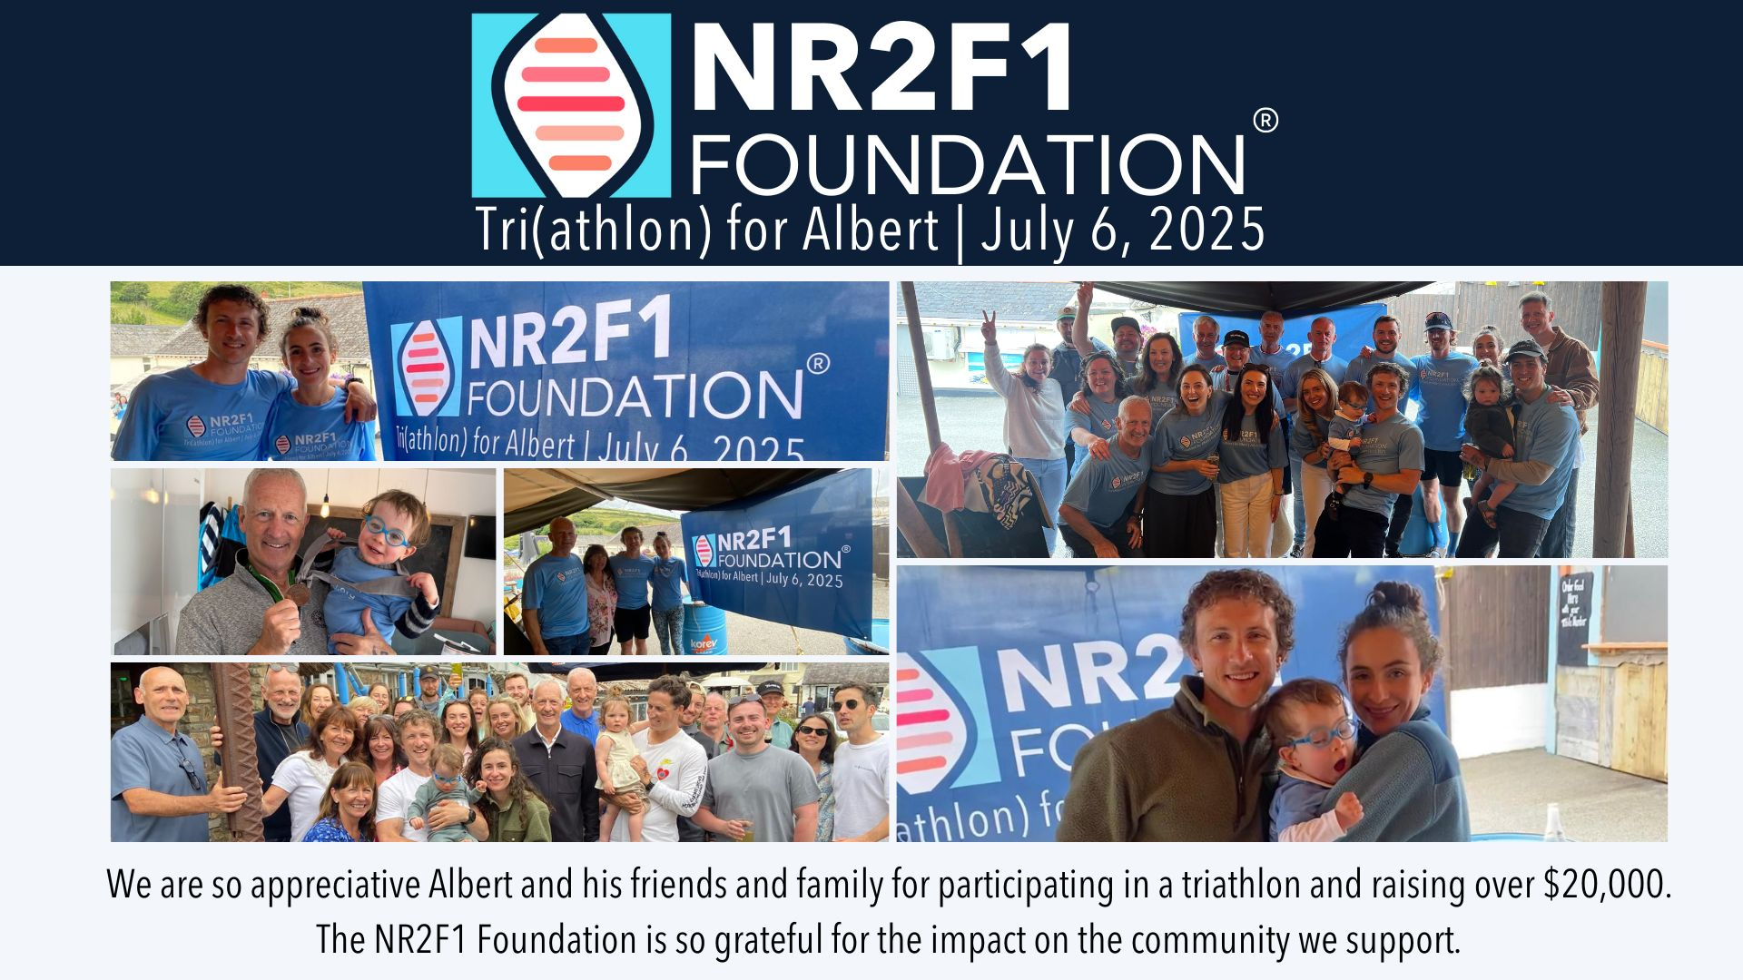
Upcoming Fundraisers:
Growler Gallop - September 28th - Detroit Riverwalk, MI
Join our Founder and Vice President, Carlie Monnier, as she runs this special family race pushing her daughter Sidelle in an adaptive stroller
Haunted Hustle 5K – Saturday, October 18 – Newtown, PA
Last year, Board member Jen Nicholls kicked off a Halloween-themed 5K run in her hometown of Newtown. It was such a hit that it’s now an annual fundraiser—with all proceeds going directly to the NR2F1 Foundation.
Whether you run, walk, or just come to cheer, we’d love to see you there! The NR2F1 Foundation board will be out in full force—and we’ll be showing our #BBSOAStrong spirit!
📅 Date: Saturday, October 18
📍 Location: Newtown, PA
🏃 How to join: Sign up here for the Haunted Hustle 5K
Can't make it but want to support or sponsor? Donate here
Let’s make this year’s Haunted Hustle the biggest one yet!
We need your help, Let’s Power a Month of Research — Together
We’re inviting families in our community around the world to lead fundraisers to sponsor one month of our post-doctoral researcher, Dr. Wassmer. This role is essential to driving forward research for BBSOAS, with a yearly cost of $90,000 — or $7,500 per month.
If every family leads a fundraiser, big or small, we can fully fund this critical work for the year. Whether you host a bake sale, fun run, online fundraiser, or simple donation drive, every effort counts.
Ready to take on a month (or even a week)? If you can help support, no matter how big of small, we would love to hear from you. Drop me an email

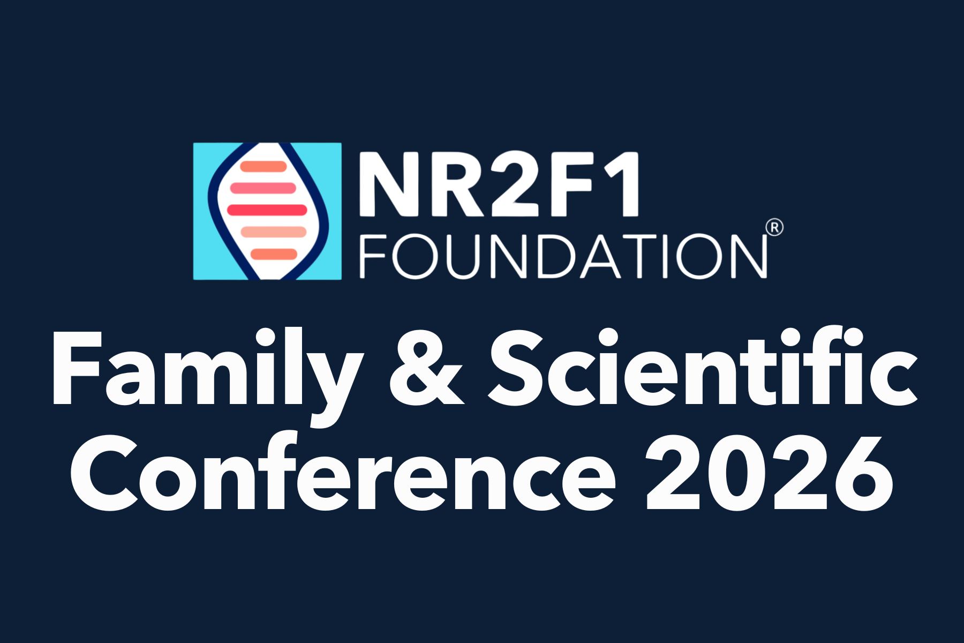
Family and Scientific Conference April 8 - 10, 2026
Every two years, we bring together leading BBSOAS researchers from around the world alongside our community to collaborate, share the latest research, and inspire positive change.
The conference is available both in person and online to ensure accessibility for families worldwide.
Why attend?
- Meet and connect with other BBSOAS families
- Meet the world leading experts and BBSOAS researchers
- Participate in essential research with our NR2F1 Biorepository
- Gain access to the latest unpublished research from leading BBSOAS investigators
- Educate our researchers on the reality of living with BBSOAS
- Learn about the critical work the NR2F1 Foundation is leading
Click here to book your conference tickets

Student volunteer
The wonderful Abi Nafus is currently our first ever rotation student!! Abi is at Kean University studying a Genetic Counselling Graduate Program. Read all about Abi, the Patient Registry and Patient Count projects she is doing for the Foundation here.
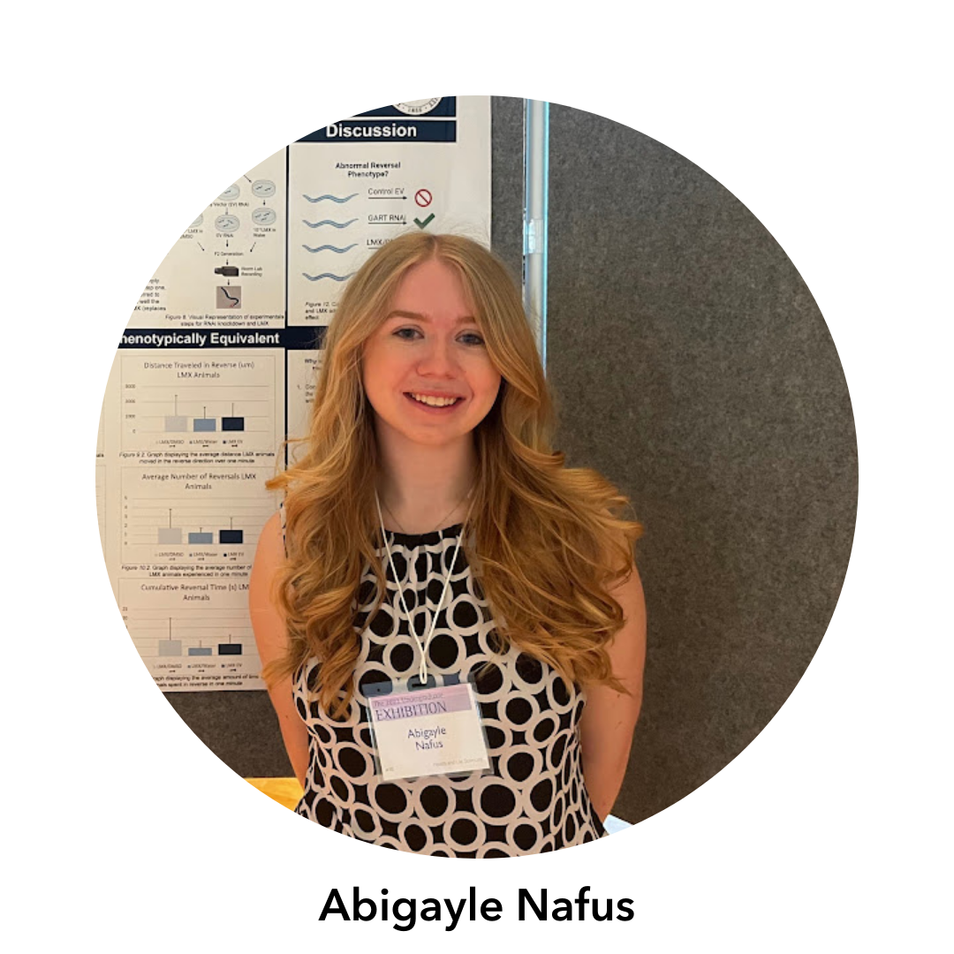

Meet our BBSOAS families
This year we have been profiling our BBSOAS families in our blog posts. Read our 3 amazing stories, including our latest from Andrew’s Mum, Karen, in Scotland: "Don't worry that you don't know what it is about yet, you will"
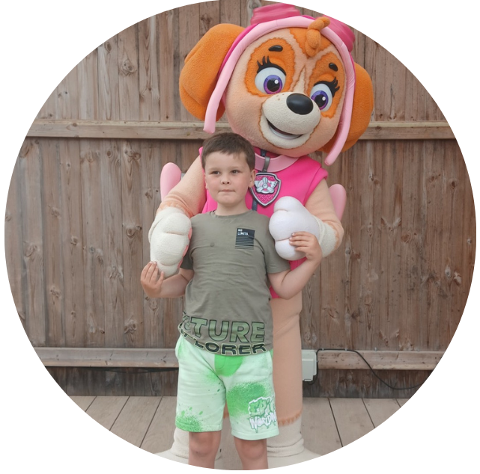
Previous stories:
“My 56-year-old Daughter Has Just Been Diagnosed” Read Susan's story here
“A parents journey of grief and uncertainty” - Mom and NR2F1 Foundation board member, Ashlee Manjon-Stierstorfer shares her feelings here

New NR2F1 Foundation website
Coming soon....and available in English, French, Spanish, Italian, Chinese, Portuguese and German. Our ambition is to improve the newly diagnosed journey for families.

BBSOAS Guides - now available in Spanish/Guías de BBSOAS - ahora disponibles en español
¡Te escuchamos!
Solicitaste que nuestras nuevas guías se publicaran en español, por lo que nos asociamos nuevamente con la organización benéfica del Reino Unido, Unique, para traértelas.
- Full BBSOAS guide/Guía completa de BBSOAS - a robust guide to BBSOAS/NR2F1 for anyone looking to understand BBSOAS and the NR2F1 gene more comprehensively (click here for English) o aquí para Español
- 'My Chromosome Story’ booklet/Folleto 'Mi historia cromosómica'- aimed at children. This can be used to start explaining a child’s diagnosis to them at a young age. It is also helpful for siblings and classmates (click here for English) o aquí para Español
- ‘Easy Read’ guide/Guía de lectura fácil- aimed at BBSOAS patients who may need a shorter version of the full guide (click here English) o aquí para Español

Thank you, as always, for your continued support!
Best,
Jennifer Coughlin
NR2F1 Foundation Board President, and most importantly, Edith's Mum

