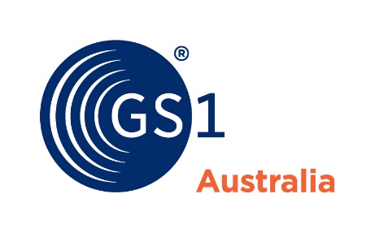
Media release
Friday 18 August, 2023
----------------------------------------------------
Half a million products and counting!
GS1 Australia is pleased to announce that over 500,000 Australian product records are now available in the global Verified by GS1 product registry service.
Local brand owners have added their products to 410 million others around the world, safeguarding the identity and ownership of those products in the eyes of global retailers, marketplaces and trade agencies.

With Verified by GS1, organisations around the world now have access to a free, global and standards-based registry that can assist them to validate key attributes about products and the companies that make them.

Global retailers including giants such as METRO, international online marketplaces like Amazon and customs agencies, for instance China Customs, can leverage Verified by GS1 to support trade processes.
GS1 Australia’s Chief Operating Officer, Marcel Sieira, commented "We are thrilled to reach this significant milestone of half a million products in Verified by GS1. This achievement underlines the value of collaborative efforts among businesses, industry partners and governments in upholding the integrity of supply chains.”

Verified by GS1 not only aids companies in protecting their brand reputation but also empowers consumers to make informed purchasing decisions with confidence.

A powerful tool, Verified by GS1 confirms the information that is entered by the product owner and linked to a product’s unique GTIN (barcode) is true and accurate. This verification process helps ensure that product data, including attributes like product description, manufacturer details, product classification and images are correct and up-to-date.

Global gains for imports and tax evasion

The effectiveness of Verified by GS1 is not only for Australian shores. Across the globe, the innovative system is pivotal in driving accountability and transparency in supply chains.

China Customs and GS1 Global Office worked closely with GS1 China as part of the customs process, allowing the agency to seamlessly authenticate and verify important details about imported products. The partnership has significantly improved risk assessment and processing of imports into China, making China’s customs clearance processes more efficient and more accurate.

The General Administration of Customs of the People’s Republic of China (GACC) is amongst several border agencies around the world that now leverages the GS1 Global Trade Item Number® (GTIN®) to expedite border declarations, minimise errors, improve compliance, combat counterfeits and enhance a whole range of customs clearance processes.
For example, many companies and brokers importing goods to China can now auto-populate product information in the ‘single window’ declaration system simply by entering the product’s GS1 GTIN.

Brazilian authority SEFAZ, the tax administration for Brazil’s states, put Verified by GS1 into action and established an authentication system that aids in minimising tax evasion. Calculating the right tax rate to apply to products is a complex affair for SEFAZ. To do it accurately, they need to know exactly what each product on an invoice is. SEFAZ now uses Verified by GS1 to authenticate the Global Trade Item Numbers (GTINs) on the e-invoices they manage. The initiative has positively impacted revenue collections and ensured that consumers receive genuine products.

A catalyst for change

Verified by GS1 has become a catalyst for change, with business, governments and consumers benefiting from a more transparent and trustworthy supply chain tool and it is growing rapidly, with approximately 300,000 product records being added daily. The impact of Verified by GS1 on product authenticity and ownership is transformative for the modern economy.

More information is available at Verified by GS1 - GS1 Australia

------Ends---------------

Contact
Tracey Kelly-Jenkins
Marketing Program Manager
GS1 Australia
P: 0408 547 530
E: Tracey.Kelly-Jenkins@gs1au.org

About GS1 Australia
GS1 Australia is the Australian arm of the neutral, not-for-profit organisation that develops and maintains the most widely used global standards for efficient business communication. We are best known for the barcode, named by the BBC as one of “the 50 things that made the world economy”. GS1 standards and services improve the efficiency, safety and visibility of supply chains across physical and digital channels in 25 sectors. With local Member Organisations in 116 countries, 2 million user companies and 10 billion transactions every day, GS1 standards create a common language that supports systems and processes across the globe.
For more information about GS1 Australia visit: GS1 Australia

Images below
