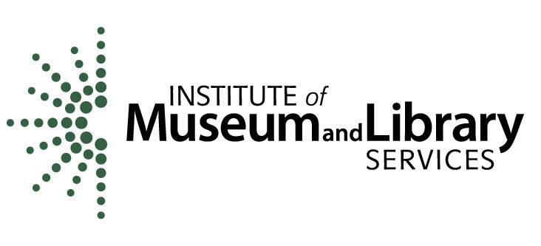

FOR IMMEDIATE RELEASE MEDIA CONTACT: Kristin Drouin
(202) 414-0781; kdrouin@susandavis.com

Institute of Museum and Library Services Announces Two Nebraska Finalists for the 2013 National Medal for Museum and Library Service
Visit IMLS Facebook Page and Share Your Story

WASHINGTON (February 14, 2013) – The Institute of Museum and Library Services today announced Omaha Children’s Museum and Omaha Public Library, as National Medal for Museum and Library Service finalists. The National Medal is the nation’s highest honor conferred on museums and libraries for service to the community and celebrates institutions that make a difference for individuals, families, and communities.

Medal finalists are selected from nationwide nominations of institutions that demonstrate innovative approaches to public service, exceeding the expected levels of community outreach. This year’s finalists exemplify the nation’s great diversity of libraries and museums and include an aquarium and marine science center, conservatory and botanical gardens, county library systems, individual libraries, children’s museums, an art museum, science centers, and more, hailing from across the country.

“Museums and libraries serve as community gathering places and centers for lifelong learning, and we are very proud to announce Omaha Children’s Museum and Omaha Public Library as finalists for the 2013 National Medal,” said Susan Hildreth, director of the Institute of Museum and Library Services. “This year’s finalists exemplify the many wonderful ways museums and libraries can respond to the needs and wants of the communities they serve.”

“We are deeply honored that Omaha Children’s Museum is a finalist for this prestigious award,” said Lindy Hoyer, Omaha Children’s Museum executive director. “Our community has come together in a way that has allowed the museum to be innovative in its approach to serving children and families. We are truly grateful to our partners and supporters for believing in the vision and programs of our organization, and of course, to the children and families who visit.”

“Omaha Public Library is excited to be among the outstanding finalists for the National Medal,” said Omaha Public Library executive director Gary Wasdin. “We’ve made a concerted effort to strengthen our community by connecting people with ideas, information and innovative services. Being recognized as a community leader helps us know that we are making a difference to those we serve.”

Finalists are chosen because of their significant and exceptional contributions to their communities. IMLS is encouraging community members who have visited the two finalist institutions to share their story on the IMLS Facebook page, www.facebook.com/USIMLS. Visit the IMLS Facebook page to learn more about how these institutions make an impact. National Medal for Museum and Library Service winners will be announced this spring.

To Share Your Story, please visit www.facebook.com/USIMLS. To learn more about the 2013 National Medal finalists, visit www.imls.gov/medals.

About the Institute of Museum and Library Services
The Institute of Museum and Library Services is the primary source of federal support for the nation’s 123,000 libraries and 17,500 museums. Our mission is to inspire libraries and museums to advance innovation, lifelong learning, and cultural and civic engagement. Our grant making, policy development, and research help libraries and museums deliver valuable services that make it possible for communities and individuals to thrive. To learn more, visit http://www.imls.gov and follow us on Facebook and Twitter.

# # #

