ONCAP Team

ONCAP Funds

ONCAP V (2024)

US$1.3 billion fund
6 platform investments and 2 follow-on acquisitions to date

ONCAP IV (2016)

US$1.1 billion fund
13 platform investments and 51 follow-on acquisitions to date

ONCAP III (2011)

C$800 million
8 platform investments and 47 follow-on acquisitions to date

ONCAP II (2006)

C$574 million
8 platform investments and 97 follow-on acquisitions

ONCAP I (2000)

C$400 million
6 platform investments and 15 follow-on acquisitions

- 41 professionals located within Onex’ Toronto and New York offices; ONCAP’s senior leadership have worked together for an average of 17 years and have more than 120 collective years of private equity experience

Investment Focus and Philosophy
Targeting significant minority or control equity investments of $20 - $250 million in North American businesses with EBITDA of $5 - $50 million and total enterprise values of $50 - $500 million
Partner with exceptional managers to jointly build businesses over the long-term with a focus on multiple of capital and not IRR
Focused portfolio – we work to make each investment successful on a standalone basis
  - ONCAP funds have never impaired capital on any realized investments since inception
- Invest in high quality businesses, with strong, sustainable free-cash-flow characteristics and market leadership in fragmented industries
- Ownership philosophy which mandates ONCAP and its management partners to personally invest in
each transaction
- Long-term track record of serving as the first significant institutional investor in founder-owned businesses across North America
- Utilize an appropriate financial structure and leverage ONCAP’s strong existing lending relationships

About Onex
Founded in 1984 and public since 1987 (TSX: ONEX), Onex is one of the oldest and most successful
private equity firms in North America
Approximately US$59.2 billion of assets under management, including over US$8.7 billion of Onex investing capital, in two private equity platforms (Onex Partners for larger transactions and ONCAP for middle-market transactions), and a private credit platform
Onex and its management team are collectively the largest investors across Onex platforms

ONCAP Sectors of Emphasis
  Consumer  - Automotive Aftermarket  - Multi-Location Consumer Services  - Health & Wellness |  |   Industrials  - Engineered Products and Materials  - Systems, Aftermarket & Services |  |   Services  - Education  - Facility Services  - Tech-Enabled Services

The largest branded title  vehicle retailer in the U.S. |  |   A vertically integrated medical device contract manufacturer focused  on micro-plastics, micro-metals, image-guided-intervention, and final device assembly |  |  |   A leading network of automotive collision repair centres |  |  |   Largest retailer of professional hair care products in Canada
  A leading provider of dealership technology solutions for the automotive industry |  |   A specialty dental service  organization focused on providing  business and administrative services to specialty dental service providers |  |  |   A leading English language school that offers language, pathway and vocational college programs in its modern boutique campuses |  |  |   A leading designer and manufacturer of industrial waste and recycling processing solutions.
  Designer, manufacturer, and marketer of bath accessories and home fashion products |  | A leading developer, manufacturer and retailer of Pilates equipment, accessories, content and education globally |  |  |   A leading provider of wireless infrastructure services to the telecommunications industry in the United States |  |  |   A leading global designer and manufacturer of dispensing solutions
  A leading North American corrugate box re-use platform. |  |   A leading national provider of before and after school childcare in the U.S. |  |  |  | 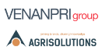  A leading manufacturer of wear components and hand tools for the agriculture, constructionm and gardening industries |  |   A leading provider of consumable surface technology solutions for industrial users
 |  | 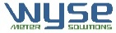  A leading provider of submetering and utility expense management solutions for the multi-residential, condominum and commercial markets in Canada |  |  |  |   A regional provider of re-occurring maintenance, repair, and overhaul services for industrial equipment and infrastructure.





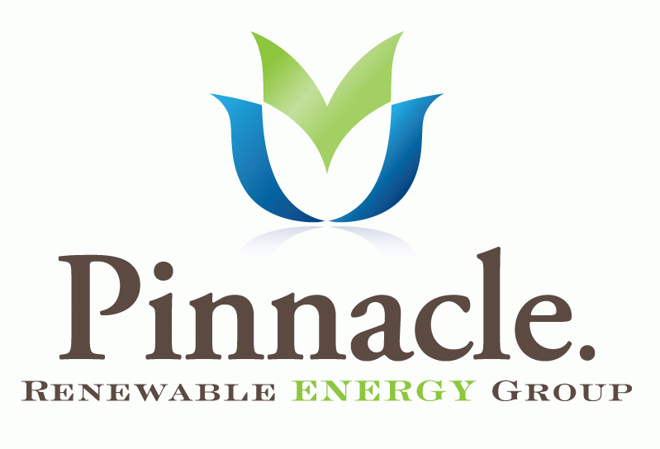

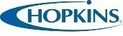



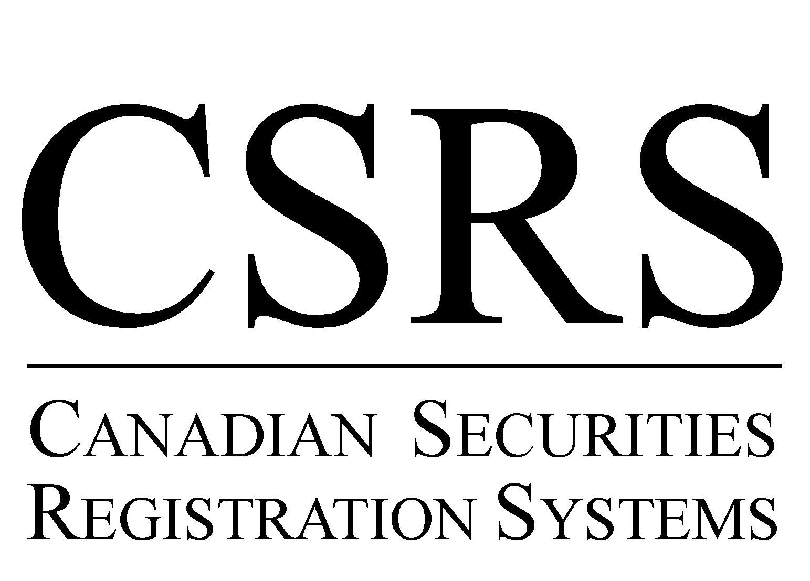


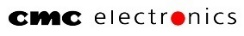



Exited Investments

Contact Information  Michael Lay  Executive Chair  mlay@oncap.com  Steve Marshall  Managing Partner, Co-Head  smarshall@oncap.com  Adam Shantz  Managing Partner, Co-Head  ashantz@oncap.com | Greg Baylin  Senior Advisor  gbaylin@oncap.com  Mark Gordon  Senior Advisor  mgordon@oncap.com  Aly Hadibhai  Managing Director  ahadibhai@oncap.com | Wole James  Managing Director  wjames@oncap.com  Rene Boissonnault  Principal  rboissonnault@oncap.com | Jason Levy  Principal  jlevy@oncap.com  Nicholas Moritsugu  Principal  nmoritsugu@oncap.com  Gietha Murugiah  Principal  gmurugiah@oncap.com  Hampton Webb  Principal  hwebb@oncap.com

