To use this template
- Turn on Formatting Marks (¶). This will help you see where the Page Breaks are and help you navigate the different text styles.
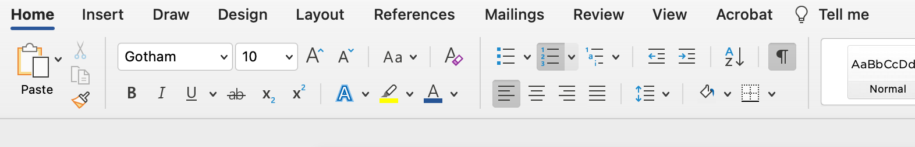
- Use the STYLES PANE to format your text. E.g. If you want to make a heading, click Heading 1.
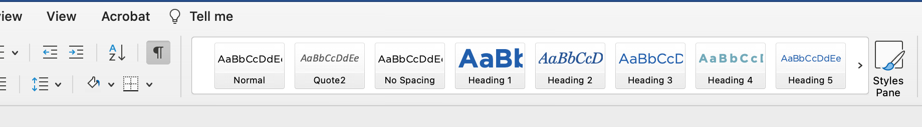
- Make sure you use ‘Page Breaks’ to create a new page (instead of hitting ‘Enter’ lots of times!). To use a ‘Page Break’ following the instructions below:
  - Mac: Command ⌘ + Enter
  - PC: Ctrl + Enter
  - Or go to the Insert tab in the task bar, and click Page Break

- Delete this instructional page.


People Management Capabilities

LEARNING PROGRAM

Why
Our ministry strategy is ambitious. We want to expand our reach and see more people join the fight against childhood poverty. This means we need to grow.
And growth out there, starts in here.
‘Increase our capability’ is one of our strategic initiatives. But why does this matter?
As a ministry, we want to increase our impact because it means more children released from poverty in Jesus’ name. It means more lives transformed and changed.
Increasing our impact requires us to increase our capability as leaders.

Project Objectives
This learning program is designed to equip and empower you in your leadership and management journey.
It provides the framework, principles and practices that will enable you to increase in your capability as a people manager. This learning program focuses primarily on one of the people management capabilities: ‘Leads high performing teams (LHPT)’, addressing the central expectations of people management.
Outlined below is the session plan:
- Session 1: Introduction to People Management Capabilities (2.5 hours)
- Session 2: LHPT Module 1: Performance Management (4 hours)
- Session 3: LHPT Module 2: Healthy Conversations, Healthy Culture (3 hours)
- Session 4: LHPT Module 3: Right People, Right Roles (3 hours – opt in)
- Session 5: LHPT Module 4: Remuneration (2 hours – held annually in Q4)

Insert Capability

Preparation
To prepare for this session, please ensure that you:
- Insert
- Insert
- Insert

Insert Capability

Learning Content
Insert key content
- Insert
Insert key content
- Insert
Insert key content
- Insert
Insert key content
- Insert
Insert key content
- Insert

Insert Capability
Notes:
- Insert
- Insert
- Insert

Insert Capability
Self Reflection
Insert any reflective questions
- Insert
- Insert
- Insert



