Exemplary blog post

5 mouth-watering ingredients
for the best salad ever

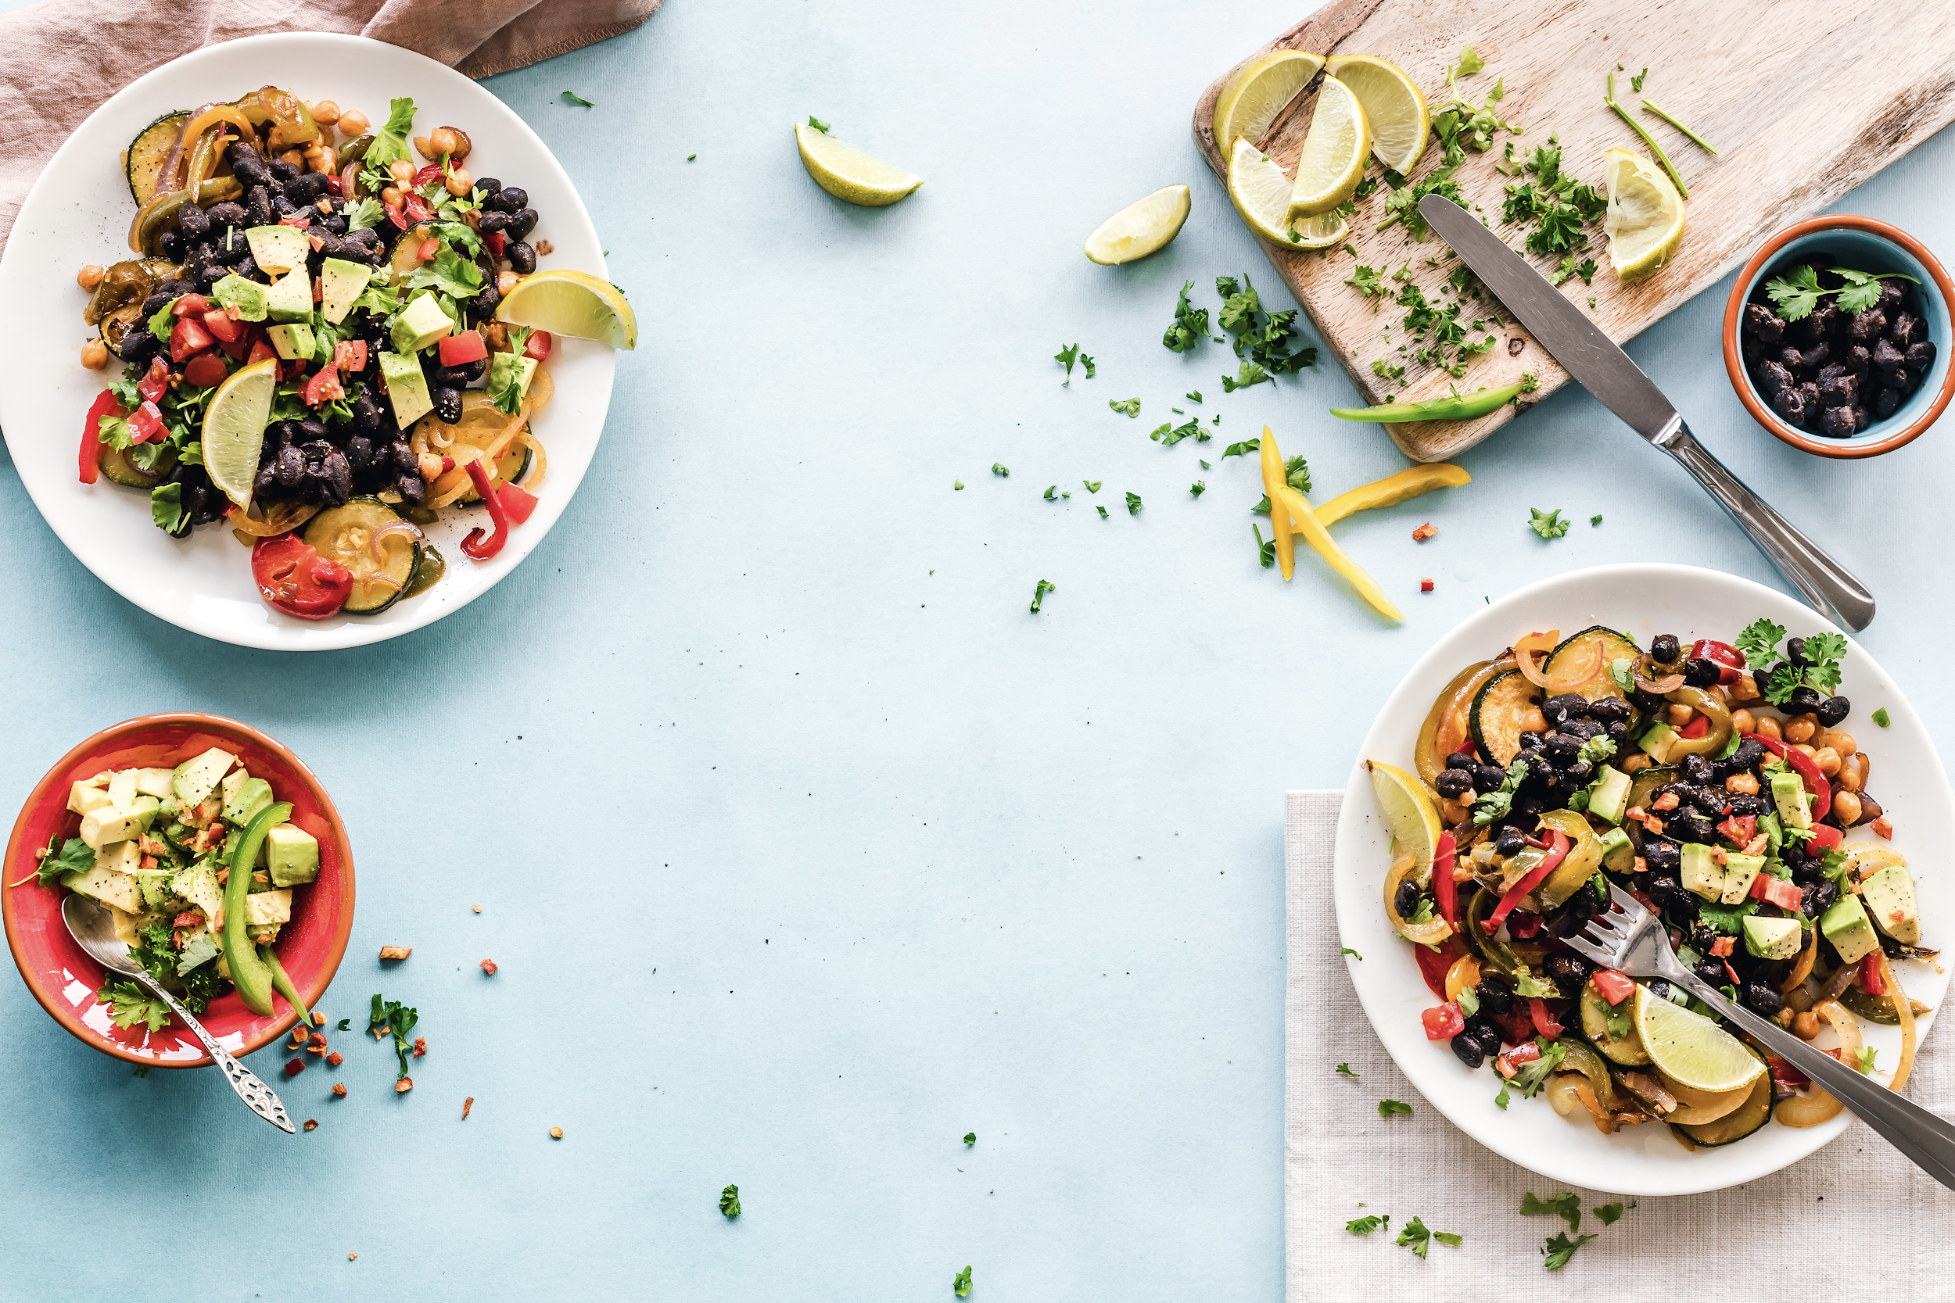

If you’ve ever tasted a boring, wilted side salad that left you craving anything else on the menu, it’s time to upgrade your salad into a filling, delicious, satisfying main meal. In this blog post, you’ll get five ingredients that make for the most mouth-watering salads.

Try these simple ingredients to upgrade your salads

Cheese
What isn’t better with cheese? Cheese turns any salad into a creamy, decadent indulgence. And the best part is, a little goes a long way. Try adding a scoop of feta with Mediterranean flavors, gorgonzola with fresh fruit, or bleu cheese with a classic cobb salad.

Nuts
If you’ve ever felt hungry an hour after eating a salad, try adding a handful of nuts. Nuts are earthy, filling, and crunchy, with plenty of healthy fats to increase satiety. Try tossing a handful of cashews, walnuts, pine nuts, macadamia nuts, or almonds into your next salad, and feel your tastebuds rejoice.

Fruits
Sweet and savory pair so well together. The next time you make a salad, think about how you can incorporate fruit, either as a base or topping—a thinly sliced apple or pear, a handful of raisins or raspberries, juicy chunks of fresh watermelon—whatever your heart desires.

Grains
If you thought grains were meant for sandwiches, think again. Grains add extra bulk, texture, and flavor to salads. Add a scoop or two of quinoa or brown rice for a healthy—and tasty—salad base.
Herbs
Herbs are an easy way to completely transform the flavor of a salad, with nothing more than a few leaves. Sprinkle a few sprigs of fresh mint, dill, basil, parsley, chives, and edible flowers over your salad for a pretty, delicate explosion of flavor.

Ready, set, salad
By adding a few new ingredients to your salad, you can take an average meal and make it spectacular. You will love all the flavors, colors, and textures that just a few simple upgrades can add to your salads—transforming your salads from an after-thought to the star of your next meal.

Let us know in the comments below: Which ingredient are you going to try first?!

Remember, submit your best work as this can be used as a portfolio piece during your job search!

