Exemplary buyer persona
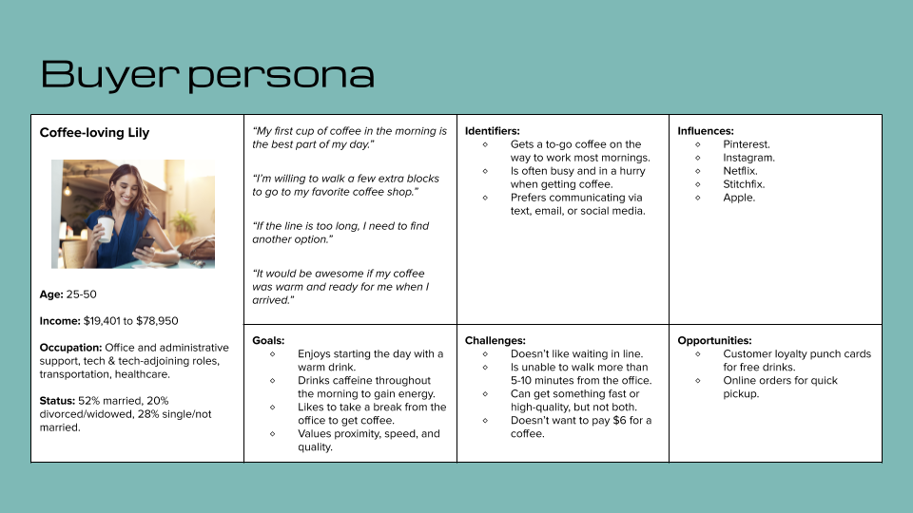
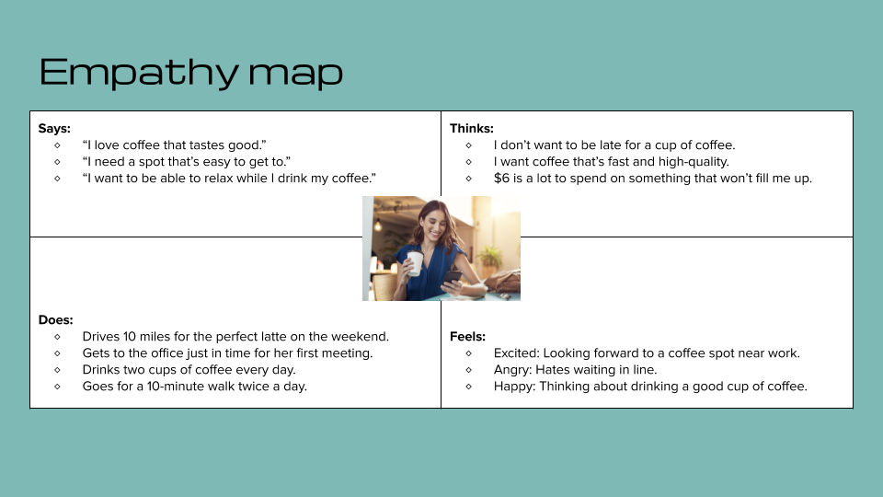

Remember, submit your best work as this can be used as a portfolio piece during your job search!

