Exemplary SEO-tailored blog post

10 surprising facts about pigs
What do you know about these remarkable animals?
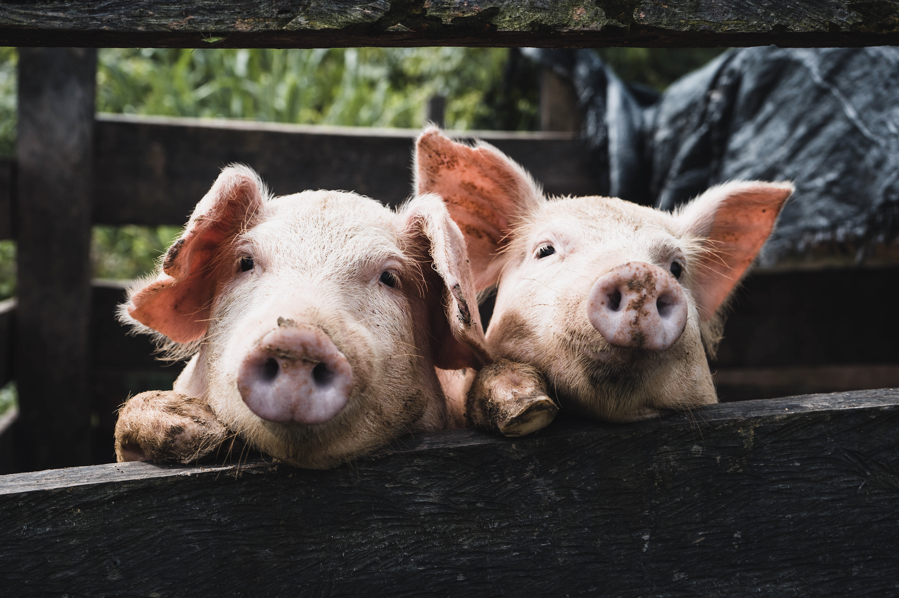

Pigs are incredible animals that have been unfairly given a smelly reputation. It’s time to set the record straight and learn more about these animals that are both so familiar and unfamiliar to us.

Fact: Pigs have personalities
Like people, pigs display consistent behavioral and emotional characteristics, like coping styles, response types, temperament, and behavioral tendencies.

Fact: Pigs are peaceful
Unless a mama pig is protecting her offspring, pigs rarely show aggression.

Fact: Pigs are foodies
Pigs are omnivores and prefer to eat their food slowly and savor it.

Fact: Pigs are social
Pigs form close bonds with each other and other animals, like to sleep nose to nose, and spend most of the day talking to each other through grunts. In fact, from an early age, piglets learn to recognize their mama’s voice and can even recognize their own name by the time that they’re two weeks old.

Fact: Pigs are clean
When pigs are given enough space, they dedicate different areas for living, eating, and going to the bathroom.

Fact: Pigs are intelligent
Pigs are smarter than young human children, dogs, and some primates.

Fact: Pigs are good gardeners
In their natural habitat, pigs root around for food, which disturbs the soil and creates new areas for plants to colonize. This helps ecosystems maintain biodiversity.

Fact: Pigs are fast
Adult pigs can run up to 11 miles per hour (that’s a five and a half-minute mile)!

Fact: Pigs have strong senses
Pigs' sense of smell is 2,000 times more sensitive than humans, and they have 6,000 more tastebuds than a human. However, pigs have poor eyesight.

Fact: Pigs make great pets for people with allergies
Pigs have hair instead of fur, which means that they don’t shed. As well, they’re easily trained to walk on a leash, learn commands and do tricks, and use a litter box.

So what do you think—would you be willing to put the pork down and, instead, have a pig as a pet? (And what would you name him?) Leave your answer in the comments!

Keyword: “Surprising pig facts”
Meta title: 10 surprising facts about pigs
Meta description: Pigs are incredible animals that have been unfairly given a smelly reputation. It’s time to set the record straight and learn more about these animals that are both so familiar and unfamiliar to us.
URL slug: rover.com/blog/pig-facts/
Image alt description: Two pink pigs looking through a wooden fence.

Remember, submit your best work as this can be used as a portfolio piece during your job search!

