Exemplary email
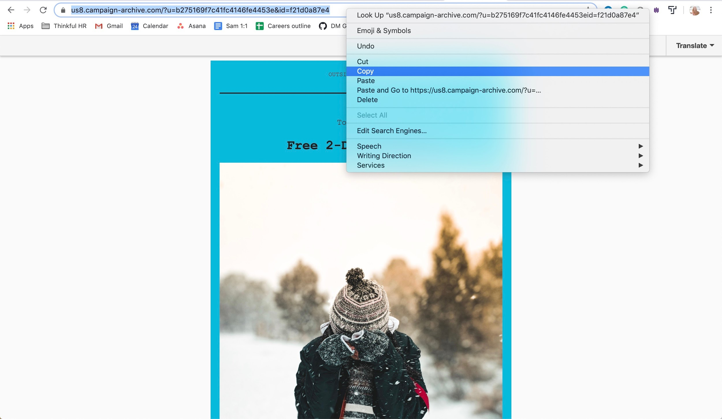

Audience: All customers
Subject line: The holidays aren’t over yet, Luke!
Preview text: Free 2-day shipping today only...
Email: https://us8.campaign-archive.com/?u=b275169f7c41fc4146fe4453e&id=f21d0a87e4

Remember, submit your best work as this can be used as a portfolio piece during your job search!

