
DME Formula Ordering Tip Sheet
- Locate and select the Add Order button on the bottom left-hand corner of the patient’s open encounter. Once selected, a search bar will appear.

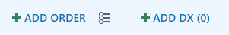

- In the Search for new orders search bar, type the name of the patient’s formula and press enter on your keyboard.

- Results will appear in a pop-up window as seen below. Your initial search is completed in the Preference List tab. If you do not see your desired formula in this list, locate and select the Database tab in the upper right-hand corner. This will reveal more options to choose from.

- Once you have selected your formula, the following ordering window will appear.

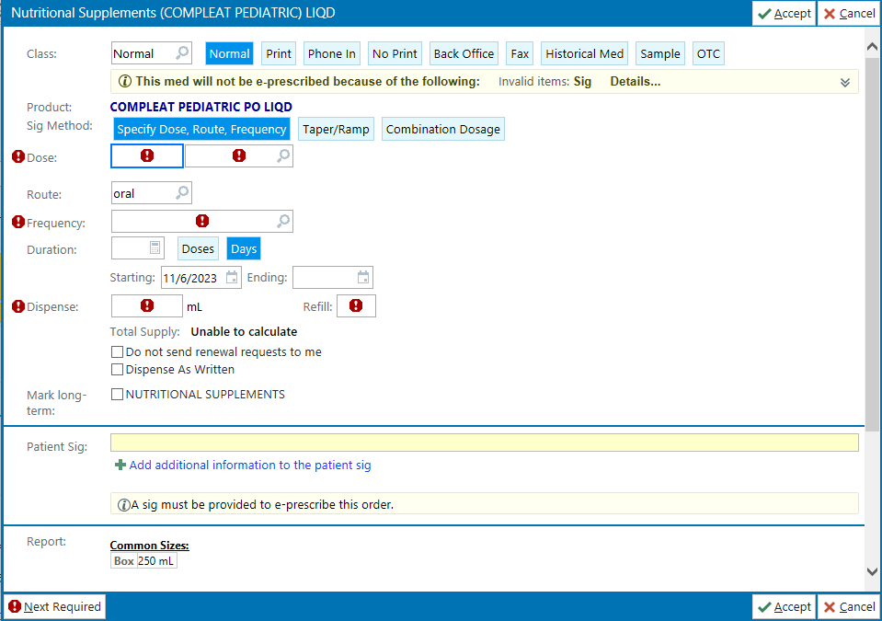
Any fields with the following graphic must be completed before the order can be sent:

Dose: | Indicate the amount desired per day or feeding followed by the unit of measurement (i.e., container, mL or oz for liquid formulas, grams for powdered).
Route: | Describe the method in which formula is provided (i.e., oral, per g-tube, oral/gavage, etc.).
Frequency: | Describe how often the dose is provided.
Duration: | Typically completed as 30 days, though it is not a required field to place the order.
Dispense: | The volume of formula needed per month (30 days).
Refills: | Indicate the number of refills desired from 0-12; this number may vary.

Once all pertinent fields are completed, select the Accept button at the bottom of the window. You can then review the order information you’ve completed in the window located at the bottom right-hand corner of your screen.

- Next, you will need to Associate diagnoses to the order. In the order window, select the Dx Association button. Select as many pertinent diagnoses as possible from the Common, Previous and/or Problems lists. If there are not any relevant diagnoses in these lists, you may search for a relevant diagnosis in the search bar.

- Your formula order is now ready to be sent to the patient’s DME. Identify the location in which this formula order will be sent. If the correct DME/pharmacy is already selected, press Sign Orders. To send to Children’s Home Healthcare, please select Children’s Home Health Supplies & DME Enteral Orders (No Rx). DO NOT SEND TO THE OUTPATIENT PHARMACY AT CHILDREN’S NEBRASKA.

