

REGIONAL FINALS TEACHER AND VOLUNTEERS RESOURCE PACK



1


SESSION OVERVIEW

When preparing for the pitch, teachers and mentors should facilitate the pitch masterclass (remember, this masterclass can be delivered flexibly over several sessions to fit in with the school timetable) to help the team develop their pitch and get ready for the big day.

TIMINGS | TEACHERS | MENTORS | TIPS
15 minutes prior to session | Try to ensure you are in reception to greet mentors and show them where the mentoring will take place. Where this is not possible, leave clear instructions with Reception staff that they should expect volunteers and be prepared to point  them in the right direction. | Arrive at Reception and sign in. Ask for the named teacher as provided to you by your King’s Trust contact. | Mentors should allow themselves extra travel time to ensure they arrive early.  Teachers should ensure they have printed enough copies of any handouts
During pre- session briefing | Teachers and mentors should discuss:  - Timings and session schedule  - Who will do what and when  - Materials and whether there are additional items required  - Any additional needs for young people who will be participating in the challenge | Mentors should consider how they will introduce themselves to the young people if this is their first session at the school. If mentor is returning and has already built relationships with the young people, they should think about how they will reacquaint themselves | It is good practice to have a copy of the Regional Final briefing paper available prior to and following each mentoring session, if only for a few minutes. This is to review what went well, what might be done differently and any issues arising from the session.
Session begins | If this is the first session, teacher should welcome young people and introduce/ re-introduce mentors to the session, introduce Stage Two of the Enterprise Challenge and facilitate an  ice-breaker session. | Participate in the icebreaker. Relax, have fun and be open and engaging with young people. | Teachers should refer to their notes about the competition timeline and ensure the classroom has video facilities to be able to show videos.
Subsequent sessions | In subsequent sessions, teachers should thank mentors for giving their time and reiterate to young people that it is important for them to reflect on their learning and support one  another to develop key skills. | Mentors can go straight into the session, recapping the previous session if necessary. | Mentors should remember their training to ensure young people are kept engaged.

Session reminder | Teachers will oversee the session ensuring that equipment is working, young people are behaving etc.  Approximately 10 mins before the end of the session, teacher should give a time warning which prompts the class to begin winding up. | Mentors should follow the session plans in this booklet to guide them as to what should be covered.  Use the teacher’s time warning to begin wrapping up discussions. If it isn’t the final session, reassure young people that there will be time at the next session to continue  discussions. | Teacher may want to take an active role in making sure everyone knows what they are doing and are making progress.
Post session (10-15 mins) | Teachers should thank mentors for giving their time and ensure that any work is handed into them by the young people.  After the session teachers and mentors should spend 10 mins debriefing. This ensures that any issues about the session are raised and can be resolved early  on. | Mentors should ensure, where necessary, that any work is collected and handed to teachers. Spend 10 mins debriefing. | During debrief, you will find an honest exchange about how the session went well and was useful.  Agree on any future actions and/or feedback to King’s Trust.


SESSION PLANS HOURS 1 - 3

 | Session: The First Hour
Aims and objectives:

- To introduce Stage Two of the Enterprise Challenge (Regional Finals)
- Introduce/ reacquaint mentors and young people – continue to build on rapport and develop a strong sense of a team
- To complete the business design worksheet
Key learnings and outcomes: |  | Resources needed: | Enterprise skill developed:
Understand what will happen at the Regional  Final |  | Whiteboard/ projector  Internet access | Communication  Teamwork
Reflect on what was learned during Stage One of the Enterprise Challenge |  | Business design worksheet  Session plan pack | Creativity
Understand what they need to do to prepare for the Regional Final
Understand what problems the local community faces

Schedule | Actions
10 minutes | TEACHER:  Introduce/ reintroduce the mentor(s).  Introduce the Stage Two of the Enterprise Challenge explain that now the students will be competing against other schools in the region in the competition. They will do this by coming up with a social enterprise!  Allow the mentor to outline the agenda of the day briefly so young people know what to expect.  Give the young people a detailed overview of what they will need to do to prepare for the Regional Final and what will be involved on the day of the event.  Explain that over the next few sessions they will be developing a social enterprise idea and an accompanying pitch that they will have to deliver to a panel of judges.

Key things to cover include:

- Their pitch will be 3-5 minutes long
- They will be competing against 4 other teams from their region
- Judges will be looking at the content of their pitch and how they deliver the pitch
Explain that the next few sessions will be working up completing their business canvas and practising their pitch.
10 minutes | MENTOR:  Start your session by delivering an icebreaker.  Two icebreakers have been identified below which focus on encouraging teamwork - but feel free to use others in appendix four if you think they are more appropriate.  It is important to encourage young people to get to know each other and build strong team links during the first hour, this will help to increase their motivation and communication throughout the sessions.  Recommended Icebreakers:  Logic Puzzle  Ask the young people to work in teams to solve answer for this question:  A cat needs to bring a wolf, a goat, and a cabbage across the river. The boat is tiny and can only carry one passenger at a time. If he leaves the wolf and the goat alone together, the wolf will eat the goat. If he leaves the goat and the cabbage alone together, the goat will eat the cabbage.  How can he bring all three safely across the river?  Once the YP have some answer ideas, reveal the solution.  Solution: Take the goat over first. Then you can take either one, and bring the goat back. Take the cabbage over to accompany the wolf. Then take the goat back on the last trip.  Then, ask them to consider: would they have wanted to complete a logic puzzle on their own? What was the benefit of working with others to complete the logic puzzle?  Going it alone – memory game  Compile a selection of random objects or pictures and something to cover them with. Show the young people the objects for 10 seconds and cover them up. Ask young people to write down on a piece of paper the objects/pictures they remember seeing, giving them just 2 minutes to write their answers – they should not speak to each other or let others see their  answers.

When they have finished, ask them if they found this easy or difficult to do on their own? Did they remember everything?

Now, repeat the exercise (or use different objects/pictures) and allow them to complete the tasks in a group. Let them discuss how they will complete the task before setting them off e.g. Will they all write things down individually? Will one person write and all give ideas?

Ask young people whether they found it easier to work as part of a team? If so, why? What else has to be considered when you work as a team? Did everyone have the same idea about how to go about the task?

TEACHER:
Support the mentor(s) by bringing the class back to attention after the icebreaker
10 minutes | MENTOR:  If time allows select one of the activities from appendix three (Sustainability Activities) from any of the sections these include activities around the UN goals, the 3 P’s and sustainable business research.  Completing a sustainability activity now will remind the students to keep sustainability at the forefront of their minds whilst they are planning their business.  Alternatively - If you are struggling for time use this video to recap the goals  → https://youtu.be/0XTBYMfZyrM
30 minutes | Explain to the students that we are now going to research a problem their local community face – we will use this research to develop a social enterprise (business with positive social and/or environmental objectives that reinvests its profits to create jobs and benefit a community or social cause) to solve this.  To complete this task the group will complete the business design template found in appendix one – this is also available as a separate document to print. The business design template is based on Apple’s Challenge Based Learning framework.

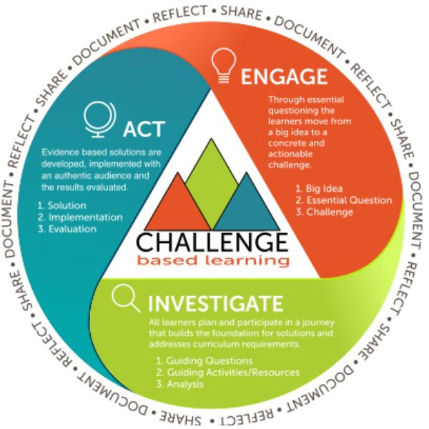

You can learn more about the framework at this link https://www.challengebasedlearning.org/about/
You can also find a completed example version in appendix two – use this to help the students to complete their own business design worksheet.
Start by asking the group to pick a UN goal or important global topic they are passionate about. The framework refers to this as a “Big idea”.
Once they have done this, they need to work through each section on the business design worksheet. This starts with turning their goal into a general question they want to answer – using the phrasing from the goal to inform this question. From this question the group will turn it into an actionable challenge – this forms the basis of their research.

Then the group will need to think about questions they will need to research to start to learn more about their challenge. They will write their questions down then write all the activities they will do to answer them.
Once the students have completed their activities they should have some new information on their challenge. They will then need to synthesize (summarise their findings).

From this research, the group should then brainstorm various social enterprise ideas which will help their community using what they have learnt as a basis.
Finally, the students will pick one idea which is their solution and will be their social enterprise idea.
When the team has completed this activity ask them to present their findings back to the mentor and teacher to wrap up the session. The business design template should then be collected in.

 | Session: The Second Hour
Aims and objectives:
- Recap on what the team learned in the last session
- Complete a business canvas outlining their idea using their research from the previous session
- Identify a team name for their business
Key learnings and outcomes: |  | Resources needed: | Enterprise skill developed:
 |  | Whiteboard/ projector | Communication
Develop a solution to the problem and understand how that solution will work as a business by using the business design worksheet |  | Business design worksheet  Business canvas - printed in A3 (you may want to print more than one copy) | Teamwork Creative thinking  Problem solving
Use the business canvas to communicate the team’s social enterprise idea |  | Internet access Session Plan Pack
 |  | Flipchart paper and pens
 |  | Plain paper – 1 piece per
 |  | team member

Schedule | Actions
5 minutes | MENTOR:  Recap on what the team learned in the previous session i.e. what issues their local community are currently facing and how they could help.  Give an overview of what will happen in this session - taking what they have learned, and their identified problem and solution and using this to develop their social enterprise idea in-line with the business canvas (you will need to provide the young people with a printed version of this – this is a separate document to be printed on A3)  TEACHER:  Ensure class is settled and you have their attention. Allow the mentor to outline the agenda of the day briefly so young people know what to expect.
10 minutes | MENTOR:  (Optional depending on timing)  Deliver a quick icebreaker ahead of the next hour session to enable you and your teams to connect again.  Recommended energiser: Making decisions in a team

Ask the group to create a mind-map, outlining the different ways that they could make decisions as part of a team. Ask them to consider how they can make sure that everyone is involved in decision-making, and that no one is left out.

You could even ask them ‘what is a good discussion?’ Some responses may include active listening; taking turns to speak, sharing opinions and ideas. This will make it easier for them to communicate their ideas and formulate a more effective discussion.

In pairs or individually give them one way of making decisions each. They should then demonstrate that way of making a decision to the rest of the group e.g. one pair could demonstrate a vote, or picking out of a hat, or leader making the decision.

Allow the young people to think about how they could demonstrate their method. Would they physically demonstrate it using a scenario, verbally explain it or a combination of both?

Ask the group to think about whether any of these options might cause problems?

Ask young people if different situations might need different approaches. For example, consider which method of making a decision may be best in the following situations:

- In an emergency where a decision is needed quickly (e.g. leader decides)
- In a classroom when you are deciding on a social enterprise idea (e.g. vote, discussion & authority decision, ideas in a hat)
- When as an individual you need to make a decision for yourself between 2 options (e.g. flip a coin, pros & cons list)
Explain that decision making will be an important part of how they work together as a team to create their pitch. Encourage the team to think about how they will make decisions as a team.

TEACHER:
Support the mentor(s) by bringing the class back to attention after the icebreaker
35 minutes | MENTOR:  Explain to the students that now we have a solution we need to start planning out how this could be a viable social enterprise.  We do this by completing the business canvas. We are going to start the business canvas today – if we don’t complete the canvas the students then can spend some of their own time completing it or we can revisit this next session for 10mins.  Help the young people to develop the solution into a viable product or

service using the key categories on the business canvas to guide the session/ discussion.

Fill out business canvas based on discussion (this can be rough for now and finalised in future sessions). Reassure young people they will get the chance to revisit the business canvas in future sessions.

For the people/place and profit sections of the business canvas you can refer to appendix three where this is an information sheet explaining what each one means.

Make sure to refer to the criteria that the judges will be looking at when judging the pitches to help the team develop their business canvas.
If the group needs another reminder about the UN goals here is the video link → https://youtu.be/0XTBYMfZyrM
5 minutes | MENTOR:  Ask your team to identify a team name using their social enterprise idea as inspiration.  TEACHER:  Facilitate the wrap-up of the session

 | Session: The Third Hour
Aims and objectives:
- Recap on what the team learned in the last session
- Identify what a pitch is and what makes a good business pitch
- Develop pitch for Regional Finals based on social enterprise idea
- Begin practicing pitch
Key learnings and outcomes: |  | Resources needed: | Enterprise skill developed:
 |  | Whiteboard/ projector | Communication
Understand what a pitch is and what makes a pitch good or bad |  | Video: Ben Towers’ Pitching Tips | Teamwork Confidence
Understand key pitching skills and the importance of strong communication and positive body language |  | Business pitch videos  Business Canvas
Create basis of social  enterprise pitch that team can continue to practice |  | Internet access  Session plan pack

Schedule | Mentor/Teacher Actions
5 minutes | MENTOR:  Recap on the previous session i.e. talk through the social enterprise idea the team has developed  Give an overview of what will happen in this session - understanding what makes a good pitch, taking their social enterprise idea and adapting in into a pitch, practicing pitch  TEACHER:  Ensure class is settled and you have their attention. Allow the mentor to outline the agenda of the day briefly so young people know what to  expect.
5 minutes | MENTOR:  (Optional depending on timing)  Deliver a quick icebreaker ahead of the next hour session to enable you and your teams to connect again.  Recommended energiser:  Sell It!  Each young person takes turns in choosing a random item from a box, and has 30 seconds to produce a sales pitch to the group. Young people to take it in turns to ‘sell’ the item. Discuss how they felt doing a ‘sales pitch’ and what they thought was good about each others sales pitches.  TEACHER:  Support the mentor(s) by bringing the class back to attention after the icebreaker
10 minutes | MENTOR:  Remind the students that lesson session we started completing our business canvas. If the students didn’t finish their canvas give them some time here – if they have, allow them 5 minutes to recap their canvas.
10 minutes | MENTOR:  Show the team the Ben Towers pitching video – access the video on the Enterprise Challenge Hub here  Ask your team to identify what a pitch is and what makes a good pitch. Encourage discussion between the group.  i.e. a short verbal presentation of an idea, project, business plan or product. This can be made to potential customers or investors – explain that investors are people who contribute (usually money) towards a business in return for some sort of ownership.  Suggested activity (time-dependent):  Mentors could show young people videos of one good and one bad pitch

and ask them to identify what is good and bad about each – Dragon’s Den videos can provide a good source for this.

A good example → https://youtu.be/bcMOP4yoJZw

Discuss videos to help develop young people’s understanding of what they need to do
Prompt questions can include:

- What could the people in the videos have done better?
- What made the good pitch good and the bad pitch bad?
- What did they notice about the body language of the people pitching?
- What can the team learn from these examples?
30 minutes | MENTOR:  Support your team to write and practice their business pitch. Young people should work through the prompts on the business canvas including each section in their pitch. This will include:  - A 1-2 sentence summary  - Explaining the problem they are going to solve  - Explaining the solution to the problem  - Explaining who the customers  - How they will build hype/promote their product  - People- how will they be ethical in terms of treating their staff etc  - Place – how they will be environmentally responsible  - Profit – how they will make money  - Invest- a summary of all that they have just explained as to why they are a good social enterprise to invest in  Encourage the students to practice as much as they can during this time. Remind them that practicing in front of different audiences before their pitch at regionals will help them!  Tips for practicing the pitch:  - Practice to time (3-5 minutes) – use a stopwatch  - Depending on the venue the young people may be using handheld microphones when pitching – practice with something (a water bottle) and think about how they will pass microphone(s) between them when pitching  - Think about how the team will stand on the stage  TEACHER:  Ensure that young people have access to any materials they may need to complete this task – paper, pens, scissors etc.
You may want to play the following videos to the young people. Both offer advice on presenting and delivering a pitch:
- John Hannah (actor) offering advice on presenting to an audience: videos.ctfassets.net/en0c1bjgheo7/5S8djILZUdC3qER9iHRLYb/6b674f2982e7319cbea097af1c37af02/John_Hannah_-_Presentation_Advice_Video_-_Enterprise_Challenge.mp4

- David Gandy (businessperson and model) offering advice on business pitches: videos.ctfassets.net/en0c1bjgheo7/qlynnOQaEduFsFYTG8Vq1/05e52abac29bba9702d2ee7e3e17e37b/David_Gandy_-_Business_Pitch_Video.mp4

Various | MENTOR:  (If time allows)  Allow young people time to review their pitch and get ready to present it during the next hour.  Deliver a session around confidence and body language to support your team in feeling more confident for the task ahead. Supporting your team to change their body language can have a positive effect on their attitudes and behaviours – improving their performance during the pitch.  Below are several activities that you can use with your team around body language and pitching. You may want to use these as warm-up activities before they start practicing their own pitch.  POWER POSE  The power pose is a great way of preparing young people for important but stressful situations in life, such as presentations or pitching business ideas.! Amy Cuddy, a Harvard Business School Professor gave a TED talk on how changing your body language can instantly make you feel more confident. Explain that our attitudes often follow from our behaviours, as opposed to the other way around. That means assuming the body language of a powerful person can make you feel confident.  Ask your team to call out what kind of gestures/body postures they associate with power and confidence. Below are some examples to help facilitate the conversation:

FEELING POWERFUL/ CONFIDENT

Expanding postures: make yourself big, stretch out, spread out, take up space, chin slightly lifted.
FEELING POWERLESS/ UNDERCONFIDENT

You close up, wrap yourself up, make yourself smaller, head down.

Encourage the young people in your team to stand in the power pose for a few seconds and reflect on how it makes them feel. This may be something they want to do before they practise and deliver their pitch in order to feel more confident.

Pass it on

Young people stand in a line facing away from one end. The first young person acts a short scenario e.g. making a cup of tea. The action gets passed along the line from person to person. The final young person performs it to their mentor or teacher, who have to guess what the scenario is. Explain that our body language and actions send a message – it’s just not always this obvious!

Brief explanation of what body language is, that often we project a message with our body without realising.

Ask them to think of a situation where they felt happy and what their body language was e.g. walking tall, smiling or having relaxed posture.

Explain that we pick up on people’s body language really quickly and it can affect how we view people.

What would we think if someone came into a room avoiding eye contact or crossing their arms?

Sell It!

Each young person takes turns in choosing a random item from a box and has 30 seconds to produce a sales pitch to the group. Young people to take it in turns to ‘sell’ the item. Discuss how they felt doing a ‘sales pitch’ and what they thought was good about each other’s sales pitches.

Say Something

The group take turns in a circle to say a word in different ways – it could be anything, ‘Enterprise Challenge’, ‘yes’ or ‘no’ with a different tone of voice. Then young people could try saying the word with different emotion
i.e. sadly, happily, excitedly. A third step to add would be to ask young people to add matching body language e.g. slumping in their seat to imply boredom as they say the word in a bored way.

This is a…
A simple item is passed around the circle.
Each member of the group must respond with a new way of using the item
e.g. a banana could be a phone, a smile etc. Mentors can demonstrate with an item first.

TEACHER:
Facilitate the wrap-up of the session

ADDITIONAL ACTIVITIES
If you have additional time with the students, you could start off the sessions by working through the sustainability resources in appendix three and selecting one activity from each focus – the UN Goals, the 3 P’s and sustainable business research. This would give the students the opportunity to grasp these sustainability concepts in more detail and enrich their knowledge in preparation for the pitch.
1 hour  Appendix Three | UN SUSTAINABLE GOALS  Remind the students in stage one of the enterprise challenge we briefly looked at the UN goals.  Explain that the UN is an international organization founded in 1945 after the second world war. The UN’s member countries have acted together to ensure global peace and security. In 2015 they launched the Sustainable Development Goals to encourage countries to work towards peace, security, and sustainability.  Either recap the SDG’s or complete an activity (or both

activities depending on time) from the sustainability activity pack- UN goals section.
This can be the matching the definition game or snap.
Both activities will encourage the students to discuss the UN goals – what they mean and how they relate back to their local community.
THE 3 P’s

Next remind the students that as well as the UN goals being an important topic in sustainability – the 3 P’s are important to understand especially when running a business.

Show the students the explanation of the 3 P’s in Appendix 4 of the sustainability workbook. Following some discussion around this move on to complete one of the two activities under the 3 P’s section of the activity workbook.

This will either be organising different words under the different headings of people, place and profit or organising the UN goals under these headings.

Completing these activities should generate discussions about why certain words belong under certain headings.

If the students are struggling with this activity move the words under the correct heading one at a time and ask the students, why it belongs there.

SUSTAINABLE BUSINESS RESEARCH

Explain to the students we will now finish the session by looking at current businesses and how they are sustainable or planning to be more sustainable. Now the students can use their knowledge of the 3 P’s to investigate this.

Complete one of the activities in the sustainability pack under the heading sustainable business research.

Explain that when they start planning their own businesses, they will need to factor in sustainability, so it is good to know how other businesses do this.

If completing the research activity give the students 10 minutes to research and 5 minutes to feedback.
Design a logo 30 mins |  | If you have a group of students who are interested in being more creative, you could also ask the students to design a logo for their business.

APPENDIX ONE

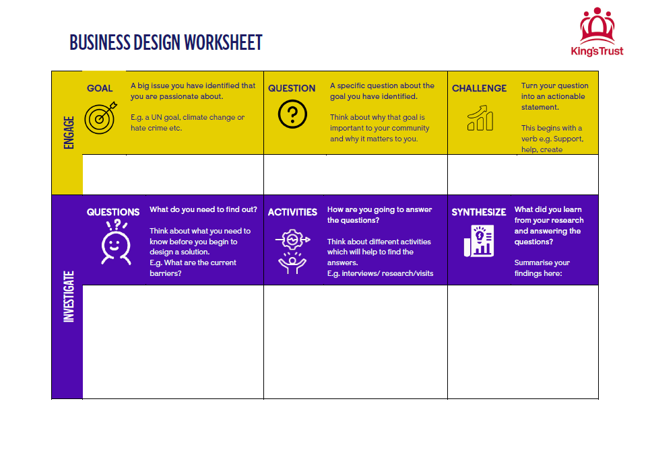

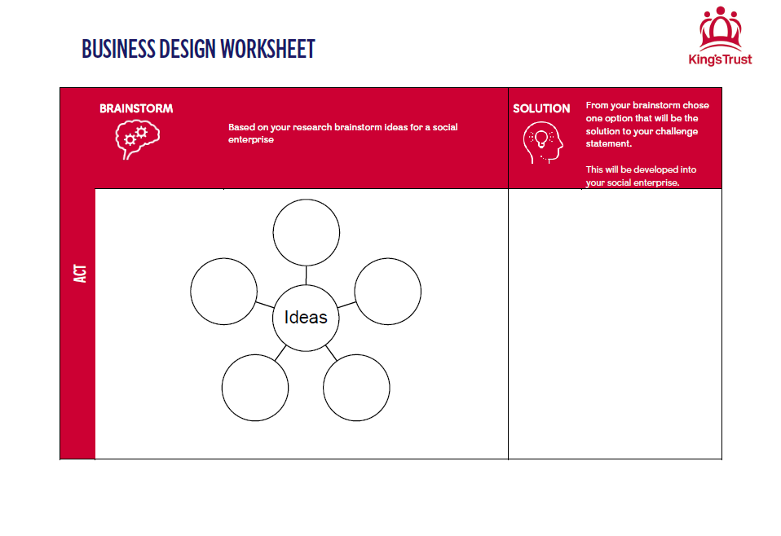


APPENDIX TWO

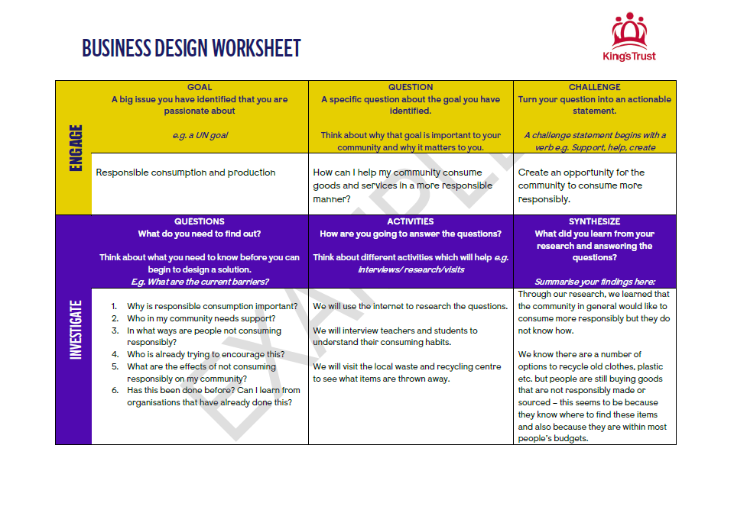

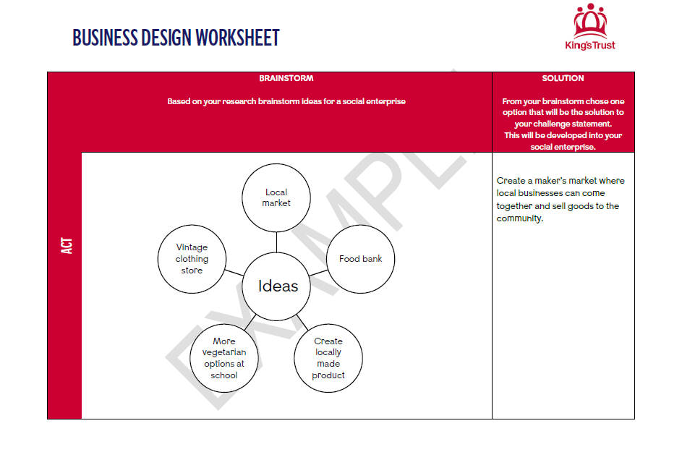

APPENDIX THREE

MATCH THE GOAL TO THE DEFINITION

Print out the UN goals and their definitions below. Cut these up and mix them up. Ask the teams to match the goals to their definitions – once this is completed ask the students to read out the goals and the correct definition. As the students are reading the goals out you could ask them to discuss that goal and how it relates to their local community - these can be things already happening or things that need to be improved.

If you have a lower ability group or have less time, use the UN goals in white to complete a shorter version of the activity.

 | End poverty in all its forms everywhere
 | End hunger, achieve food security and improved nutrition and promote sustainable agriculture
 | Ensure healthy lives and promote well-being for all at all ages
 | Ensure inclusive and equitable quality education and promote lifelong learning opportunities for all
 | Achieve gender equality and empower all women and girls

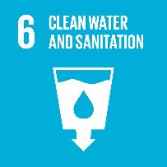 | Ensure availability and sustainable management of water and sanitation for all
 | Ensure access to affordable, reliable, sustainable modern energy for all
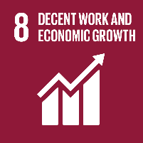 | Promote sustained, inclusive and sustainable economic growth, full and productive employment and decent work for all
 | Build resilient infrastructure, promote- inclusive and sustainable industrialisation and foster innovation
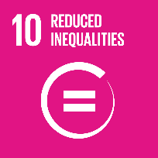 | Reduce income equality within and among countries

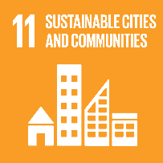 | Make cities and human settlements inclusive, safe, resilient, and sustainable
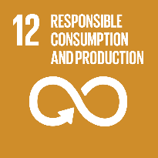 | Ensure sustainable consumption and production patterns
 | Take urgent action to combat climate change and it’s impacts by regulating emissions and promoting developments in renewable energy
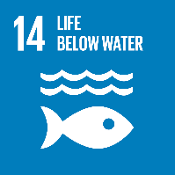 | Conserve and sustainably use the oceans, seas, and marine resources for sustainable development
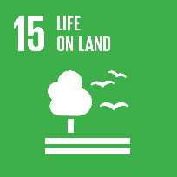 | Protect, restore and promote sustainable use of terrestrial ecosystems, sustainably manage forests, combat desertification, halt and reverse land degradation and halt biodiversity loss

 | Promote peaceful and inclusive societies for sustainable development, provide access to justice for all and build effective, accountable, and inclusive institutions at all levels
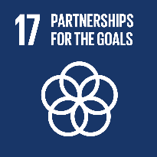 | Strengthen the means of implementation and revitalise the global partnership for sustainable development

SUSTAINABLE GOALS SNAP

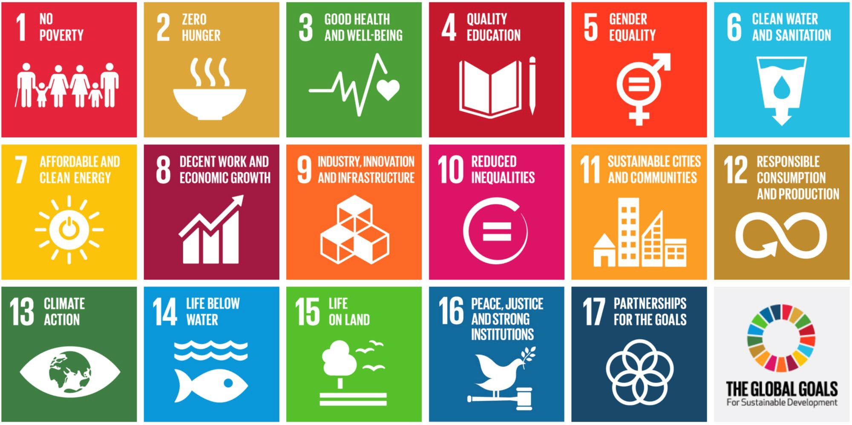
Print out the below UN goals – cut each square out to create UN ‘cards’ . In pairs play snap – when someone gets a ‘snap’ the pair discuss the global goal. As the students are reading the goals out you could ask them to discuss that goal and how it relates to their local community these can be things already happening or things which need to be improved




THE 3 P’S OF SUSTAINABILITY


Show the teams the 3 P’s information sheet to clarify what we mean by each of the three P’s.

PLACE
We must make sure that we act without using all the Earth’s natural resources, harming wildlife, or damaging the ecosystems. It is important to remember that every decision would have consequence or influence and a business needs to do all it can to ensure that this is a positive thing.

To do this, businesses can make more environmentally friendly decisions such as using biodegradable packaging, renewable energy, non-toxic cleaning products, resourcing sustainable food sources, and recycling properly should be incorporated into the day-to-day running of the business.
PEOPLE
A business must ensure that all people involved in the business are treated fairly and ensure that no group is harmed or exploited by anything the business says or does.

This includes employees, stakeholders (any person who has an interest in the business), families, clients, suppliers, communities, or anyone affected by the organisation. As customers are beginning to pay more attention to the sustainable impact of companies, businesses are operating in a more environmentally friendly way and are being more truthful in their promotion of this.
PROFIT
In this circumstance profit doesn’t refer purely to making money this could include generating employment, inventing green innovations, creating wealth, and paying taxes.
Making a profit should be considered as a means to operate more sustainably, not as an end goal for the business.

The 3 P’s
Print off and cut up the list of words below. Each of the words can be categorised under one of the three P’s of sustainability; people, place and profit – ask the students to put the correct word under the correct heading and generate discussions about why they belong there.

PLACE
Management of land
Freshwater
Oceans
Forests
Air
Natural resources
Wildlife
PEOPLE
Fighting poverty
Social justice
Peace
Promoting diversity
Quality of living
Access to healthcare
Education
Cultural heritage
PROFIT
Economic viability
Profit
Profitability is one component of a company’s strategy

THE 3 P’S AND UN GOALS

Show the teams the definitions of the 3 P’s of sustainability. Print off and cut up the SDG’s below along with the three headings. Ask them to group the UN goals into each of the three categories - people, place and profit. Encourage discussions as to why they have categorised these and what the thought process is. You may just want to focus on some of the more relevant goals depending on time and ability.

PLACE
SDG 12: Responsible consumption and production
SDG 13: Climate action
SDG 14: Life below water
SDG 15: Life on land
PEOPLE
SDG 1: No poverty
SDG 2: Zero hunger
SDG 3: Good health and well-being
SDG 4: Quality education

SDG 5: Gender equality
SDG 6: Clean water and sanitation
SDG 10: Reduced inequalities
SDG 11: Sustainable cities and communities
SDG 16: Peace, justice, and strong institutions
PROFIT
SDG 7: Affordable and clean energy
SDG 8: Decent work and economic growth
SDG 9: Industry, innovation, and infrastructure
SDG 17: Partnerships for the goals

RESEARCH A SUSTAINABLE BUSINESS

Either ask the students to think of a company/business or have a few selected e.g. Apple, Boots, Tesco etc. Ask the students to research on computers how these businesses are sustainable and how they plan to be more sustainable in the future.
Inform the students that they should focus on how these businesses are sustainable in regards to the 3 p’s of sustainability.

Ask the students to present their research back to the group.

HOW MIGHT THESE BUSINESSES BE SUSTAINABLE?

Have a selection of items on the table from various different companies e.g. a coffee cup from McDonald’s, an iPad, a paper bag from boots, a shoe from Toms etc. Ask the students to discuss how these companies are being more sustainable e.g. the
packaging is biodegradable paper not plastic bags, Apple bringing down their carbon emissions.

Facilitate group discussions on how these companies can be sustainable in a variety of ways referring to the three P’s.

APPENDIX FOUR

TEAM HATS

You have £200 to spend on anything you like! Decide as a team how you are going to spend the money.
Assign each member of the group a different role to play/hat to wear. They shouldn’t tell anyone else in the team what their role is!

- Mr/Miss Difficult - Won’t agree with anyone on anything. Always finds a problem with other people’s ideas
- Mr/Miss Keen - Super positive, even for the silliest ideas!
- Mr/Miss Quiet - Doesn’t contribute to a discussion unless they have to
- Mr/Miss Lazy - Doesn’t pull their weight. Might even wander off during a discussion!
- Mr/Miss Talkative - Doesn’t stop talking, even if it’s got nothing to do with the task!

Give each team 10 minutes to come to a decision. Then ask whether they found working in that team easy or difficult. Did they work out what each person’s role was?

SELL IT TO ME…

Give the teams a random object. Inform the team they have 15 minutes to come up with a creative pitch to sell this object to the other teams.
Challenge the students with boring everyday objects e.g. a pencil – how can they make this sound so exciting that the other teams have to buy it!

This encourages the students to think creatively and encourages them to deliver their pitches enthusiastically.

SOLVING RIDDLES

Tell the learners that you have some brain teasers for them to think about and work out the answer in their groups. Either ask the brain teasers or have them up on the board.

- Johnny’s mother had three children. The first child was named April. The second child was named May. What was the third child’s name?
- A clerk at a butcher shop stands five feet ten inches tall and wears size 13 sneakers. What does he weigh?
- Before Mt. Everest was discovered, what was the highest mountain in the world?
- How much dirt is there in a hole that measures two feet by three feet by four feet?
- What word in the English language is always spelled incorrectly?

- Billie was born on December 28th, yet her birthday always falls in the summer. How is this possible?
- In British Columbia you cannot take a picture of a man with a wooden leg. Why not?
- If you were running a race and you passed the person in 2nd place, what place would you be in now?
- Which is correct to say, “The yolk of the egg is white” or “The yolk of the egg are white?”
- A farmer has five haystacks in one field and four haystacks in another. How many hay stacks would he have if he combined them all in one field?

Riddle Answers
- Johnny.
- Meat.
- Mt. Everest. It just wasn’t discovered yet.
- There is no dirt in a hole.
- Incorrectly (except when it is spelled incorrecktly).
- Billie lives in the southern hemisphere.
- You can’t take a picture with a wooden leg. You need a camera (or iPad or cell phone) to take a picture.
- You would be in 2nd place. You passed the person in second place, not first.
- Neither. Egg yolks are yellow.
- One. If he combines all his haystacks, they all become one big stack.

This encourages the teams to work together and think creatively to solve the riddles.

WHAT COULD THIS BE?

How many different things can this do … give the teams an item such as a paperclip. Ask the teams to think about as many different and creative ways this could be used – not just as a paperclip!

Encourages the teams to think creatively and generate innovative ideas.

WOULD I LIE TO YOU?

Ask each member of the team to think of three statements. Two are true and one is false. However; unlike two truths and a lie, the other team members can ask questions to try and figure out which statement is the lie.

This encourages the students to think on their feet and be persuasive with their language.

DESERT ISLAND

In their teams, the students imagine they’re stranded on a deserted island. Inform the students that the soonest they can be rescued is two weeks. They can only pick 6 items from the list which will help them to survive until they are rescued and the whole team has to agree on the item before it is selected.

List of items to choose from:

- Blanket
- Plastic containers
- Steel plate
- Shovel
- Matches (box of 10)
- Canned fruit and vegetables
- Fishing net
- Fishing rod
- Trident
- Toilet paper (one roll)
- Pen knife
- Solar powered torch
- Radio
- Tent
- Rope
- A magnifying glass
- Compass
- Axe

