Erratum: Chapter 1, p. 18-19

Figure 1-7 referred to in Chapter 1 of the book at p. 18-19 is actually not included in the book itself, but represented here:
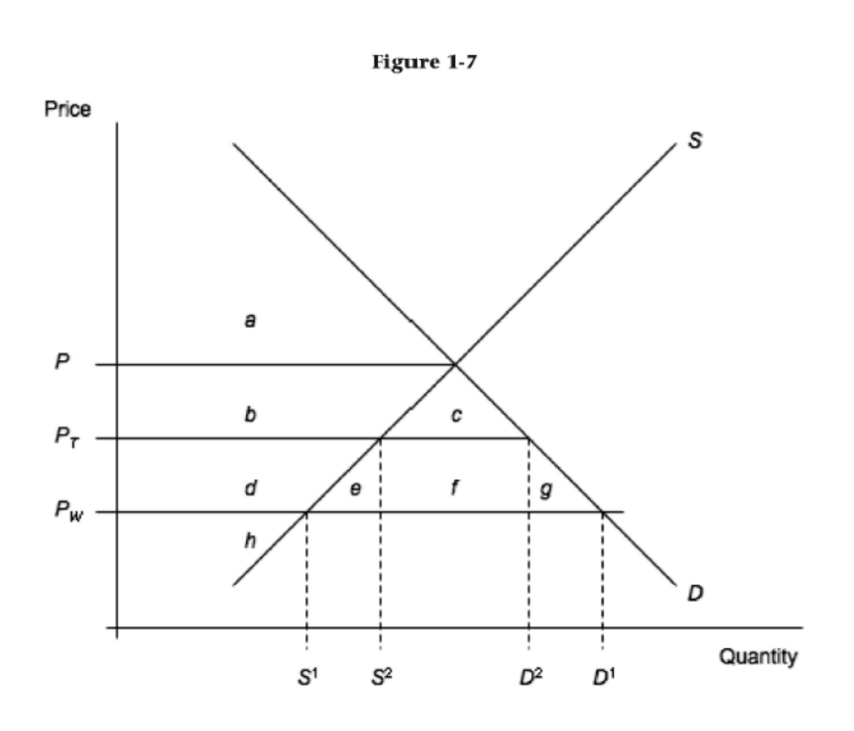

The Figure 1-7 that is included in the book relates to intra-industry trade and mistakenly replaced “old” Figure 1-7. It should simply have been added as new Figure 1-8. Our apologies for that.

Erratum, Chapter 5, p. 147

In Chapter 5, the third edition of our book (at p. 147) mistakenly omitted a flowchart with the different steps and timelines in WTO dispute settlement. You can find it here (following page). Our excuses for this error.
