**Introduction to the Use of the Contract Database**

Since many activities in the book ask you to critique, analyze, and compare contract precedents in the database, we designed a system to aid you in navigating through the contracts. The following instructions explain 1) how to locate a specific contract, 2) how to locate specific words or word combinations in a contract or in various contracts, and 3) how to locate similar provisions in various contracts.

The contracts included in the database are not perfect. Thus, do not treat them as models of well-drafted contracts, and do not use them—or any portion of them—as models to simply “cut and paste” into one of your drafts. They are provided solely for the purpose of working on the exercises in the book or for working on exercises provided by your professor. The exercises are opportunities for you to apply the concepts presented in the book and to build your drafting skills, including the important skills of reviewing, critiquing, and revising precedent.

Additionally, please keep in mind that the contracts are not exact copies of the originals.

Party names as, for example, “ACME Inc.” and other company names have been changed to “Supplier,” “Distributor,” “Manufacturer,” “ Company” or similar generic names that reflect the function of the party rather than the real name. Similarly, names of individuals have been changed from, for example, “Mr. John Miller” to “Mr. X”.

Likewise, addresses and other information that could identify the original parties to the contract have been changed or deleted.

The names of parties, dates, dollar amounts, and technical business information found in contracts in the Asset Purchase Agreement database file have been replaced with fictitious information. Retaining extensive technical data and business information originally provided in those contracts was unnecessary to fulfilling the purpose of the contract database.

For the most part, we did not change the wording of the original other than in the instances mentioned above. For some exercises, we did, however, change wording or structure for pedagogical reasons.

Last but not least, the formatting of the contracts in all the databases is not like the original formatting and should not be used as a guideline as to how to format a contract.

Please, follow the guidelines provided in this book on how to format and tabulate a contract.

**1. Locating a contract**

The database provides **three files**: One is a collection of distribution contracts, another is a collection of consulting contracts; and yet another is a collection of asset purchase contracts. Each file is a single word document containing forty contracts, enumerated 1 through 40. Thus, the Distribution Contract file is a word document approximately 800 pages in length, with an average of 20 pages per contract. In the book, a contract is referenced by (a) an identifier (“**DA**”means distribution contract, “**CA**”means consulting contract, and “**APA**” means asset purchase agreement), and (b) the number assigned to it in the database file. Thus, DA#15 would references distribution contract numbered 15 in the *Distribution Contracts* file*.* The contract identifier and number can be found in the header of the contract.

**2. Locating Specific Words or Word Combinations**

The collection of contracts offers native speakers an opportunity to see how contractual language is used in context in 40 contracts in each database file. It alsooffers non-native English speakers the opportunity to research how specific words or word combinations are used. By seeing the same word or word combination used over and over, you can get an understanding of the meaning and the use in a particular context. Thus, if you want to find out, for example, what preposition(s) the word *arise* takes, you can do a word search for *arise* and find out that it is most commonly used as *arise from* or *arise out of*. Furthermore, the context in most passages that contain the word *arise* often refers to losses, claims, demands, actions, causes of action, suits, costs, attorney's fees, damages, expenses, compensation, penalties, liabilities, obligations.

The easiest way to find a word or word combination is through the document search function available on most word processing programs, such as the **FIND/ADVANCED FIND** function in WORD software for PCs.

In the search window, you can enter a word that you want to find in a document. In most search applications, you can specify the exact word to find in a document, such as *depend* so the results show all instances of the exact word **depend** instead of its variation such as in**depend**ent, **depend**s, or **depend**ed. Some applications can count the times a word appears in the document. You might also be able to specify word combinations to look for in a document, such as the combination *commercially reasonable* versus *commercially feasible*.

The following instructions focus on the **FIND/ADVANCED FIND** function in WORD for PCs. Let’s assume you want to find out how the word *submit* is used in contracts, open any of the three contract database files on your computer and type *submit* into the FIND window.

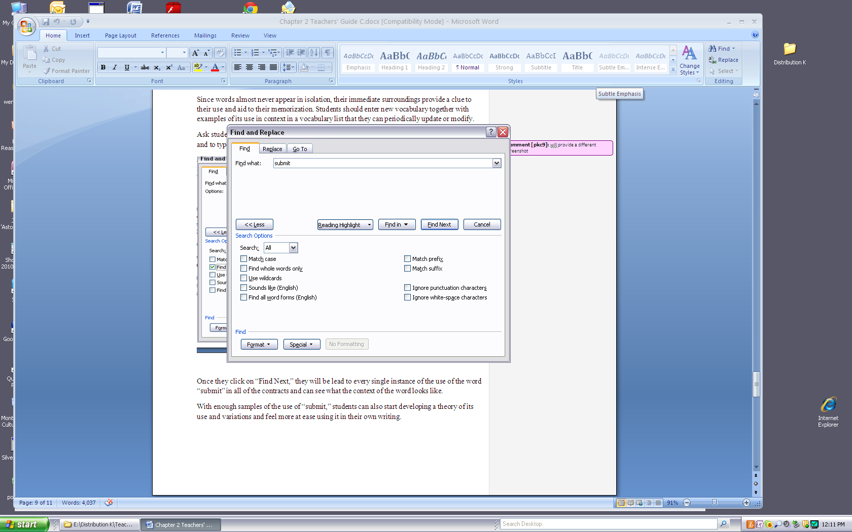

Every time you click on *Find Next*, you will be led to the next part of the document where the word *submit* appears. With enough samples of the use of *submit*, you can start developing ideas as to its use and variations and feel more at ease using it in your own writing. Below, you will see an abbreviated version of what you might find in the text of the contracts when you look for the word **submit**:

Example:

1 …materials Distributor desires to translate, are to be **submitted** to Supplier for approval prior to use.

2 Distributor agrees to **submit** to the personal  jurisdiction of any court of competent subject mat…

3 Distributor agrees to **submit** to Supplier within thirty (30) days hereof a marketing plan detaili…

4 Further, Distributor shall **submit** all documentation requested by the authorities or notified bodies f…

5 All Purchase orders **submitted** by Distributor shall be governed exclusively by the terms and co…

6 The Distributor shall prepare and **submit** to Company periodic reports relating to its activities as Distribut…

7 (a) Distributor must **submit** a request for an RMA number to Company in writing, and should inclu…

8 materials **submitted** in connection with such proceedings will not be admissible in an …

9 Audit findings will be **submitted** to the Distributor in writing within *** from the day the audit…

10 Distributor shall **submit** a written purchase order to Manufacturer! for each order and Manufa…

11 All documents **submitted** to the arbitrator will be in English or accompanied by a certify…

12 …, and all evidence **submitted** to such arbitration shall be **submitted** in the English language.

13 …ent, and as a condition precedent to the validity hereof, DISTRIBUTOR shall **submit** a Purchase Order (as …

14 …English language, and all evidence **submitted** to such arbitration shall be **submitted** in the English language. 21.3.

15 Although Licensee may **submit** to Licensor its request to use certain images, the specific images…

16 Invoices will be **submitted** upon shipment; provided, that, if any Related Charges and other…

17 The parties hereto, and each of them, hereby **submit** themselves to the jurisdiction of the state courts of….

Once you have seen enough examples of the use of the word *submit*, you begin to understand how it is used in the context of a contract. You will probably see that the word *submit* takes on roughly two meanings in the context of contracts, and you will see the words that appear together with the word *submit*:

1. To send or turn in a written document: materials, plans, documentation, reports, purchase orders.

*When you search for a word or phrase, look at its use in as many contracts as possible. With the FIND function, start with the first contract in the contract database file. Don’t merely depend on the examples found in the first few contracts or, even worse, from one contract only. By reviewing as many examples as possible of the word or phrase as used in the contracts, you will gain a better understanding of the correct use of that word or phrase.*

1. To agree to be subjected to a specific legal process or system: personal jurisdiction

**3. Locating Similar Provisions in Various Contracts**

In some exercises you will be asked to find and critically compare particular clauses (e.g., governing law clauses) among two or more contracts in the database file. The FIND or search function of your word processing program can help you locate these clauses. Using the same approach used in 1. above, you will enter a word or word combination that you think might commonly appear in these clauses or the headings for these clauses.

As shown in figure 2.1, the drafter used the heading *governing law* to search for a choice of law provision, selected three provisions, and pasted them into a separate document for review, analyzing, and critiquing.

***Figure 2.1 Three Governing Law Provisions***

|  |
| --- |
| Governing Law. This Agreement shall by governed by the laws of the Commonwealth of Pennsylvania. DA#15  GOVERNING LAW AND JURISDICTION. This Agreement shall be governed by the laws of Michigan, USA. All disputes hereunder shall be resolved in the applicable state or federal courts of Michigan. The parties consent to the  jurisdiction of such courts, agree to accept service of process by mail, and  waive any jurisdictional or venue defenses otherwise available. DA#22  Governing Law. This Agreement shall be governed by and construed in accordance with the internal laws of the State of Florida, United States of America applicable to agreements made and to be performed entirely within Florida, without regard to the conflicts of law principles of such State. Distributor acknowledges, represents and warrants that it is aware of the laws of the State of Florida, and has been duly advised and willfully chooses the laws of the State of Florida as the governing law for this Agreement. The Parties hereby agree that neither the "United Nations Convention on Contracts for the International Sale of Goods", nor the Convention on the Limitation Period in the International Sale of Goods and the Protocol amending such Convention, done at Vienna April 11, 1980, shall govern the rights, duties and obligations of the Parties under this Agreement. DA#27 |

The three provisions can now be analyzed with regard to word choice and the desired legal effect. Provision DA#27, for example, contains information about the exclusion of certain international conventions to the agreement. Why was this information not included in DA#15 and DA#22? Also, is it necessary to include a sentence that specifies that parties consent to the jurisdiction of a certain court, as in DA#22? How much overlap is there in the actual wording of the three provisions? What are the strengths and weaknesses of each provision?