Sloan Basic Legal Research Workbook Rev. 5th ed. – Text Updates
For Fall 2023 (as of August 2023)

Note: When Lexis released Lexis+ changes were made in the home page, nomenclature, and in the way to perform some searches. Changes that should not be difficult to follow are not listed below, such as the change of a tab from “Explore Content” to “Explore” or the relabeling of the left-side “Narrow By” to “Filters.” More substantive changes are noted below, including replacement pages for Chapter 9 on Online Search Techniques (pp. 191-99). The electronic version of the text should incorporate these changes, which are not reflected in the current print edition.
Summary of Changes
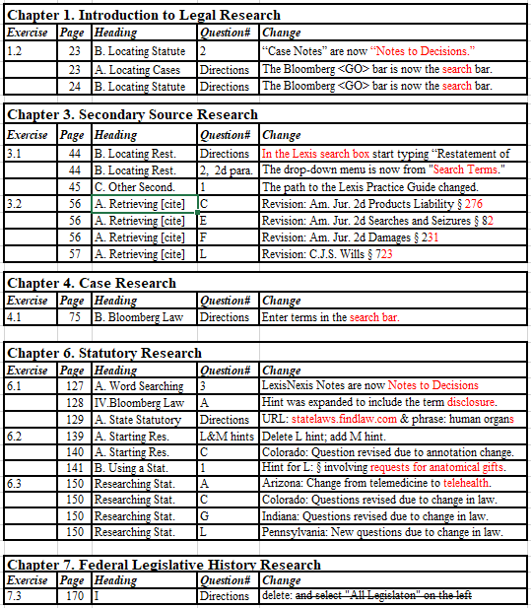
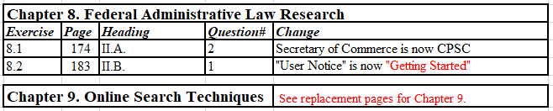
Sloan Basic Legal Research Workbook Rev. 5th ed. – Text Updates
For Fall 2023

Chapter 1. Introduction to Legal Research
Exercise 1.2 II. Lexis
Page 23 - B. Locating Statutes in Lexis
“Case Notes” are now “Notes to Decisions.” Beginning with the third sentence the paragraph should read:
Case summaries appear after the section in the annotations called “Notes to Decisions.” You can find this section by scrolling through the document or by using the navigation tools on the left side of the screen. (Depending on the browser, you can mouse over the circled dots to reach the Notes to Decisions, click on the Notes to Decisions, or drag the navigation bar to Notes to Decisions.) Click on the blue downward arrow next to any topic in the Notes to Decisions, or scroll past the list of topics to the case summaries.

Exercise 1.2 III. Bloomberg
Page 23 - A. Locating Cases in Bloomberg Law
Page 24 - B. Locating Statutes in Bloomberg Law
The Bloomberg <GO> bar is now the search bar.

Chapter 3. Secondary Source Research
Exercise 3.1 II. Lexis
Page 44 - B. Locating Restatements of the Law Using Word Searches
Replace the first line of the last paragraph of instructions before the search terms:
In the main Lexis search box, start typing “Restatement of Agency” and select “Restatement of Law, Agency 3d—Official Text” when it appears. Click the link and execute the search below.
On question 2, second paragraph, the menu has changed.
Select “respondeat superior” from the drop-down “Search Terms” menu.

Chapter 3. Secondary Source Research (continued)
Exercise 3.1 II. Lexis
Page 45 - C. Researching Other Secondary Sources
The path to the Practice Guide in question 1 has changed.
1. Using the “Filters,” narrow your results to the LexisNexis Practice Guide on Illinois Personal Injury Litigation. (Hint: In the “Search within results” box in “Filters,” type “Illinois Personal Injury Litigation” in quotes).
Exercise 3.2 II. Researching by Citation in Legal Encyclopedias
Page 56 - A. Retrieving a Source by Citation
The Am. Jur. 2d topics have been updated with new section numbers.

Problem Set C. Am. Jur. 2d Products Liability § 276
Problem Set E. Am. Jur. 2d Searches and Seizures § 82
Problem Set F. Am. Jur. 2d Damages § 231

Page 57

Problem Set L. C.J.S. Wills § 723

Chapter 4. Case Research
Exercise 4.1 III. Word Searching in Online Databases

Page 75 – B. Bloomberg Law

The first sentence should read:

To conduct a search in Bloomberg Law, enter terms in the main search bar, or use the “Keywords” search bar after selecting your source.

Chapter 6. Statutory Research
Exercise 6.1 III. Lexis

Page 127 - A. Word Searching
The second sentence in question 3 should read:
Scroll down until you find Notes to Decisions LexisNexis Notes and Case Notes.
Chapter 6. Statutory Research (continued)

Exercise 6.1 IV. Bloomberg

Page 128 -
The hint in A should read:
(Hint: Click “View All” to see the entire list, look for the section covering disclosure, and open it to view the chapter heading in the outline near the top of the page.)

Exercise 6.1 V. Statutory Research on the Internet

Page 129 - A. State Statutory Research*
Replace the last line of the first paragraph of instructions before the URL, the URL, and the first two lines of the next paragraph:

One way is through the Findlaw website:
statelaws.findlaw.com
From the State Laws page click on “New York Law” and in the first paragraph click “New York’s official online statutes.” [Using the drop-down menu under “Laws” select “Laws of New York.”]

Search terms should be plural: human organs

*Fastcase suspended the Public Library of Law so www.plol.org no longer works for this question.

Exercise 6.2 I. Annotated State Codes

Page 139 - A. Starting Research with an Index
Delete the Hint for Problem Set L and add:
(Hint for Problem Set M: From “Generally” where you find the “Revised Uniform Anatomical Gift Act; short title,” go to the “Table of Contents” to find “Definitions.”)

Chapter 6. Statutory Research (continued)

Page 140 -
C. Colorado
Question should read:
The name and citation of a 2015 law review article The citation of a practice aid concerning anatomical gifts made by a donor (Regarding His or Her Own Organs)

Page 141 - B. Using a Statutory Outline
The Hint for Problem Set L should read:
(Hint for Problem Set L: Review the table of contents for the entire act, and locate the section involving requests for anatomical gifts rights and duties at death.)

Exercise 6.3 Researching Statutes on Your Own

Note: Several jurisdictions changed telehealth laws in response to COVID-19 which necessitated changes to the questions.

Page 150
A. Arizona
In questions 1 & 2 telehealth should replace telemedicine:
1. What is the definition of telehealth telemedicine under Arizona’s public health and safety laws?
2. What does Arizona law require a health care provider to obtain before health care can be delivered to a patient through telehealth telemedicine?

C. Colorado
Questions 1 & 2 should read:
1. What is the definition of telehealth under Colorado’s insurance provisions governing health care coverage as of Jan. 1, 2017?
2. Does telehealth “remote monitoring” include synchronous and asynchronous technologies use of telephone or email fall within the definition of telehealth (as of Jan. 1, 2017)?

Chapter 6. Statutory Research (continued)

Page 151
G. Indiana
Questions 1 & 2 should read:
1. What is the definition of telemedicine (telehealth) under Indiana’s health insurance laws?
2. Does telehealth include delivery using secured videoconferencing the use of a telephone constitute a telemedicine service?

L. Pennsylvania
Questions 1 & 2 should read:
1. When a “Health Collaborative” program was defined, were they given the ability to implement best practices for telemedicine-supported care? (Hint: See “Duties of Department.”)
2. How many regions were established in the Commonwealth for health collaboratives?

Chapter 7. Federal Legislative History Research
Exercise 7.3. Researching the Legislative History of a Federal Statute with Congress.gov

Page 170.
Question I second sentence should end:
Enter the following search phrase in the search box and select “All Legislation” on the left:

Chapter 8. Federal Administrative Law Research
Exercise 8.1 II. Researching Federal Regulations Using Statutory Annotations

Page 174 A. 2
Question 2 should now reference the Consumer Product Safety Commission:
The statute defines the required markings but then grants authority to the Consumer Product Safety Commission Secretary of Commerce to alter those requirements. What authority does the Consumer Product Safety Commission Secretary of Commerce have with respect to look-alike guns used in theatrical productions?
Chapter 8. Federal Administrative Law Research (continued)

Exercise 8.2 II. Researching Federal Regulations Using General
Government Research Websites

Page 183 B.
Question 1 should begin:
1. Read the Getting Started” link “User Notice”“at the beginning of the e-CFR.

Chapter 9. Online Search Techniques
Exercise 9.1.
See Replacement pages for Chapter 9 with the new Lexis+ directions at https://www.aspenpublishing.com/sloan-researchworkbook5.

