Wombat Forest facing destruction again…

A small group of environmental campaigners has visited an area of Wombat State Forest, near Bullarto and discovered a large area of land completely destroyed by industrial scale logging. We were unable to see other logged coupes because of barriers and road blocks throughout the forest.

The Mount Alexander Knitting Nannas met with Amy Calton (of Wombat Action Group) on Tuesday 1st April to survey the damage caused by VicForest in a recent operation, close to Bullarto in the Wombat State Forest. A large area of land has been clear felled, with many trees uprooted, causing serious erosion and degradation of the whole ecosystem.

As a result of an agreement between the state government and VicForest in 2024, logging is supposed to be illegal in native state forests in Victoria. However, it seems VicForest has been able to use loopholes in these laws to operate on a large scale. The agreement with the state government was for VicForest to be able to cut down trees (after storms – “salvage” logging) and to be able to cut barriers through the forest to create less of a fire hazard (“fuel breaks”). Many people have witnessed fully laden trucks carrying very large, undamaged, freshly felled Eucalyptus trees, creating the strong impression that logging contractors continue to profit, making as much money as they can.

Both of the practices of salvage logging and clearing fuel breaks have been called into question by eminent scientists (like David Lindenmayer) who after conducting extensive research believe that instead of reducing the risk of fires, these methods create conditions for worse fires, in their intensity and frequency. As well, cutting down lots of trees releases even more carbon into the atmosphere, thus increasing emissions.

Trees, even if they are damaged, create important nesting places for many animals, including the Powerful Owl. When large areas of land are razed, nocturnal animals (like the Greater Glider) cannot fly from tree to tree. They must run along the ground leaves them exposed to predation from feral animals. This causes populations of local species to further decline, leading to more extinction.

Because VicForest’s operations are in isolated and remote parts of the forest, they have escaped scrutiny. Many public roads have been blocked and barriers erected to prevent ordinary people from being able to visit the logging sites. Some major local access routes, linking communities to towns, have been blocked, with no notice or warning given to local people. This is a serious risk to local inhabitants in the case of bushfires and other emergencies.

Picture of some of the Mount Alexander Knitting Nannas in front of the road block on Leonard’s Hill/South Bullarto Road.

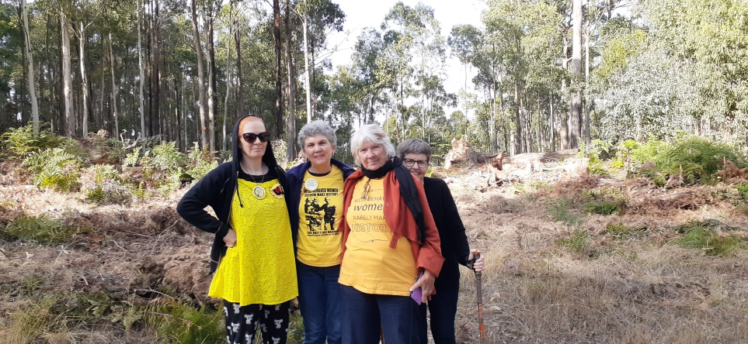

Picture of the destroyed landscape on Wombat Creek Road, the coupe is called “Silver Queen”, the source of the Werribee River

