**Pushing the needle**

[By Jo Chandler](https://www.themonthly.com.au/node/205730)

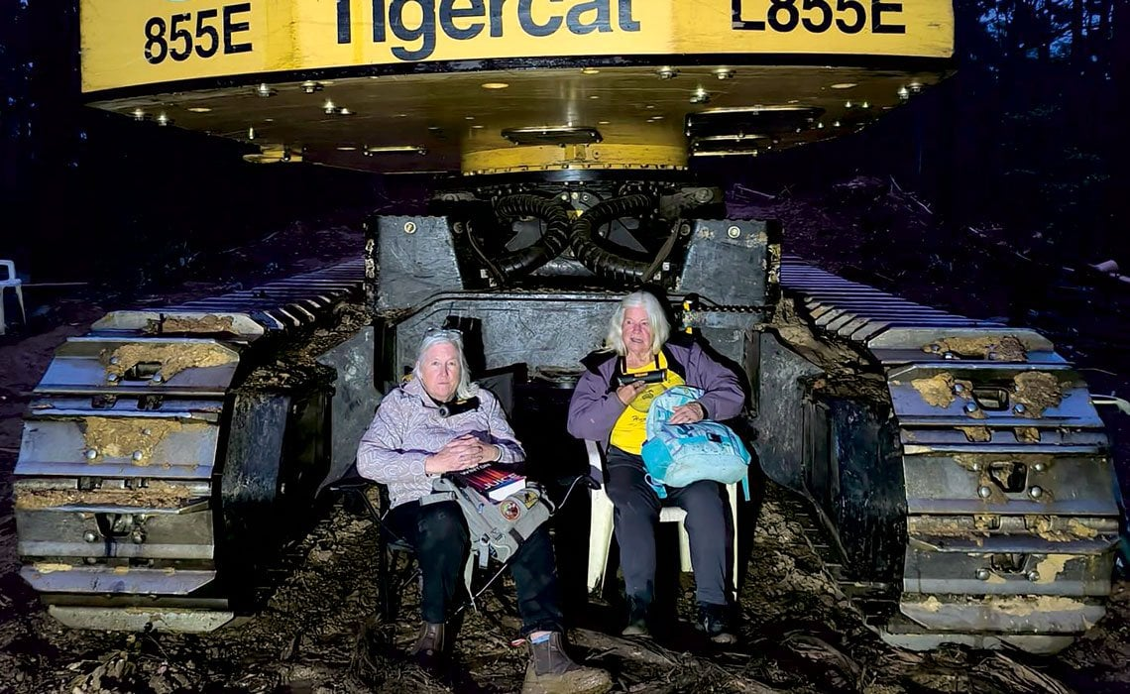

Knitting Nannas Dom Jacobs and Helen Kvelde locked on in Bulga State Forest

As climate protests gather force around the country, what is driving a wide range of people from despair to direct action?

It’s 4.30am when two grey-haired women pick their way by torchlight across the logging coupe in New South Wales’s Bulga State Forest. They plant a pair of green plastic chairs in the churned earth under a monster tree-harvester. They get some help bolting onto the machine – chunky D-locks looped around their necks, the weight nestled on rolls of towelling. Then it’s just the two of them.

Dawn dials up the birdsong and illuminates a wash of mist rolling through the trees they have come to save. They wait.

One pulls out a book – Professor David Lindenmayer’s *The Forest Wars* – and they both have their knitting at hand, to pass the time and calm the nerves. They settle into the wadding of their big girl nappies. It is a measure of their stalwart dignity that these remain dry for the 10 hours the women are locked on, then sawn off – angle grinders screaming – then tossed about the back of a police paddy wagon on the bumpy ride into town. (“Longest I have ever gone in my life!” one says later.)

They listen to the forest and each other, the calmer of the two soothing the anxieties of her older friend. Companionable. Determined. Joyful. Every hour they are here, keeping the machinery of logging idle, 50 trees remain upright. Detractors argue their presence merely delays the inevitable. But someone else might come tomorrow, they answer. One way or other, they are changing the story.

They are the resistance, the people who may be our last best hope as politics and policy, markets and laws, fail to meet the urgent reckoning of climate cataclysm. And they are everywhere, once you get your eye in. Harder to see is the matrix of threads that connect them, sharing information and resources like the tangle of mycelia sustaining the trees in this forest.

Their ranks are often female, and skew older, like this pair, or very young; the generation in between busy elsewhere. They may or may not achieve their immediate objective. Regardless, “protest that endures”, as veteran American activist, writer and farmer Wendell Berry observed, “is moved by a hope far more modest than that of public success: namely the hope of preserving the qualities of one’s own heart and spirit that will be destroyed by acquiescence”.

One of the Bulga pair, Dom Jacobs, 60, a retired childcare worker, describes herself as “married, mother of seven – five foster children and two homegrown”. Also a grandmother of four, and wildlife carer (mostly wallabies, “and they’re like little babies too”). During her first 50 years she kept herself nice – “barely even a speeding ticket”. Now, she laughs, “I’m, like, totally on the other side of the law.” Today will end in her third arrest.

What tipped her into activism was energy company AGL’s proposal to drill coal-seam gas wells near her home in Gloucester, north of Newcastle. Her first arrest was in 2016, locking on to a Santos plant near Narrabri. Her second was in 2022, at a blockade of Sydney’s Port Botany. She was charged under new anti-protest laws rushed through by the New South Wales government introducing penalties of up to $22,000 and two years in prison.

Her fellow Bulga protester, Helen Kvelde, 73, “an almost retired psychologist and mother of three”, was arrested alongside Jacobs at Port Botany. For her, too, it had been a local skirmish that tipped her into the global fight for nature and climate. She was despairing after fighting, and failing, to save five hectares of precious bush habitat in the Manly Dam catchment. In 2022, as then federal environment minister Sussan Ley successfully argued she did not have a duty of care to protect young people from climate change when assessing fossil fuel projects, Kvelde thought, *No, I’m over this*.

Despite a lifetime of campaigning going back to student days protesting the Vietnam War, today will be just her second arrest, though she has “tried a couple of other times and failed”. She once joined a blockade with Extinction Rebellion activists, “but because I was so much older than them, I still hadn’t got down on the road. [Police] dragged them off and they left me there.” A truck driver yelled, “Get off the road, you fucking bitch.”

The pair relish their solidarity as part of the buttercup-clad guerrilla-hood of the Knitting Nannas. “Sit, knit, plot, yarn, have a cuppa and bear witness” has been their proven recipe for disruption on gas and other projects since 2012. Jacobs and Kvelde are poster nannas for the movement. They went to the NSW Supreme Court to challenge the increasingly repressive laws under which they were arrested at Port Botany, securing a celebrated pushback when the court ruled that parts were unconstitutional because they constrained the right to peaceful protest.