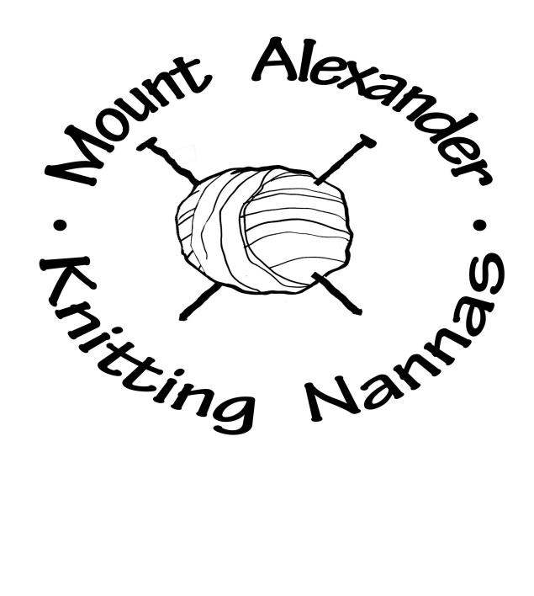

**Mount Alexander Knitting Nannas Songbook**

**Mount Alexander Knitting Nannas Songbook**

*Thanks to Sydney Knitting Nannas for these songs.*

**Songs to sing (without instruments) – dance moves?**

1. “Divest” – tune of “Go West” by the Village People

2. “We will stop you!” – tune of “We will rock you” by Queen

**Songs to sing with instruments**

3. “Bye, bye coal!” – tune of “Bye bye love” by Felice and Boudleaux Bryant

4. “We’re using sunshine” – tune of “You are my sunshine” by Rice Brothers’ gang

5. “Sing for the climate -We need to wake up” – tune of “Bella Ciao” – Italian anti-fascist song of resistance during WW1

6. “Climate change” – tune of “Baby face” by Harry Akst

7. “A world without coal” – tune of “A world of our own” by the Seekers

8. “Global Warming Dreaming” – tune of “California dreaming” by the Mamas and the Papas

9. “These gates were made for lockin’” – tune of “These boots were made for walkin’” by Nancy Sinatra

10. “The koala song” – tune of “Wouldn’t it be loverly” from the musical “My Fair Lady

11. “Coal seam gas” – tune of “Om Pah Pah” from the musical “Oliver”