# **Plant-based Meat: Overview**



### **Bridging the gap between animal meat and sustainable alternatives**

Versions of plant-based meat substitutes have been available since at least the 1970s when MorningStar Farms introduced its line of vegetarian meat substitutes. Although these failed to garner a large or long-lasting consumer base, today plant-based meat is having another moment, in a revival driven by growing demand for healthier food choices that are less harmful to the environment. Unlike the distinctly un-meat-like quality of the original veggie burger, today’s plant-based meat products are produced using sophisticated processes that combine vegetable byproducts, seeds, and grains as well as mushrooms, mycelium, seaweed, and algae to mimic the flavor, color, nutritional profile, and mouthfeel of meat (possibly the most significant achievement in the industry).

Despite a slowdown in the [2022](https://gfi.org/blog/2023-outlook-the-state-of-the-plant-based-meat-category/#:~:text=Global%20trends&text=Indeed%2C%20global%20dollar%20and%20weight,by%20weight%20grew%20five%20percent.) retail sales of plant-based meat in the US, global sales remained strong. Consumer interest in a new generation of non-meat products continues to grow, and startups have seized the opportunity to produce improved plant-based products, swiftly closing the taste gap between real and alternative meat.

High extrusion cooking is the most widely used technology by plant-based meat startups for production; both front runners, [Beyond Meat](https://sp-edge.com/companies/118530) and [Impossible Foods](https://sp-edge.com/companies/238405), produce their alternative meat offerings using this technology. Wet extrusion cooking is another emerging technology that's used by Nestle and Haofood, while the novel shear cell technology is used by [Rival Foods](https://sp-edge.com/companies/1358468) to transform plant ingredients into plant-based whole-cut meat and fish products. Some startups (based mostly in Israel and Europe) are also using 3D printing technology to replicate the shape and texture of real meat. Recently, the industry has seen an influx of plant-based meat startups using fermentation—[Nature’s Fynd](https://sp-edge.com/companies/666849) and [Motif Foodworks](https://sp-edge.com/companies/728236) are two of the leading startups that use this technology.

### **Key segments**

|  |  |  |
| --- | --- | --- |
| **Segments** | **Description** | **Notable startups** |
| Supplier (Technology/ Ingredients) | Suppliers of plant ingredients such as legume, mycelia, and other proteins for the production of plant-based meat, fish, poultry, and pork products; and suppliers of technology related to the production of plant-based meat | [MycoTechnology](https://sp-edge.com/companies/203389), [Motif Foodworks](https://sp-edge.com/companies/728236), [ENOUGH](https://sp-edge.com/companies/502559), [Solar Foods](https://sp-edge.com/companies/616197), [Mycorena](https://sp-edge.com/companies/786294) |
| Manufacturer (Beef) | Producers of plant-based beef alternatives using plant proteins such as peas, soy, wheat, mung beans, etc. Products are manufactured mostly in a burger patty, sausage, meatball, or minced form | [Beyond Meat](https://sp-edge.com/companies/118530), [Impossible Foods](https://sp-edge.com/companies/238405), [NotCo](https://sp-edge.com/companies/492971), [Heura](https://sp-edge.com/companies/808653), [Redefine Meat](https://sp-edge.com/companies/788769) |
| Manufacturer (Seafood) | Producers of plant-based seafood alternatives using plant proteins such as peas, soy, chickpeas, etc. Some startups use more unique ingredients such as algae, konjac (a Japanese yam root), tomatoes, and eggplants. Products are manufactured mostly in shredded or cuts (for sushi) | [Revo Foods,](https://sp-edge.com/companies/1341038) [Future Farms](https://sp-edge.com/companies/783026), [Wicked Kitchen](https://sp-edge.com/companies/1467847), [Konscious Foods](https://sp-edge.com/companies/1508376), [The Plant Based Seafood Co](https://sp-edge.com/companies/2191757) |
| Manufacturer (Poultry) | Producers of plant-based chicken, turkey, and duck alternatives using plant proteins such as peas, soy, wheat, etc. Products are manufactured mostly in nuggets or shredded form | [TiNDLE Foods](https://sp-edge.com/companies/1152699), [Daring Foods](https://sp-edge.com/companies/878675), [Vegan Food Group](https://sp-edge.com/companies/1326601), [THIS](https://sp-edge.com/companies/779482), [SHICKEN Foods](https://sp-edge.com/companies/3408306) |
| Manufacturer (Pork) | Producers of plant-based pork alternatives using plant proteins such as pea, soy, wheat, etc. Some startups also use unique ingredients such as mushroom mycelium (whole-cut bacon) and jack fruits (pulled pork) to produce pork alternatives. Products are manufactured mostly in sausage or pulled (pork) form | [Upton's Naturals](https://sp-edge.com/companies/1263303), [La Vie](https://sp-edge.com/companies/1013187), [Umaro Foods](https://sp-edge.com/companies/1831626), [Plantcraft](https://sp-edge.com/companies/903717), [Meat The Mushroom](https://sp-edge.com/companies/3431890) |

Source: SPEEDA Edge

### **Emerging technologies enable plant-based meat production**

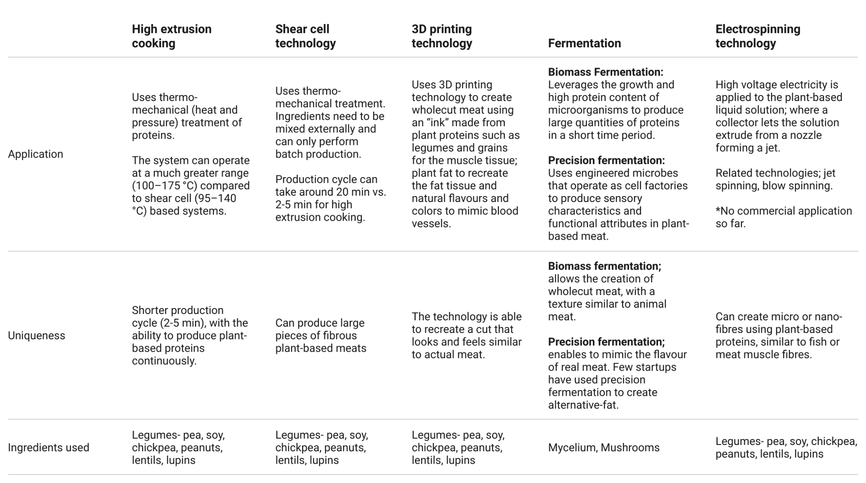

### **Production process for plant-based meat alternatives using high extrusion cooking**

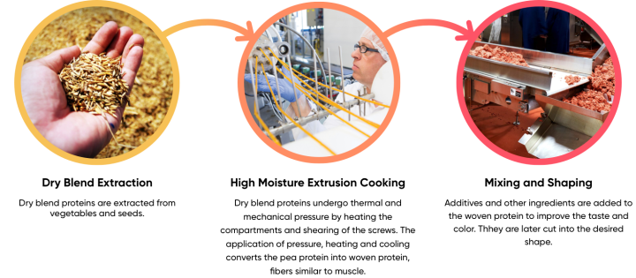

Source: Compiled by SPEEDA Edge based on information from the Institute of Food Technologists, Center of Food Safety by the Government of Hong Kong SAR

# **Driving factors**

## **1. Americans are cutting back on meat consumption driven by health concerns**

Although the US is historically the largest global consumer of meat, Americans are eating less red meat, mostly due to changes in health and lifestyle trends. The fall in meat consumption has constituted a sustained, long-term trend, albeit with a recent modest upturn in the past few years. However, projections from the US Department of Agriculture (USDA) indicate that this decline is expected to persist, falling close to the consumption levels observed in 2015, which marked the lowest per-capita meat consumption in the 2003–2022 period. Importantly, meat alternatives are not being consumed exclusively by non-meat eaters: The majority of recent converts to meat alternative products are categorized as flexitarian, meaning a person who has voluntarily reduced—but not completely eliminated—meat from their diet.

### **Per capita beef consumption in the US**

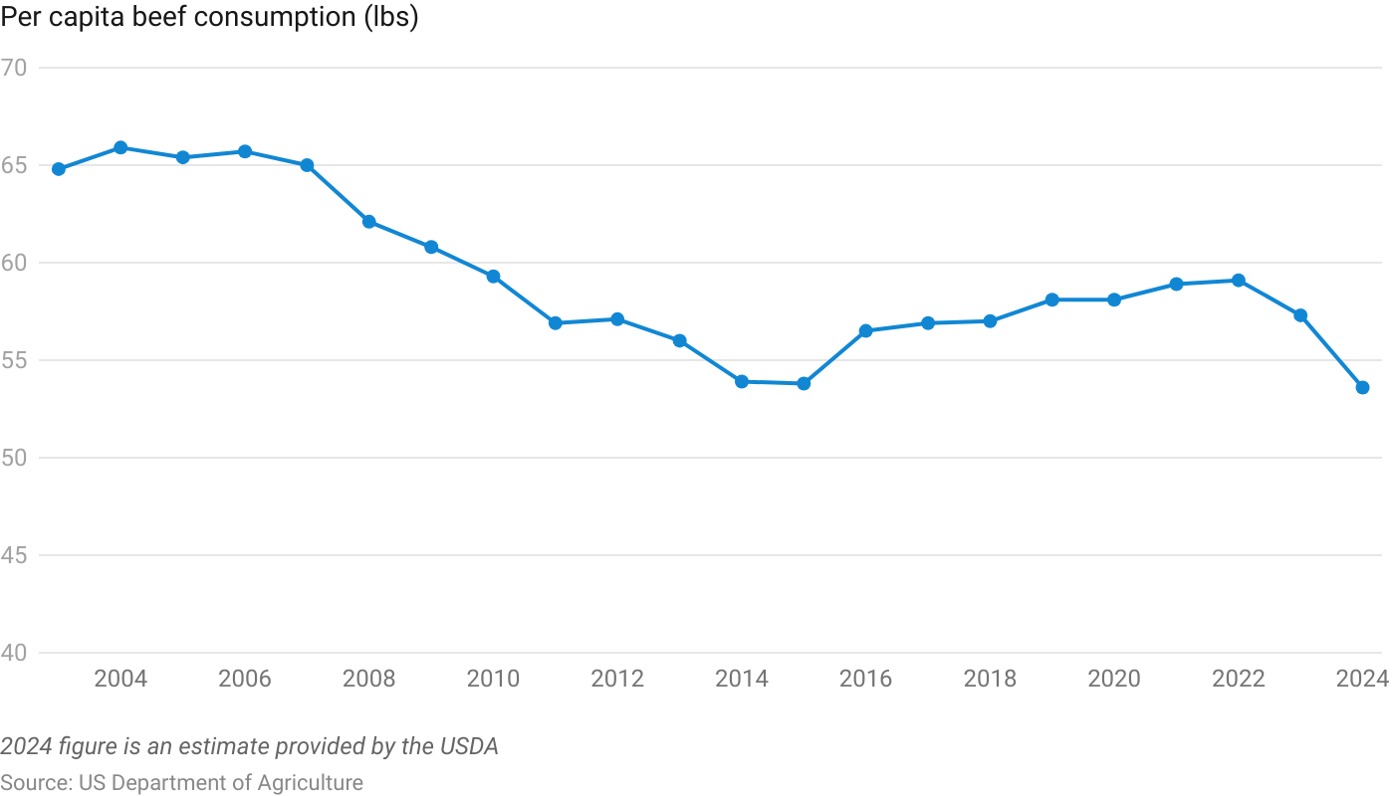

An additional concern with the high consumption of red meat is its association with adverse health conditions such as cardiovascular disease, type-2 diabetes, and certain kinds of cancers. An August 2020 [study](https://med.stanford.edu/news/all-news/2020/08/plant-based-meat-versus-animal-meat.html) by Stanford Medicine discovered that replacing red meat with plant-based alternatives can lower the risk of cardiovascular diseases. Due to these factors, more than 40% of Americans reportedly reduced the amount of red meat in their diets between 2013 and 2015. The main motivations cited were the high cost of meat and health concerns. Studies show that in 2019, nearly 23% of meat eaters cut down on red meat consumption, with some switching to healthier meats such as chicken.

### **Nutritional comparison of plant-based meat and beef**

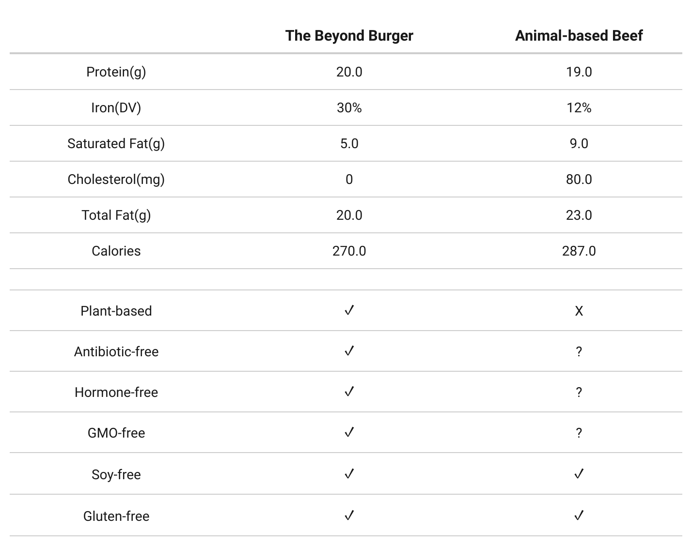

Source: USDA National Nutrient Database

## **2. Outbreaks of disease and worsening climate conditions for the US cattle industry**

Despite the long-term decline in beef consumption in the US, the country’s per capita beef consumption at 57.1 lbs was still [4x the global average](https://sentientmedia.org/beef-consumption-in-the-us/) (as of 2023). However, meat production in the US is vulnerable to increased risk from disease and adverse weather conditions. US cattle inventory drifts through expansion and contraction (liquidation) cycles determined by various factors such as calf prices, weather, and disease outbreaks. The current cycle, which began in 2014 after a 2011 heatwave, peaked in 2019 and is now on its descent, moving to the liquidation cycle, driven partly by dry weather affecting pastures and ranges. In January 2023, the US beef cow inventory was down [3.6%](https://www.ers.usda.gov/data-products/chart-gallery/gallery/chart-detail/?chartId=106369) compared with the previous year. While the drought conditions have improved, its lingering effects have made it harder for farmers to sustain herds and retain breeding stock.

Factory farming accounts for 99% of beef produced in the US and is a common practice for other livestock meat producers. The method confines large numbers of animals to small cages, usually in a contained environment, which facilitates the spread of diseases such as bovine spongiform encephalopathy (commonly known as “Mad Cow Disease”) in cattle, swine influenza virus (“Swine Flu”) in hogs, and avian influenza (“Bird Flu”) in poultry. In November 2021, the US suspended Brazilian beef imports due to the prevailing mad cow disease threat in the country.

Furthermore, the outbreak of the African swine flu in August 2019 killed an estimated 25% of the world’s pig population within a year. A second wave of the flu resulted in around 8 million pigs being killed during the first three months of 2021. As a result, hog prices in China (in March 2021) were almost 2–3x higher than the 2017/2018 prices.

### **Cattle and calves inventory and per capita beef consumption**

### 

## **3. Use of antibiotics in animal agriculture raises health concerns**

Antibiotics are commonly used in animal agriculture to both prevent infections and enhance livestock growth. Globally, 73% of medically important antibiotics sold are used in livestock production. When eating antibiotic-treated meat, consumers ingest various amounts of antibiotics. Since these are the same antibiotics used to treat humans, this can lead to people building up resistance to the drug, diminishing the effectiveness of the antibiotic to fight disease and helping create antibiotic-resistant strains of infection. Over 2.8 million cases of antibiotic-resistant infections were discovered among Americans in 2019, leading to 35,000 deaths that year.

## **4. Growing climate change awareness**

According to the UN Food and Agriculture Organization, livestock farming accounts for [11.1%–19.6%](https://thebreakthrough.org/issues/food-agriculture-environment/livestock-dont-contribute-14-5-of-global-greenhouse-gas-emissions) of global greenhouse gas emissions, which is more than the entire transportation sector. Land usage change, production of animal feed, and animal digestion and waste processes are the key contributors to these emissions. With global demand for meat predicted to rise [50%](https://gfi.org/resource/environmental-impact-of-meat-vs-plant-based-meat/) between 2013 and 2050, the need for sustainable solutions is critical. Plant-based meat accounts for comparatively low greenhouse gas emissions and resource usage.

# **Risks to growth**

## **1. Premium pricing of alternative meat products threatens to curtail demand**

Most plant-based meat products are priced at a significant premium compared to real meat products due to the high production cost base. Pricing was not a significant factor for first movers such as Beyond Meat and Impossible Foods, but due to rising inflation, consumers tend to opt for cheaper protein products. According to Nielsen data, in 2021, plant-based meat was 2x more expensive than beef, over 4x more expensive than chicken, and over 3x more expensive than pork per pound.

However, according to an [analysis](https://www.greenqueen.com.hk/plant-based-meat-price-gap-shrinking/#:~:text=According%20to%20ProVeg%2C%20in%20February,cents%20per%20kilo%20cheaper%20today.) by ProVeg International, the price gap between plant-based alternatives and animal meats is depleting. Price cuts by Alpha Foods (July 2021: 30%), Impossible Foods (March 2020: 15%, January 2021: 15%, February 2021: 20%), and Revo Foods (September 2023: 25%) have helped to narrow the price gap between plant-based meat and animal meat products

## **2. The perception of plant-based as overly processed by certain consumers**

To achieve its desired meat-like quality, plant-based meat is made from highly processed ingredients such as pea protein isolate and soy protein, along with various plant byproducts of fats and acids. According to an Australian study (in 2021), plant-based meat consumers are more susceptible to depression than peers who consume more fresh produce, and findings from the US National Institutes of Health indicate that plant-based meat contains less protein, zinc, and vitamins, along with an unhealthy amount of salt, despite being a good source for fiber, folate, and iron. Furthermore, a study conducted by the University of Leeds in the UK revealed that women who follow a plant-based diet face a 33% higher risk of hip fractures compared to meat eaters. If this trend continues, it will cost plant-based meat producers a significant potential consumer base.

Additionally, plant-based meat patties from Impossible Foods and Beyond Meat show nearly identical caloric values as beef patties and contain more sodium, which raises health concerns for some consumers. Beyond Meat even faced a lawsuit accusing the company of overstating the protein content of its products by 30% and for using methylcellulose despite claiming to have no synthetic ingredients in its products.

## **3. Global labeling regulations threaten marketability**

In May 2018, the state of Missouri voted to approve a provision that would ban the use of the word “meat” by plant-based meat producers when labeling. Since Missouri’s bill, close to 24 other US states have introduced similar bills. As of 2023, 14 states (Alabama, Arkansas, Georgia, Kansas, Kentucky, Louisiana, Mississippi, Missouri, Montana, North Dakota, Oklahoma, South Carolina, South Dakota, and Wyoming) have passed bills. However, several plant-based companies have successfully challenged some of these laws. In Arkansas, a court ruled against the bill, citing it violation of the free speech rights of plant-based meat producers.

In September 2023, France submitted a proposal to ban the usage of meat-like terminology for plant-based meat products, highlighting its desire to avoid misleading claims. This decree aims to ban the usage of 21 specific terminologies, including steak, escalope, spare ribs, ham, and butcher, and will only apply to plant-based meat products made and sold in France.

*Last updated: September 2023*

©2024 Uzabase, Inc. All Rights Reserved. The information contained herein: (1) is proprietary to Uzabase Inc. and/or its content providers; (2) may not be copied or distributed; and (3) is not warranted to be accurate, complete or timely. Neither Uzabase Inc. nor its content providers are responsible for any damages or losses arising from any use of this information.