# **Natural Fetilizers: Overview**



## **Using nature to nurture crop growth**

Natural fertilizers consist of organic material like plants, animals, or microorganisms (such as bacteria, algae, and fungi) that are added to the soil or plant tissue to provide the necessary nutrients for plant growth.

Potassium, phosphorus, and nitrogen are the three primary macronutrients found in fertilizers. In certain instances, fertilizers can add secondary nutrients, such as sulfur, magnesium, and calcium. These nutrients have so far been primarily derived from synthetic (inorganic) sources. However, natural fertilizers, considered sustainable alternatives to previously used chemicals, are increasingly popular.

The natural fertilizer industry comprises organic fertilizers and biofertilizers. Advances in biotechnology primarily facilitate the evolution of the industry’s biofertilizers.

#### 

#### 

#### 

#### 

#### 

#### 

#### 

#### 

#### 

#### 

#### 

#### 

#### 

#### 

#### **Types of fertilizers**

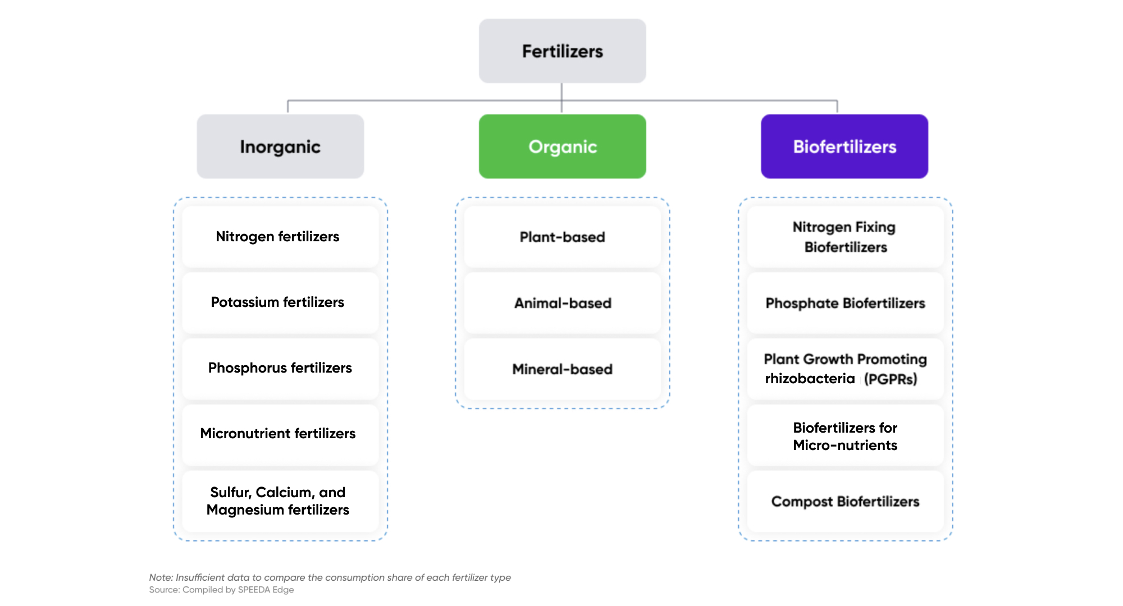

### **Organic fertilizers segmented by source feed the soil**

Organic fertilizer, also known as farm manure, is compost derived from natural or organic sources like animals (e.g., ground bones, crushed shells, fish), plants (e.g., seaweed, cottonseed meal, wood), or minerals (e.g., phosphate rock and green sand). It can be segmented by source as animal-based, plant-based, or mineral-based fertilizers. These are added to the soil and absorbed by the plant.

#### **Organic fertilizers feed the soil**

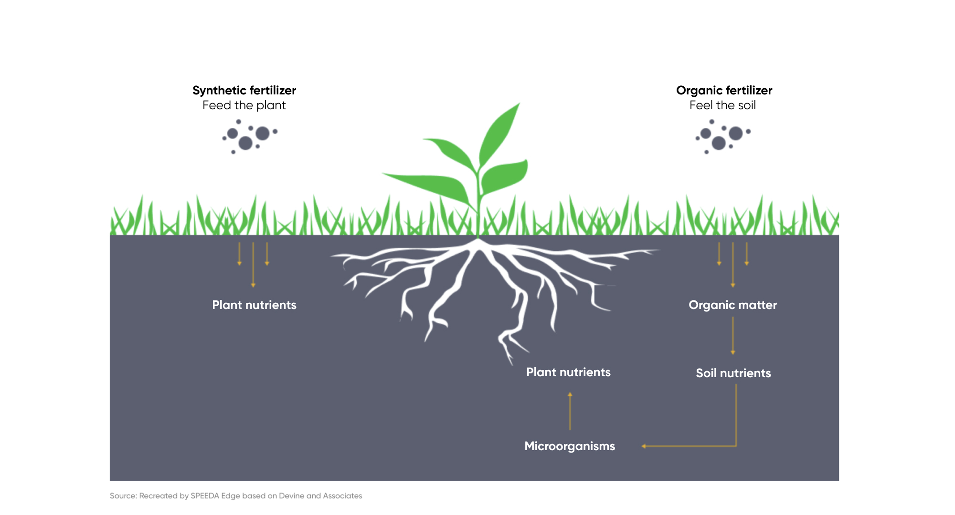

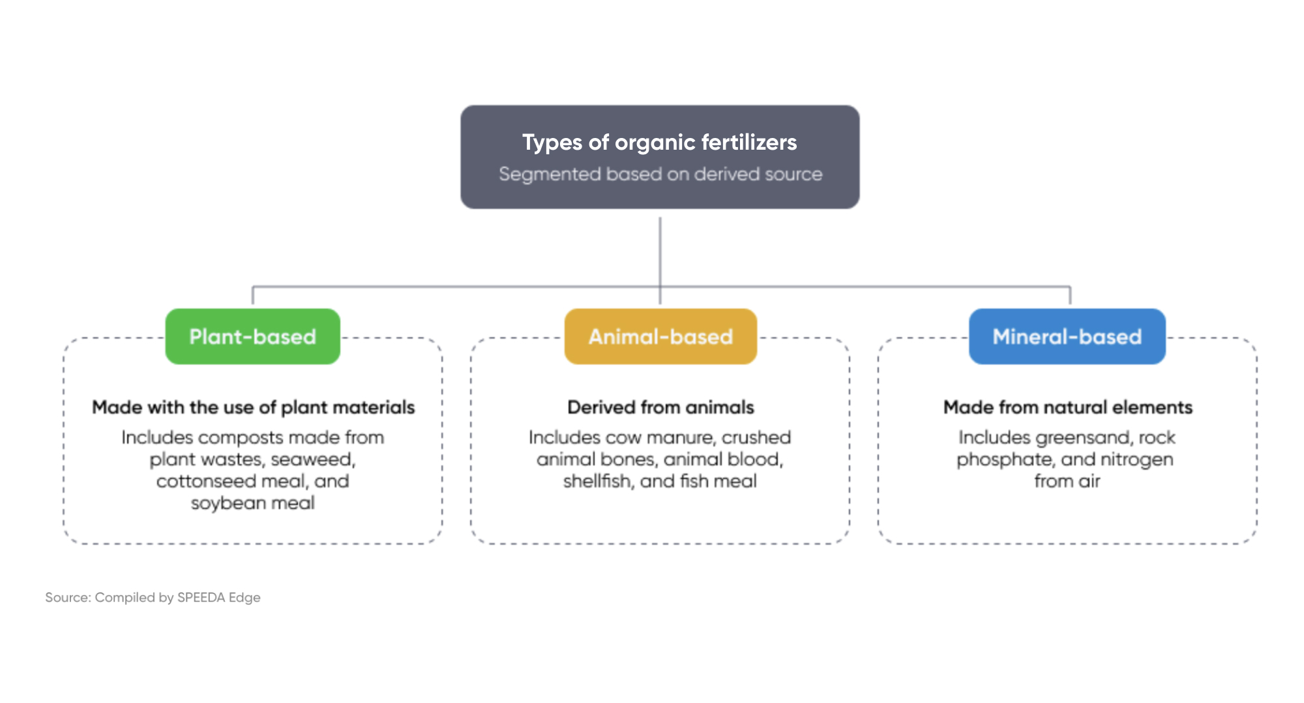

### **Biofertilizers segmented by use activate soil nutrients**

Biofertilizers focus on fixing the availability of nutrients in the soil using microorganisms such as bacteria, algae, and fungi. These living organisms work within plant roots to safely convert complex organic material into simple compounds, which can be easily absorbed by plants. [Studies](https://www.indianjournals.com/ijor.aspx?target=ijor:jefa&volume=10&issue=2&article=001&type=pdf) show that biofertilizers can increase crop yield by 10%–40% and replace at least 25%–30% of chemical nitrogen and phosphorus while stimulating plant growth.

#### 

#### **Biofertilizers activate soil nutrients**

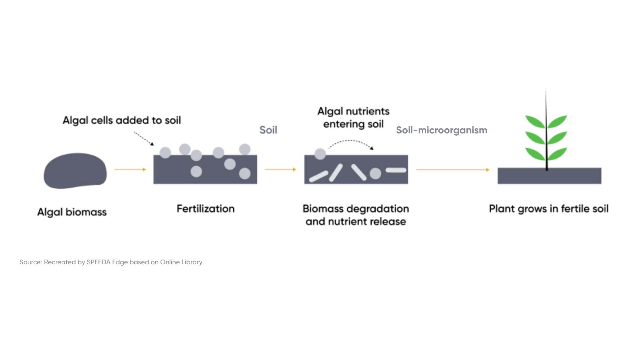

Biofertilizers can be categorized by their usage as shown below. Of these types, nitrogen-fixing biofertilizers, which accounted for around 74% of biofertilizers (by volume) in 2022, were broadly used by farmers in the production of high-demand crops such as wheat, rice, and oilseed. Rhizobia is the most commonly used microorganism to correct the soil’s nitrogen level and support plant growth.

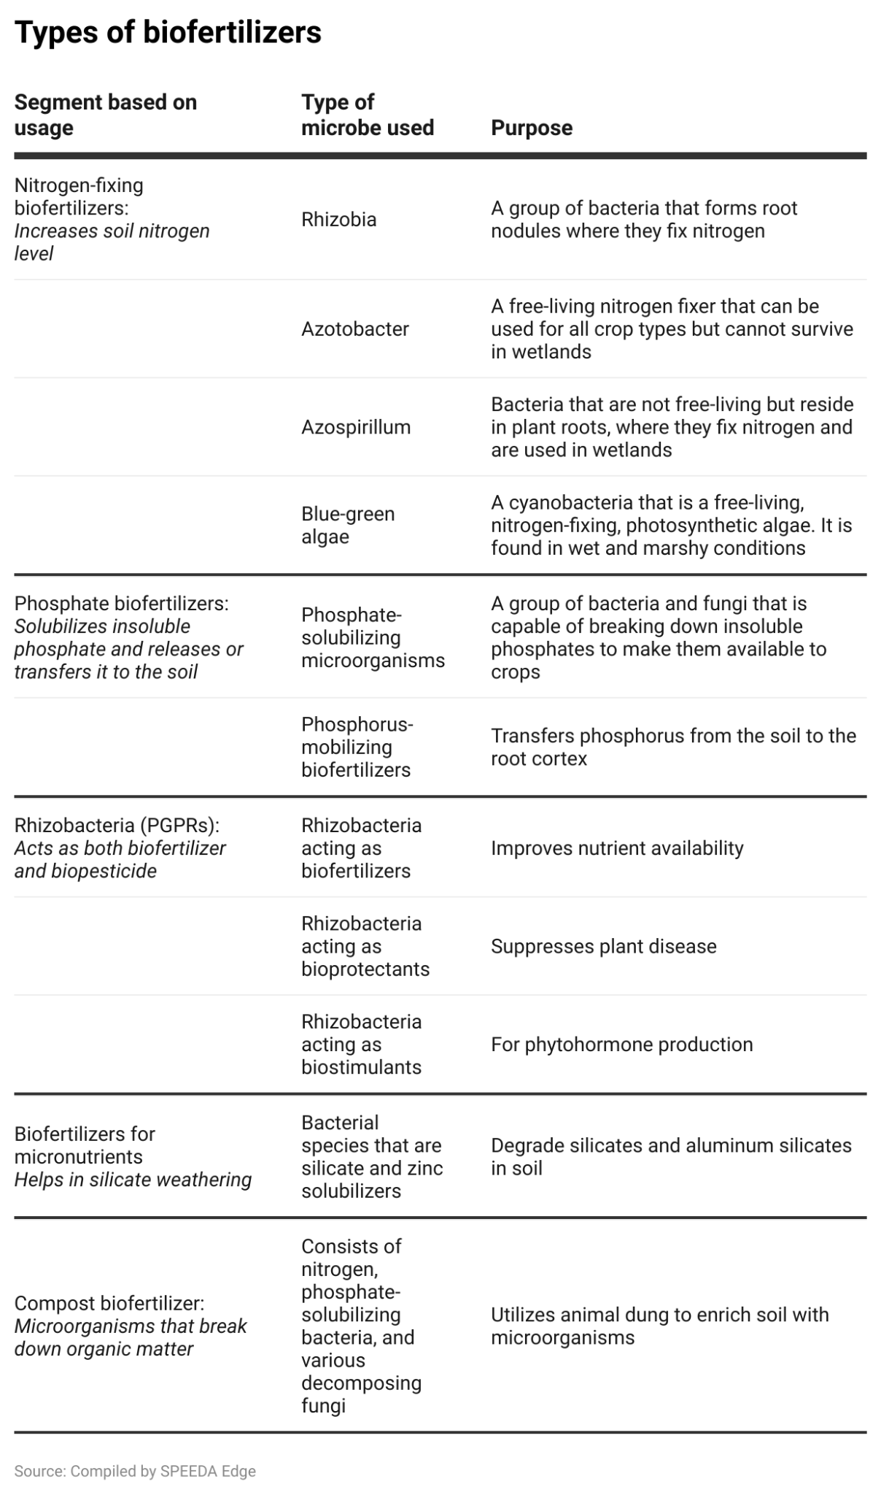

## 

## **Driving factors**

#### **1. Increase in organic farming spurred by rising consumer preference for organic produce**

Organic farming is on the rise given increasing consumer demand for and awareness of organic food. Land dedicated to organic farming in the US in 2021 was 4.9 million acres (~0.6% of total farmland in the US), after growing at a CAGR of 6% over 2015–2019 (organic farming land for 2020 was not disclosed). Organic products in the US are now available at nearly half of all grocery stores. Furthermore, organic sales accounted for over 6% of total US food sales in 2022, up from 3% in 2008. Fruits and vegetables is the organic product category that posted the highest demand (~39% of organic sales in 2022).

Consumers are growing more conscious of food safety and gaining greater awareness about their food’s chemical residue levels. A [survey](https://www.pewresearch.org/science/2016/12/01/americans-views-about-and-consumption-of-organic-foods/) conducted in 2016 showed that four out of 10 Americans consumed organic products. The survey also revealed that 76% of US adults bought organic food for health reasons and 33% for environmental concerns. In 2018, a group of consumers took legal action against pharmaceutical and chemical company Bayer over its glyphosate-containing weedkiller, which it alleged caused cancer.

Therefore, to keep pace with the demand for organic products, farmers are looking for alternatives to agrochemicals, setting their sights on natural fertilizers given their health and environmental benefits.

#### 

#### **Land used for organic farming in the US**

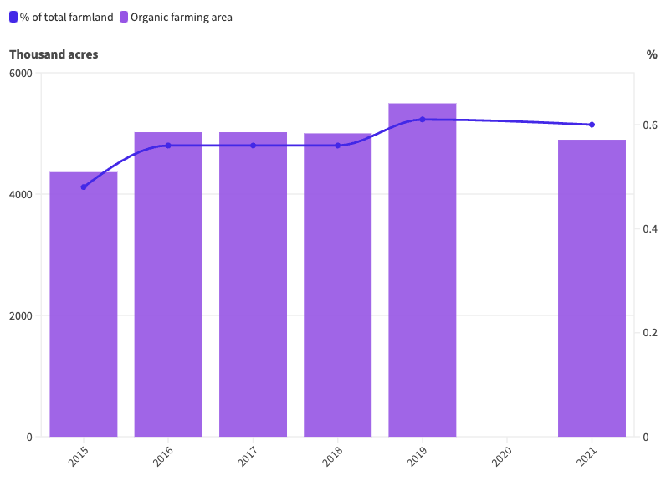

Source: USDA

#### 

#### 

#### **Growth in US organic food sales revenue**

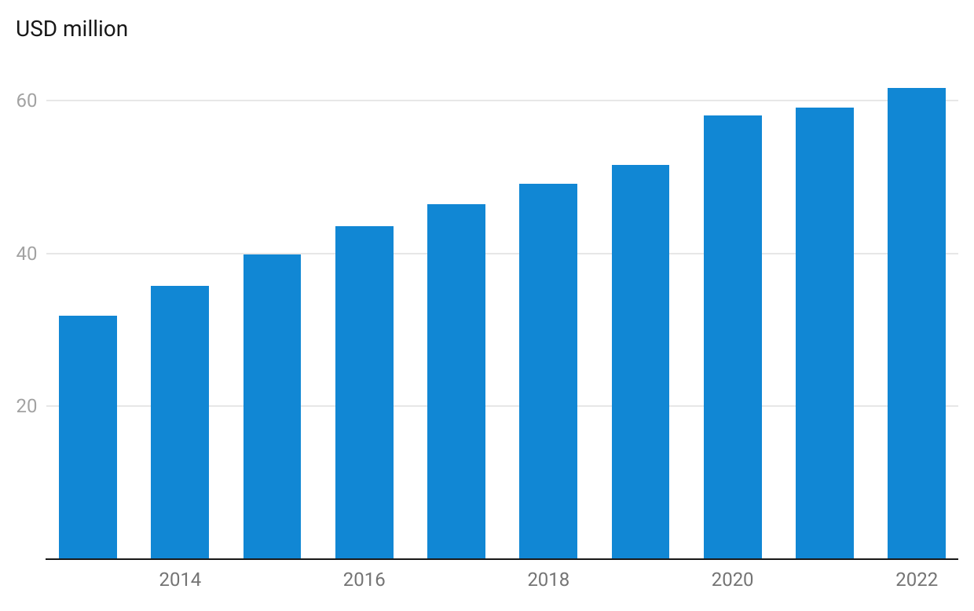

#### 

#### **2. Biofertilizers are an attractive option due to better fertilizer profile and inorganic fertilizers’ rising prices**

Biofertilizers are gaining momentum in the natural fertilizer space and possess high potential. Microorganisms can naturally increase the level of nitrogen and phosphorus available to plants while improving soil quality by restoring their normal fertility levels. Biofertilizers can also enable plants to grow even in adverse conditions, like during droughts. They provide these added benefits while improving yield and are, therefore, a better alternative.

Furthermore, given rapid technological advancement, the necessary microbes can be developed relatively quickly, at a lower cost, and for large-scale application. Startup [BioConsortia](https://sp-edge.com/companies/189856), which produces biostimulants using algae through DNA sequencing, noted that the development of a genetically modified crop takes around 12 years and an investment of ~USD 130 million, while a synthetic pesticide requires eight to 10 years and ~USD 250 million. By contrast, BioConsortia developed its platform and technology in three to five years, with an investment of USD 5 million–15 million.

#### 

#### **Biofertilizers improve yield**

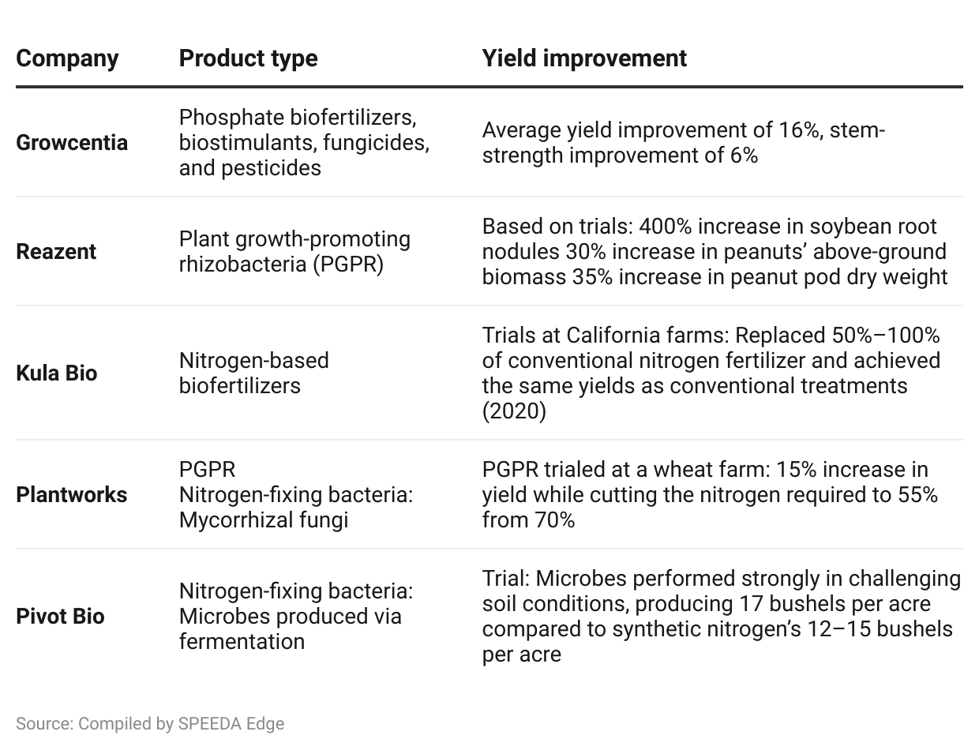

Given the better fertilizer profile, rising prices of inorganic fertilizers make biofertilizers more attractive. From 2006 to 2021 (as of June), the price index of nitrogen fertilizers climbed to 85.7 from 42.7. The increasing prices of such a dominant fertilizer variety have affected overall food prices. The food price index over the period increased by around 73% to 125.3 in 2021 (as of June) from 72.6 in 2006. Against this backdrop, biofertilizers, though expensive outright, are likely to be more attractive because of their long-term improvement in yield and potential cost savings. Trials in 2019 have shown that nitrogen-fixing biofertilizers that use rhizobacteria have allowed savings of around USD 110 per hectare compared to synthetic alternatives.

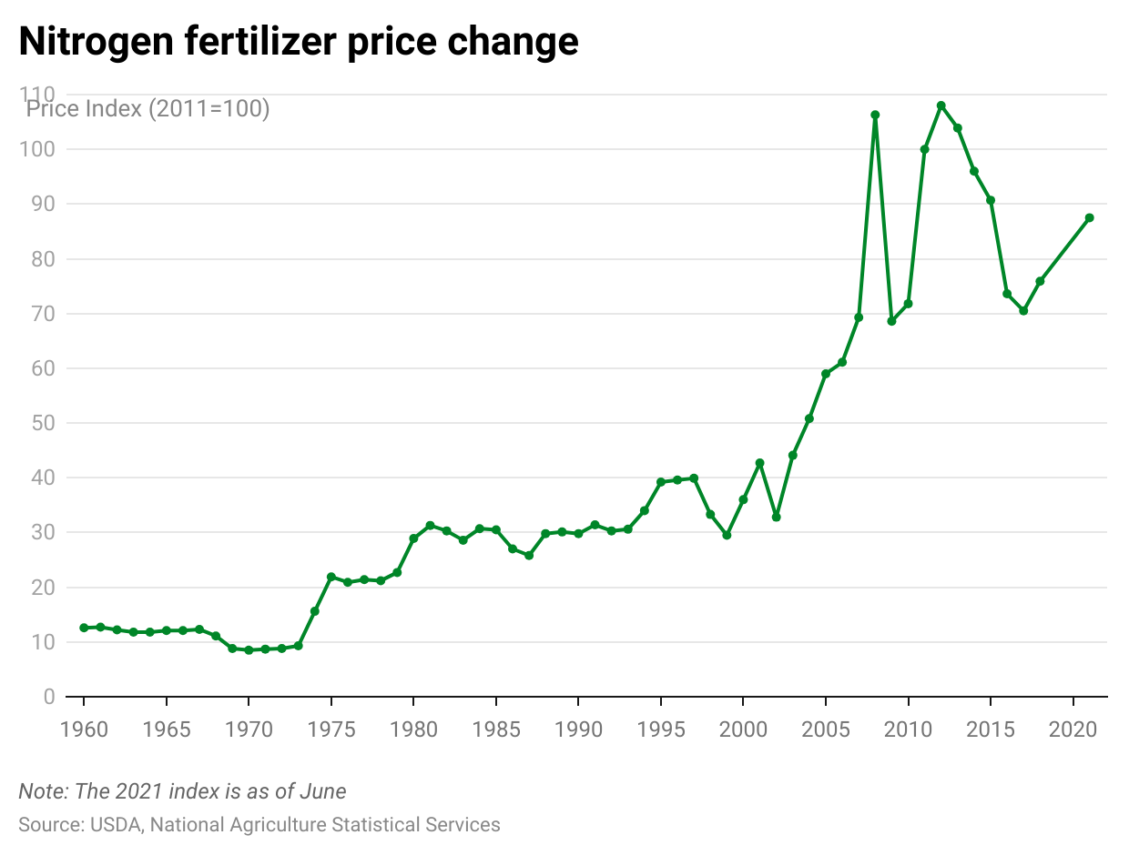

#### **3. Regulatory push to adopt organic farming practices**

Synthetic fertilizers’ chemicals harm the environment and plants. Studies have shown that applying chemical-based fertilizers reduces oxygen levels in US waters, forming low-oxygen “dead zones” and destroying habitats.

In general, the US agriculture sector has faced mounting pressure from regulators to adopt healthier and more eco-friendly practices. For instance, fertilizers and pesticides need to be certified as “organic” by the US Department of Agriculture’s National Organic Program before they can be released for use. Such measures bode well for natural fertilizer players.

Some regulations to ensure organic farming practices include:

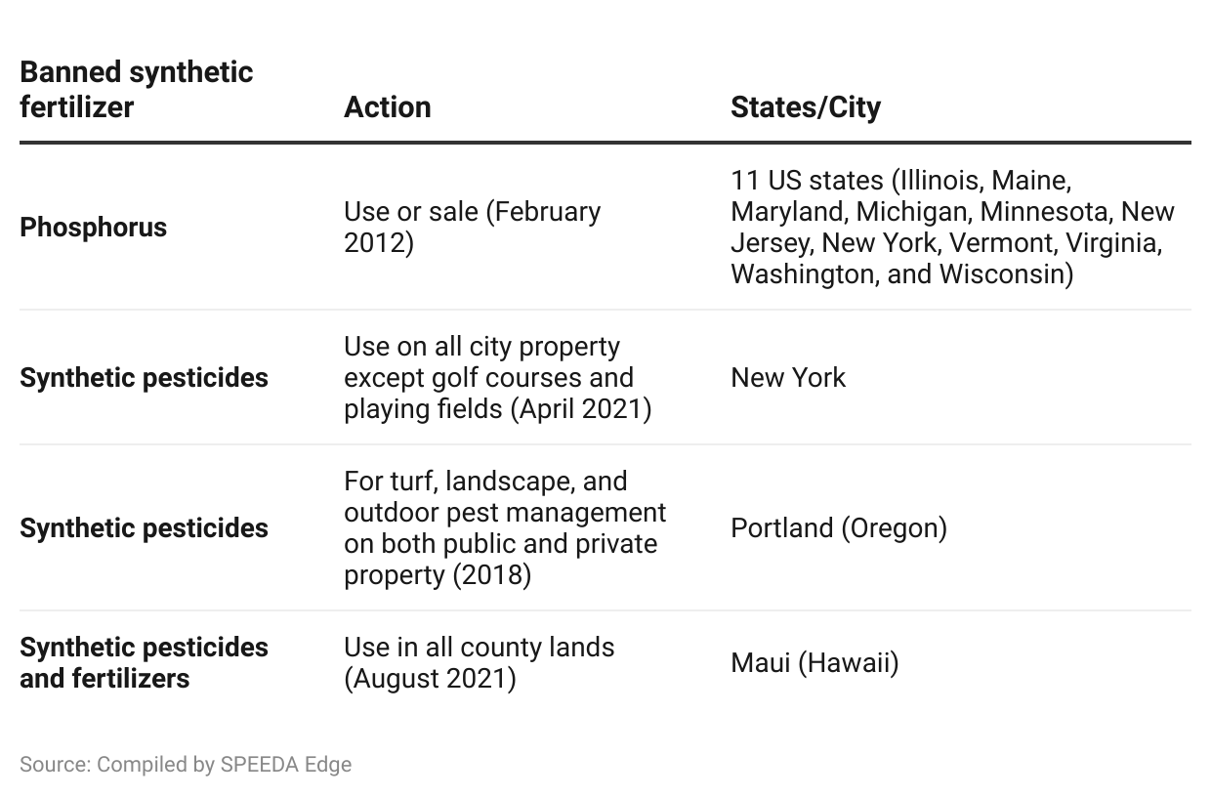

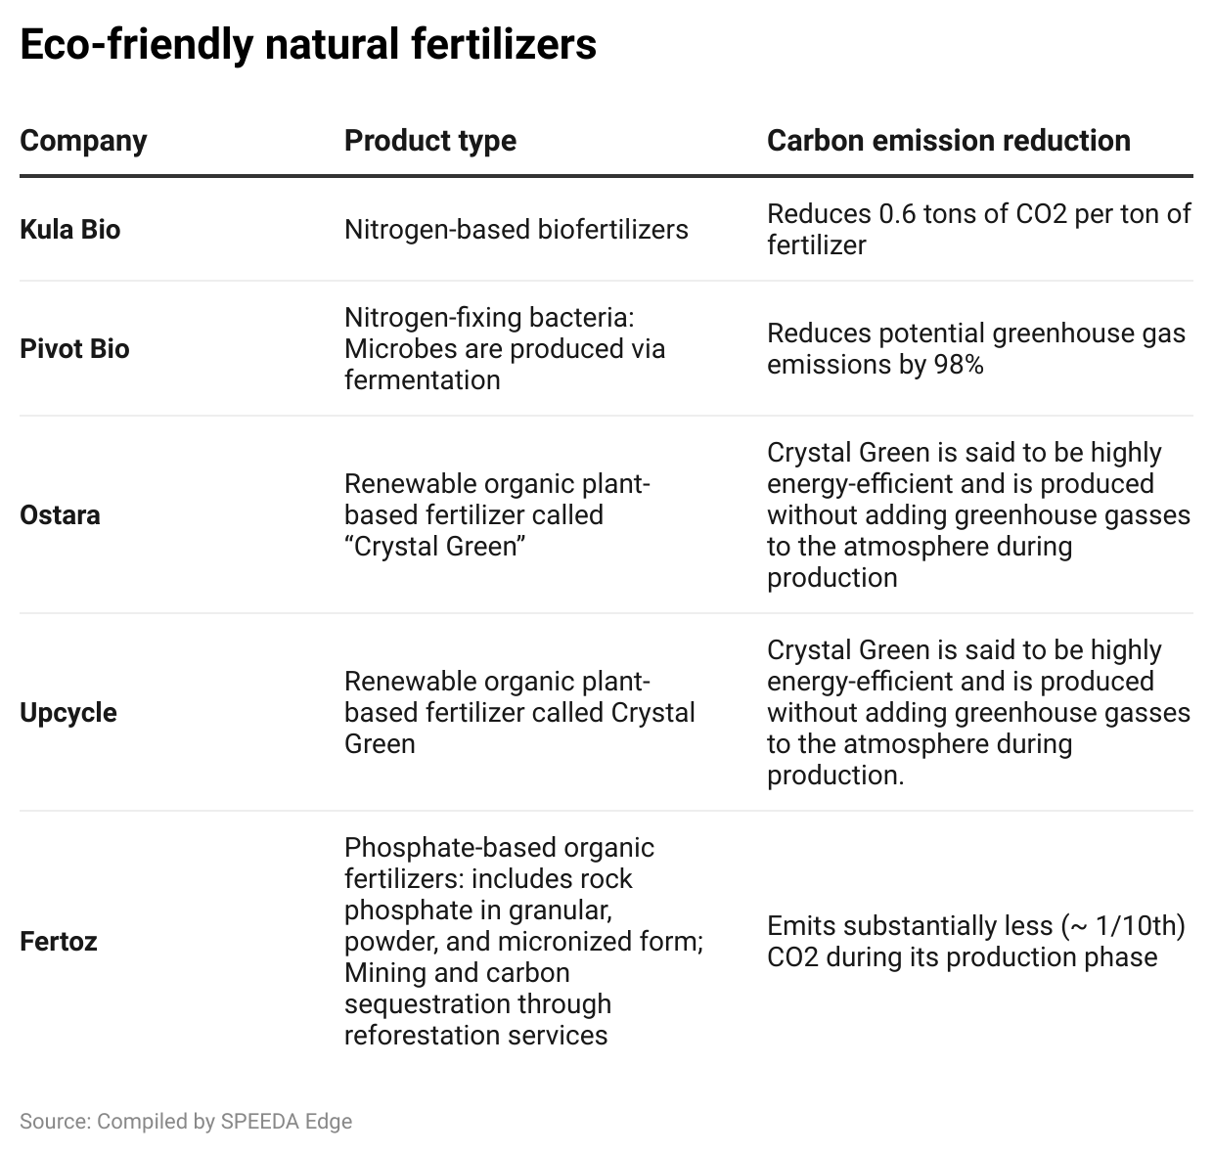

**Risks to growth**

#### **1. Low nutrient concentration and long time needed for natural fertilizers to act**

Inorganic fertilizers usually contain the necessary primary nutrients and can typically take effect within a day. Organic and biofertilizers, on the other hand, have a low nutrient concentration, require around two to six weeks to take effect, and are generally referred to as a “process” rather than an “event.” Given the strong growth in demand for food and the [need to double food production by 2050](https://press.un.org/en/2009/gaef3242.doc.htm), farmers have sought quicker ways to increase crop production. This is mainly why most of them still use inorganic fertilizers, which, in turn, has led to the underutilization of natural fertilizers. However, they could see heightened use as awareness of natural fertilizers’ better yields spreads among farmers.

#### **2. Low awareness among farmers**

Despite their benefits and positive field trials, natural fertilizers, especially biofertilizers, remain underutilized. A major reason is an inability to convince growers that biofertilizers are a dependable solution. Additionally, farmers are unaware of their benefits and how to use them to access these positive attributes.

#### 

#### **3. Biofertilizer has a shorter shelf life and requires special storage**

Although they have a better fertilizer profile than their synthetic and organic counterparts, biofertilizers have a relatively low shelf life and require special storage. This makes it challenging for farmers to use the product in large quantities and maintain a sufficient supply.

For instance, liquid biofertilizer can be stored for around [two years](https://www.ncbi.nlm.nih.gov/pmc/articles/PMC9813699/), while its solid form can be kept for about six months, much shorter than synthetic (remains usable for an indefinite period) and organic (liquid can be used for around five years) alternatives. Therefore, biofertilizers require special storage for long-term use (to be kept in cold and dry places) and must be used within a relatively short time to be fully effective.

*Last updated: March 2024*

©2024 Uzabase, Inc. All Rights Reserved. The information contained herein: (1) is proprietary to Uzabase Inc. and/or its content providers; (2) may not be copied or distributed; and (3) is not warranted to be accurate, complete or timely. Neither Uzabase Inc. nor its content providers are responsible for any damages or losses arising from any use of this information.