# **Vertical Farming : Overview**



## **Vertical farms enhance crop yields and improve proximity to sellers**

Vertical farming, a key subsector of the indoor farming industry, refers to growing crops in vertically stacked beds or shelves inside controlled-environment buildings or containers. The process uses artificial lights and soilless growing techniques to simulate a crop’s optimal growing environment and control the desired outcome in terms of yield, texture, size, and other characteristics.

Indoor farming, or controlled-environment agriculture (CEA), allows producers to grow pesticide-free crops year-round regardless of weather conditions and the availability of arable soil. CEA also requires fewer resources such as water, which makes it more efficient than traditional farming.

Greenhouses currently dominate the indoor farming landscape, but commercial vertical farms have become increasingly popular. These high-tech vertical farms generally have light-emitting diode (LED) lighting and various automation technologies. This allows farmers to grow crops just as effectively as greenhouses, which use sunlight, but at a larger scale, as vertical farms can generate higher yields per square foot with their stacked configuration of crops, which allows growers to capitalize on space and maximize yield.

Since vertical farms can be built in an enclosed space, they can also be situated closer to urban areas than traditional farms and greenhouses, which typically cultivate crops on horizontal planes in rural areas. This improves the freshness of crops by reducing the delivery time to vendors.

Currently, most startups in the vertical farming space cultivate low-growing crops, which can be stacked to greater heights and tend to have fast-growing cycles to maximize yield. Leafy greens, microgreens, and herbs are among the most popular foods grown on vertical farms. Because pesticides are not necessary in contained growing environments, vertical farm crops can be certified organic fairly easily.

### **Three types of soilless growing techniques**

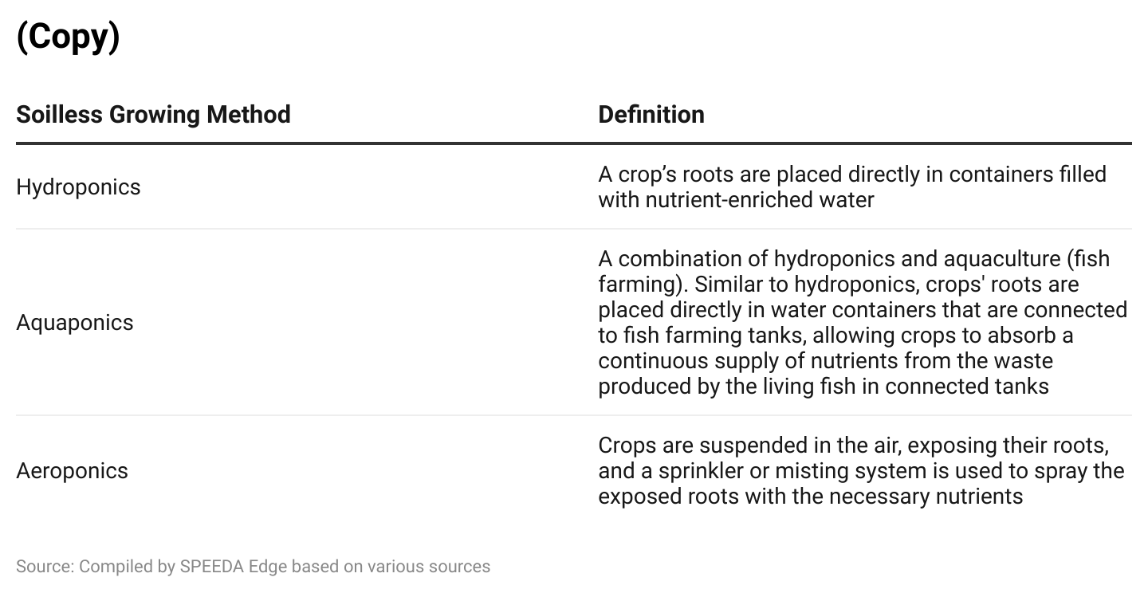

**Vertical farms mean higher crop yield and customer convenience**

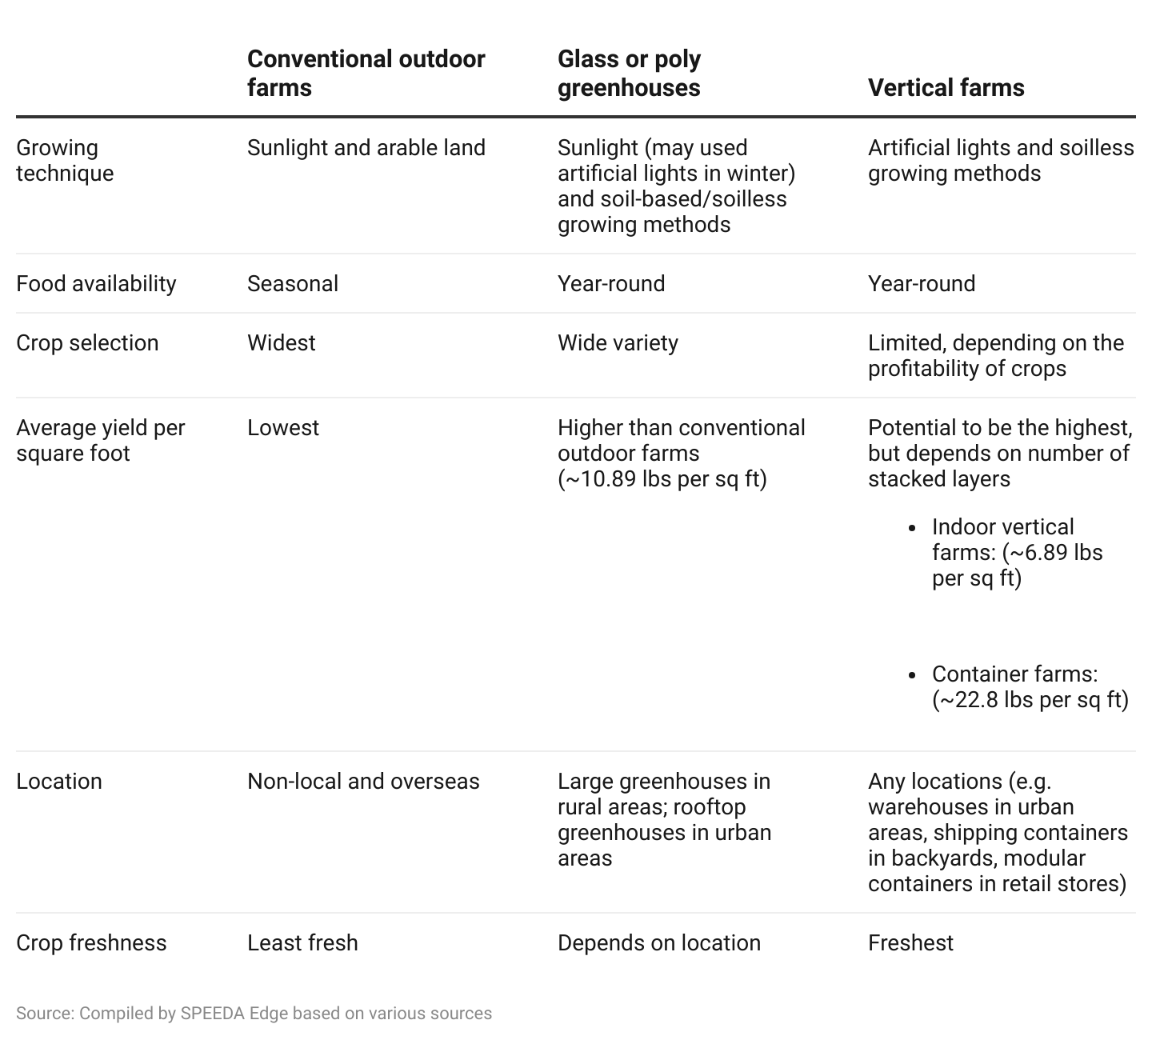

**Automation allows vertical farms to reduce labor costs and become profitable**

The first-generation technology of the climate-controlled environment system has largely shaped today’s vertical farming industry. It has allowed growers to maintain optimal conditions throughout the year with the ability to regulate the environment in buildings and containers to desired levels of light, water, temperature, humidity, airflow, and carbon dioxide.

Second-generation technologies have also played a big part, with a combination of Internet of Things (IoT) technology, big data, machine learning, and robotics to automate various parts of farm operations. For instance, IoT technology enables a network of cameras and sensors to monitor the growth of crops during their life cycles, mainly by gathering large amounts of data sets to track images, temperature, humidity, and more and by centralizing data in cloud storage for analysis.

While many commercial vertical farms have implemented the climate-controlled environment system, only well-capitalized vertical farms have pursued these second-generation technologies, which can easily cost more than USD 15 million (as of 2019) to implement. To make money, as of 2023, vertical farms have to price their products at premiums because they incur high labor costs (up to 60% of operating expenses) and energy costs (1,025% of operating expenses). In a [survey](https://www.agritecture.com/blog/2021/2/10/the-promise-and-peril-of-vertical-farming) of 150 indoor farmers (for which US players accounted for 81% of respondents) conducted in 2021, only around 27% of indoor vertical farms were profitable compared to 67% of greenhouse farms and 50% of container farms.

Many existing commercial vertical farms have now prioritized automation for farm operations to reduce labor costs. According to Artemis’ [2020 State of Indoor Farming](https://artemisag.com/wp-content/uploads/2021/06/State-of-Indoor-Farming-2020.pdf) report, 39% of indoor farmers aim to manage operations more efficiently, 20% aim to lower the cost of production, and 19% aim to improve yields.

A few of the largest startups (AeroFarms, Plenty Unlimited, and Bowery Farming) have invested heavily in automation technologies to scale up operations, reduce operational costs, and improve profitability. They also aim to move from niche to mass markets by pricing the products competitively for mainstream audiences once the cost per unit declines.

### 

### 

### 

### 

### **Benefits of automation reported by vertical farming companies**

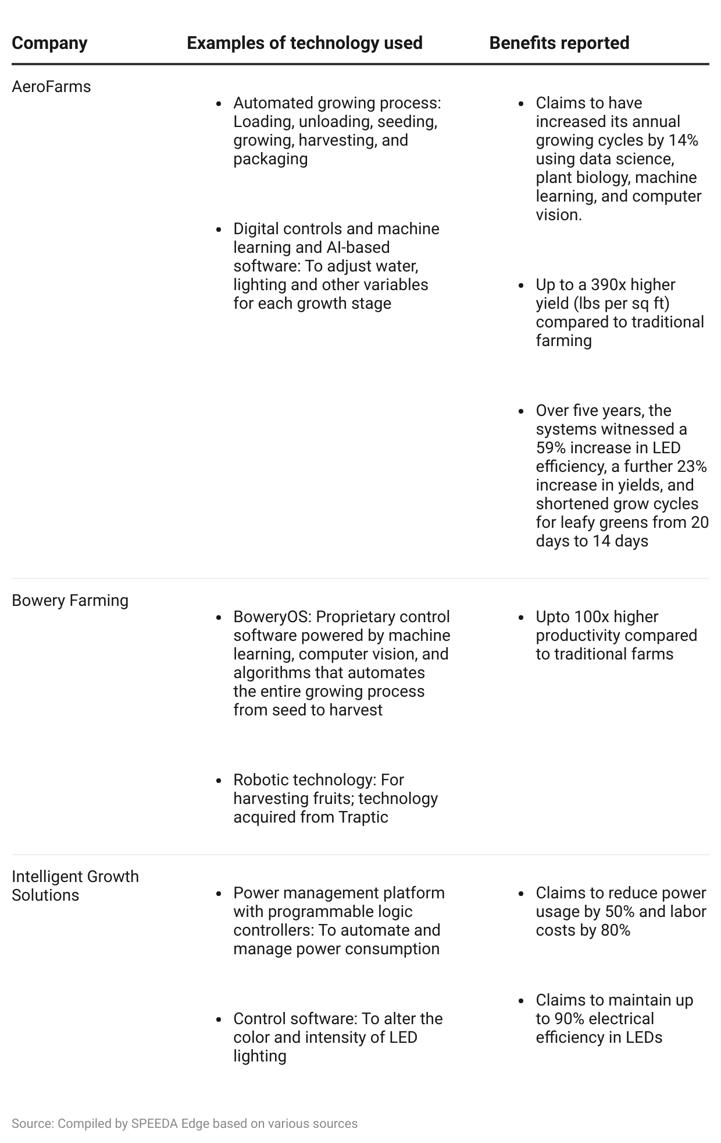

## **Reduced manufacturing costs of LED technology**

Alongside the rapid advancement of automation technologies, another biggest factor driving the growth in the number of vertical farms is the declining cost of LED systems. In the past, LED technology was only viable for producing highly lucrative crops (such as marijuana) due to the prohibitive cost of manufacturing. Amidst developmental trends in the industry including increased competition among LED manufacturers, increased economies of scale, and innovation LEDs have now become an affordable tool to grow a broader range of crops.

The implementation of LEDs is crucial for growing crops successfully in vertical farms because the light spectrum, intensity, and frequency can be tailored according to the needs of a specific crop, allowing farmers to optimize the taste and quality of crops. LED prices have dropped significantly (about 80% from 2011 to 2018), are much more efficient (LED lights use up to 80% less electricity compared to compact fluorescent lamps [CFL])), and have a longer shelf life (almost double that of regular lighting systems, functioning for around six years). LEDs also release less heat and can be positioned closer to crops without the risk of burning or drying.

# **Driving factors**

## **1. Larger urban populations are demanding organic, locally grown foods**

The growing urban population in the US, which represents ~83% of the population in 2022 (compared to ~75% in 1990) has led to a greater demand for locally grown foods and organic produce, along with an increasing awareness of food traceability. The US population is expected to increase by ~7% to reach 360 million in 2050 from 334 million in 2022, with ~89% living in urban areas.

#### **Share of urban population in the US continues to rise**

In line with this growth, the sales of organic produce has also grown. Sales of organic produce grew at a CAGR of 8.23% during 2012–20221. A study by the Organic Trade also shows that organic foods have maintained popularity in the US despite premium pricing due to perceived health and wellness benefits of organic products, brand loyalty, and environmental benefits. Organic goods are available in 75% of US grocery retail stores as of January 2023. Accordingly, the vertical farming industry is set to benefit given that vertical farms are capable of producing organic products with nutritional value and a minimal impact on the environment and climate.

### **Organic food sales growth in the US**

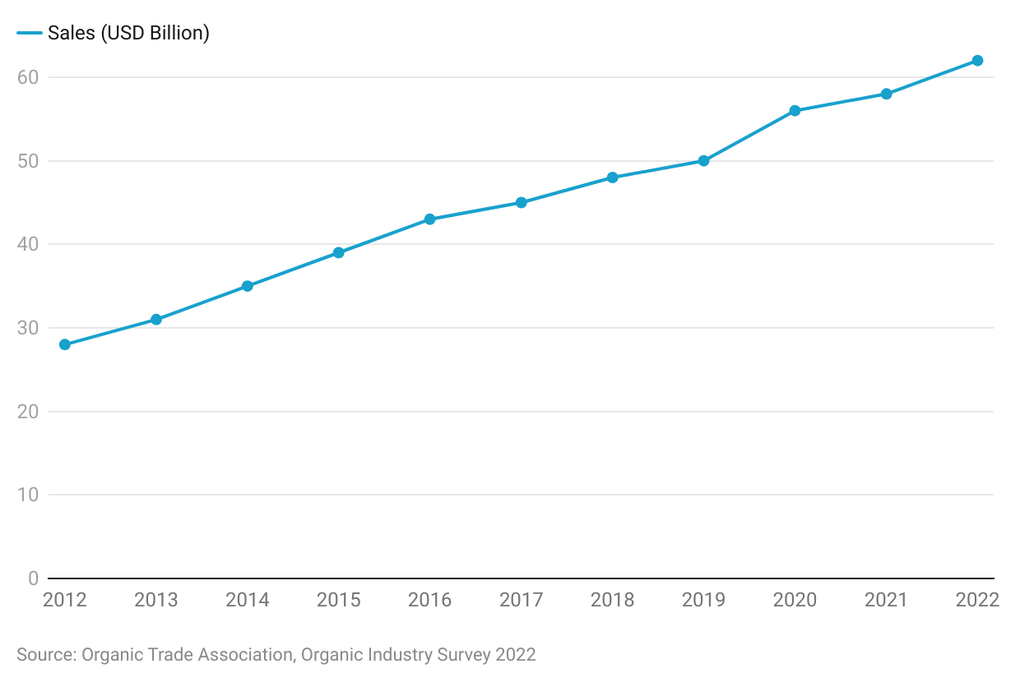

Moreover, most fruits and vegetables in the US are currently shipped from California and Arizona or imported from overseas; the US currently imports 40% of its fresh vegetables, which may take up to two weeks to arrive at a retail destination. Thus, as the population grows vertical farms have become a viable solution to the fresh food and food traceability movement as they are located closer to the end consumer such as warehouses in urban areas, modular containers in retail stores, and shipping containers in parking lots.

## **2. Limited arable land and climate change drive long-term global demand for vertical farms**

Amidst climate change and extreme weather conditions, rising temperatures can lead to droughts, deterioration in soil fertility, reduction of crop nutrients and shrink arable land, leading to greater threats of food insecurity. As the population grows, the decline in arable land adds to the food security threat. Vertical farming provides a potentially secure alternative to traditional farming.

Arable land in the US has declined from 180.6 million hectares in 1961 to 157.7 million hectares in 2021. Arable land per capita in the US has also steadily declined since 1961 from 0.98 hectares per person to 0.48 hectares per person in 2021. In order to feed the global population by 2050, a [study](https://phys.org/news/2018-10-fruits-vegetables-grown-planet-reveals.html) by the University of Guelph shows that the world will need another 12 million hectares (ha) of arable land and around 1 billion ha of pasture soil. The study also shows that switching production from grains and other crops to fruits and vegetables to meet the growing demand of a health-conscious population will reduce the use of arable soils by 50 million ha, which means people would have to consume less grains and other crops.

Although vertical farms alone cannot overcome the anticipated shortage in the supply of future nutrients, they stand to significantly ease some of the pressure given their high yield capacity and smaller land requirements. As industry technology evolves, vertical farms will be able to grow a wider range of crops.

### **Arable land in the US from 1961 to 2021**

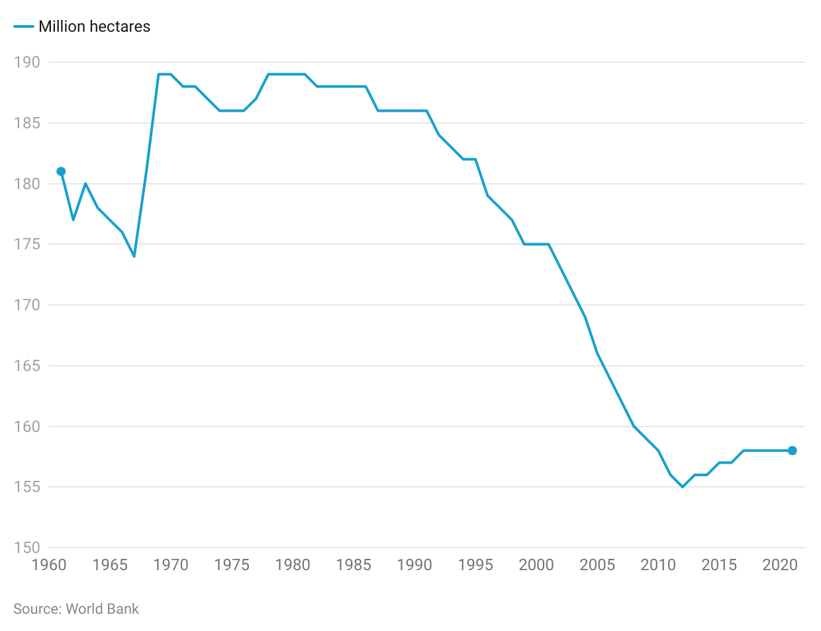

**Risks to growth**

**1. Mass production is highly dependent on extensive automation**

A major risk for vertical farms is that the current proprietary technologies are not sufficient for mass production. Currently, none of the vertical farms are able to price their products [competitively](https://www.mdpi.com/2311-7524/8/4/322#:~:text=Crops%20from%20vertical%20farms%20usually,compared%20to%20conventionally%20grown%20crops.) in the mass market. This indicates that many startups are still trying to find the best way to improve operational efficiency and scale.

Improving proprietary technologies and/or automating entire farm operations may also take time, as it is very complex and requires a lot of resources, such as large capital expenditures and combined efforts from engineers, biologists, plant pathologists, machine learning experts, data scientists, dietitians, and others—along with patient investors to supply the necessary capital.

## **2. High capital expenditure and operating costs**

Starting a vertical farming company can be costly given the high capital expenditure and operating cost involved when compared to greenhouse or convention farms. It is estimated that average building costs for a large-scale vertical farm range between USD 10,000 to USD 100,000 per acre, which is around 2x higher than similarly sized greenhouse farms.

According to a study conducted in 2019, the cost of growing a pound of greens in a vertical farm (69,000 sq ft, 2 million pounds of greens per year) and a greenhouse (200,000 sq ft, 2 million pounds of greens per year) is almost 4.7x and 3.6x the cost of growing in a conventional farm, respectively. With most startups in the space backed by funding, access to sufficient funding and working capital is needed to successfully open and operate a vertical farm.

### **Vertical Farms have the highest capital and operating costs**

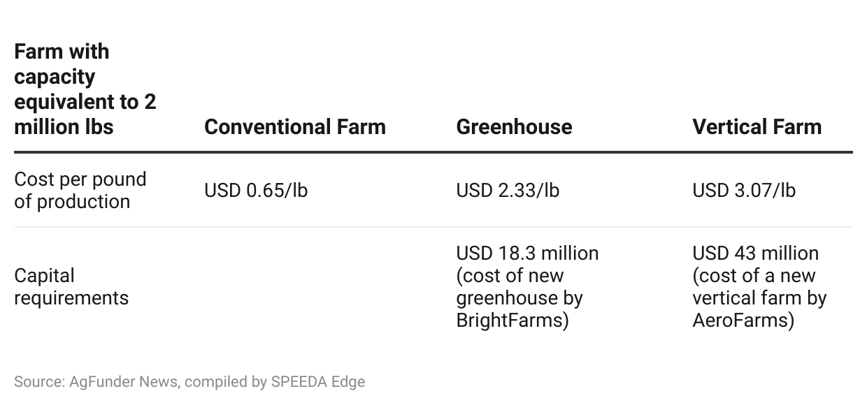

## **3. High cost of producing staple crops indoors**

The vertical arrangement of farms is not a hindrance to cultivating a wide range of crops. However, almost all players currently grow the same high-yield crops (leafy greens, herbs, strawberries, etc.) because producing other vegetables and fruits may not be as profitable. Due to high energy and production costs, certain staple crops like wheat are [too expensive](https://planet.outlookindia.com/news/wheat-may-be-grown-indoors-but-the-cost--news-414527) for large-scale indoor production. Economies of scale are essential for such crops, making premium pricing for vertically grown indoor wheat impractical.

Even if vertical farms decide to grow less profitable and slower-growing crops, it will take time for botanists to study the needs of particular crops in different life cycles before commercializing them.

## **4. Sustainability risks due to slower renewable energy adoption**

Although the farms themselves do not directly produce large amounts of greenhouse gases that cause global warming, vertical farms emit a lot of greenhouse gases through their high use of electricity. According to a [study](https://www.greenforges.com/blog/how-different-types-of-agriculture-impact-co2-emissions) conducted by Dutch vertical farming operator [OneFarm](https://sp-edge.com/companies/532111), conventional vertical farms that use non-renewable energy emit up to 5,744 kg of CO2 per ton of harvested lettuce, compared to 575kg of CO2 for conventional greenhouses, and up to 540 kg of CO2 for open-field agriculture. The study also showed that “green vertical farms” (those that use renewable energy and recycle waste energy) can reduce emissions by 70% to 160kg of CO2 per ton of harvested lettuce. Without the use of renewable energy, vertical farms may not be sustainable in the long run.

*Last updated on: December 2023*

©2024 Uzabase, Inc. All Rights Reserved. The information contained herein: (1) is proprietary to Uzabase Inc. and/or its content providers; (2) may not be copied or distributed; and (3) is not warranted to be accurate, complete or timely. Neither Uzabase Inc. nor its content providers are responsible for any damages or losses arising from any use of this information.