# **Hospital Interoperability: Overview**



## **What are EHR systems?**

Before diving into hospital interoperability, we need to understand what Electronic Health Record (EHR) systems are and examine why they need to be interoperable. An EHR system is a digital database that can store patients' health records, replacing traditional paper filing systems. In addition to managing medical and treatment history, EHR systems can collect and provide information on demographics, other clinical data (lab results, diagnoses, and medications), administrative data (medical claims and insurance), and behavioral data. In short, EHR systems offer a simple and secure way to share patient information with authorized healthcare providers and organizations.

**Clinical workflow within an EHR system**

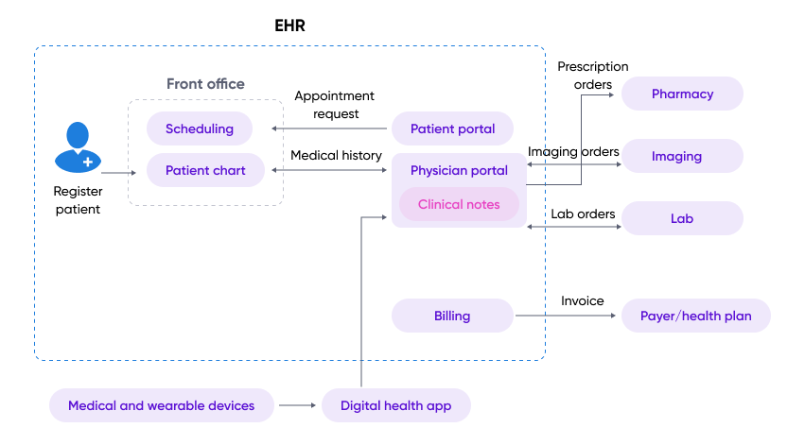

Source: Created by SPEEDA Edge based on Altexsoft and several other sources

Most US hospitals (96% in 2021 compared to 12% in 2009) and physicians’ offices (72% in 2021 compared to 22% in 2009) currently have an EHR system. Despite this high adoption of EHRs, health systems currently face the following challenges:

* Clinical and non-clinical data are currently divided into silos with varying data standards, similar to the divisions in paper records, resulting in fragmented data and missed opportunities for preventative care and improved patient health outcomes.
* Outdated legacy health IT systems are incompatible with modern technology, delaying digital transformation efforts.
* Healthcare providers have reportedly restricted patient access to their EHRs, and EHR vendors have been accused of charging healthcare providers additional fees to access or export electronic health information. Interfering with the access to, exchange of, or use of patient information is known as information blocking.
* Using point-to-point integrations to connect different systems is costly to maintain and does not scale across an organization. In the US, most hospitals use at least 10 different systems to obtain a complete database of patient information, which can also result in higher healthcare costs instead of cost savings.

Due to these challenges, nearly 70% of all medical information exchanges were conducted through fax machines as recently as 2017 when EHR adoption was already 96% among hospitals.

## **What is hospital interoperability?**

Hospital interoperability refers to the ability of hospitals, healthcare providers, and other organizations to seamlessly connect, exchange, and interpret shared data via computerized systems and software applications across organizations, regions, and countries. Even though many health systems share data, the context is often missing, resulting in insufficient actionable information. Data can be preserved in its original context through interoperable systems, allowing end users to interpret and understand the data. The goal of interoperability is to break down data silos and remove barriers to facilitate the exchange of health information in real-time while protecting individual privacy. In addition to ensuring accurate patient data, it could help streamline clinical workflows, improve care coordination, and identify potential gaps in care, leading to better health outcomes.

Interoperability consists of four layers, each of which transmits data at increasingly sophisticated levels. In a survey conducted by the Healthcare Information and Management Systems Society (HIMSS) in 2019, ~75% of respondents said they have progressed in foundational interoperability.

**Layers of interoperability**

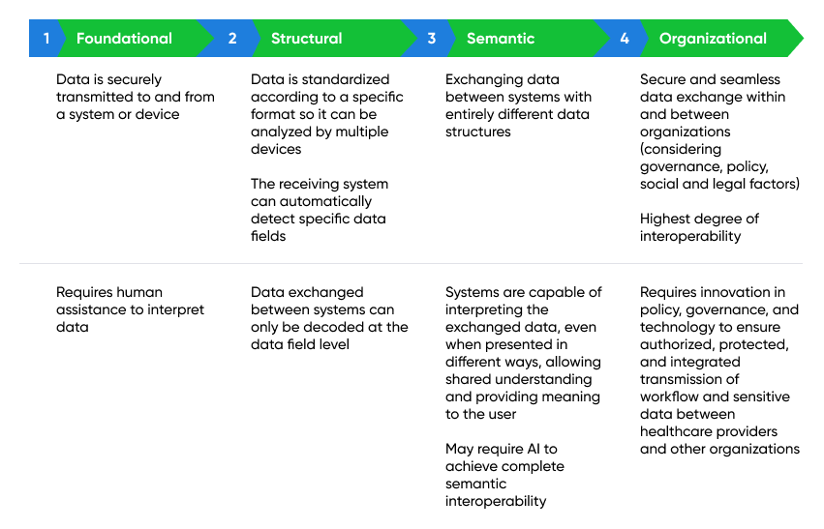

Source: Complied by SPEEDA Edge based on multiple sources

## 

## 

## **Why is interoperability gaining traction?**

* **Value-based care (VBC) gathers momentum:** Access to large amounts of patient information and efficient data exchange are crucial factors in supporting the transition from a traditional fee-for-service (FFS) model to VBC. VBC incentivizes healthcare providers to deliver high-quality, cost-effective care by linking reimbursements to patient outcomes and the quality of care delivery. The shift toward VBC is gaining momentum, as nearly 41% of US hospital reimbursements were tied to VBC in 2019, compared to only 23% of healthcare payments in 2014. As more healthcare providers adopt a VBC model, demand for interoperability solutions will also increase, bolstered by the Centers for Medicare & Medicaid Services' expectations that all Medicare payments (representing ~20% of all hospital reimbursement revenue in 2020) will come from VBC models by 2030.
* **Curbing wasteful healthcare spending:** Excessive spending in the US healthcare system is estimated at USD 760 billion–935 billion (accounting for 25% of total healthcare spending) annually. Interoperability solutions help providers gain a more comprehensive understanding of their patient's health and medical history, which could reduce needless spending in care delivery (~13%–17% of total excessive costs) and over-treatment or low-value care (10%–11% of costs). Interoperability also facilitates efficient care coordination (4%–8% of costs) by ensuring timely data sharing and reducing manual administrative processes (~35% of costs) that are time-consuming and costly.
* **Scaling at-home services as the US aging population grows:** The growing aging population in the US (21% of the US population is expected to reach retirement age by 2030) and interest in at-home care by seniors as they age will move care delivery away from hospitals to patients homes in the long term. According to McKinsey, up to USD 265 billion worth of care services for Medicare beneficiaries could be delivered at home by 2025 without compromising the quality of care. Therefore, interoperability will be vital to scaling the use of new technologies that allow hospitals to treat acutely ill patients in their homes, unlocking its long-term value. Furthermore, pilot “hospital-at-home” programs successfully reduced complications (only 7% of home hospital patients were readmitted after 30 days, compared to 23% for inpatients) and reduced costs by ~30%.
* **Proliferation of digital technologies:** The use of digital health apps and connected devices, including the Internet of Medical Things, has become more widespread due to the demand for personalized care, remote patient monitoring, and the self-management of health. Digital health is here to stay, as evidenced by a record-breaking USD 29 billion raised by US digital health companies in 2021 (nearly doubling from USD 14.9 billion in 2020). Since these systems generate large volumes of siloed health data that need to be shared to be effective, they are the driving force behind improving interoperability. With this data tethered to EHR systems, healthcare providers could receive real-time continuous patient information and deliver timely and informed treatment interventions.

## **Regulation and data standards play a key role in the interoperability journey**

Data exchange has been a goal of the Office of the National Coordinator (ONC) since 2004, but challenges arose when it came to sharing this electronic data with other healthcare providers and systems. Although true interoperability is still far off in the healthcare industry, the US government has introduced legislation, rules, and incentives designed to promote interoperability and kick-start adoption. The Health Information Technology for Economic and Clinical Health (HITECH) Act of 2009 was a key juncture in moving toward interoperability. The slow uptake, however, led Congress to enforce the 21st Century Cures Act in 2016, prohibiting information blocking and standardizing EHR and software data exchange.

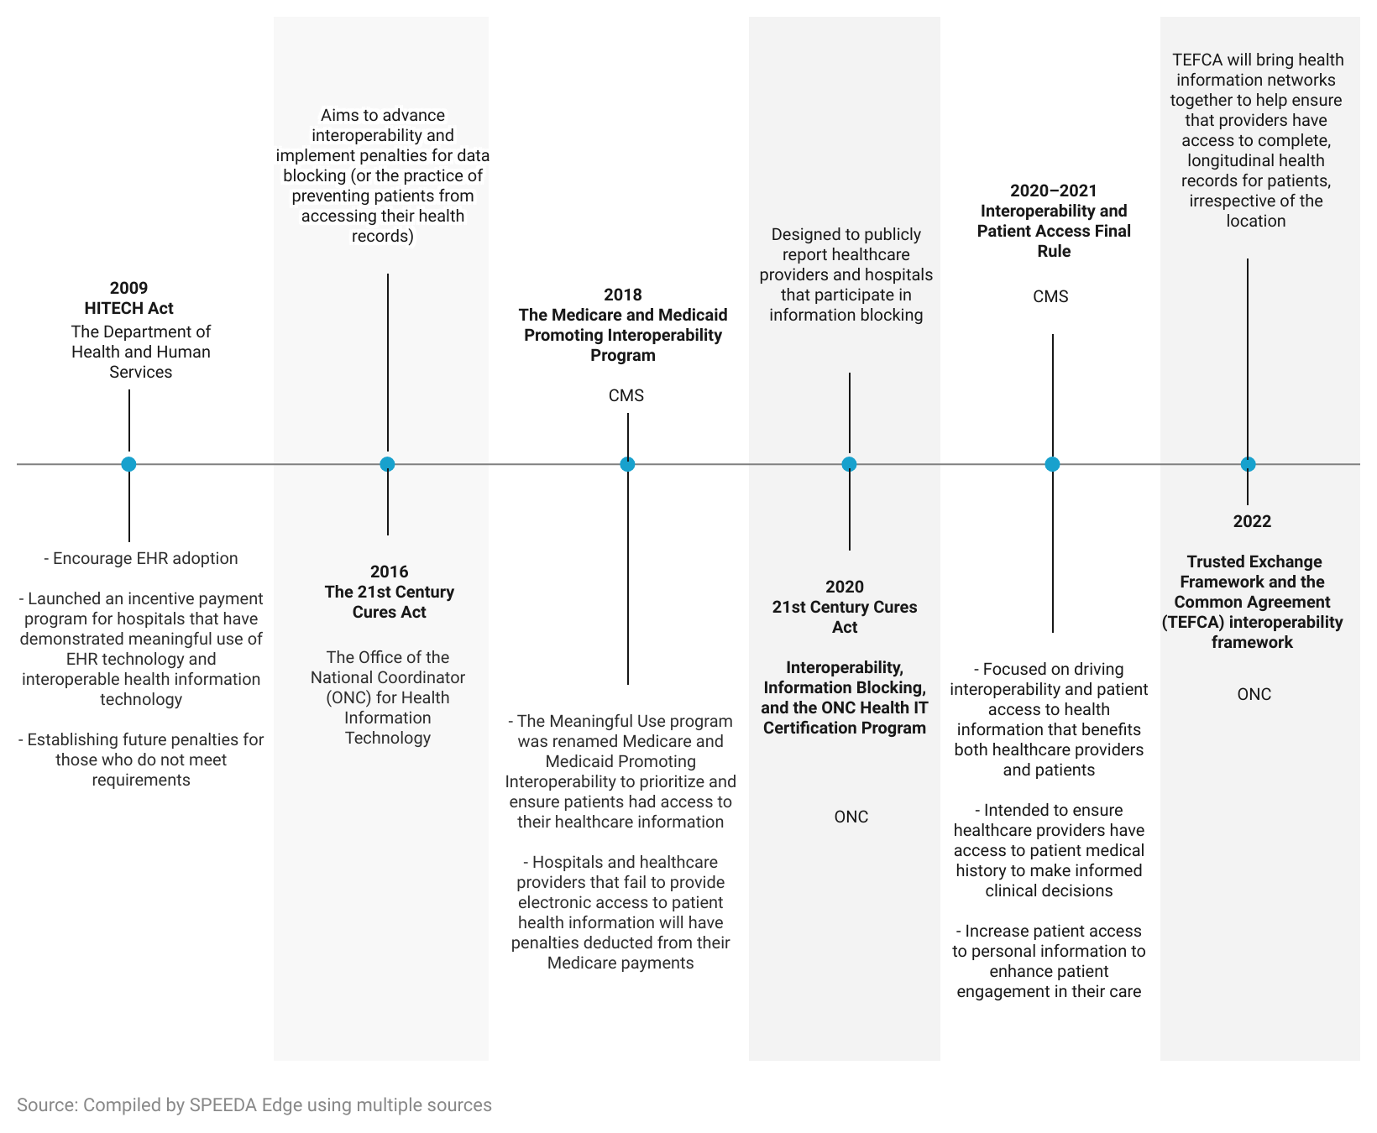

**Timeline of the regulations and rules that have aimed at promoting interoperability**

The adoption and use of health data standards have also enabled interoperability between EHR systems and healthcare providers. Data standards are a set of rules that allow the sharing of information in a uniform and consistent manner. Popular data standards such as FHIR (Fast Healthcare Interoperability Resources) and HL7 (Health Level Seven International) allow one or more systems to transmit data and communicate with each other using common vocabulary (semantic standards) and grammar (syntactic standards). A supplement to the existing FHIR standard is the Substitutable Medical Applications and Reusable Technologies (SMART) platform. It allows HealthTech companies to streamline their app development efforts without having to build custom connections to each EHR database, offering an open-source and standards-based system.

## 

## **What types of solutions are currently used to improve interoperability between EHR systems?**

* Certified EHR systems with structured data offer healthcare providers a secure **email-based solution** to exchange messages and patient information. (e.g., [Surescripts](https://sp-edge.com/companies/249337), [Health Catalys](https://sp-edge.com/companies/97179)t, and [Kno2)](https://sp-edge.com/companies/166179)
* **Health Information Exchanges** (HIEs) gather patient information across multiple hospitals and EHR systems, allowing providers to request and share patient-related health data. These non-profit organizations provide access at a regional, state, or national level. (e.g., [Hawaii Health Information Exchange](https://sp-edge.com/companies/1345707) and [Indiana Health Information Exchange](https://sp-edge.com/companies/69131))
* **Automated algorithms** in an EHR system compare demographic data from various sources to ensure the data is related to the same person. Inconsistencies in formats can therefore hinder the accuracy of matches. (e.g., [Healthjump](https://sp-edge.com/companies/174804) and [Lyniate](https://sp-edge.com/companies/1182858))
* ​​**Natural language processing** converts unstructured text into structured text, making it more accessible and usable. (e.g., [HITEKS](https://sp-edge.com/companies/455978))

According to research from HIMSS Media in 2019, hospitals and other healthcare facilities believed registering with an HIE was the best strategy to support interoperability, followed by using natural language processing and shifting to a single EHR vendor.

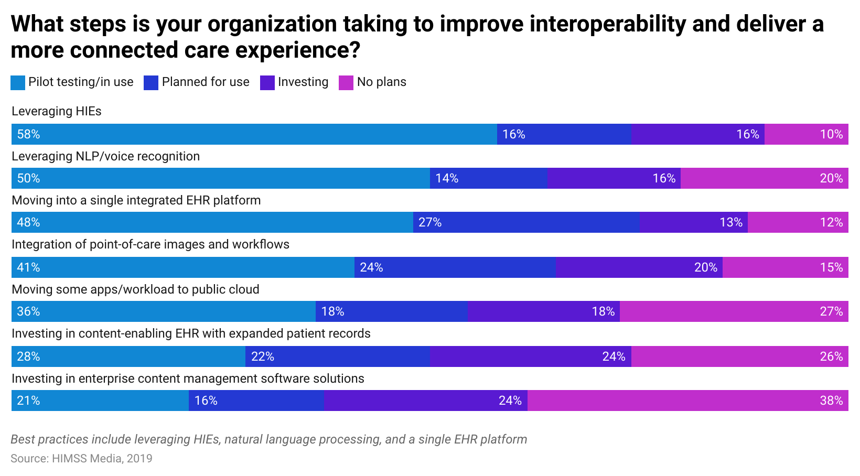

## **Interoperability solutions use case map**

In most cases, incumbent EHR vendors support data exchange or record sharing between their customers. Several startups, such as [Moxe Health](https://sp-edge.com/companies/99823) and [Particle Health](https://sp-edge.com/companies/651389), have also entered the segment by offering solutions that help locate patients across EHR systems. These solutions enable them to import records, automate the release of information, and reconcile patient profiles.

Data integration is a competitive area for EHR vendors and startups. While EHR vendors offer their marketplaces for third-party applications, disruptors focus on specific EHR integrations. For example, [Redox](https://sp-edge.com/companies/181705) primarily provides integrations for medical device data.

There are also startups such as [Commure](https://sp-edge.com/companies/663000), [Health Gorilla,](https://sp-edge.com/companies/113856) and [Innovaccer](https://sp-edge.com/companies/161290) that combine EHR data with other information to create data intelligence platforms.

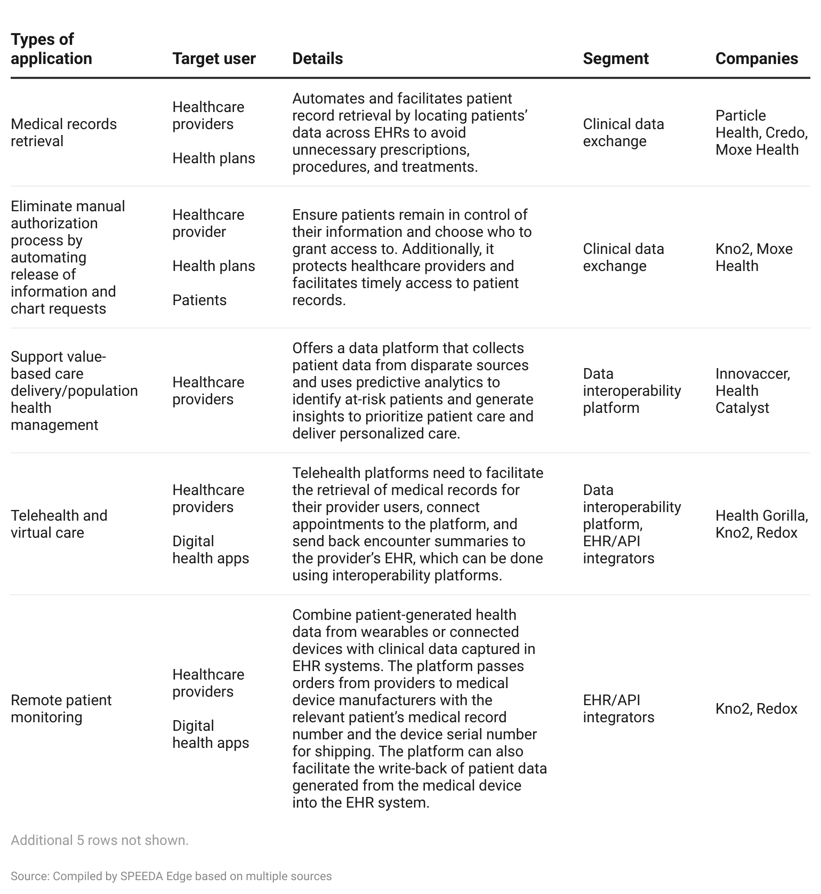

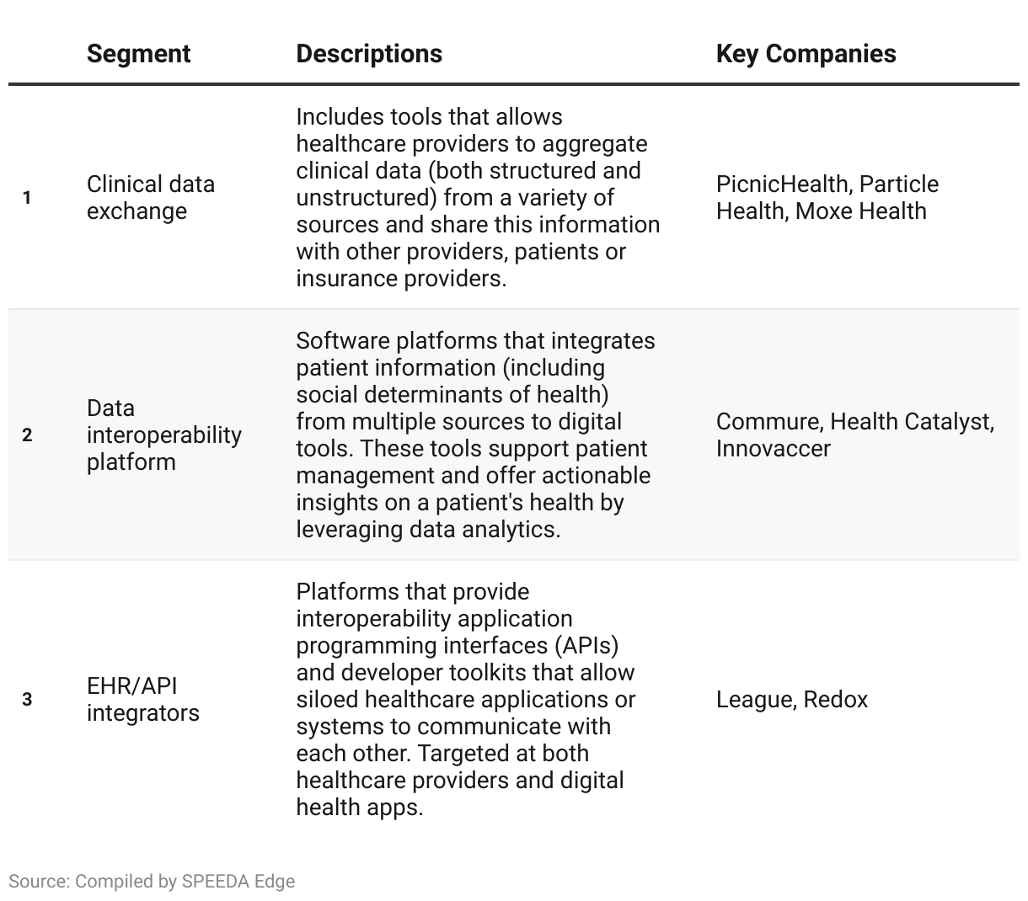

## **Key segments for Hospital Interoperability landscape**

**However, we exclude the following areas when selecting companies for this industry:**

1. Interoperability solutions that support other stakeholders outside a hospital setting such as tools for health plan services (insurance underwriting or health plan member management) and life science companies (drug development and clinical trial management); excluded because the focus is on interoperability tools for hospitals, health systems, and healthcare providers.

2. While interoperability is important to clinical decision support tools, they are out of scope because the main focus is to assist providers in clinical decisions.

## **Why is interoperability so difficult?**

* **Several EHR systems with varying data standards:** Currently, the EHR space is highly fragmented, with approximately 16 distinct EHR platforms used in 2018. Additionally, most hospitals had at least 10 EHR platforms running on an average workday, and the use of specialty EHRs for specific therapeutic areas could increase this number to ~18 EHR systems. Different data formats, clinical terminologies, and technical specifications make it challenging to create a single interoperability format for sharing data. Although the CMS has proposed several regulations and standards to overcome this challenge, the use of varying vocabularies when implementing these standards still exists. Poorly enforced standards can hamper interoperability by further complicating the process of reconciling data.
* **Migrating outdated legacy systems:** Healthcare providers with obsolete legacy systems face a challenge in modernizing their IT infrastructure while maintaining interoperability requirements because the data is often stored in formats that may not match the requirements of the new system, compromising the quality and context of the original data. Providers may also have to opt for expensive customized interfaces to support interoperability, reportedly costing between USD 5,000 and USD 50,000.
* **Security and privacy concerns over sensitive information**: Interoperability requires stakeholders to share sensitive patient data with third parties’ apps, medical device manufacturers, and APIs. The challenge of providing access to sensitive patient information without compromising privacy has remained a deterrent to interoperability. Healthcare providers and EHR vendors are not allowed to impose security assessments or restrict third-party access to patient-authorized information, which could result in significant data breaches. For example, a cyber attack on Onyx Technologies’ interoperability platform exposed 97,000 patients’ data in August 2022.

## **What’s next?**

A survey by athenahealth on physician sentiment toward interoperability indicated interoperability made a significant improvement in care delivery but remains a long way from transforming healthcare as it is today. In an ideal world, true interoperability ensures data transmission with a complete view of a patient's health records, accessible anywhere and at any time.

* **Technological advances will continue to support the adoption of interoperability solutions:** The healthcare industry is working toward interoperability by adopting API standards that allow EHRs to communicate with apps and connected devices. Over the next decade, the healthcare industry could see more standardization and technological advancements in AI-driven data mapping, machine learning, and blockchain that support smoother data transmission and greater adoption among healthcare providers.
* **Providers to invest in interoperability over the medium term:** Healthcare providers could invest heavily in interoperability in the next three to five years as they begin to recognize the importance of interoperability and the benefits of external data transmission. A survey by Deloitte indicated that more than half of surveyed executives stated interoperability would be extremely important in the future (three to five years), compared to only 34% in 2019. Disruptors will continue to invest in the expansion of their product and service portfolio, while incumbent EHR vendors may favor M&A or partnerships to introduce new features.