# **Smart Farming : Overview**



**Smart farming can resolve future food shortages**

**Smart farming refers to the application of technology to maximize efficiency throughout the agriculture value chain.** Smart farming also includes the field of precision farming. Though the technology used across both types of farming is similar, the key difference is that precision farming makes decisions with a higher degree of accuracy by analyzing the needs of individual fields and crops, while smart farming generally facilitates informed decision-making at a broader farm or field level.

### 

### 

### 

### 

### 

### 

### 

### 

### 

### **Smart vs. precision farming processes**

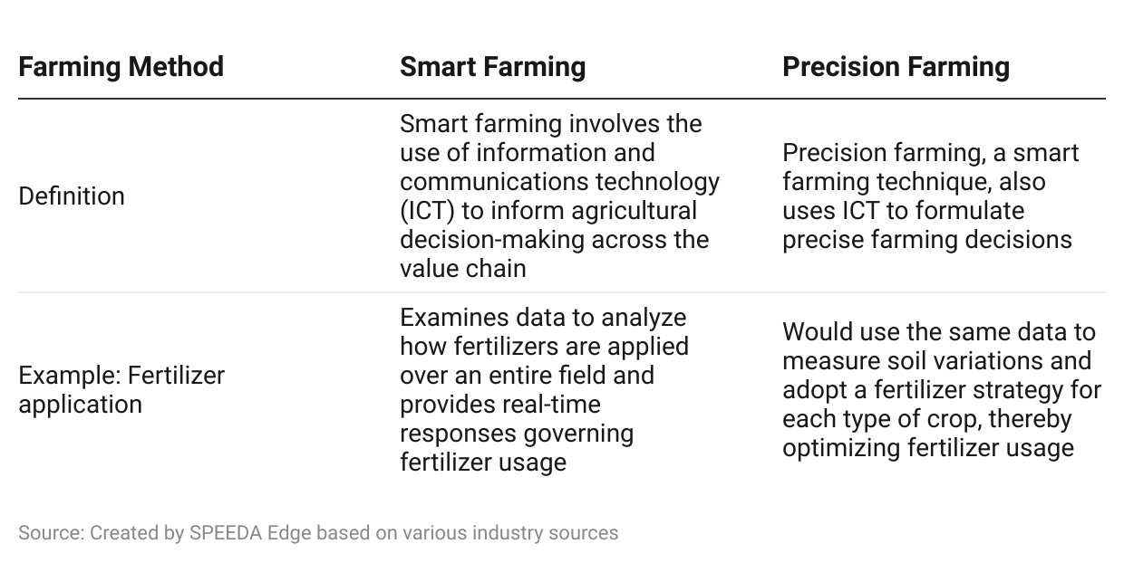

IoT and Big Data advancements have strongly supported the evolution of smart farming. Agricultural technologies have become increasingly crucial given the continuously growing demand for food, the limited availability of land for farming, and rising labor costs.

We break the industry down into several segments based on technology solutions: smart hardware, software, and drones and satellites.

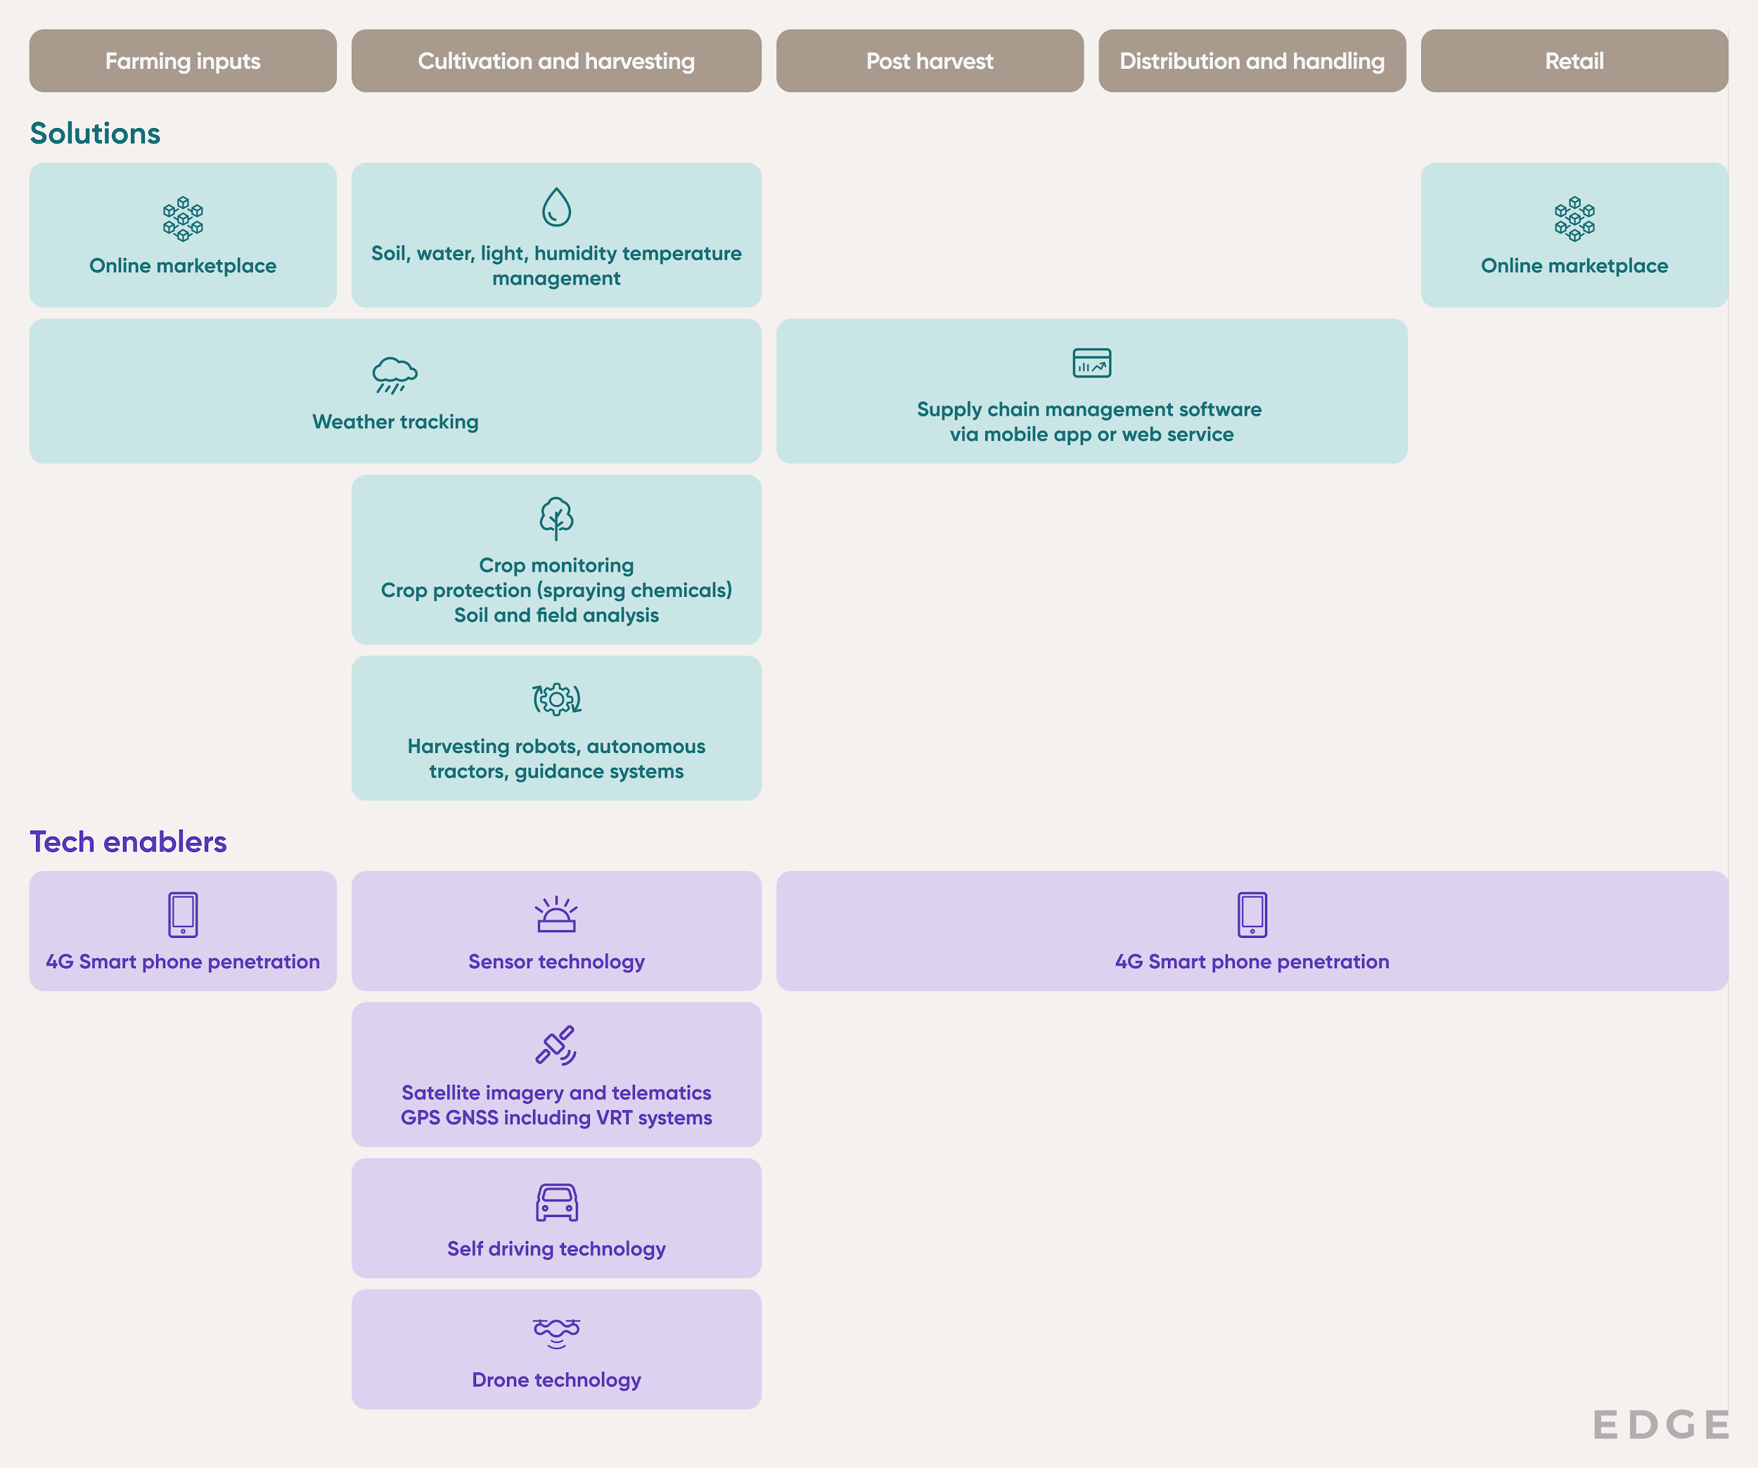

Source: SPEEDA Edge

### **Sensors, IoT, Big Data, and Cloud Platforms Enable Evolution in Smart Farming**

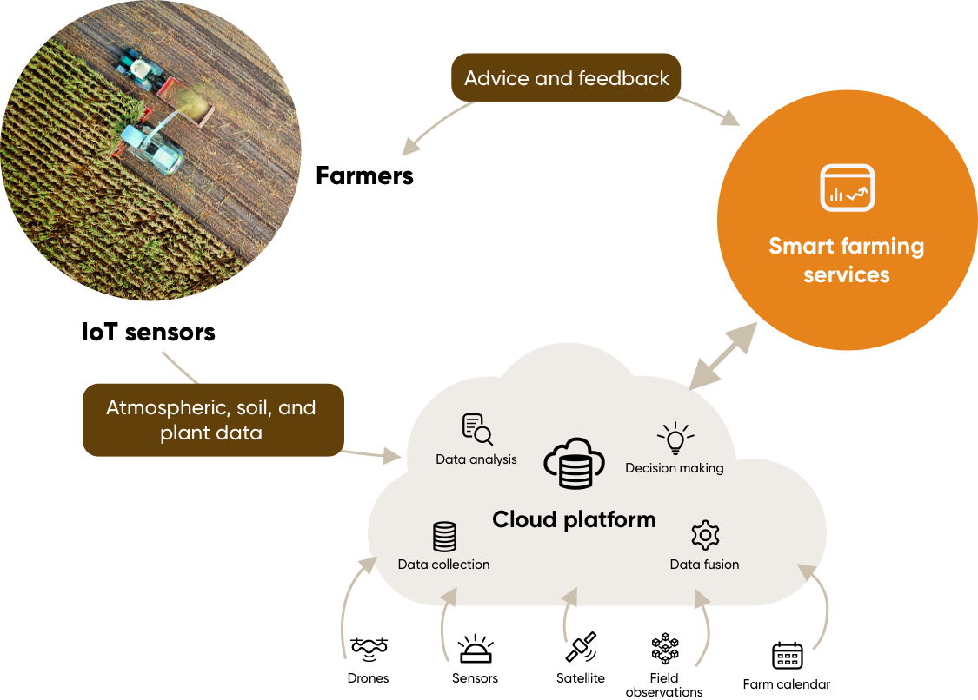

Source: MDPI

## **Driving Factors**

## **1. Need for yield enhancement amidst growing demand for food and decline in agricultural land**

The smart farming industry is primarily driven by projected increases in population and the accompanying demand for food amid a decline in agricultural land.

The US population has grown by around 8% from 2010–2022, and it is expected to swell by another 4% by 2030 and 11% by 2050 to reach USD 347 million and USD 371 million respectively. However, the area of farmland available in the country declined by 2% during 2010–2022. As a result, agricultural land available per capita has declined by nearly 10% to 2.67 acres in 2022 from 2010. This has given rise to a need to improve yield.

Corn, the largest crop in terms of total US production, delivered an average yield of around 172.8 bushels per acre (nearly 15% higher than the average corn yield of 149.9 bushels per acre recorded over 2003–2013) over 2014–2022. This improvement was due to smart farming techniques introduced by incumbents such as John Deere. Studies suggest that the potential global corn yield improvement if smart farming techniques are adopted could be 30%.

### **Available Farmland Declines**

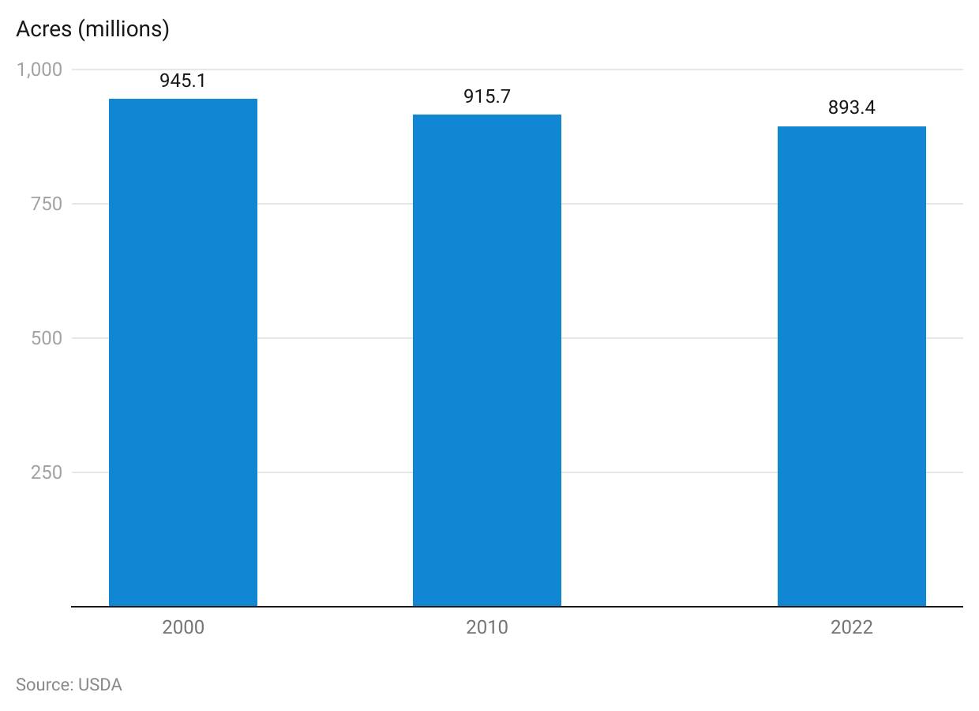

### **Corn Yield has improved in recent years**

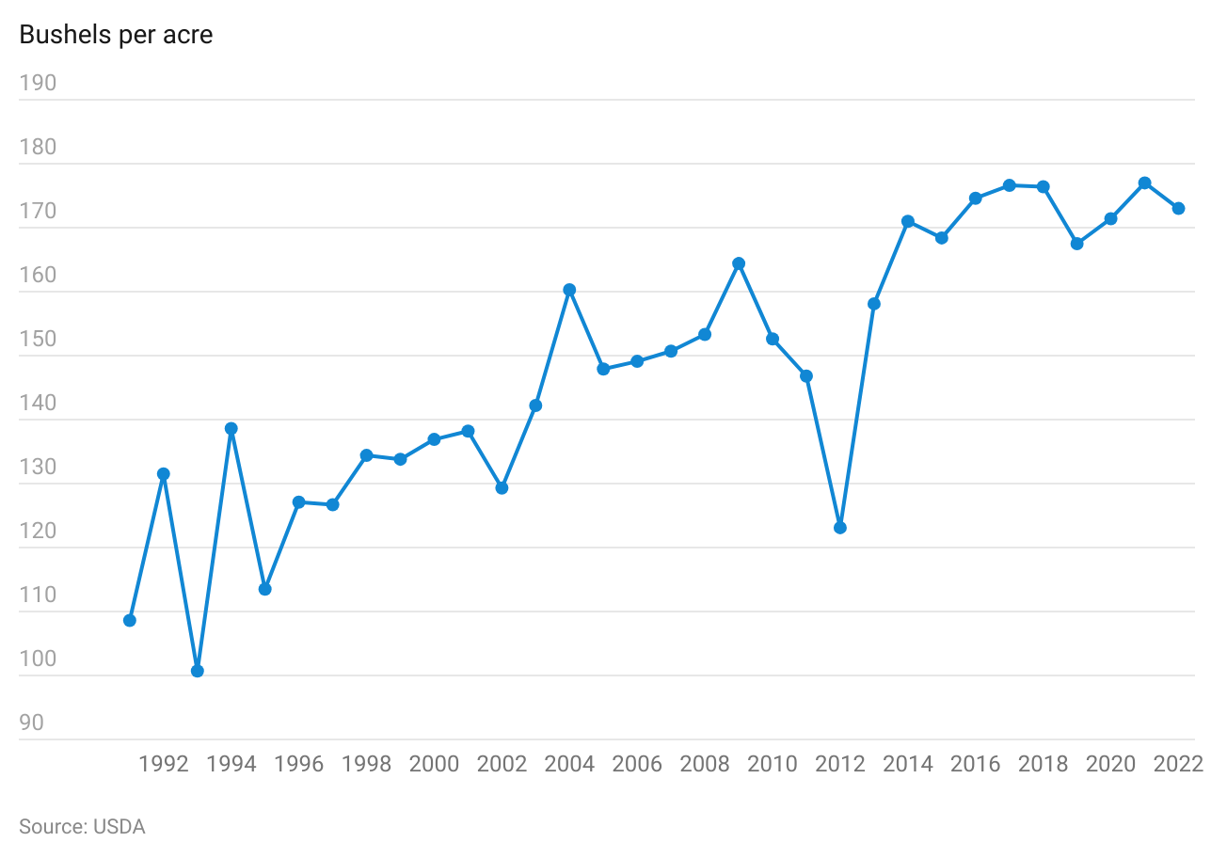

### **Effective Yield Improvement Potential Exists Across Different Types of Crops Globally**

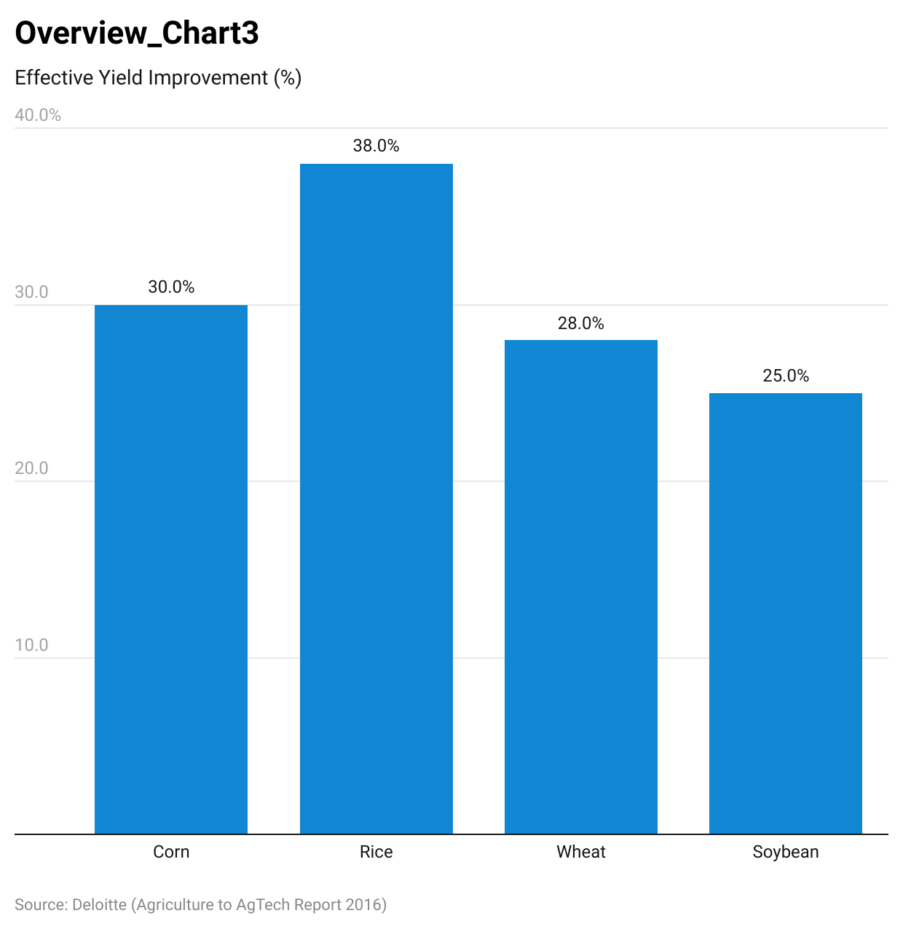

## **2. Reduce Supply Chain Inefficiencies**

Global value chain losses for the agriculture industry sit at around 33%, amounting to an estimated USD 680 billion across industrialized countries (more than twice those of developing nations). To mitigate these losses, production yields must increase by around 50%, based on several studies.

While yield improvement compensates for supply chain losses to some extent, the adoption of smart farming tech across the supply chain can improve overall supply chain efficiency, helping farmers convey the benefits from any potential yield improvement directly to their bottom line. Studies state that improving supply chain efficiency by 5%, will result in a 10% improvement in yield.

The majority of losses—22% of production, 69% of total losses in North America—occur post-harvest. Startups like Full Harvest, in an attempt to eliminate waste and losses incurred towards the latter stages of the value chain, have developed a network that connects farmers with food and beverage companies. This allows surpluses and oddly shaped produce to be sold via a negotiated deal. With this technology and business model, Full Harvest aims to turn 20 billion pounds of produce wasted each year into an earning opportunity of USD 10 billion for growers.

### **Value chain losses per processing step by region, as a percentage of initial production**

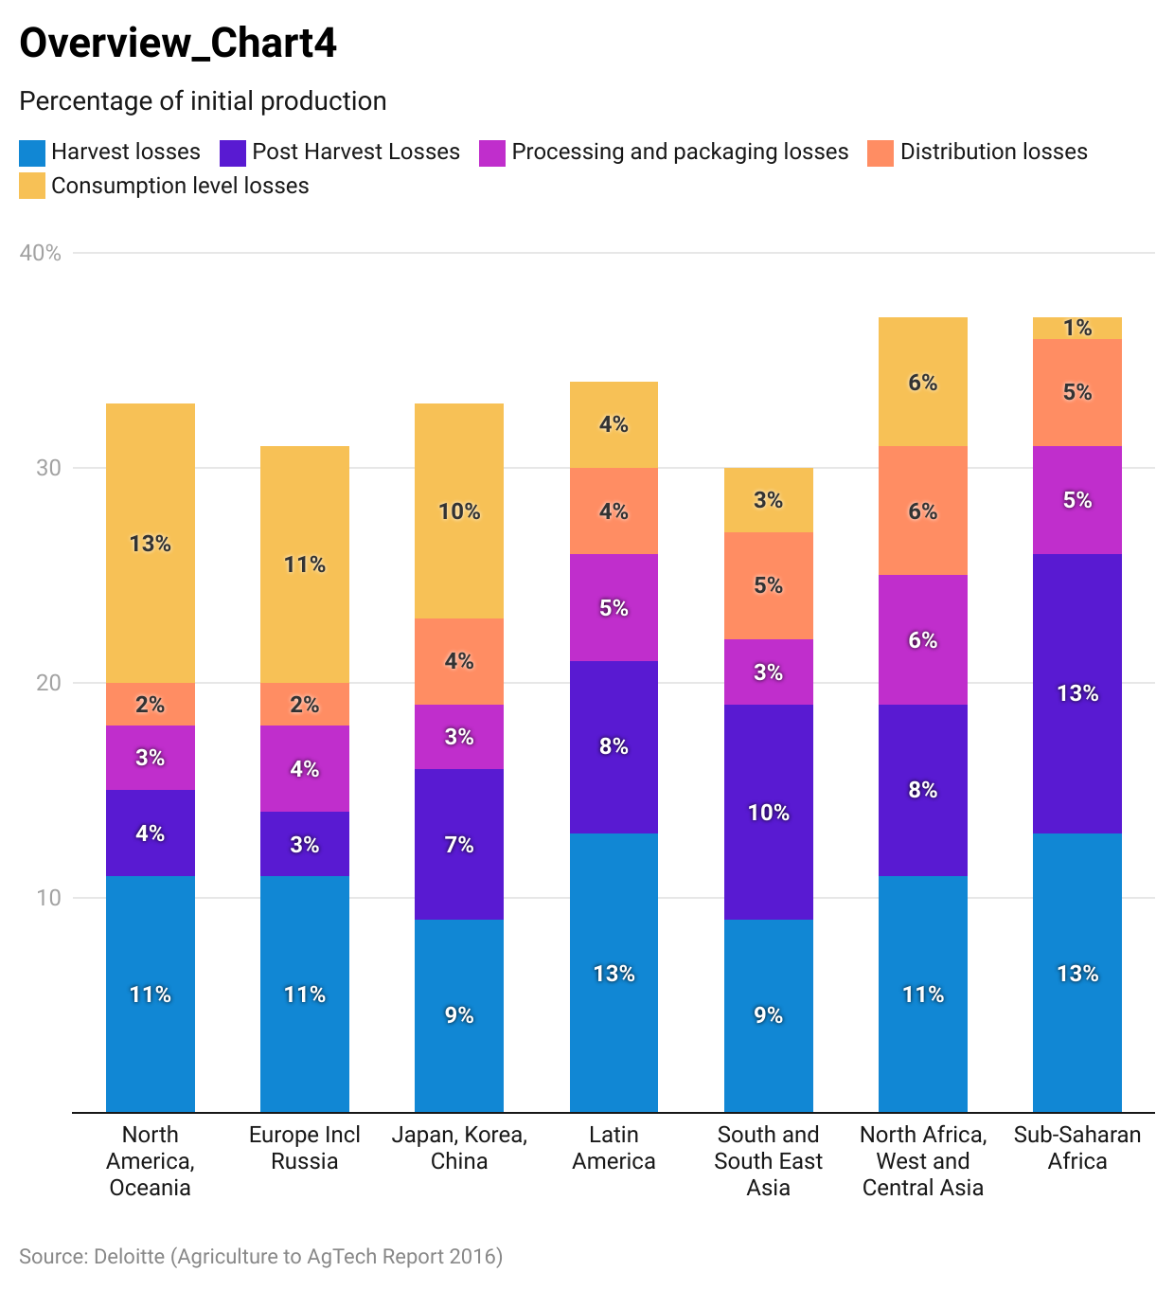

## **3. Increasing labor costs amidst declining labor supply**

Around 50% of overall farm costs go toward wages. As the US labor market tightens post-pandemic, automation-led savings are a driving force of smart farm tech adoption. The US agriculture workforce shrank by nearly 7% during 2000–2021, with the sector’s share of total workforce employment dropping to 1.7% in 2021, down from 2.3% in 2000.

From 2000 to 2021, the labor cost of non-supervisory farms grew 30.8%, while wages for non-farm workers grew at almost half this level, at 17.0%. More specifically, during 2015–2021, the labor cost of non-supervisory hired workers rose nearly 16% to USD 15.6 in 2021 from USD 13.4 in 2015 but still grew at a faster pace compared to non-farm worker wages—7.8% during the same period.

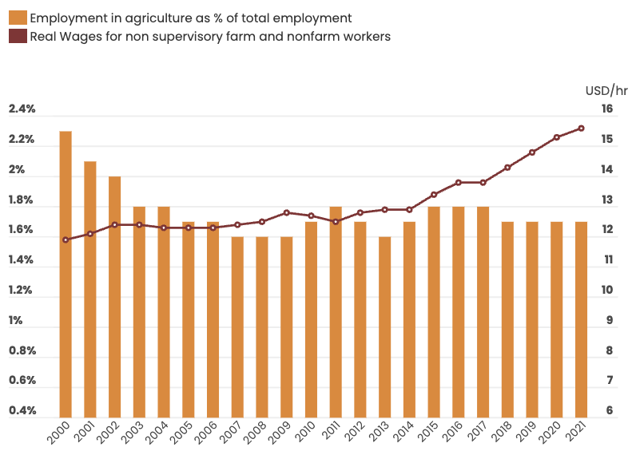

Source: USDA

As a result, mechanization can provide attractive prospects for the future of farming:

* Mechanical harvesting in California costs between USD 100 and 300 per acre for grapevines compared to a hand-harvesting cost of between USD 500 and USD 700 per acre.
* Harvest CROO Robotics’ automatic harvester is said to replace around 30 farm workers and can operate 24/7. Its potential price tag of USD 100,000 compares extremely favorably to the median pay of agricultural workers in 2021, with a break-even point of 3.37 agricultural workers per year.

## **4. Farmer’s Push to Improve Profitability**

The majority of American farmers are suffering from rising levels of debt, alongside low farm income. Although net farm income after production expenses is positive, it appears insufficient to meet growing debt levels (total debt was forecast to be 3.1x net farm income in 2022). Since 2013, more than half of existing farmers have experienced regular annual financial losses and have gone out of business. As such, small-scale farmers—who make up around 88% of the farming population and 18% of farm production in 2022—may be increasingly likely to adopt smart farming techniques.

As of 2022, around 69.3% of farm debt was real estate debt (real estate kept as collateral), which has grown nearly 79% since 2009. Farm real estate debt is projected to further increase to USD 376 billion in 2023, representing a 5% YoY increase.

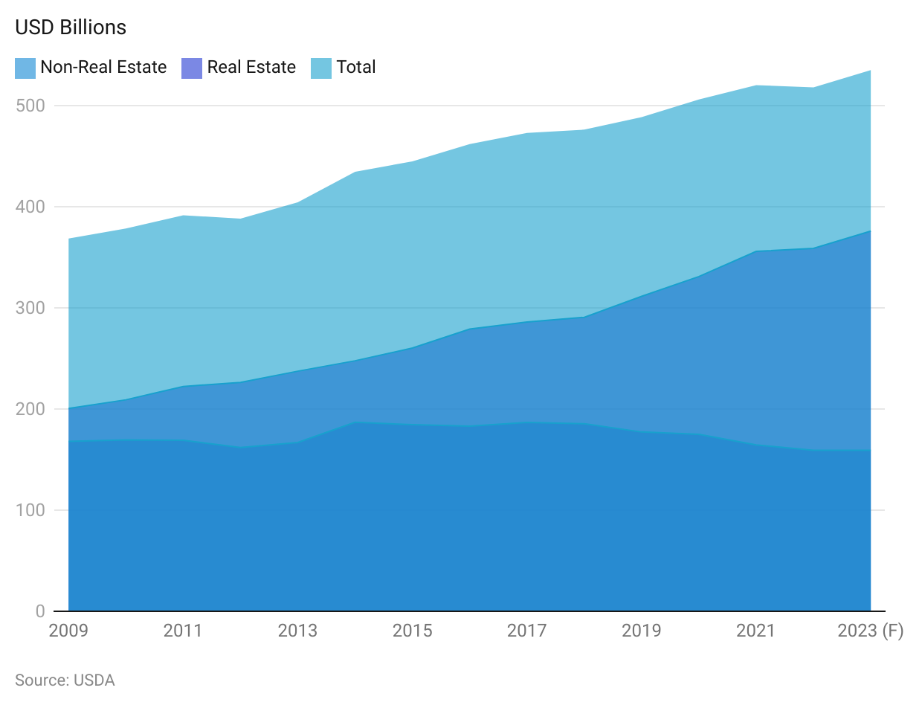

In contrast, mid- to large-sized farmers (11% of all farms in 2022)—who are capable of affording the technology—accounted for nearly 65% of overall production in 2022.

* Studies indicate that the adoption of precision farming technologies such as GPS mapping, guidance systems, and variable-rate technology (VRT) have allowed the operating profits of corn farmers to increase by 3%, 2.5%, and 1.1% respectively.
* Moreover, disruptors like Kray Technologies report that their drones, which are used for crop protection, are one-tenth or less the cost of more conventional alternatives, and can save a 5,000-acre farm up to USD 1 million over six years compared to traditional ground and aerial application crop protection methods.

### **Small Farmers Gain Minimal Income from Farming and Are Dependent on Government Support and Off-Farm Income**

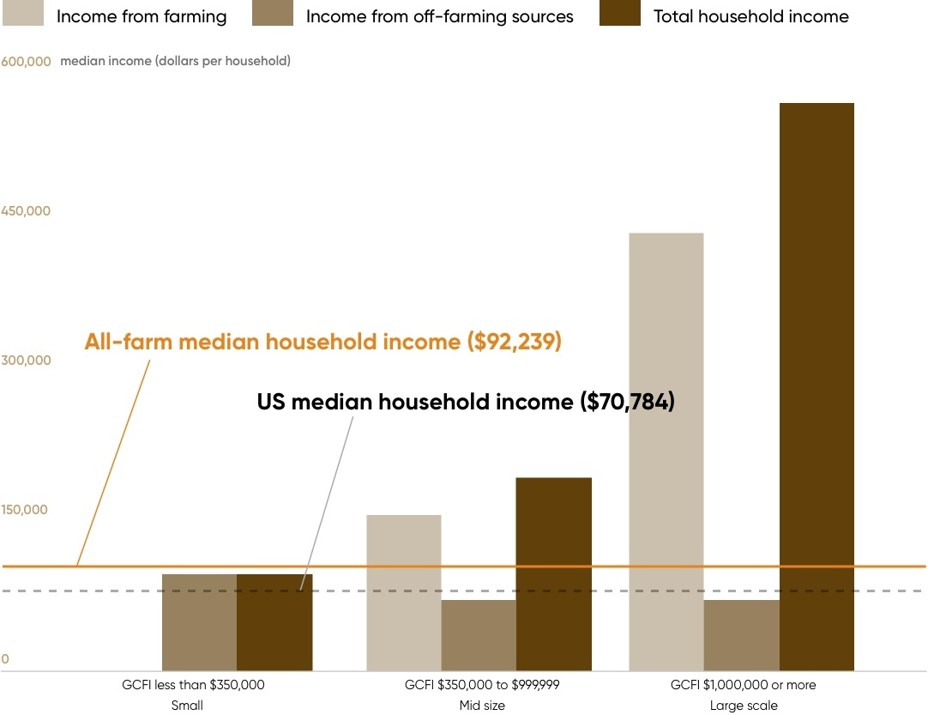

Source: USDA

## 

## 

## **5. Increasing support from regulatory bodies**

The United States Department of Agriculture (USDA) and the Federal Communication Commission (FCC) have formed a task force to develop policy recommendations to increase broadband internet services for the country’s agricultural lands in order to boost smart farming activities in the US.

Regulatory and government bodies are mainly targeting smaller farms, which are generally investment-constrained. For instance, the USDA, since 2013, has extended more than 70% of its microloan facilities to small farmers in order to help them gain access to basic technology and equipment. Detailed below are some of the USDA’s programs to accelerate the development and use of automation in the production of specialty crops. From 2008 to 2018, USD 287.7 million (nearly 6% of total funding) has been allocated by the USDA via different programs to develop smart farming technologies including machinery automation, machine learning, precision agriculture, and sensing technology.

### **Funding for USDA programs used to accelerate the development and use of automation or mechanization in the production or processing of specialty crops, FY 2008 to FY 2018 (Nominal $)**

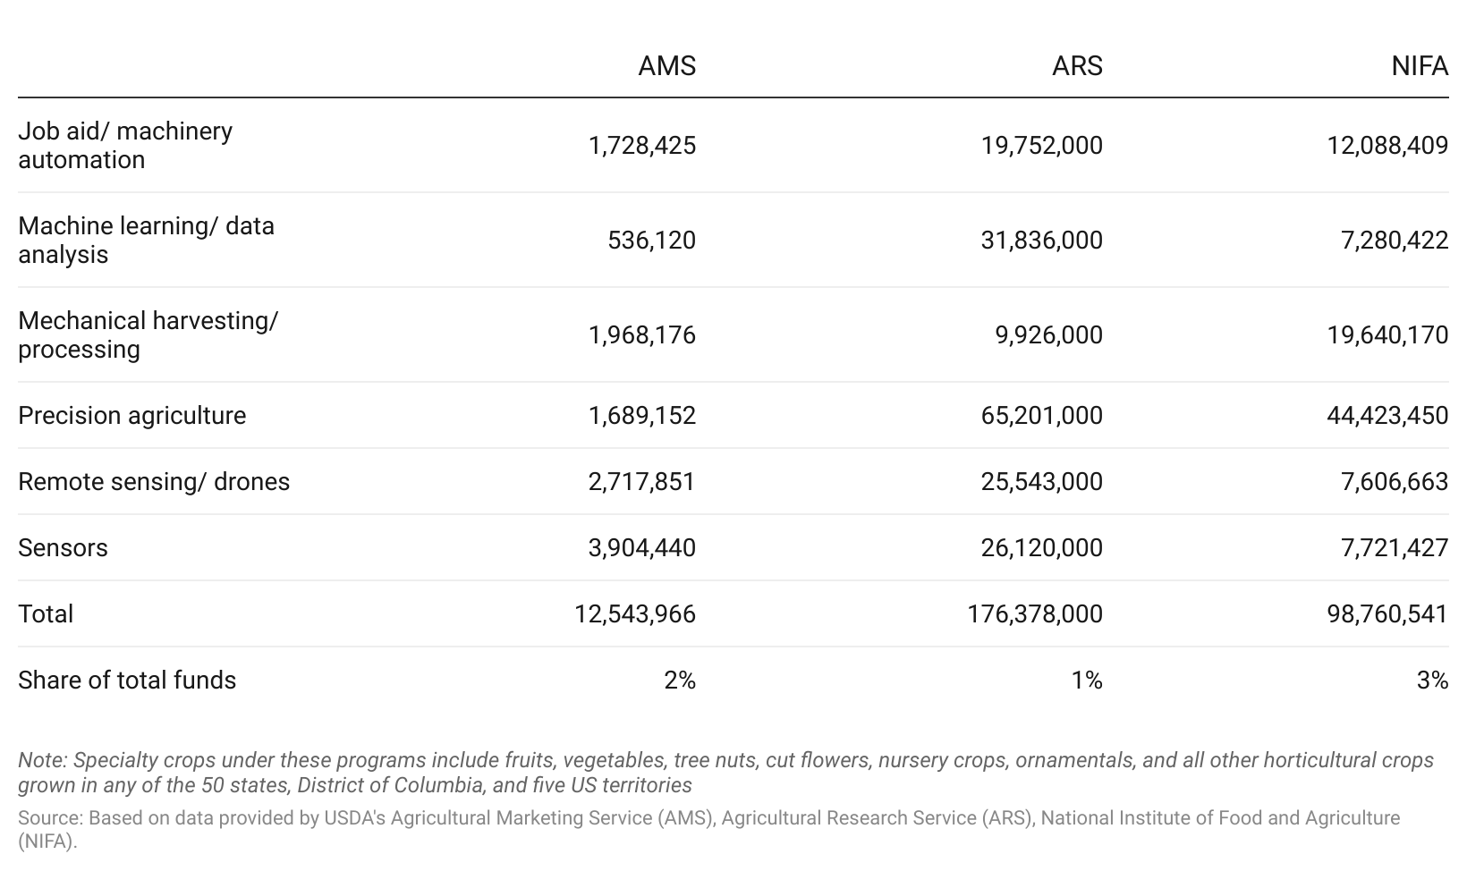

## 

## 

## **6. Reducing the industry’s carbon footprint**

The agricultural industry is under pressure to reduce waste and energy consumption. The US agricultural sector was responsible for 690 million metric tons of carbon dioxide equivalent (MMtCO2e) in 2020, which constituted around 11.2% of total greenhouse gas emissions in the US (9.5% in 2015) that year. The USDA expects agricultural emissions to increase further given growth in population and demand.

By 2050, agricultural emissions from the three largest sources of agriculture activity - enteric fermentation, manure management, and soil management—is projected to increase by nearly 6% from 2005’s levels on a base case estimate. This could drive demand for smart farming solutions like soil management, crop management sensors, and smart machinery systems to reduce the agriculture sector’s carbon footprint. Studies have identified 25 tech-enabled farming practices that would help reduce global farming carbon emissions by 4.6 gigatons by 2050. This represents about 20% of the total emissions from agriculture, forestry, and land use.

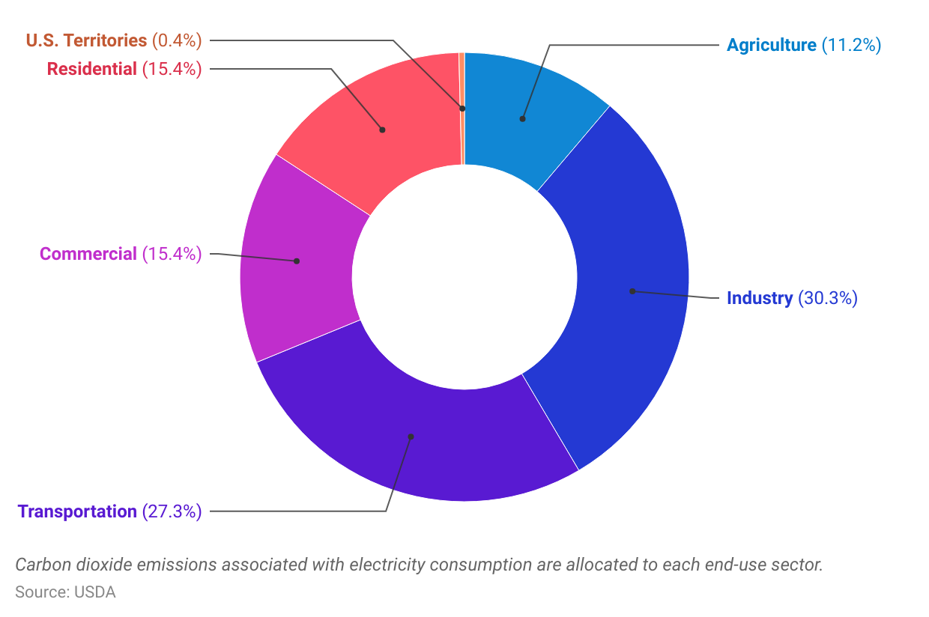

**Risks to Growth**

## **1. Volatility of crop prices raises concerns over profitability**

The ultimate revenue and bottom-line impact of adopting smart farming is heavily dependent on crop prices.

For example, corn prices started to rise over 2021–2022, averaging USD 5.8 per bushel, compared to low corn prices over 2014–2020, averaging USD 3.5 per bushel. This resulted in stronger top-line performance; average revenue over 2021–2022 grew around 64% to roughly USD 1,044 per acre from around USD 622 per acre over 2014–2020.

Price volatility has affected top-line as well as bottom-line, performance. When considering the historical cost factors of the US corn market, the average cost during 2021–2022 increased around 68% to USD 825 per acre from around USD 681 per acre during 2014–2020. Resultantly, the corn market registered net profits over 2021–2022 with an average of USD 219 per acre as the revenue generated over the period was higher than the costs incurred. However, the corn market recorded continuous losses over 2014–2020, as low corn prices resulted in a weaker top line.

As such, considering the US corn market as a case study, though the adoption of smart farming techniques can provide a meaningful improvement in crop yields, bottom-line disruptions could persist if it creates a mismatch between demand and supply.

## **2. Investment Constraints for Small Farmers**

Given that the majority of US farmers handle small family farms, they could lack the necessary financial support to invest in smart farming given their lower profitability and higher debt levels. However, increased state support in the form of financial subsidies and aid should mitigate this risk to some extent.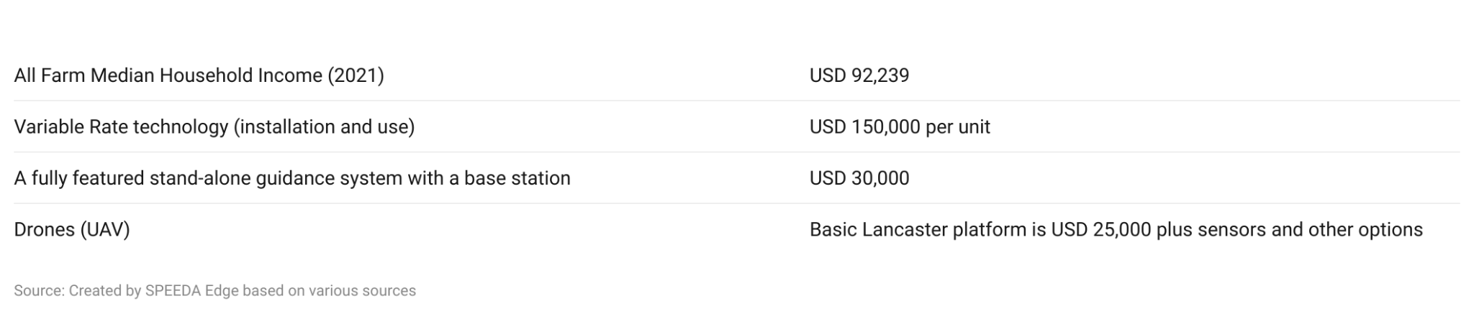

*Last updated on: August 2023*

©2024 Uzabase, Inc. All Rights Reserved. The information contained herein: (1) is proprietary to Uzabase Inc. and/or its content providers; (2) may not be copied or distributed; and (3) is not warranted to be accurate, complete or timely. Neither Uzabase Inc. nor its content providers are responsible for any damages or losses arising from any use of this information.