# **Digital Twin: Overview**

# 

# **DTs driving the application of Big Data for physical assets, saving time and costs**

DTs are an extension of the focus on data-driven approaches across industries and use cases. A DT is a virtual representation of a physical object known as a physical twin. Using real-time data, DTs are capable of instantly reflecting any changes in the physical twin in their digital copy. DTs differ from standard simulations–which use static data and study a single process–because they can run simulations on multiple processes. There are broadly four categories of DTs, each increasing in the magnitude of the type of asset or process being virtually represented. This includes the simplest form, known as a component or part twins, which could be as simple as extracting data from a sensor in the nuts and bolts of a particular piece of equipment, to the broadest form, known as a process twin to represent production factories virtually.

### 

### **Types of DTs**

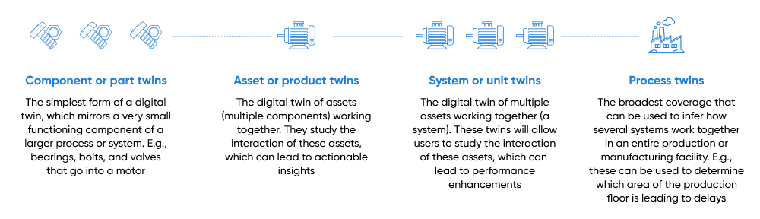

Source: IBM, Unity

In order to build DTs, the physical twin is fitted with IoT devices to collect data (e.g., indicators of asset health and temperature), which is processed and applied to its digital copy. The data is sourced from drones, sensors, and satellite images; the DT’s accuracy to simulate the physical twin is greatly influenced by the amount of data used. Using a combination of ML models and data visualization, the DT can run simulations to understand the performance and efficiency of the physical twin and also how it changes under several real-world scenarios, including how it is performing in the present and predicting how it will perform in the future. DTs are similar in appearance to their physical counterparts (e.g., a wind turbine, a car, an off-shore oil rig, or factory equipment), and, in some instances, such as those used in product development and design, are developed before the physical object that they replicate.

### **How do DTs work?**

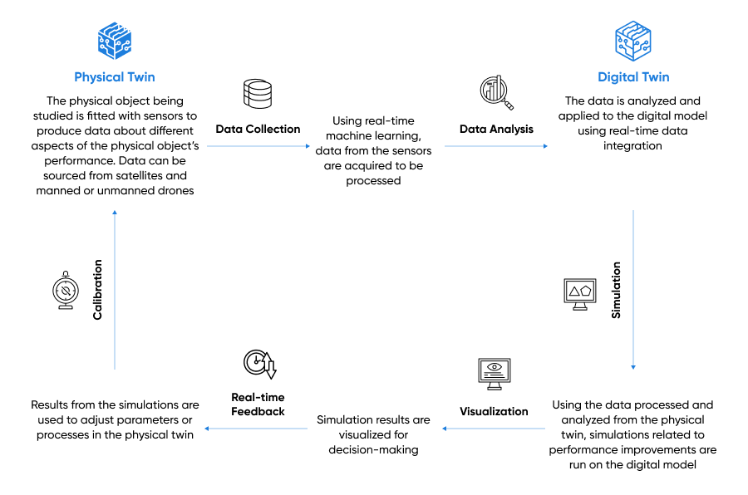

Source: Prepared by SPEEDA Edge based on multiple sources

# 

# **What’s bringing DTs to life?**

### **1. Advancements in IoT sensors and reducing costs make data collection more comprehensive**

The more data that the DT can extract from assets, the better its performance, making real-time operational data imperative for the functionality of DTs. The enhancements in the underlying technology with the introduction of micro-electro-mechanical systems (MEMS), micro-sensor implants, and biodegradable sensors have made sensors more compact and dynamic to extract more detailed data in real time. At the same time, the use of DTs has become widespread due to the significant decrease in the cost of sensors (average cost of USD 0.44 in 2024 vs. USD 1.38 in 2004).

These twin factors have been a catalyst for the emergence of IoT technology, especially in factory automation and industrial processes known as IIoT (for more details refer our [Smart Factory](https://sp-edge.com/industry/6) industry hub), which significantly improves the integration of software and physical assets, making the DT data collection process more prolific. This is expected to continue according to Cisco’s [Annual Internet Report](https://www.cisco.com/c/en/us/solutions/collateral/executive-perspectives/annual-internet-report/white-paper-c11-741490.html), which forecast the number of machine-to-machine (M2M) connections to reach 14.7 billion by 2023 from 7.4 billion in 2019. Moreover, 50% of all networked devices are projected to be IoT-based by 2023.

### **2. Evolution in computing infrastructure, AI/ML, and analytics streamline DT modeling**

Due to the vast amount of data that DTs handle, gleaning meaningful insights can be a challenge. Data analytics and modern visualization tools (e.g., computer-aided technologies for design, engineering, and manufacturing), which incorporate interactive 3D, VR, and AR capabilities, supported by advancements in AI/ML (use of supervised/unsupervised learning and deep learning), which assist in handling significant amounts of data, have improved the ability to parse through data faster and identify appropriate data points for simulations. Access to superior computational power and storage as well as low latency networks contribute to the enhanced processing of DTs. Moreover, startups such as [CONXAI](https://sp-edge.com/companies/1305711), which caters to the construction industry, have incorporated no-code capabilities, which could allow DTs to appeal to a wider, non-technical customer base.

DT is further enhanced with GenAI, providing unparalleled levels of intelligence and adaptability, enabling them to simulate complex scenarios with greater precision and efficiency. [Cognite](https://sp-edge.com/companies/702278) has launched a GenAI-powered remote operations control room featuring interactive dashboards, voice command access to key metrics, and real-time safety and reliability insights. [NVIDIA](https://sp-edge.com/companies/4353), a DT incumbent company, also leverages GenAI to offer clients an immersive experience and facilitate virtual design, construction, and validation processes for products, manufacturing, and factories.

# 

# **Segmental Overview: What are DTs used for?**

Since the days of the Apollo program, the application of DTs has spread to other sectors, including automotive, construction, real estate, and power and utilities. The main appeal of DTs is their ability to assist companies to enhance process efficiency to drive down operational costs and time to market and stay on top of evolving consumer needs. [ABI Research](https://www.abiresearch.com/press/use-digital-twins-urban-planning-yield-us280-billion-cost-savings-2030/) projects that cities would achieve USD 280 billion in cost savings by 2030 through the use of DTs for urban planning. In the automotive sector, Rolls Royce used DTs to conduct safety evaluations of engine parts and reportedly halved its test analysis times. In addition, the [Hong Kong International Airport](https://opengovasia.com/hkia-develops-digital-twin/) developed DTs to aid in the design and implementation of new projects, passenger service, and maintenance.

We have identified key DT use cases below:

* **Maintenance and monitoring:** To facilitate the real-time monitoring of asset performance from which it uses data to simulate and predict possible repair and maintenance requirements before any functionality issues arise. In addition, these solutions can help analyze geography to optimize land utilization
* **DT modeling**: Used for capturing the necessary data (e.g., factory floor plans) and offering analytics for a variety of use cases
* **Planning and management:** To gain insights for use in commercial planning, logistics and distribution, and other supply chain processes
* **Predictive assessments:** To identify risks and recommend solutions in areas such as disaster management (by creating virtual replicas of vast geographical areas), the creation of human DTs for DNA testing, and clinical trials (to simulate effects of treatments)
* **Building and design:** Used to design and build components contributing to smart cities, roads, airports, public transportation systems, etc.

### 

### 

### **Key segments within the DT landscape**

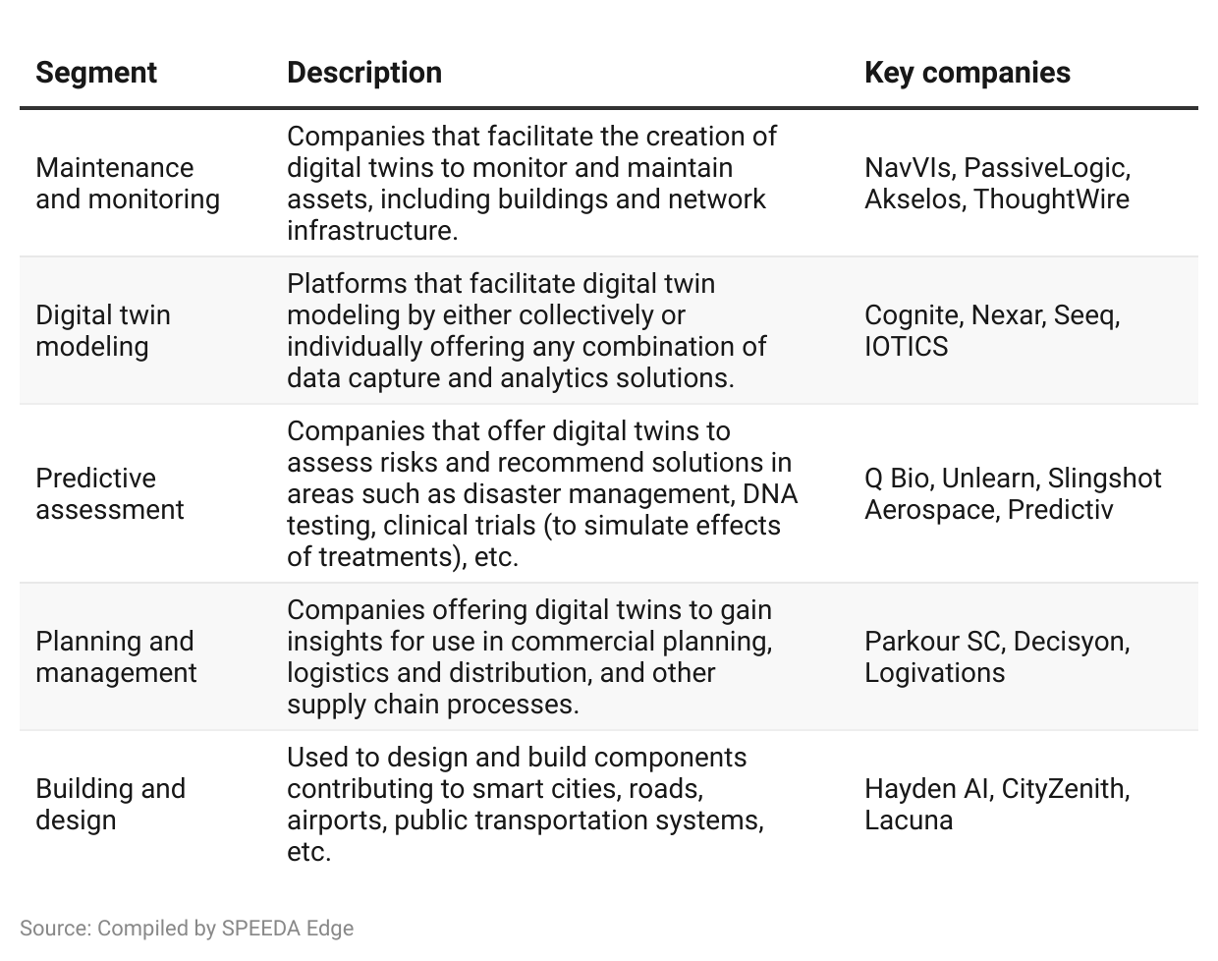

**However, we exclude the following areas when selecting companies for this industry:**

1. 3D commerce, virtual showroom, and retail store virtualization software (covered under [Content Creation Tools](https://sp-edge.com/industry/113))
2. Pure-play simulation software, which often represent static simulations (digitized objects not run on real-time data)
3. Software and solutions that use DT tech for digital rendering of NFTs or other digital assets and social virtual worlds (e.g., [metaverse platforms](https://sp-edge.com/industry/132))

# **Driving factors**

## **1. DTs can reduce monitoring costs and prevent unplanned repairs and maintenance**

DTs enable enterprises to monitor and evaluate physical assets in real time at significantly lower costs, both in financial and human resource terms. The current monitoring processes for physical assets are usually based on periodic manual inspections, which can be costly and dangerous depending on the nature of the asset. Additionally, due to the risks of failure or damages between inspections, most physical assets are designed with a higher degree of tolerance, resulting in heavier products, which, in turn, require more frequent monitoring and maintenance.

In addition to saving operating costs, a DT has the potential to save costs in the product development and testing stages. Specifically, companies are able to simulate the planned production process using DTs and identify potential failures in the product and production process, both under normal and unexpected scenarios. This improves risk assessment and allows companies to proactively adjust new products to improve the reliability and efficiency of future products and production. In one instance, a manufacturing company was able to reduce the labor force required for structuring the design process by nearly 85%.

Looking at other potential users of DT, it is estimated that smart cities could save up to USD 280 billion over 2021 to 2030 through the deployment of DTs for urban planning and management of physical infrastructure.

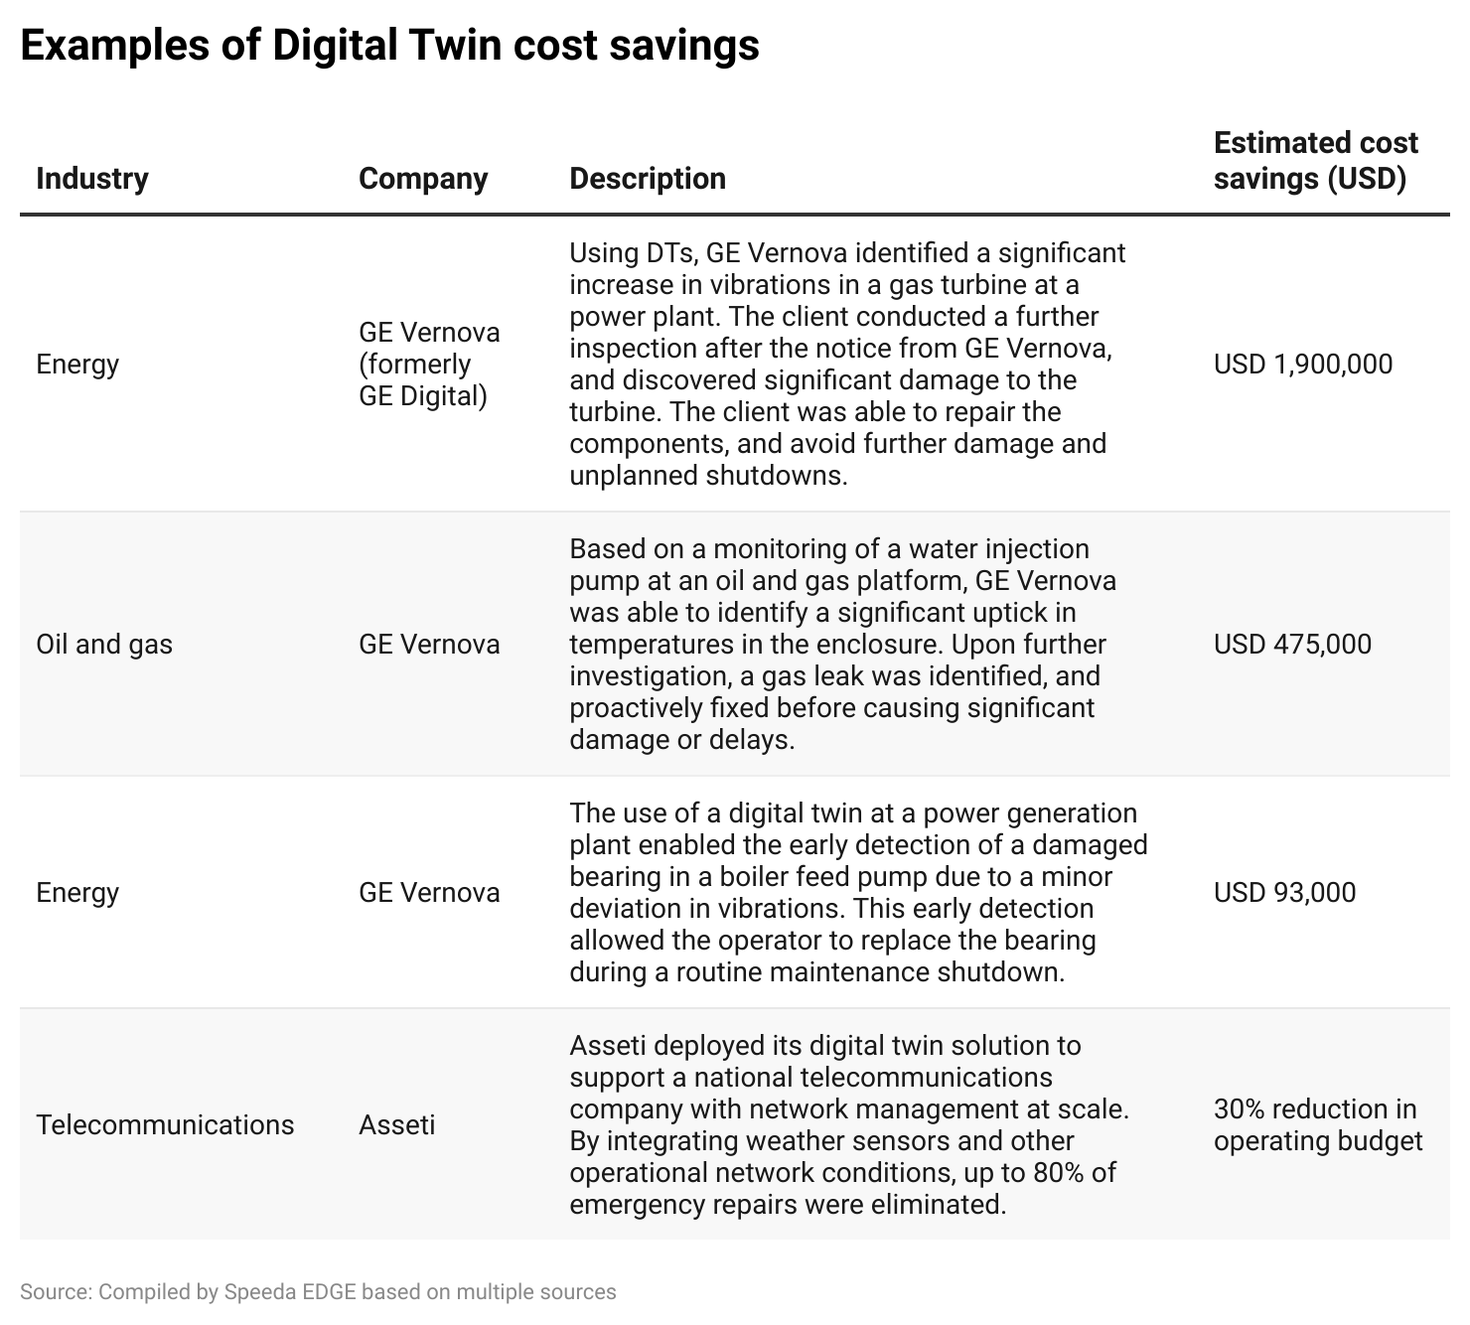

## 

## **2. Ability to run multiple simulations quickly can speed up product development timelines**

DTs allow companies to continuously evaluate potential new products to identify risks and potential failures earlier in the development cycle. As a result, companies can avoid multiple test and repair loops by proactively addressing risk factors during development, thus speeding up time to market. Looking at AI as a whole, DTs are estimated to be able to reduce the time for implementation of AI-driven capabilities by up to 60%.

Another benefit in terms of speed is in the production process; similar to the cases on cost savings, the ability to run various simulations helps to identify potential improvements in the production process before implementation. These improvements would reduce the production time per unit.

A clear example of this is the pharmaceutical industry, where companies are applying DTs to monitor the production process, including bioreactors where drug manufacturers grow new medicines. DTs are able to simulate potential mixing conditions to identify the best set of conditions for this growth process and refine it to ensure production in a timely manner with high-quality yields.

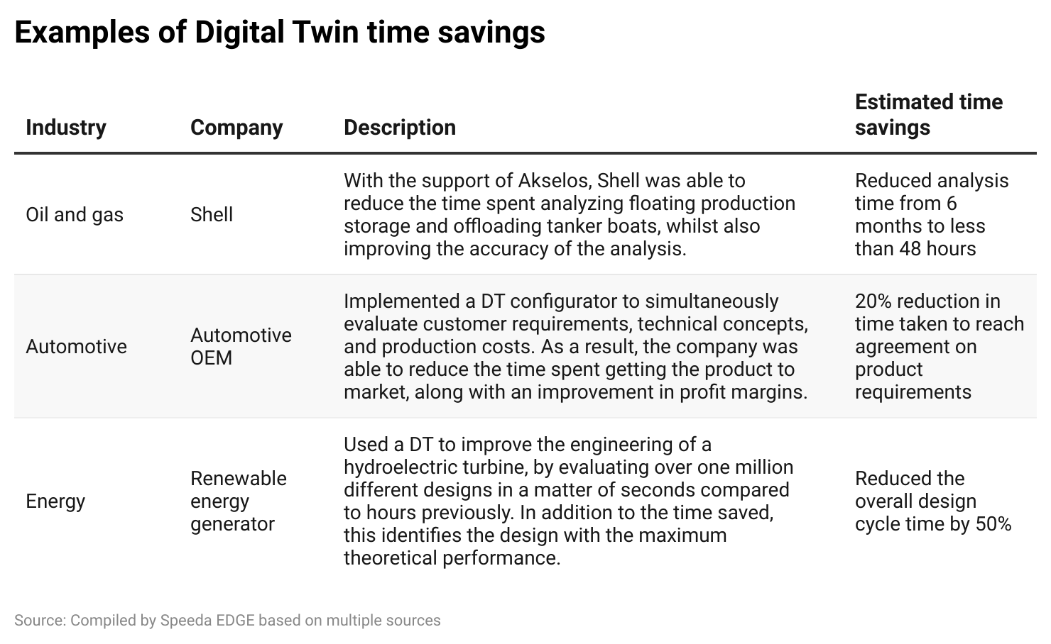

## **3. DT simulations can identify optimal operating conditions and drive revenue generation across industries**

In addition to providing savings in terms of costs and time, DTs have the ability to unlock incremental gains in revenue for companies across industries. Specifically, the collection of historical data and ability to run simulations using various conditions and changes in operating processes can quickly identify the optimal conditions for revenue generation.

Primarily, this can be seen in the industrial sector, particularly power generation, where minor changes in operating conditions like temperature and pressure can have significant impacts on the generated power output. Another example is the agricultural sector, where DTs are used to monitor environmental and biological conditions, including soil, climate, and crop conditions. Based on the data collected, farmers were guided toward planning choices that would maximize their yields and reduce the risk of wastage or losses.

# 

# 

# **What are the challenges to growth?**

## **1. Quality of data and interoperability of systems could compromise the accuracy and use of DTs**

The accuracy of DTs largely depends on the quality of the data it is fed. The data needs to be error-free and uninterrupted for the sustainable function of the DT. Inconsistent and inferior data quality leads to underperformance and unreliable insights for decision-making. Adoption by enterprises will depend on how well they can develop methods to isolate and filter inferior data and close gaps in inconsistent data streams.

Moreover, the interoperability of systems, which influences how data and models can be shared from one application to another, could hinder the mainstream adoption of DTs due to restrictions that can make it harder to scale them. For instance, incumbent players such as [Siemens](https://sp-edge.com/companies/7166) and [Dassault Systèmes](https://sp-edge.com/companies/5506) focus on facilitating the exchange of data for product lifecycle management. As enterprises come into the fold, they are likely to attempt integrating data from multiple vendors to then find out that they are unable to scale. The DT Consortium’s [interoperability standards](https://venturebeat.com/arvr/digital-twin-consortium-pursues-open-source-collaboration/) aim to mitigate this to an extent.

## 

## **2. Vulnerability to cybersecurity risks and privacy concerns**

Effective management of DT cybersecurity will be imperative, as the links that DTs use to exchange data with their physical twin could be targeted by cybercriminals. This could have detrimental consequences for the physical twin, as control of sensitive data streams and physical assets in the hands of malevolent actors could deter enterprises from using DTs altogether. Moreover, DT players, especially those used in healthcare for predictive assessments such as clinical trials and DNA testing services, are privy to personal data. Therefore, startups need to ensure adherence to external policies and the implementation of internal best practices for data use.

*Last updated: April 2024*

©2024 Uzabase, Inc. All Rights Reserved. The information contained herein: (1) is proprietary to Uzabase Inc. and/or its content providers; (2) may not be copied or distributed; and (3) is not warranted to be accurate, complete or timely. Neither Uzabase Inc. nor its content providers are responsible for any damages or losses arising from any use of this information.