# **Online Freelancing Platforms: Overview**



## **Online freelancing platforms overhaul traditional freelancing services by offering them online**

The term ‘gig economy,’ is often used as a synonym for services provided via digital platforms. In its broadest sense, however, any type of freelance work—whether brokered online or offline—can be included within this definition. Due to the growth of sharing economy platforms (SEPs) in transportation (e.g. Uber, Lyft) and hospitality (e.g. Airbnb), freelancer gigs are increasingly procured online, as opposed to traditional avenues like temp or staffing agencies.

These online marketplaces allow freelancers to bid and submit proposals for jobs and facilitate the logistics from matching to invoicing and payment. Some platforms provide integrated verticals (e.g. [Fiverr](https://sp-edge.com/companies/33808) and [Upwork](https://sp-edge.com/companies/253)), while others focus on specific work categories from software and web development (e.g. [Braintrust](https://sp-edge.com/companies/711794), [Gun.io](https://sp-edge.com/companies/181924)) to writing and translation (e.g [Textbroker](https://sp-edge.com/companies/47887) and [ServiceScape](https://sp-edge.com/companies/399556)), design and creative work (e.g. [Snapper](https://sp-edge.com/companies/397132), [Dribble](https://sp-edge.com/companies/43110), [Perforcal](https://sp-edge.com/companies/269376)), and law-related work (e.g. [Priori](https://sp-edge.com/companies/165761) and [LAWCLERK](https://sp-edge.com/companies/1047202)). For skilled professionals who are no longer constrained by geographical proximity to work, OFPs can fulfill a desire for flexibility and a balanced lifestyle. For companies, online freelancing platforms are a cost-efficient way to gain access to professionals with specialized skills on an on-demand basis, providing them with flexibility based on project needs.

Recently, the industry has witnessed major product launches, offering end-to-end solutions, to capture a larger share of enterprise spending. For instance, in June 2022, [Fiverr](https://sp-edge.com/companies/33808) launched [Together](https://sp-edge.com/updates/10989), a new platform that connects enterprise-grade freelance creative teams with leading global brands and agencies. Further, In 2021, [Fiverr](https://sp-edge.com/companies/33808) and [Upwork](https://sp-edge.com/companies/253) have launched services to manage [back-end operations](https://sp-edge.com/sectors/work/updates/6528) and sell [bundled freelance services](https://sp-edge.com/sectors/work/updates/344). Moreover, Fiverr announced two acquisitions to offer [learning and development solutions](https://sp-edge.com/sectors/work/updates/5896) for freelancers and [freelance management solutions](https://sp-edge.com/sectors/work/updates/6403) to enterprises. LinkedIn, an incumbent in the space, also launched a [freelance marketplace](https://sp-edge.com/sectors/work/updates/6294), signaling elevated competition for enterprise dollars.

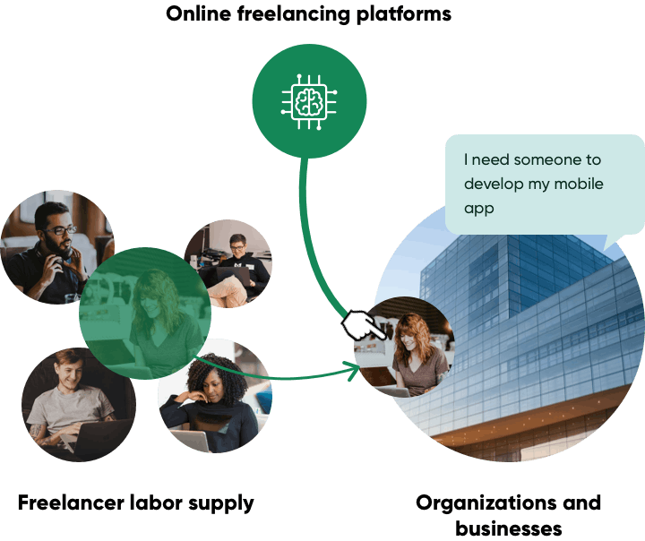

Source: Staffing Industry Analysts

# 

# 

# 

# 

# **Driving Factors**

## **1. A younger freelancer workforce**

Millennial and Gen Z employees are expected to account for approximately 56% of the US labor force by 2025. This influx of tech savvy and digital natives who value balanced lifestyles are likely to find freelancing as an attractive option. In fact, a 2021 survey has shown that 42% of Gen Z candidates prioritize work-life balance, working from home, and flexible vacation time above other priorities such as career passion (19.6%) and money (16.5%).In addition, Gen Z and millennial generations have higher freelancer participation rates, with 43% and 46% of their respective populations freelancing in 2022.

### **Millennials and Gen-Z are expected to account for a larger share of the US labor force**

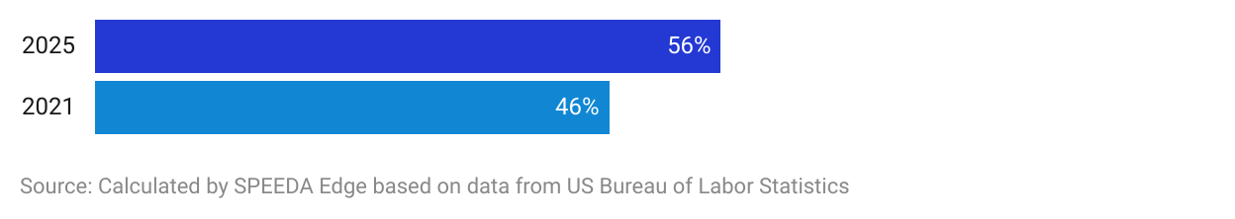

### 

### 

### 

### 

### 

### 

### 

### 

### 

### **The freelancer workforce is trending younger with participation rates among Gen Z and millennials in the lead**

## 

## **2. Demand for flexibility and supplementary income**

In the aftermath of the Global Financial Crisis of 2008, individuals have increasingly been seeking flexible work options that would either supplement or replace their primary income (i.e. the contingent workforce). 57% of freelancers reported earning more than they did with their traditional employer within a period of 6 months in the immediate aftermath of the pandemic. Further, global movements such as “The Great Resignation” and “Quiet Quitting” has led to a once-in-a-generation reassessment of how individuals prefer to work.

Consequently, this may have led to the share of professionals freelancing in the US reaching an all-time high (60 million Americans) in 2021. A recent survey has shown that globally, freelancers have charged an average hourly rate of USD 105 with a monthly average net income of USD 6,884 during May–July 2021, whereas the median white-collar hourly rates in the US ranged between USD 20–35 in Q2 2021.

In addition, the share of full-time freelancers increased by ~8% from 2014 to 2021 as 39% of the total freelancers worked on a full-time basis in 2021. Currently, there is still a minority that freelance because they are unable to find traditional employment, but many workers are now choosing to stay away from typical office jobs. In 2022, ~73% of freelancers have stated that perceptions of freelancing as a career are becoming more positive, up from 68% in 2021.

## **3. Access to on-demand specialized talent pools**

The on-demand nature of OFPs allows companies to deal with temporary shifts in the business cycle where short-term labor requirements may increase. More than half (59%) of the hiring managers stated they will use some form of flexible talent in 2020. Using OFPs eliminates potential hiring barriers (e.g. location) and allows hiring managers to focus on swiftly acquiring the best talent for the task at hand and reduce any labor shortages due to labor immobility.

OFPs are becoming more specialized, with niche knowledge-intensive and creative occupations being in high demand. In 2022, 51% of freelancers provided skilled services such as computer programming, marketing, IT, and business consulting, up marginally from 50% in 2021. A 2022 Upwork survey indicated that the top job category hiring managers need to fill most urgently is accounting (33% of respondents), which is a shift from previous developments where software development (US market share of 27%) has consistently been the most in-demand skill. This indicates a gradual diversification of the freelance market away from the narrow focus on tech to other occupations. The survey also indicated that 66% of hiring managers expect to increase the use of freelancer talents in the coming two years.

**Hiring managers are more likely to utilize freelancers in work which requires specialized skills**

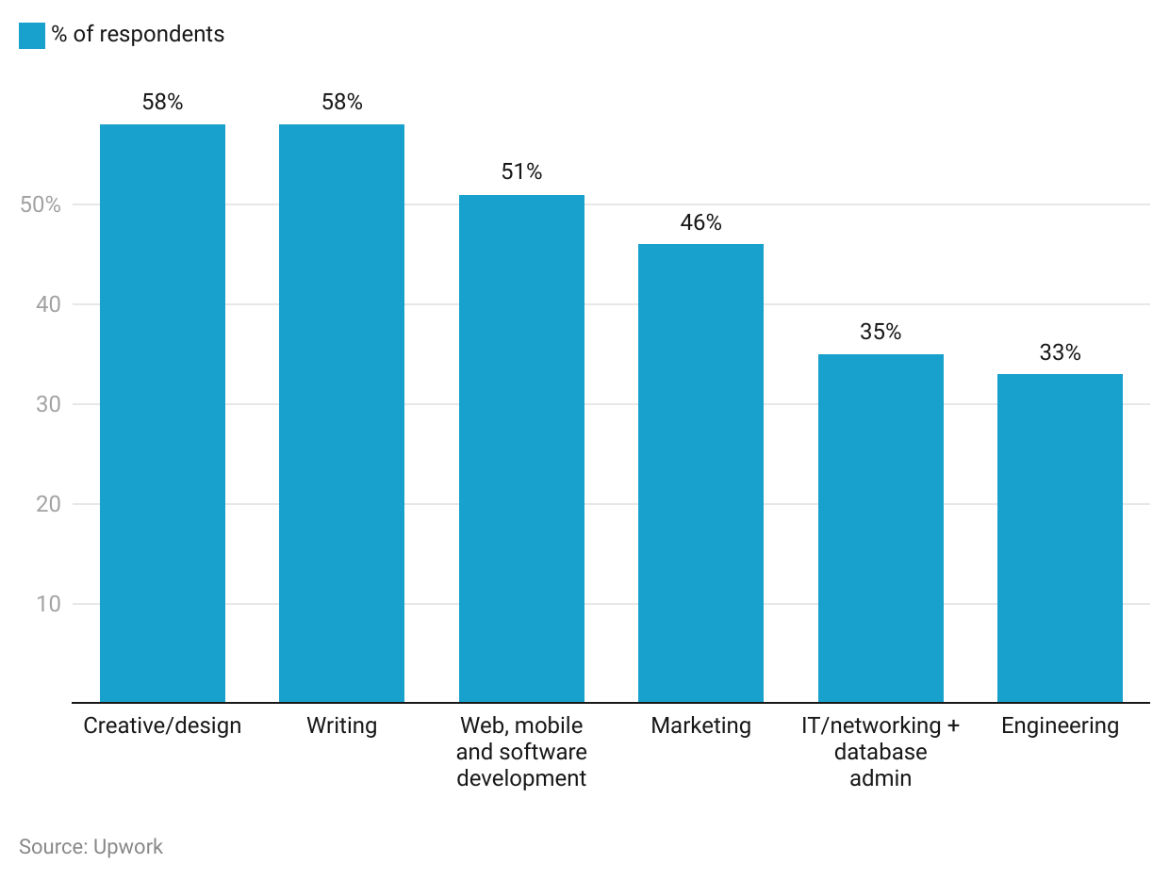

As of September 2019, it takes approximately 42 days to fill a job vacancy globally on average, this extends to 59 days for more specialized roles such as engineers. Companies can utilize OFPs to access a pool of talented professionals in a timely manner, which would likely make the hiring process quicker. Corel Corporation (a global software company headquartered in Canada) reported an average fill rate of 88% compared to the industry average of 50% when using the [Upwork](https://sp-edge.com/companies/253) platform.

# **Risks to Growth**

## **1. Potential for disintermediation**

OFPs spend on research and development to improve platform algorithms that assist in matching freelancers with businesses. However, the future benefit of this arrangement may not be accrued by these platforms if employers and freelancers forego various fees to form a direct work arrangement. That is, the risk of these platforms becoming a place to connect with freelancers to form future beneficial relationships for employers. This is the risk that [Upwork](https://sp-edge.com/companies/253) attempted to mitigate with its tiered pricing model, which they introduced in 2016.

## **2. Heavy spending on customer acquisition hinders profitability aspirations**

OFPs need to spend heavily on customer acquisition to grow their client base. Although [Fiverr](https://sp-edge.com/sectors/work/updates/356) and [Upwork](https://sp-edge.com/sectors/work/updates/365) have reported improved profitability driven by positive pandemic effects, platforms rely heavily on the volume of work to drive margins and hence, profitability depends on the sales and marketing return on investment (ROI) these companies can generate. There is a risk that these companies may not turn profitable in the near future if sales and marketing ROI continues to remain low, despite investments in platform design and customer acquisition.

## **3. Regulatory hurdles in the form of worker classification and data privacy laws**

The ongoing battle between regulators and sharing economy companies over worker classification does not currently impact OFPs. However, there is a possibility that it could pose a significant threat to OFPs in the future. For example, the classification of [Upwork](https://sp-edge.com/companies/253)’s freelancers as employers would mean that they are liable to pay minimum wage, employee benefits, overtime pay or paid leave, which could have a detrimental effect on their goal to achieve profitability. In addition, OFPs are subject to consumer privacy laws such as the California Consumer Privacy Act (CCPA), which provides additional data privacy rights to consumers. In addition, the company can face regulation on aspects such as security, data protection, intellectual property, and taxation.

*Last updated: January 2023*

©2024 Uzabase, Inc. All Rights Reserved. The information contained herein: (1) is proprietary to Uzabase Inc. and/or its content providers; (2) may not be copied or distributed; and (3) is not warranted to be accurate, complete or timely. Neither Uzabase Inc. nor its content providers are responsible for any damages or losses arising from any use of this information.