# **Logistics Tech: Overview**



## **Technology shaping the logistics industry**

Logistics is a central focus of the supply chain, dedicated to the fluid movement, storage, and procurement of goods within the supply chain. The Logistic Tech covers a landscape where software, hardware, and digital innovation are combined to automate tasks, improve efficiency, and mitigate logistic-related challenges. In particular, rising customer expectations, fueled by the rise of ecommerce, have also increased the urgency for companies to fine-tune their logistics capabilities.

In response to these challenges, the industry has seen the adoption of technologies like AI, IoT, digital twins, and sensors to predict and simulate future outcomes. These advancements enable companies to optimize their logistics operations, improve efficiency, and reduce costs. Additionally, real-time tracking technologies have enabled better coordination and scheduling, minimizing delays and risks in logistics operations.

## **The future of logistics management: How technology is transforming the industry**

Logistics Tech refers to the use of software, hardware, and other digital tools to automate and digitize tasks pertaining to the movement of goods and services from suppliers to consumers. These tasks can include vendor evaluation, procurement, warehousing, and delivery. Today, cloud computing, big data analytics, smart sensors, robotics, and IoT can help simplify these tasks, improve efficiency, and reduce costs.

Logistics tech is part of supply chain management (SCM) that takes a broad perspective, representing the entire process of planning, implementing, and controlling the flow of goods, services, and information from the source of raw materials to the end consumer. It aims to optimize every aspect of the value chain from procurement to production, distribution, and delivery to maximize customer satisfaction and minimize costs. The main focus of this industry hub is the logistics aspect of the supply chain, which centers around the movement, storage, and procurement of goods. It involves the detailed planning and execution of transportation, warehousing, and procurement management to ensure the timely delivery of products (for more information and details on players focusing only on supply chain aspects, please refer to our [Supply Chain Tech hub).](https://sp-edge.com/industry/157)

According to the 2023 KPMG CEO survey, supply chain risk was one of the key inhibitors to business growth in 2022, driven by increasing complexities in the supply chain and geopolitical uncertainties. Moreover, a KPMG index that measures global supply chain stability indicated a rapid increase in supply chain stressors due to issues with sourcing, labor, and inventory management. However, several tech developments have provided companies with the building blocks to manage these challenges, paving the way for logistics technologies.

### **Key technologies used in logistics tech**

## 

## **Key segments across the Logistic Tech landscape**

Logistics technologies play a pivotal role in the supply chain, offering solutions intricately tailored to the specific operational needs of companies at various points of the supply chain. Our segments are based on key areas of operational focus within the logistics industry, and we categorize companies based on their core expertise and offerings. These cover optimizing warehouse operations, streamlining procurement, improving fulfillment efficiency, and outsourcing logistics to third-party providers that offer specialized tools, robotics, and other services to streamline logistics operations and enhance productivity and efficiency.

### **Principal logistic technologies**

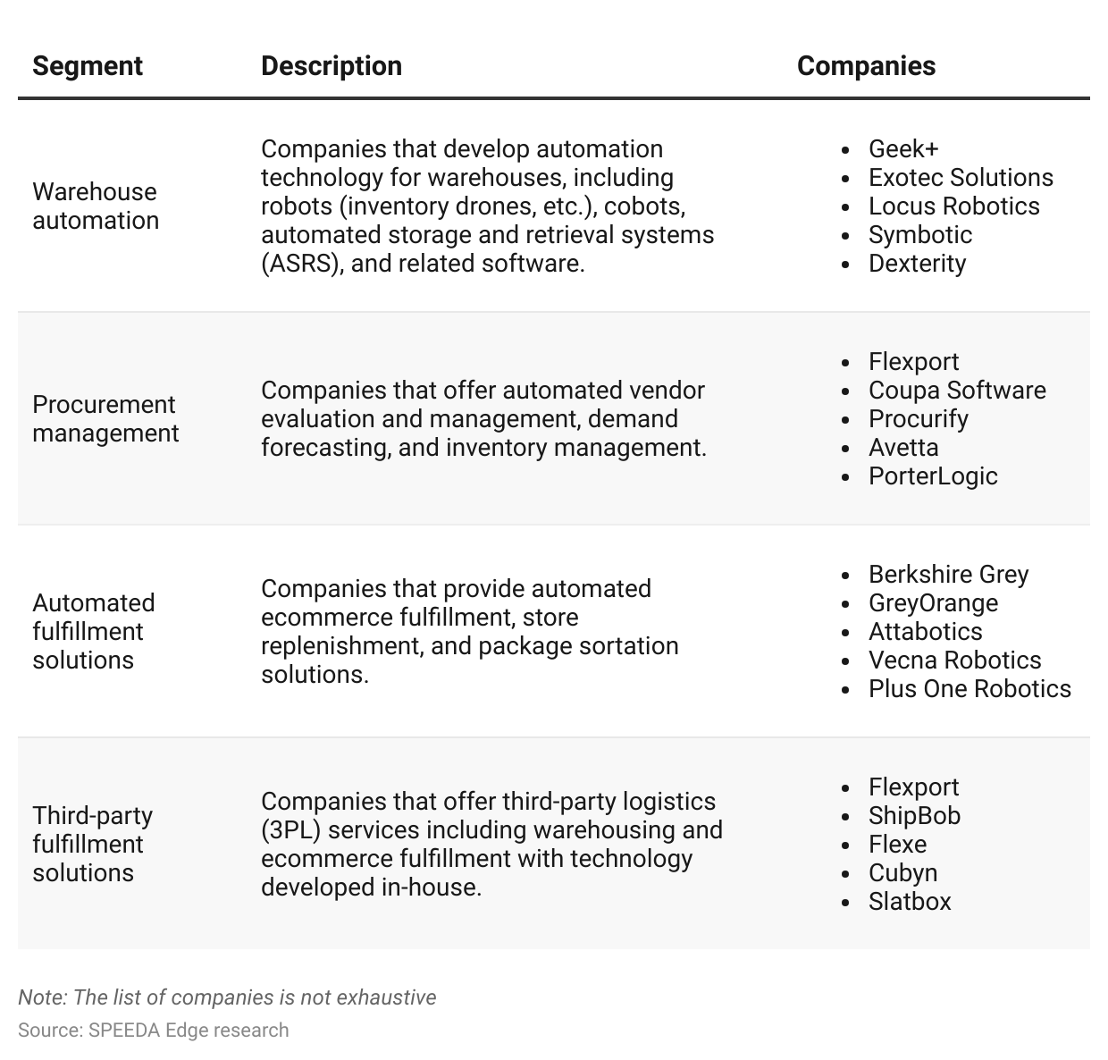

## 

## **Advances in AI, IoT, and digital twins to predict future outcomes instantly**

Advances in AI and [digital twin](https://sp-edge.com/industry/149) technologies have revolutionized logistics, improving efficiency and optimization across the industry segments. Several startups in the Logistics Tech space, including [Geek+,](https://sp-edge.com/companies/465313) [Locus Robotics,](https://sp-edge.com/companies/367758) [Symbotic](https://sp-edge.com/companies/85491), and [Coupa Software](https://sp-edge.com/companies/3670) have already incorporated AI and digital twin technologies into their products.

For example, warehouse automation harnesses AI to optimize inventory management, automate order fulfillment, and improve resource allocation. Machine learning algorithms analyze historical data to predict demand patterns, ensuring timely replenishment and reducing costly overstocks or stockouts. In addition, AI-powered robots, supported by real-time data insights, are gaining the ability to navigate warehouses, pick, pack, and deliver orders. Furthermore, AI-driven predictive maintenance ensures continuous operations by identifying equipment issues before they escalate, maximizing productivity. In fact, the MHI predicts that enterprise adoption of AI-powered warehouse solutions will reach more than 60% by 2026, up from a little over 10% in 2020.

In parallel, digital twin technologies offer significant benefits for logistics operations, providing replicas that simulate real-world processes and enabling risk-free testing of new strategies and layouts. In procurement management, digital twins are used to model supplier relationships and procurement lifecycles. They allow for scenario simulations that refine procurement strategies, optimizing supplier selections and negotiation approaches. Digital twins of fulfillment centers enhance third-party logistics by facilitating iterative optimization of workflows and resource allocation.

### **Advantages of AI in logistics**

### 

### **Adoption of AI-powered warehouse solutions by businesses**

## **Growth in real-time tracking technologies, sensors, and intelligent labeling brings logistics technologies within reach**

Real-time tracking technologies, sensors, and intelligent labeling are crucial enablers for logistics technologies. These technologies optimize logistics processes, improving efficiency and customer-centric solutions in the industry.

In warehouse automation, real-time tracking with GPS and RFID provides continuous visibility of inventory and assets, enhancing inventory management and order fulfillment efficiency. Sensors monitor environmental conditions, ensuring optimal storage for sensitive goods, while intelligent labeling streamlines identification and tracking. For example, Amazon uses an IoT-based warehouse management system to automate tasks in its warehouses. This system uses sensors and robots for tasks such as stocking shelves, packaging orders, tracking inventory in real time, and conducting predictive analytics.

In procurement management, real-time tracking keeps managers informed of shipment progress, enabling proactive handling of supply chain disruptions. Sensors monitor inventory levels, aiding data-driven decisions for stock replenishment, while intelligent labeling streamlines data capture.

For automated fulfillment, real-time tracking ensures precise and timely order processing, while sensors enhance product handling and sorting. Intelligent labeling facilitates accurate identification and processing. In third-party fulfillment, real-time tracking offers comprehensive visibility of inventory and orders, enhancing customer service. Sensors maintain optimal storage conditions, and intelligent labeling ensures accurate tracking for various clients. For example, Fashion Tech brand Mous partnered with third-party fulfillment and procurement management services provider [Flexport](https://sp-edge.com/companies/220062) to track and manage end-to-end shipments, transit times, cost per weight, and invoices. This enabled the company to respond to issues and automate its freight process.

# **Driving Factors**

## **1. Customer expectations and growth in ecommerce**

Customers have become more demanding in recent years, fueled by the rise of online shopping and on-demand services. Consumers now expect fast, accurate, and cost-effective deliveries, along with seamless order tracking and transparency.

To meet these expectations, companies are turning to warehouse automation technologies and automated systems, such as robotics and conveyor belts, that can optimize order picking and packing processes, reducing errors and improving efficiency. By streamlining and automating operations, companies can also accelerate order fulfillment, ultimately meeting the need for speed and accuracy in today's ecommerce-driven world.

For example, Amazon Prime and other ecommerce retailers offer same-day or even two-hour delivery to gain brand loyalty from customers. This puts businesses under increasing pressure to improve their logistics capabilities to meet these expectations.

The share of goods purchased online in the US stood at 15.5% in Q3 2023, up from 5.9% in Q3 2013. This growth in ecommerce is also driving the adoption of new logistics technologies. As more people shop online, companies need to find ways to efficiently and effectively manage the increased volume of orders.

**Faster delivery drives brand loyalty**

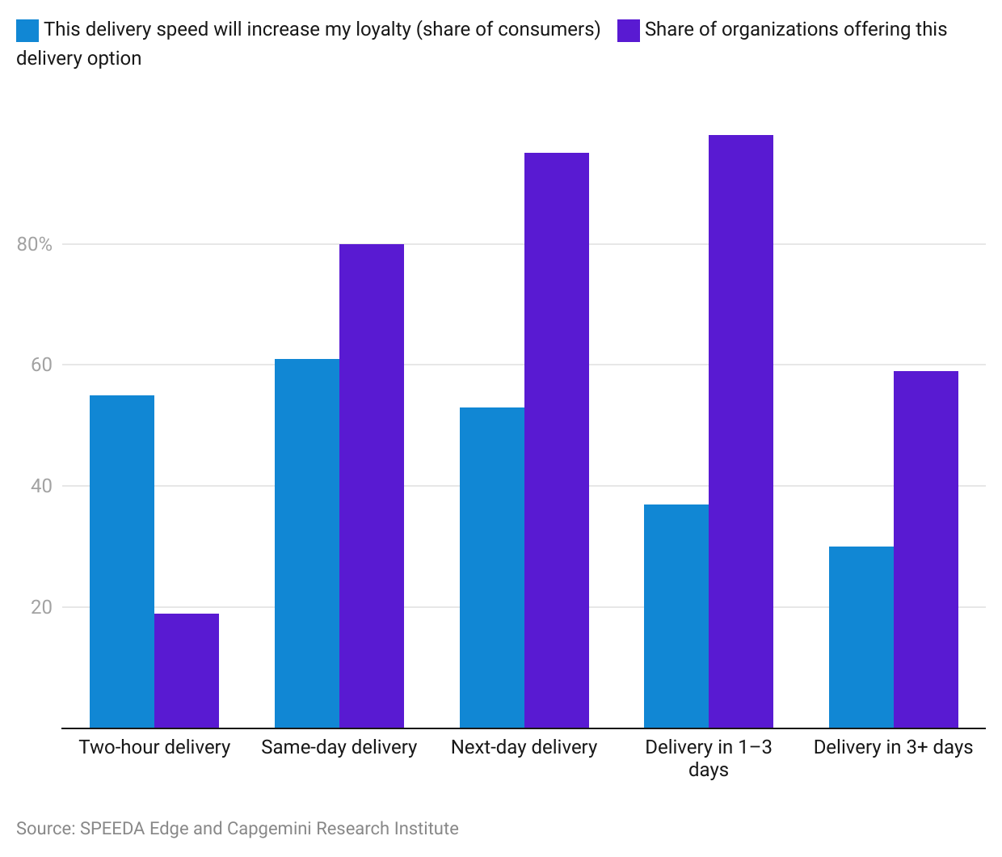

**US consumers increasingly opt for ecommerce purchases**

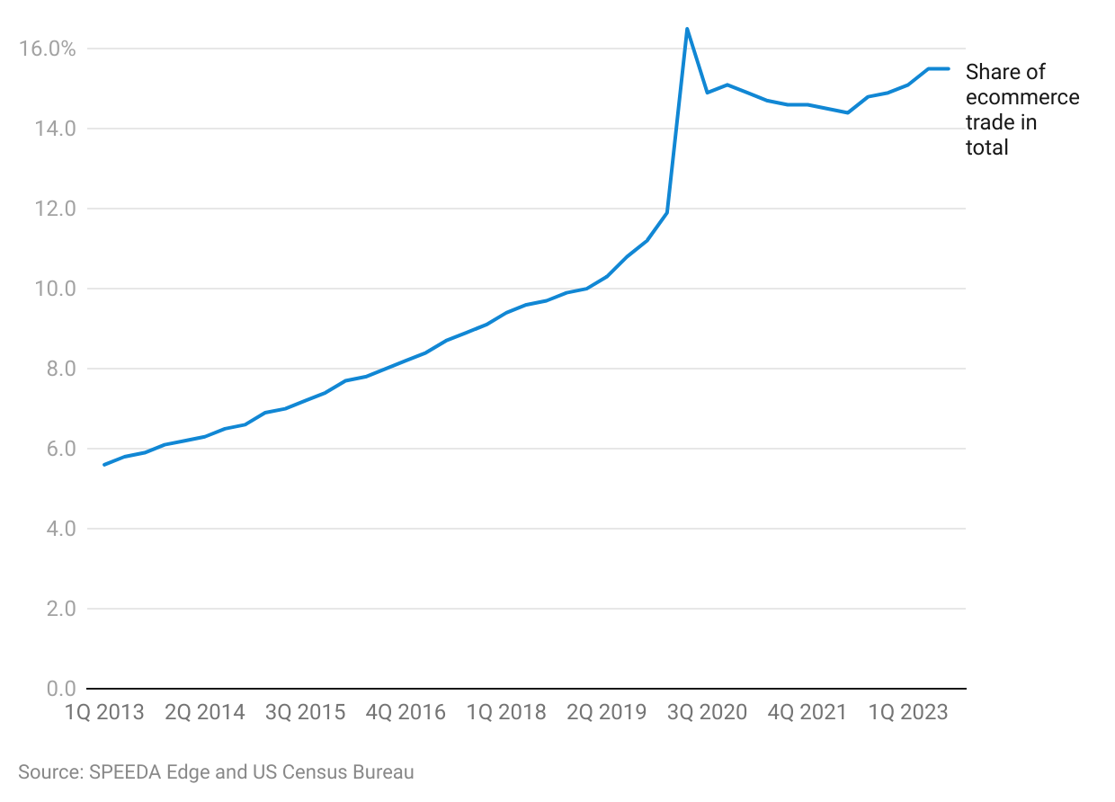

## **2. Labor cost savings achieved via warehouse automation**

Warehouse automation offers a compelling solution to reduce labor costs and address pressing challenges in the warehousing industry. With labor expenses typically accounting for 50%–70% of a warehouse's budget, finding the right workforce and optimizing productivity are crucial goals for warehouse managers. However, the industry faces a high injury rate (about 5.5 per 100 employees in 2021), rising hourly wages (up ~20% over 2019–2023), and difficulties in hiring and retaining qualified employees.

Warehouse automation has emerged as a strategic remedy to these issues. Implementing technologies like robotic order pickers, automated guided vehicles (AGVs), and conveyor systems can optimize operations, streamline processes, and reduce the reliance on manual labor. By embracing automation, warehouses can achieve significant cost savings, improve efficiency, and lower the risk of workplace injuries.

Today, more warehouse workers are also willing to work in a technology-driven environment—further facilitating the adoption of robots and other automation methods at warehouses. In fact, a June 2022 survey found that 75% of workers want technology to assist them in warehouse operations.

# **Risks to Growth**

## **1. Data limitations may lead AI systems to generate inaccurate predictions**

Developing a fully AI-based model requires all the data generated by an organization to be in digital form. Most organizations use a mixed approach. The translation of analog to digital has been challenging, limiting the amount of data that is fed into the AI models. The risk of such a system is that it might generate inaccurate predictions, leading to erroneous actions. However, while analog data is not expected to become obsolete anytime soon, according to a survey by the Council of Supply Chain Management Professionals and ToolsGroup, 93% of companies were actively engaged in digitalizing their supply chains in 2023 (i.e., connecting to their suppliers via digital platforms).

## **2. Risk of security breach**

As supply chains and logistics become more complex, they become more difficult to secure, as there are more points at which goods and information can be vulnerable to attack. Therefore, cyberattacks are a growing threat to logistics technologies, as they often rely on the internet and other interconnected networks that can be exploited by hackers. Hackers can steal sensitive data, disrupt operations, and even take control of critical infrastructure. This can have a devastating impact on businesses, leading to lost revenue, damaged reputations, and even legal liability. For example, in 2017, the Maersk shipping company was hacked by the NotPetya ransomware attack, causing widespread disruptions to Maersk's operations and resulting in ~USD 300 million in revenue losses.

To mitigate these risks, companies need to implement strong security measures. This includes using strong passwords, implementing multi-factor authentication, and keeping software up to date. Businesses also need to be aware of the risks posed by cyberattacks and take steps to mitigate them, including training employees on how to identify and report suspicious activity. Finally, businesses need to have a plan in place in case of a cyberattack. This plan should include responsive steps such as isolating infected systems and restoring data from backups.

*Last updated: May 2024*

©2024 Uzabase, Inc. All Rights Reserved. The information contained herein: (1) is proprietary to Uzabase Inc. and/or its content providers; (2) may not be copied or distributed; and (3) is not warranted to be accurate, complete or timely. Neither Uzabase Inc. nor its content providers are responsible for any damages or losses arising from any use of this information.