# **Esports: Overview**



## **Esports ecosystems comprise numerous elements**

The term esports, short for “electronic sports,” refers to organized competitive video gaming played at a professional level. The esports industry covers a host of gaming genres including multiplayer online battle arena (MOBA), first-person shooter (FPS), battle royale (BR), and real-time strategy (RTS). MOBA games make up the largest genre by viewership and include popular titles such as League of Legends, Mobile Legends: Bang Bang, and Dota 2.

The esports ecosystem comprises game developers, leagues, third-party league organizers, team organizations, broadcasting platforms, and players on PCs, gaming consoles, and mobile devices.

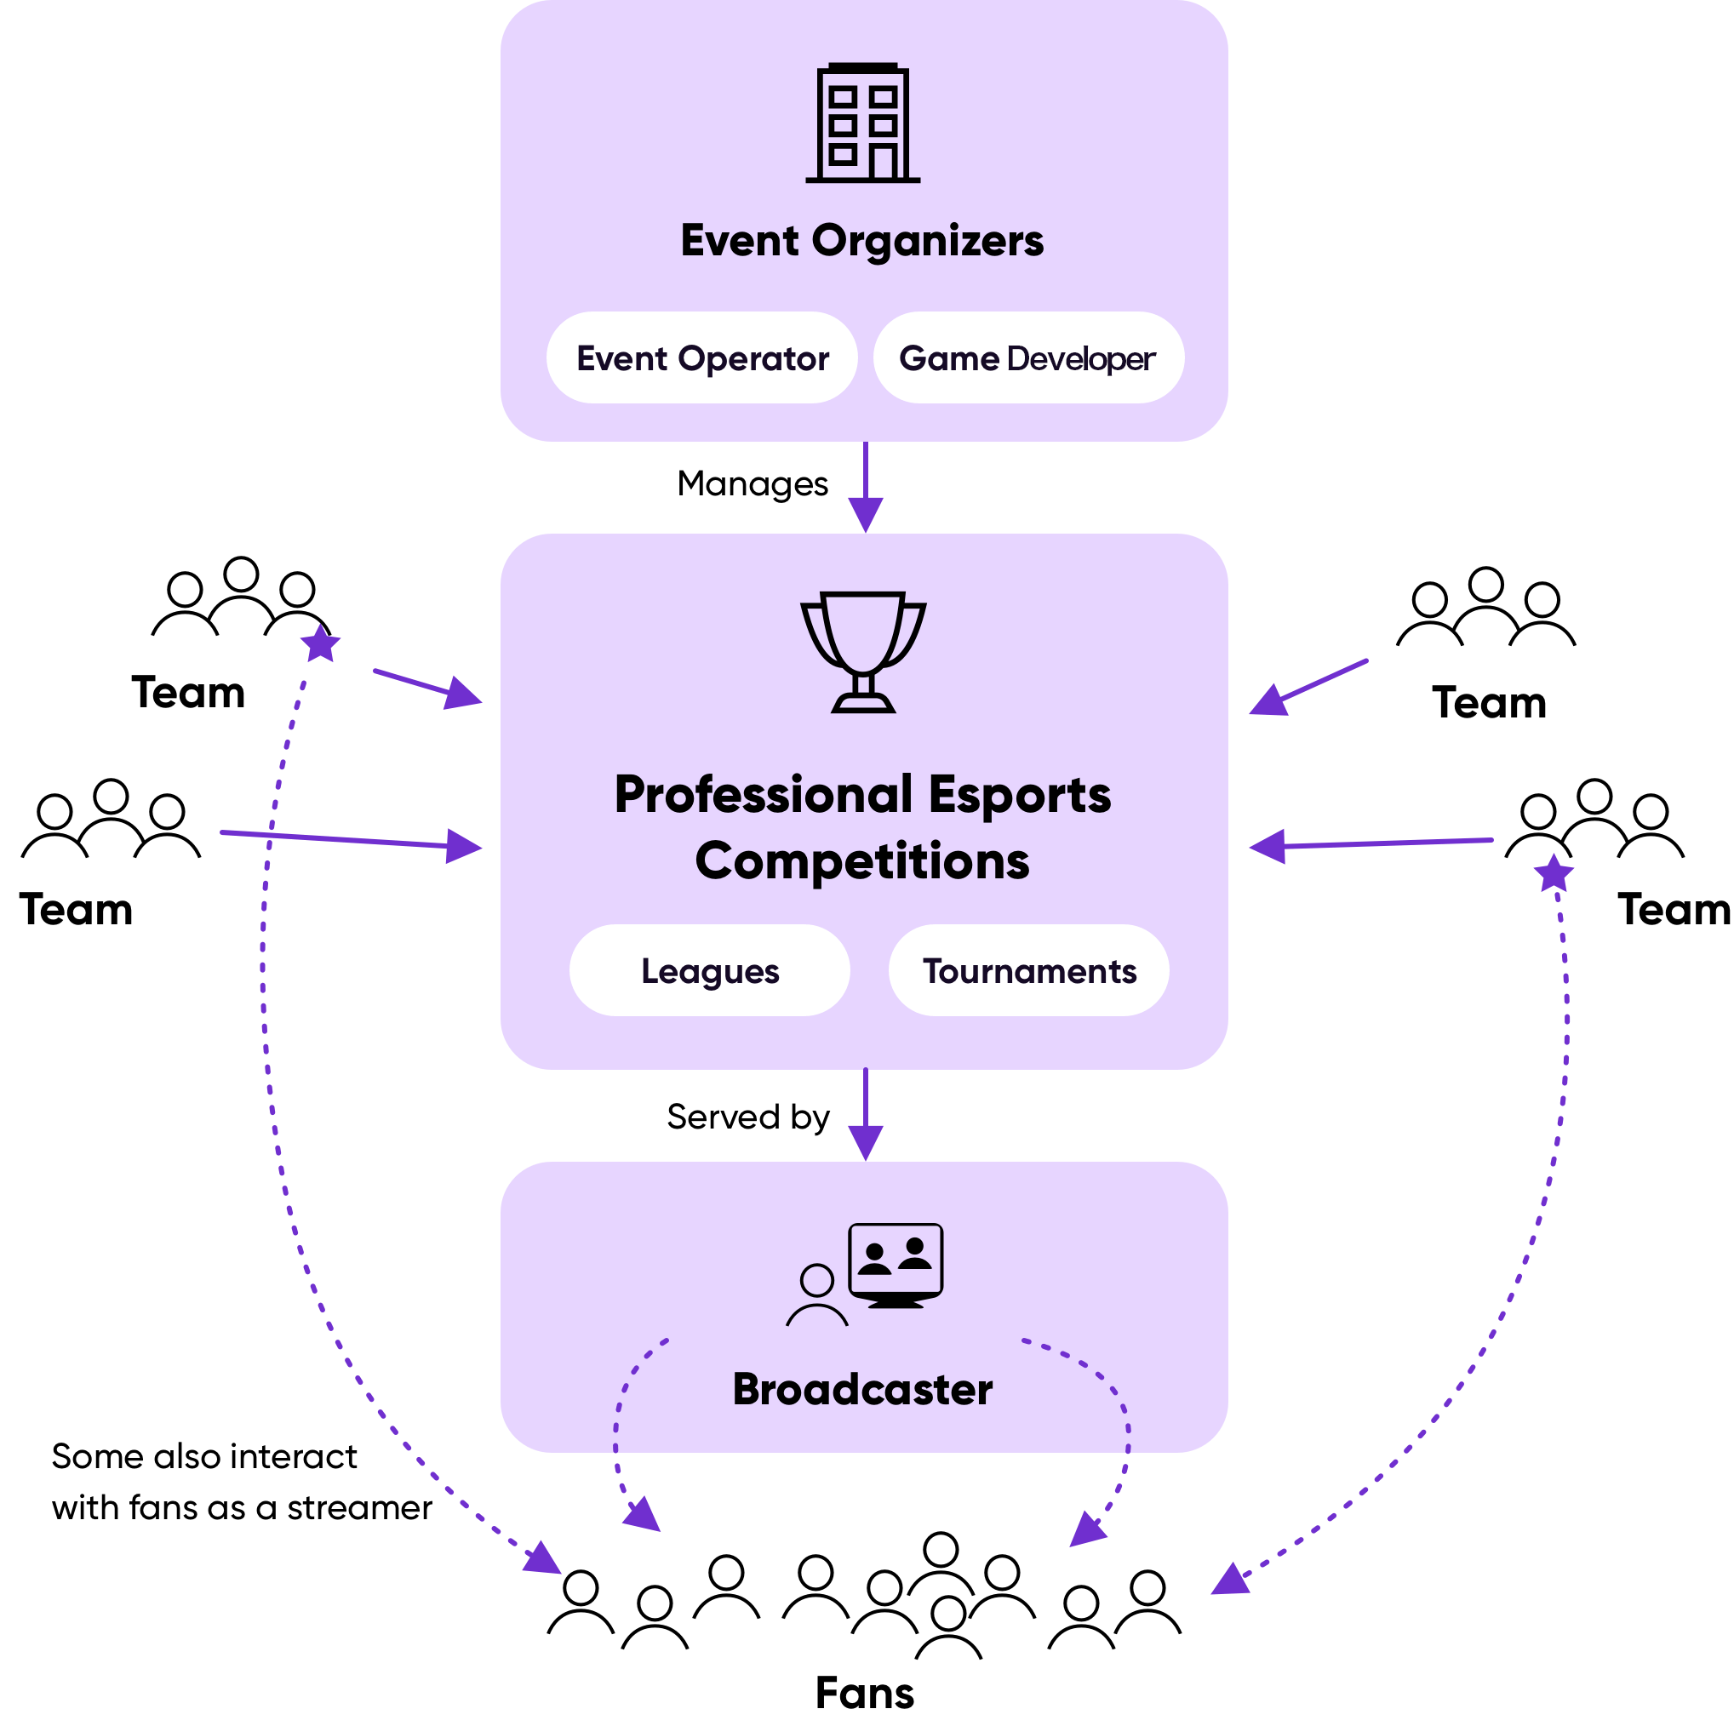

Source: Nielsen

We expect the esports market in the US to reach ~USD 233 million in 2022, down from USD 285 million in 2021 (an 18% YoY decline). The industry faced a dip in revenue in 2020, driven by Covid-led cancellations of live events. While this was counteracted by growth in esports viewership during the pandemic, the loosening of Covid-19 restrictions in 2022 has resulted in a dip in esports viewership. Nevertheless, we estimate that esports enthusiasts (core fans who watch professional esports content more than once a month) amount to 74.6 million in 2023. We further expect this to grow to ~132 million in 2028, reflecting a CAGR of 12.1%.

### **The esports ecosystem’s key segments**

| **Segment** | **Description** | **Examples** |
| --- | --- | --- |
| **Game developers** | Game developers are central to the ecosystem because they own the intellectual property and other rights to games. They exert considerable control over who can host leagues and tournaments using their games. They also leverage their central role to build leagues to; market, increase engagement, and extend their games’ shelf life | [Microsoft](https://sp-edge.com/companies/201465) (Activision Blizzard), [Valve Corporatio](https://sp-edge.com/companies/8662)n, [Riot Games](https://sp-edge.com/companies/6509), [Epic Games](https://sp-edge.com/companies/288018) |
| **Team organizations** | Similar to NCAA basketball, baseball and ice hockey teams, esports organizations can recruit players to form rosters to compete in tournaments and leagues in a variety of video games. | [FaZe Clan](https://sp-edge.com/companies/741374), [100 Thieves](https://sp-edge.com/companies/672695), [Guild Esports](https://sp-edge.com/companies/1152475) |
| **Broadcasting platforms** | These platforms are used for streaming individual player gameplay and esports events. This attracts core fans, leading to advertising revenue per view, and also builds a team's fan base to bring in sponsorships | [Alphabet](https://sp-edge.com/companies/314571) (YouTube), [Amazon](https://sp-edge.com/companies/203208) (Twitch), [Caffeine](https://sp-edge.com/companies/524591), [Genvid Holdings](https://sp-edge.com/companies/385357) |
| **Esports Infrastructure** | Companies operating esports arenas and providing technical expertise for hosting and broadcasting competitive leagues and tournaments | [Vindex](https://sp-edge.com/companies/816357), [ESE Entertainment](https://sp-edge.com/companies/1189868) |
| **Tournament platforms** | Companies facilitating competitive online and in-person esports tournaments. | [Skillz](https://sp-edge.com/companies/109523), [Game.tv](https://sp-edge.com/companies/870153), [Super League Gaming](https://sp-edge.com/companies/306402) |
| **Communication platforms** | Facilitate communication among esports players or between players and esports communities during gameplay. | [Discord](https://sp-edge.com/companies/319482), [Partie](https://sp-edge.com/companies/1246552), [Rune](https://sp-edge.com/companies/665977) |

## **Social media and advancing gaming infrastructure support esports audience growth**

**Growth in social media platforms:** The rapid penetration of social media platforms, such as Twitter, Facebook, and Instagram, has given rise to esports influencers. Social media allows players and teams to build up a following and directly interact with fans, thus boosting their value from an advertising and sponsorship perspective.

### **Esports teams' social media following comparable to that of large North American sports franchises**

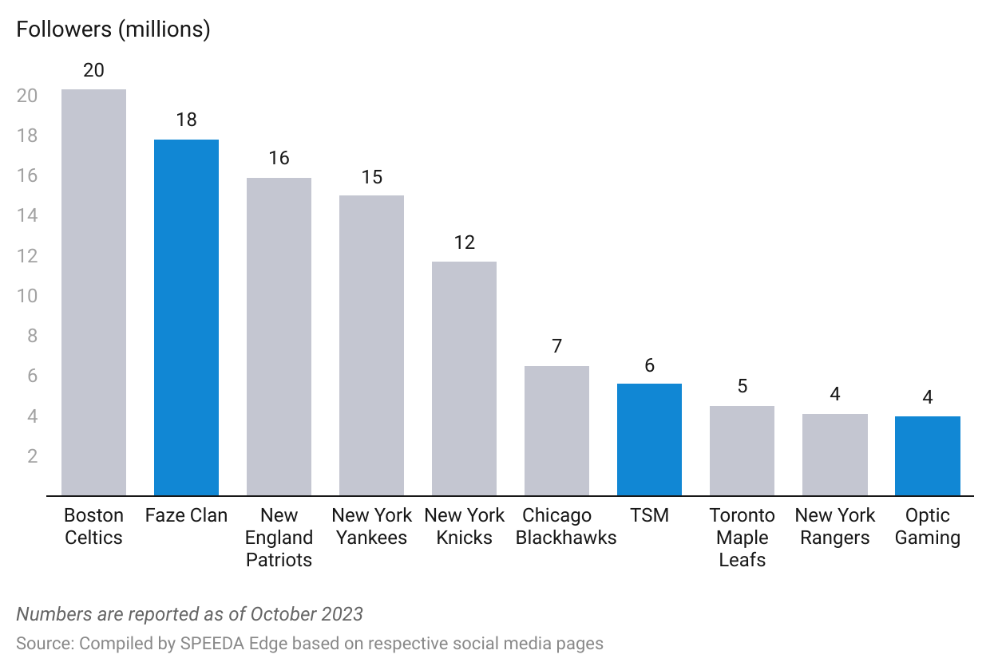

**Advancements in gaming infrastructure:** Advanced hardware (higher processing power and speed) in modern-day gaming consoles offers superior graphics and higher frame rates. The central processing unit (CPU) in the PlayStation 5 (released in November 2020), for instance, is ~90x faster and has 512x the memory capacity (RAM) of PlayStation 2 (released in 2000). This means game developers can use 3D modeling to build improved, more visually appealing video games.

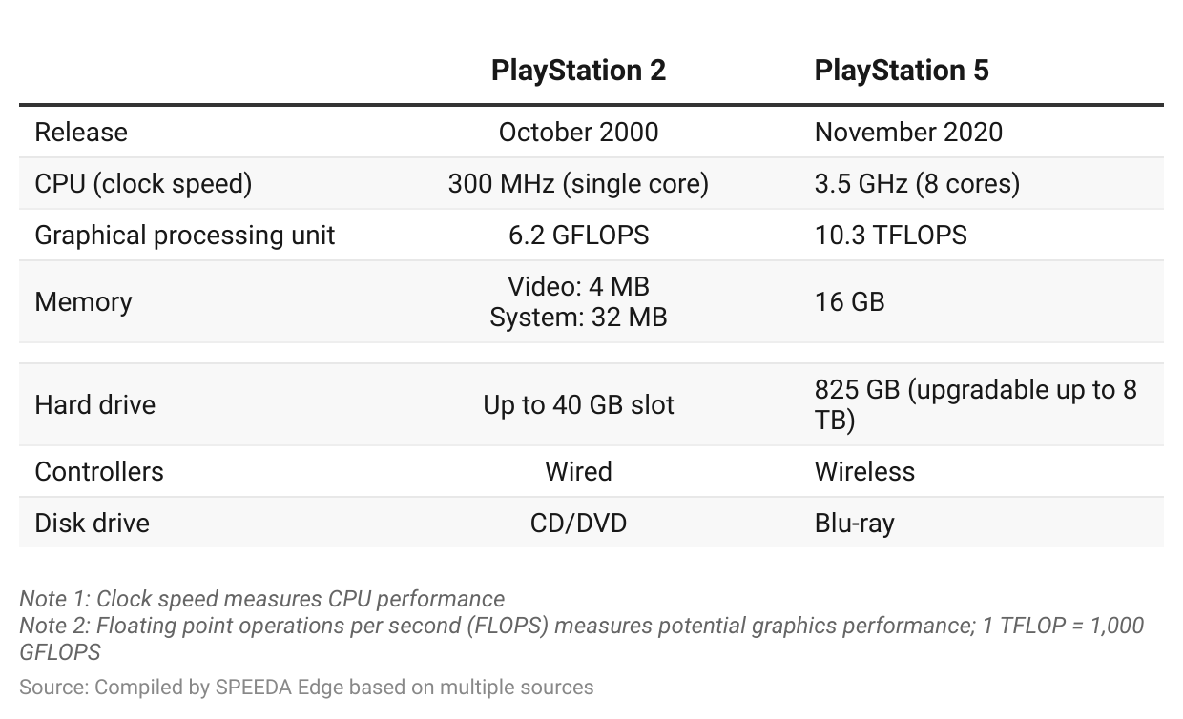

**Sponsorships and ads dominate teams’ revenue; player salaries and training dominate costs**

Much like traditional sports, esports team revenue is closely correlated with team performance, which drives audience size. Audience growth is the primary driver of sponsorship and ad revenue, forming the bulk of esports teams’ revenue. Player-related expenses (salaries and training) and marketing spend dominate costs. Most esports teams have not yet achieved profitability.

Esports team merchandise is also sold in traditional forms such as team-inspired apparel (jerseys, t-shirts, etc.) and gaming accessories (mice, headphones, mouse pads, etc.). For instance, the esports team [100 Thieves](https://sp-edge.com/companies/672695) has a lifestyle brand and continues to release merchandise in limited quantities at a premium price. It has also entered the gaming peripheral market through the acquisition of [Higround](https://sp-edge.com/sectors/education-and-media/updates/5982). Moreover, esports team organizations attempted to diversify revenue streams by expanding into content. OpTic Gaming’s [acquisition](https://sp-edge.com/updates/11761) of streamer monetization tool Botisimo and 100 Thieves’ [plans](https://sp-edge.com/updates/10570) to develop a video game were major announcements related to this in 2022. Below are expected revenue and cost items that would appear in an esports team’s income statement.

**Unique merchandising models and media rights for tournaments create additional revenue streams**

| **Item** | **Share of revenue** | **Details** |
| --- | --- | --- |
| Sponsorships | 50%–55% | - Sponsorships entail product placement during player live streaming, social media campaigns, and brand logo placements on team jerseys (similar to traditional sports) - Sponsors include endemic brands (Alienware, HyperX, Logitech G, etc.) and non-endemic brands (BMW, G Fuel, Red Bull, etc.) |
| Advertising | 20%–25% | - Teams share revenue from ads shown during esports events streamed on platforms such as Twitch |
| Merchandising | 6%–8% | - Purchasable, team-specific graphic designs or color schemes for playable characters created by game developers (called “in-game skins”). Teams get a revenue share of ~25%  - Team apparel and gaming peripherals  - NFTs and other digital assets |
| Ticket sales | 6%–8% | - Teams and organizers share ticket revenue from esports events |
| Media rights | 6%–8% | - Revenue share from tournament streaming (tournament streaming is done by teams as a whole, not individual players) |
| Tournament/League winnings | 2%–5% | - Prize winnings are split between teams and their players, where players take ~70%–90% - E.g., The Fortnite World Cup Winner in 2019 paid up to 20% of his USD 3 million prize money to his team (Sentinels) |

Source: Compiled by SPEEDA Edge based on various sources

**Costs dominated by player-related items and marketing spend**

| **Item** | **Share of cost** | **Comment** |
| --- | --- | --- |
| Player-related costs and marketing | 50% | **Player salaries:** Players are offered a contracted base salary, plus additional revenue based on the game the player is contracted to play. Player salaries have approximately doubled, with the average salaries in some leagues ranging between USD 240,000 and USD 480,000 in 2023 from USD 150,000 in 2017. |
|  |  | **Player accommodations/training costs** (i.e., gaming house system):  Some teams have built dedicated training facilities (e.g., Team Liquid, TSM) and have even partnered with real estate companies (e.g., 100 Thieves). |
|  |  | **Branding:** Marketing efforts to sustain and build a budding fan base |
| Other | 50% | **Support staff salaries:** Coaches and other non-technical staff |
|  |  | **Content creation cost:** Design team salaries, merchandising materials |

Source: Compiled by SPEEDA Edge based on various sources

## **“League franchising” aims to boost team revenues with hefty franchise fees**

Esports leagues have mainly followed a promotion/relegation model, where teams switch between leagues depending on their performance. Since 2018, however, Activision’s Overwatch and Call of Duty and Riot’s League of Legends have used a franchise model similar to traditional US sports leagues. Teams pay high franchise fees (USD 10 million-USD 60 million) to buy into these leagues and teams typically opt to buy franchise slots for the following purported benefits:

* **Larger sponsorship and media rights:** The franchise model eliminates the risk of being relegated, and supports brands’ confidence in esports, leading to long-term commitments to teams (via sponsorships) and potentially high-value media rights deals for leagues. Teams can also benefit as their share of media rights deals through revenue-sharing agreements increase. In the North American League of Legends Championship Series, teams are entitled to 32.5% of league revenues, with 50% distributed evenly, and the rest based on team standing and other predetermined factors.
* **Higher ticket and merchandise revenue:** City-based teams and home arenas, rather than neutral locations, should support esports ticket sales and revenue from merchandise, which fans are more likely to wear while attending competitions. League participation also provides additional merchandise revenue in the form of skins. For instance, Blizzard’s *Overwatch* league created team jerseys for its *Overwatch* characters to be purchased by fans at USD 5 per skin, with revenue split equally among the league's 12 teams.

# **Driving Factors**

## **1. Growing esports audience attracts advertisers and sponsors**

* The total global esports audience grew at a CAGR of 10.0% from 2017 to 2021, compared with the falling viewership of traditional pay-TV subscribers (-0.56% CAGR from 2017 to 2021).
* While 70% of esports enthusiasts are males aged 13–40, young adults in the US have continued to engage in “cord cutting” with only one-third (vs. 65% in 2015) of Americans between ages 18–29 and less than half (vs. 73% in 2015) between ages 30–49 consuming TV through cable or satellite.
* Esports streaming platforms (YouTube and Twitch) are catching up in viewership numbers compared to entertainment platforms such as Netflix, HBO, and ESPN.
* In 2022, the League of Legends World Final recorded 5.1 million peak viewers, up a million viewers from 2021. In comparison, the NBA Finals had a peak audience of 14 million and the MLB World Series averaged 14.7 million viewers.

### **Esports platform user numbers comparable to those of popular entertainment platforms globally**

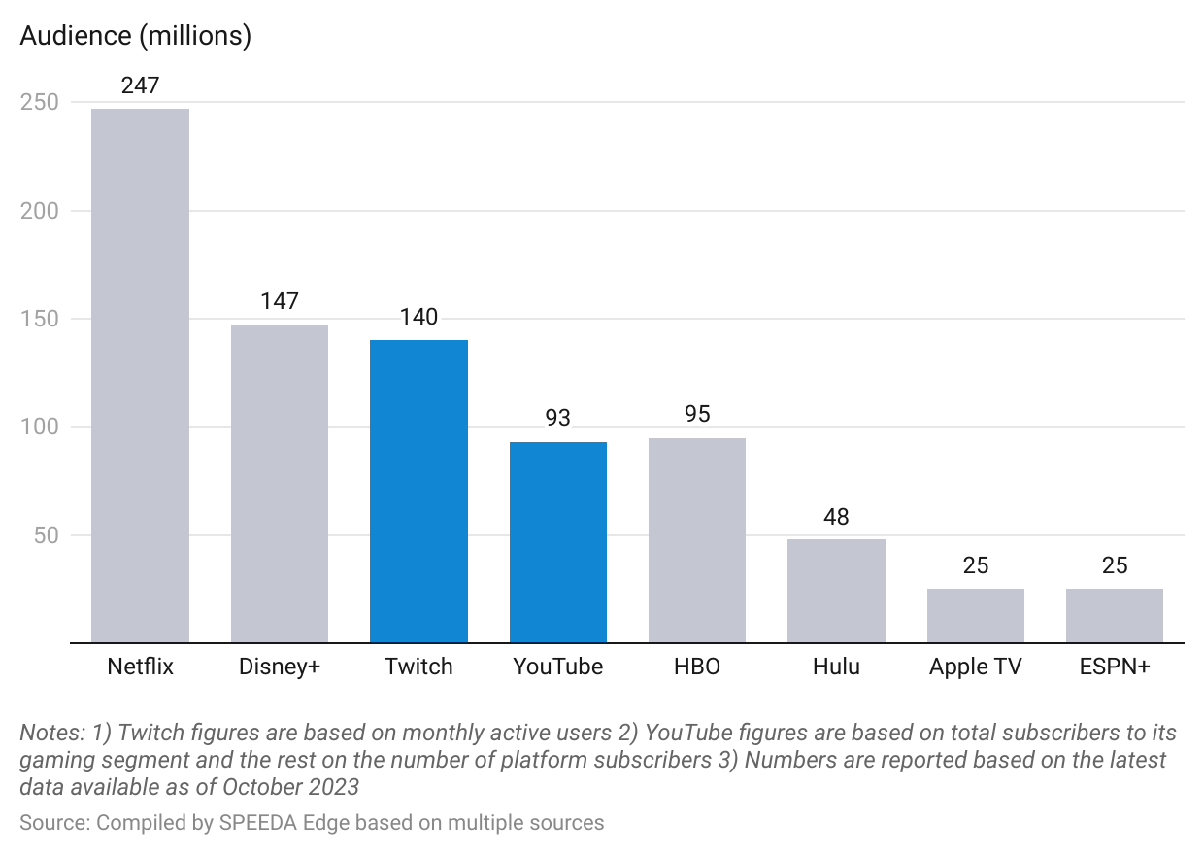

These factors present an opportunity for endemic brands (products directly associated with esports, such as PC hardware and gaming peripherals) and non-endemic brands (products unrelated to esports, such as food and beverages) to engage more with the male demographic that is leaving traditional TV. Esports' growing viewership compared with that of traditional sports events is driving sponsorships in the industry.

### **Major sponsorships announced in 2023 and 2022**

| **Date** | **Esports company** | **Partnered company** | **Summary** |
| --- | --- | --- | --- |
| October 13, 2023 | Cloud 9 | KIA America | To create new content and fan experiences for Cloud9's League of Legends team |
| October 12, 2023 | NRG Esports | KIA America | To add KIA's logo to NRG's official championship jerseys for the 2023 League of Legends World Championship in South Korea |
| October 10, 2023 | Berlin International Gaming | Yum! Brands | To incorporate Yum! Brand's subsidiary, Pizza Hut's, branding across BIG’s social media platforms to promote its Pizza Hut Melts product series |
| September 21, 2023 | DUX | PUMA | To become the official technical sponsor for DUX, providing equipment for DUX Logroño women’s football team and esports athletes |
| September 11, 2023 | Guild Esports | Sky | To become the official television partner of Guild Esports |
| July 17, 2023 | G2 Esports | Ralph Lauren | To release a collection of apparel items consisting of T-shirts, polo shirts, hoodies, tracksuits, and caps, bearing both brands' logos |
| July 13, 2023 | Tribe Gaming | AT&T | To 1) become the official telecom partner of Tribe Gaming, with its logo featured on the company's jerseys 2) collaborate for social media content creation |
| June 23, 2023 | Giants Gaming | Burger King | To renew its partnership with Burger King, which will see the fast food chain's logo be featured on the front of Giants jerseys and its social media platforms. |
| June 22, 2023 | Godsent | Philips | To extend its partnership with Philips which would feature its OneBlade product branding across Godsent's communication channels, player jerseys, and during broadcasts from Godsent content creators |
| June 14, 2023 | Team Vitality | KIA America | To enter into a two-year partnership for the creation of content focused on the League of Legends esports title |
| June 6, 2023 | T1 | Mercedes-Benz | To feature Mercedes’ branding on the jerseys of the T1’s League of Legends team, alongside hosting giveaways and other activations |
| May 10, 2023 | 100 Thieves | Subway | To make Subway the marquee sponsor its LCS League of Legends team, alongside other team jersey logo placements |
| April 21, 2023 | Gamers8 | Aramco | To make Aramco the sponsor of two esports events: Gamers Without Borders and Gamers8: The Land of Heroes |
| February 8, 2023 | TSM | Jersey Mike's | To offer fans sweepstakes for prizes, as well as launch a ‘Subs for Subs’ initiative. |
| February 6, 2023 | Williams Racing | Gulf Oil International | To enter into a multi-year partnership which will see the Gulf logo appear on the apparel of Williams Esports, and collaborate on activations |
| January 19, 2023 | FaZe Clan | Porsche | To enter into a multi-year partnership, with Porsche becoming the official partner for its esports teams, providing a new Porsche-themed gaming room for its players, as well as Porsche-branded merchandise for fans |
| November 29, 2022 | Excel Esports | INZONE | The one-year deal saw INZONE become the official gaming headset and monitor partner for Excel Esports. |
| October 07, 2022 | Revenant Esports | PUMA | The deal saw PUMA become the official kit supplier for all Revenant Esports teams and their content creators. |
| September 20, 2022 | Gen.G | Bose | Bose became the official audio lifestyle partner of Gen.G and sponsored Gen.G’s NBA 2K team and collaborated on new content. |
| August 18, 2022 | Team Vitality | GG.Bet | GG.BET became the official international betting partner for Team Vitality. |
| July 21, 2022 | Guild Esports | Coca-Cola | The one-year deal saw Coca-cola become the official soft drink and hydration partner of Guild Esports. |
| June 17, 2022 | Team Liquid | Honda | The multi-year deal gave Honda naming rights to the esports organization’s League of Legends franchise and academy teams. |
| June 13, 2022 | Team Vitality | Garnier | The two-year deal saw Garnier become the official hair care supplier of the esports organization. |
| May 23, 2022 | FaZe Clan | Disney | The companies announced a one-year apparel collaboration, which included a line of t-shirts, sweatshirts, and hats. |
| April 22, 2022 | Riot Games | Santander Bank | Riot Games announced a five-year deal with Santander Bank covering the League of Legends esports ecosystem in Brazil. |
| March 17, 2022 | Guild Esports | Razer | Razer became the official gaming chair partner for the esports organization. Razer was also featured across Guild's social media and digital content. |
| March 11, 2022 | Misfits Gaming Group (MGG) | Tezos | The company became MGG's official blockchain partner, supporting the launch of MGG's blockchain gaming platform Block Born. |
| February 9, 2022 | Immortals Gaming Club | Bitstamp | The three-year partnership saw Bitstamp become the esports organization’s official cryptocurrency exchange as well as a “founding partner.” The partnership also included a series of activations. |
| February 3, 2022 | OverActive Media | Nobis | The Canadian apparel brand became the official outerwear partner for OverActive's Toronto-based teams Toronto Ultra and Toronto Defiant. |
| January 18, 2022 | Guild Esports | Bitstamp | The three-year partnership worth GBP 4.5 million (~USD 6.1 million) with crypto exchange Bitstamp was the team’s largest esports deal. Bitstamp branding was to feature on Guild player jerseys, digital content, and its London headquarters. |
| January 14, 2022 | Excel Esports | JD SPORTS | JD SPORTS branding was featured across Excel Esports jerseys, while it also secured the naming rights to Excel’s academy roster, which was renamed JDXL. |
| January 13, 2022 | Immortals Gaming Club | Progressive Corporation | The multi-year naming rights deal with the insurance provider was centered around the esports organization's League of Legends team, which was renamed Immortals Progressive. |
| January 12, 2022 | Fnatic | L’Oréal | In addition to the L’Oréal Men Expert’s logo placement on the Fnatic team jerseys, both entities planned to develop content and product activations. |

Source: Compiled by SPEEDA Edge based on multiple sources

Note: The above is not an exhaustive list of sponsorships announced in 2023 and 2022

## **Esports’ risk-return profile is favorable for investors**

The industry has seen an influx of investments in esports by players and owners from other professional sports leagues. Notable investments include those from NBA stars Michael Jordan (Team Liquid) and Steph Curry (Team SoloMid), and former NFL player Steve Young (Team SoloMid). Esports investments have a favorable risk-return profile driven by the following factors:

* The industry is under-monetized compared with other professional sports. Esports ranks last among peers in terms of revenue per enthusiast viewer (active fan).
* Esports team valuations are lower than those of other professional teams. NBA, NHL, MLB, and NFL teams on average cost USD 2.6 billion to acquire, compared with an average of USD 353 million for an esports team.
* Esports players' annual salaries (USD 50,000 to USD 410,000 on average) are significantly lower than other professional athletes’ salaries (NBA: USD 8.3 million, NFL: USD 3.3 million, MLB: USD 4 million).

### **Esports under-monetized compared with other professional sports leagues**

### 

### **High prize pools for esports league tournaments**

Despite the esports prize pools falling 7% YoY to USD 239.7 million in 2022, it grew at a ~16% CAGR from 2016 to 2022. With prize pools having recovered from their lows in 2020 due to the cancellations of live events, the industry’s increasing prize pools and lucrative prospects can attract more players, helping boost viewership and ultimately industry revenue.

The Dota 2 championship The International (TI) recorded the highest prize pool across all esports events in 2022 at USD 18.9 million. This was, however, a steep drop from its 2021 prize pool of USD 40 million, given a lower frequency of in-game microtransactions, which contributed to a five-year CAGR of -5.3%. Despite the lower prize pool, its size is comparable to The Masters (golf tournament) and The Indy 500 (automobile racing).

### **Large prize pools aim to capture greater interest from players and audiences**

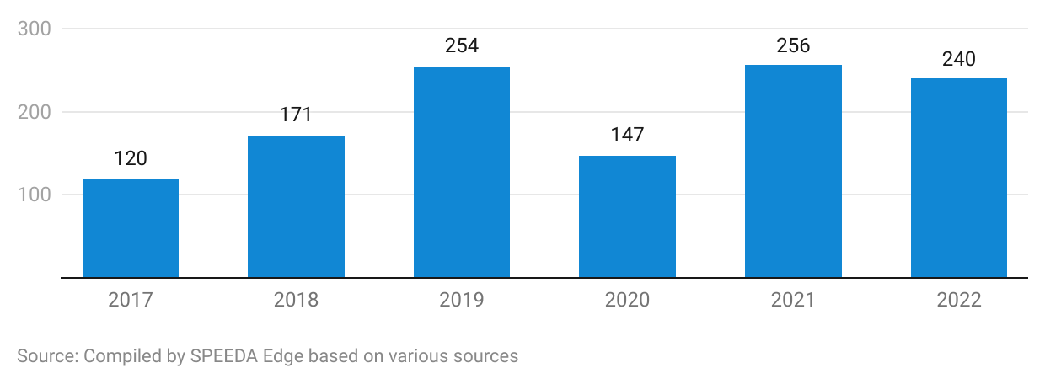

# **Risks to Growth**

## **High upfront costs and sustainability of titles a threat to esports team organizations’ profitability**

Esports organizations require significant upfront investments for building out rosters with top talent; state-of-the-art training facilities and accommodation can cost as much as USD 35 million. Substantial capital is also needed for buy-ins for some franchise leagues, which can cost as much as USD 25–60 million upfront. These high upfront costs are a risk to profitability unless an organization can top a large number of tournaments and leagues to attract additional sponsorship revenue.

The declining viewership of older games is also a challenge as new titles are released. Established esports teams can lose their relevance and see sponsorships dry up as they fall behind the new releases. Companies need to draft new rosters to compete in newer titles, incurring the upfront costs of building a new team. The sustainability of titles, or lack thereof, could mean some esports companies may never realize returns on their investment for some of their rosters.

## **Esports gamers and tournaments vulnerable to cybercrime**

The ascension of the esports industry makes it a prime target for cybercrime groups. Gamers are susceptible to ransomware attacks that lock them out of their gaming profiles; they are likely to pay ransoms as the profiles account for hundreds of hours of saved gameplay. Additionally, the increasing amount of microtransactions and in-game purchases can attract malware that steals account credentials and credit card information.

Esports tournaments are also affected by distributed denial of service (DDoS) attacks that disrupt games by causing latency issues (when every second is critical to a game’s outcome). These attacks cause revenue losses for tournament organizers, sponsors, and teams. There have been instances of DDoS attacks on high-profile tournaments such as The International Dota 2 Championship in 2015, which had a prize pool of USD 18 million.

## **Professional gamers’ mental and physical health could deter growth in gamer pipeline**

Players are the esports industry’s main assets, so their health and safety are vital. Professional gamers practice close to 80 hours a week and face substantial mental and physical stress, potentially causing burnout and even leading gamers into retirement by their mid-20s.

Physical health issues, such as chronic pain in the wrist, back, and neck, can arise from poor posture and can ultimately shorten careers. A survey of collegiate-level esports gamers showed that the most frequently reported complaint was eye fatigue (56%), followed by neck and back pain (42%). Constant repetitive motions on a keyboard or a controller can lead to carpal tunnel syndrome. Excessive consumption of caffeine and sugar and the sport’s sedentary nature can lead to metabolic dysregulation. Esports gamers are also more likely to experience depression and anxiety as their every move is criticized via social media.

## **Industry vulnerable to advertising regulations**

In November 2020, the UK Government proposed a ban on the online advertising of high fat, sugar, and salt products (HFSS) as part of its obesity strategy announced in July 2020. Under the regulation, organizations marketing HFSS products on social media should ensure that they are seen by users actively seeking them and that ads should not be directed at viewers under the age of 16. The regulations were partly imposed in October 2022, with additional regulations coming into force by 2025.

This could have an adverse impact on the esports industry’s sponsorship revenue (the largest share of total revenue) through its effect on 1) social media content created by HFSS brands (i.e., Red Bull, Monster, G Fuel) sponsoring esports teams such as FaZe Clan, G2 Esports, Cloud9, and Team Liquid, 2) in-game advertisements and tournament partners established by publishers, and 3) advertising revenue arising from online live streaming platforms. Furthermore, there is a possibility that other countries may implement similar regulations, which could impact the industry’s long-term growth.

## **Match-fixing and e-doping draw negative publicity to the industry**

The esports industry is witnessing cases of match-fixing and e-doping, with a string of scandals affecting titles such as Dota 2, Counter-Strike, League of Legends, and Overwatch. Match-fixing involves players intentionally losing games to benefit bets made against them; whereas e-doping is the use of software to gain an unfair advantage against opponents. In May 2022, several players were implicated in match-fixing scandals across Counter-Strike and League of Legends. Furthermore, in March 2023, 46 players were banned from Dota 2 esports events for using vision hacks in tournament matches. These instances can create doubt surrounding the integrity of esports competitions and could lead to the loss of fan interest.

*Last updated: November 2023*

©2024 Uzabase, Inc. All Rights Reserved. The information contained herein: (1) is proprietary to Uzabase Inc. and/or its content providers; (2) may not be copied or distributed; and (3) is not warranted to be accurate, complete or timely. Neither Uzabase Inc. nor its content providers are responsible for any damages or losses arising from any use of this information.