**Cloud Tech (Q2 2024): Funding rebounds amid IBM’s HashiCorp and RHEL AI plays**



*This Insight covers quarterly updates on Cloud Tech and focuses on our coverage of the* [*Cloud-native Tech*](https://sp-edge.com/industry/170)*,* [*Cloud Optimization Tools*](https://sp-edge.com/industry/128)*,* [*Serverless Computing*](https://sp-edge.com/industry/25)*, and* [*Edge Computing*](https://sp-edge.com/industry/33) *industry hubs.*

# 

# 

# 

# Key takeaways

* **Funding**
  + **Edge Computing mega rounds stood out:** Cloud Tech funding reached its highest in the past three years, raising USD 3.7 billion across 19 funding rounds (+4x QoQ and +1.5x YoY). Edge Computing accounted for ~82% of the total raised, led by [EdgeConneX](https://sp-edge.com/companies/51144)’s (USD 1.9 billion) and [DataBank](https://sp-edge.com/updates/28498)’s (USD 725 million) large-debt rounds to expand global data center capacity. Other Edge Computing startups [Yondr](https://sp-edge.com/updates/29959), [Hailo](https://sp-edge.com/updates/28115), and [Blaize](https://sp-edge.com/updates/29003) also raised USD 100 million+ each, with a notable shift toward growth-stage rounds. Funding in Cloud-native Tech, Serverless Computing, and Cloud Optimization Tools saw significant gains, with Cloud Optimization Tools experiencing an exceptional 45x YoY growth.
* **Product updates**
  + **Red Hat launched RHEL AI:** Red Hat Enterprise Linux AI ([RHEL AI](https://sp-edge.com/updates/29181)) enables the efficient, flexible deployment of AI models at the edge by providing optimized container images, hybrid cloud capabilities, and seamless integration with enterprise IT operations. It simplifies scaling AI across distributed edge environments, accelerating the adoption of AI-powered applications in resource-constrained, distributed settings.
  + **Focus on edge AI hardware innovation:** The edge AI landscape witnessed a flurry of new chip releases, with [EdgeCortix](https://sp-edge.com/updates/29739), [Hailo](https://sp-edge.com/updates/28101), and [Kneron](https://sp-edge.com/updates/30099) introducing advanced edge AI accelerators and servers. Incumbents like Intel and AMD also made significant advancements, with Intel launching edge-optimized [CPUs, GPUs, and FPGAs](https://sp-edge.com/updates/28301) and AMD unveiling its [Versal adaptive SoC](https://sp-edge.com/updates/28366). Alongside these hardware innovations, we noted numerous product announcements focused on enhancing Kubernetes adoption and capabilities in Cloud-native Tech.
* **Partnerships**
  + **Simplifying AI deployments and enhancing edge management:** Collaboration between incumbents and disruptors aimed to simplify and enhance AI deployments and edge management. Noteworthy partnerships included [Vapor IO and VAST Data](https://sp-edge.com/updates/29002) integrating edge and core AI systems and Red Hat with [Intel](https://sp-edge.com/updates/29309), [Cloudera](https://sp-edge.com/updates/29311), [Veeam](https://sp-edge.com/updates/29347), and Nutanix to bolster AI, security, and virtualization. Additionally, [Dell partnered with Nvidia](https://sp-edge.com/updates/29818) to accelerate edge AI adoption.
* **M&A**
  + **IBM acquired HashiCorp:** IBM's acquisition of HashiCorp for [USD 6.4 billion](https://sp-edge.com/updates/28730) was a strategic move to enhance its hybrid cloud and AI capabilities. By integrating HashiCorp's tools into its Red Hat OpenShift platform, IBM plans to offer customers greater flexibility in cloud deployments. The combination of IBM's expertise (including [Red Hat](https://sp-edge.com/companies/6078)) and HashiCorp's security and management solutions is expected to create a holistic platform tailored for the AI era, strengthening IBM's position in the rapidly evolving cloud and AI market.
  + **Cloud-native Tech and Serverless Computing dominate activity:** We tracked nine other M&A deals, primarily in Cloud-native Tech and Serverless Computing. Harness bolstered its product portfolio by [acquiring Split Software](https://sp-edge.com/updates/29964), further strengthening its acquisition-driven growth strategy. Other notable transactions included EQT's [purchase of WSO2](https://sp-edge.com/updates/29112), Timescale's [acquisition of PopSQL](https://www.prnewswire.com/news-releases/timescale-acquires-popsql-to-bring-a-modern-collaborative-sql-gui-to-postgresql-developers-302108558.html), and SUSE's [buyout of StackState](https://sp-edge.com/updates/30568).
* **Outlook**
  + As the cloud and Edge Computing industries continue to evolve, several critical developments are shaping the landscape for GenAI adoption. Key players like Red Hat, SUSE, NVIDIA, AMD, and Intel have unveiled innovative products and platforms to enable the deployment of GenAI models across hybrid cloud and edge environments.
  + Red Hat's RHEL AI and OpenShift AI, for instance, aim to make open-source AI more accessible and enterprise-ready, while partnerships between companies like VaporIO, Dell, and Red Hat are positioning them to capitalize on the GenAI revolution. Additionally, cloud optimization tools are increasingly incorporating AI-based features, such as Red Hat's "Lightspeed" and [CAST AI](https://sp-edge.com/companies/849470)'s AI Advisor, to enhance cloud resource management and governance.
  + These developments suggest a growing focus on making GenAI more scalable, cost-effective, and user-friendly across diverse cloud and edge computing setups, potentially removing key bottlenecks.

# IBM expands cloud and AI capabilities with HashiCorp acquisition and RHEL AI launch

## IBM acquired HashiCorp

IBM announced the acquisition of [HashiCorp](https://sp-edge.com/companies/252953), a leading provider of multi-cloud infrastructure automation solutions, for USD 6.4 billion.

The acquisition aligns with IBM's goal of creating a holistic hybrid cloud platform designed for the AI era. By integrating HashiCorp's cloud-agnostic infrastructure provisioning and management tools, such as Terraform, into its Red Hat OpenShift platform, IBM aims to provide customers with greater flexibility in their cloud deployments. Additionally, HashiCorp's Vault, a security product for managing sensitive data, can be leveraged to drive revenue growth in IBM's existing accounts and introduce the broader HashiCorp portfolio to new customers.

The acquisition also addresses some challenges HashiCorp has faced in its transition to a SaaS-based subscription model, as IBM's resources and expertise can help the company refocus on its core strengths and deliver value to customers more effectively.

## Red Hat launched RHEL AI

Red Hat Enterprise Linux AI (RHEL AI) is a new platform from Red Hat that makes it easier for businesses to use and develop AI technologies. It combines Red Hat's popular Enterprise Linux operating system with open-source AI models and tools, allowing companies to run and customize AI applications easily on their existing IT infrastructure.

RHEL AI includes AI models called "Granite" from IBM Research, which can be fine-tuned by domain experts using the InstructLab project. It also provides tools for deploying AI models across on-premises servers and public clouds. By making AI more accessible and customizable, RHEL AI aims to accelerate the adoption of AI across various industries

**Red Hat Enterprise Linux AI development stack**

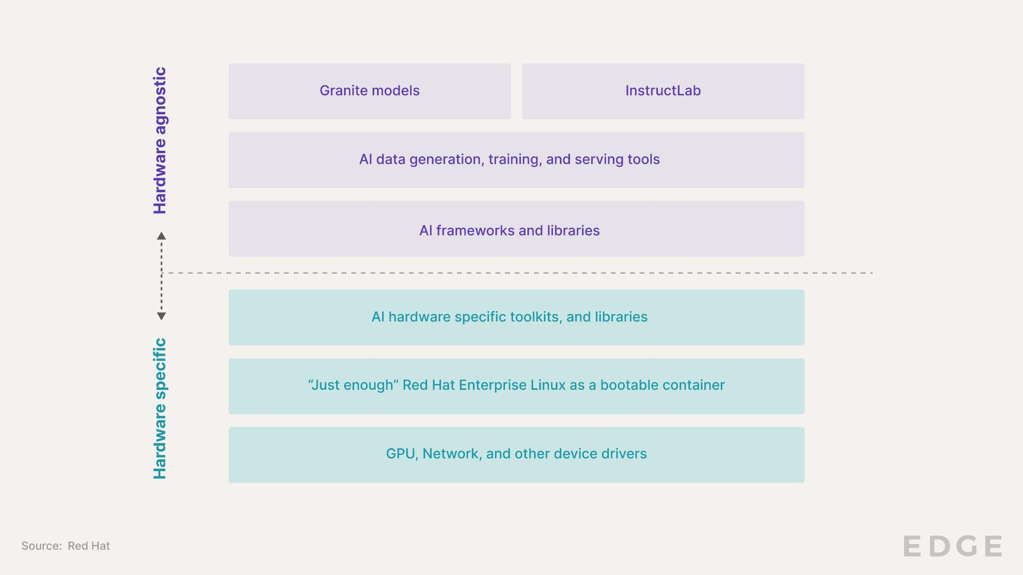

# RHEL AI aims to make AI development more accessible, customizable, and scalable

Red Hat’s recent announcements introduced solutions across the AI application development value chain. Together, IBM and Red Hat have strategically positioned their AI offerings to address key challenges in GenAI adoption by enterprises.

**Granite LLMs:** IBM's open-source large language models (LLMs) provide a strong foundation for AI applications. By offering Granite models under the Apache 2.0 license, IBM and Red Hat enhance transparency and accessibility over proprietary models. The training datasets are transparent, helping users understand the models' capabilities and limitations.

**InstructLab:** This open-source project, based on IBM's LAB methodology, allows developers to improve Granite models by adding skills. InstructLab removes the need for costly human annotations, making AI development more accessible.

**RHEL AI Container Images:** These optimized container images for Red Hat Enterprise Linux create a ready runtime environment for AI models across various hardware platforms.

**OpenShift AI:** Red Hat's hybrid MLOps platform enables organizations to scale Granite models, InstructLab, and RHEL AI across distributed environments, utilizing Kubernetes for efficient model management.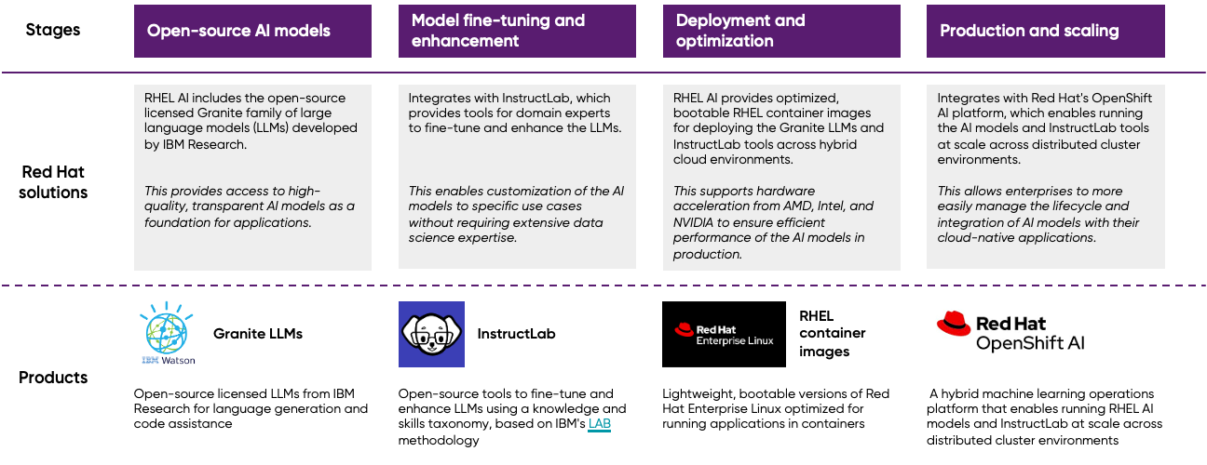

# Funding: Edge Computing mega rounds stand out; Cloud Optimization Tools makes a comeback

**Analyst Take:** Cloud Tech startups raised USD 3.7 billion during Q2 2024. This figure significantly exceeded the average quarterly funding of USD 1.3 billion over the past three years. The resurgence in cloud tech funding mirrored the broader [uptick](https://news.crunchbase.com/data/global-funding-ai-biotech-h-2024/) in global venture funding during this period.

Mega rounds from Edge Computing startups stood out, with [EdgeConneX](https://sp-edge.com/companies/51144)’s USD 1.9 billion and [DataBank](https://sp-edge.com/companies/62294)’s USD 725 million debt rounds to expand global data center capacity comprising ~70% of total Q2 funding. There was also a notable shift toward growth-stage funding, with [Yondr](https://sp-edge.com/companies/1356537), [Hailo](https://sp-edge.com/companies/645206) and [Blaize](https://sp-edge.com/companies/427341) each raising USD 100 million+. Yondr also plans to use the funds for data center expansion, while Hailo, and Blaize focus on advancing GenAI at the edge.

Other notable rounds included [Vercel](https://sp-edge.com/companies/600588)’s USD 250 million in Series E funding to advance AI-powered website generation and security products and [Harness](https://sp-edge.com/companies/530924)’ USD 150 million in debt funding to enhance its platform with GenAI and acquire [Split Software](https://sp-edge.com/companies/370464).

**Cloud Tech funding mix Q2 2024 (USD million)**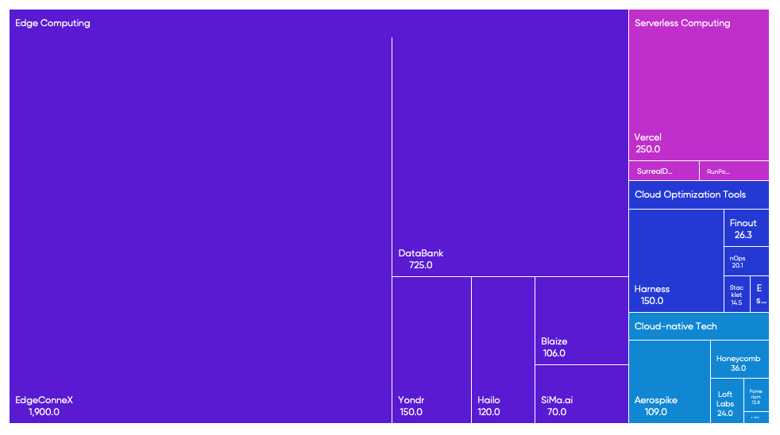

Source: Funding data powered by Crunchbase

* The funds raised, excluding DataBank and EdgeConneX, experienced a significant 3x QoQ growth, helping funding reach parity with the Q2 2023 level
* The median funding round size in Q2 2024 reached USD 48 million, a significant 2x increase from the previous quarter. This figure was also substantially higher than the trailing 3-year median round size of USD 18 million.

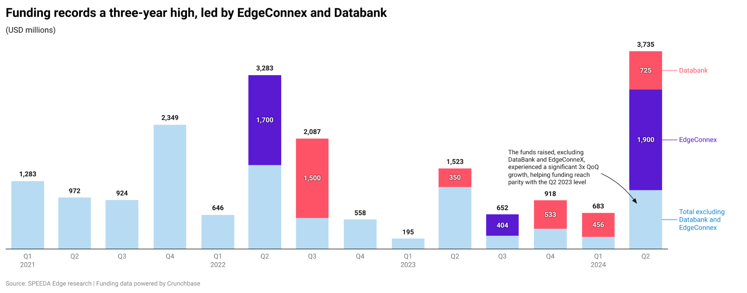

* Funding across all industry hubs saw significant gains, led by Edge Computing, which raised USD 3.1 billion, growing +4x QoQ (+128% YoY). This was followed by Serverless Computing with USD 290 million, a growth of +6x (+190% YoY). Cloud Optimization Tools raised USD 222 million after a dismal USD 12 million over the past three quarters. Cloud-native Tech grew a relatively moderate 15% QoQ to raise USD 152 million (+230% YoY).

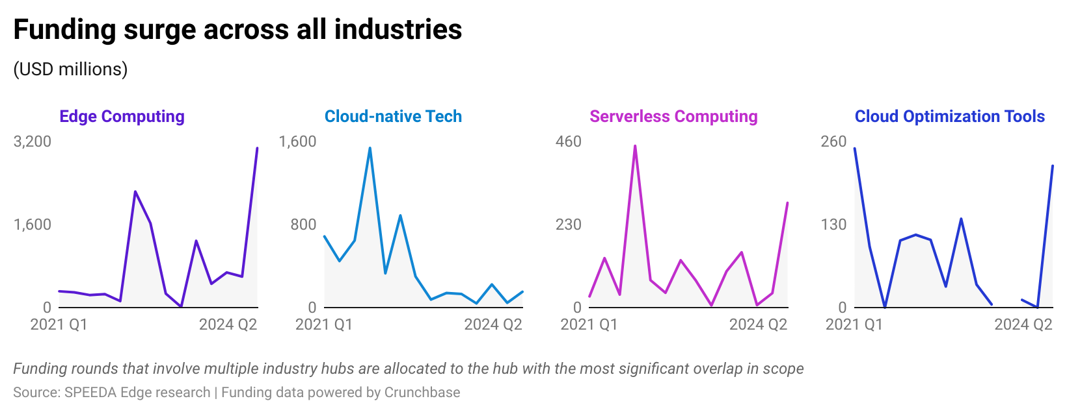

* Growth rounds dominated the quarter, totaling USD 3.6 billion (highlighted by mega rounds from EdgeConneX and DataBank) and supported by Series C or later rounds from Hailo, SiMa.ai, Blaize, Aerospike, and Vercel.

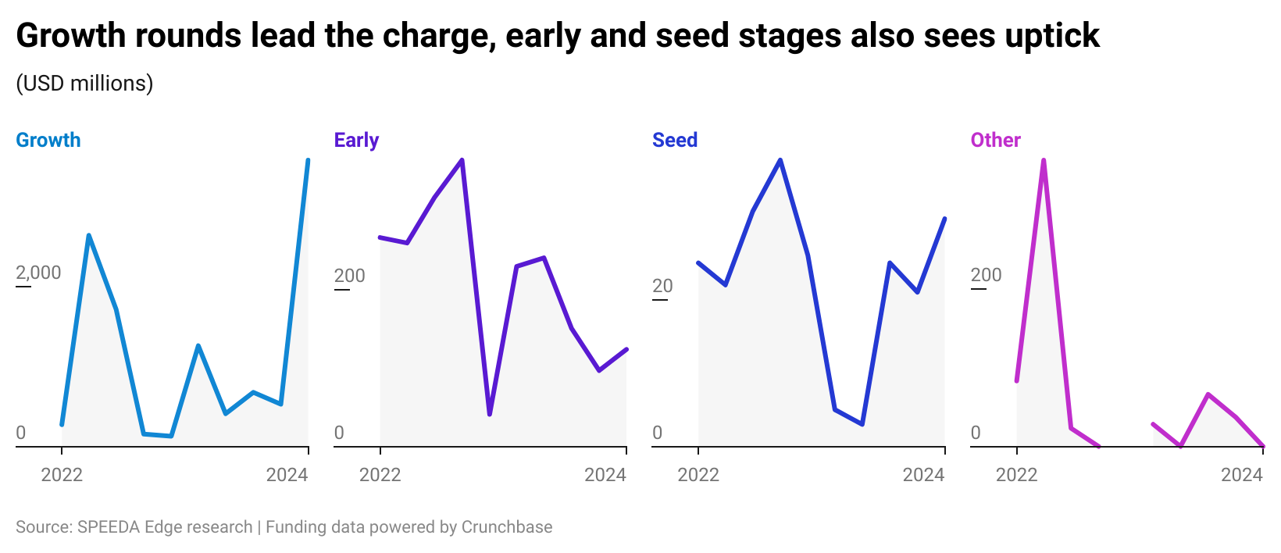

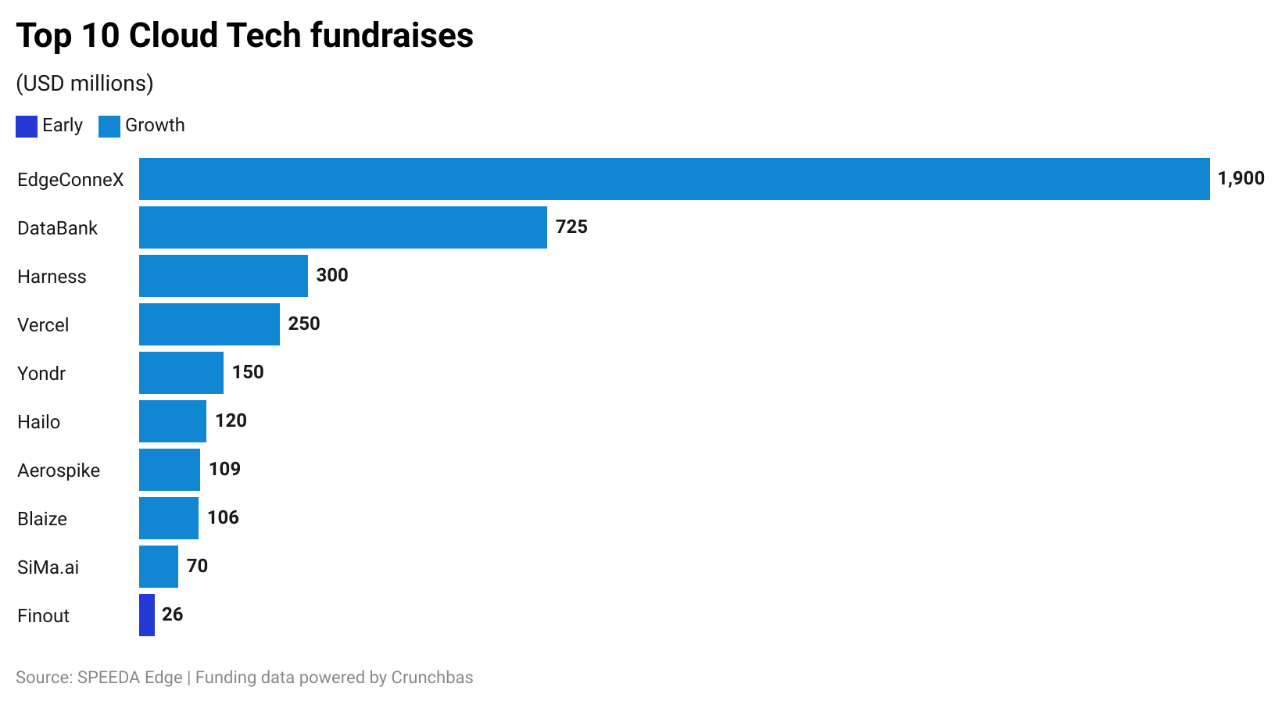

# Product updates: Edge AI ecosystem energized by a wave of hardware releases

**Analyst Take:** IBM’s (Red Hat) release of RHEL AI underscores its focus on hybrid cloud as a key enabler of AI. Unlike other tech giants developing proprietary approaches, IBM positions itself as an "open hybrid/multi-cloud provider" that can integrate with competitors' cloud services (AWS, GCP, Azure). By combining infrastructure automation, a leading enterprise Linux distribution, and AI capabilities, IBM aims to provide a holistic solution for enterprises looking to harness AI while maintaining control over their IT environments.

Meanwhile, edge AI chips from companies like [EdgeCortix](https://sp-edge.com/companies/781961), Hailo, [Kneron](https://sp-edge.com/companies/569645), Intel, and AMD enable powerful GenAI capabilities on resource-constrained edge devices. These chips accelerate LLMs and multi-modal AI workloads, enabling hybrid cloud-edge architectures that leverage the strengths of both. Software-driven approaches, particularly from EdgeCortix, are democratizing GenAI access by allowing the deployment of edge AI capabilities on existing hardware systems while providing flexible, updatable edge AI solutions that can continuously evolve to meet changing needs.

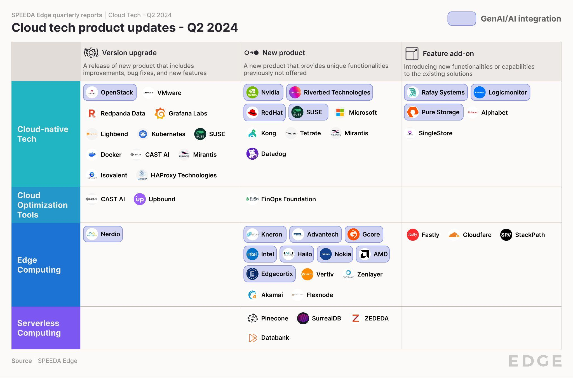

* **Cloud Tech-GenAI integration took center stage.** Numerous disruptors and incumbents persistently incorporated GenAI technologies into their product offerings, while many released products and services to facilitate GenAI workloads.

| **GenAI use case** | **Company** | **New developments** | **Industry** |
| --- | --- | --- | --- |
| Products to facilitate Gen AI workloads | Red Hat | Red Hat is bolstering its AI and machine learning capabilities across its products. The company has launched [RHEL A**I**](https://sp-edge.com/updates/29181), a foundation model platform combining RHEL, open-source Granite models, and InstructLab to simplify working with open-source AI. **Red Hat OpenShift AI** now enables deploying models to edge environments via single-node OpenShift, allowing both predictive and GenAI on a single platform to reduce costs. Additionally, [Podman AI](https://www.redhat.com/en/about/press-releases/red-hat-announces-podman-ai-lab) Lab provides developers with local workspace to build GenAI apps using sample models before deployment to OpenShift/Kubernetes | Cloud-native tech, Edge computing |
|  | NVIDIA | Unveiled [NVIDIA NIM](https://sp-edge.com/updates/30032), a service offering inference microservices for deploying GenAI applications | Cloud-native tech |
|  | SUSE | Announced its AI strategy and [SUSE AI](https://techcrunch.com/2024/06/18/suse-wants-a-piece-of-the-ai-cake-too/) solutions, a new vendor- and LLM-agnostic GenAI platform | Cloud-native tech |
|  | Intel | Launched a series of new [chips and FPGAs](https://sp-edge.com/updates/28301) aimed at expanding AI capabilities to the network edge, including several edge-optimized CPUs and GPUs and the Agilex 5 Series FPGAs | Edge computing |
|  | AMD | Expanded its [Versal adaptive SoC](https://sp-edge.com/updates/28366) portfolio with AI Edge Series Gen 2 and Prime Series Gen 2 | Edge computing |
|  | Edgecortix | Unveiled the [SAKURA-II](https://sp-edge.com/updates/29739) edge AI accelerator to handle GenAI tasks efficiently and effectively, especially in restrictive environments at the edge | Edge computing |
|  | Hailo | Launched the [Hailo-10](https://sp-edge.com/updates/28115) high-performance GenAI accelerator for lower-latency AI models to run locally at the edge without relying on cloud-based servers | Edge computing |
|  | Kneron | Launched [KNEO 330](https://sp-edge.com/updates/30099), its second-generation edge GPT server that can handle AI inference with 48 TOPs of AI computing power | Edge computing |
|  | Gcore | Launched "[Gcore Inference at the Edge](https://sp-edge.com/updates/30354)” to deliver low-latency experiences for AI applications by allowing the distributed deployment of pre-trained machine-learning models to edge inference nodes | Edge computing |
|  | Pinecone | Released [Pinecone Serverless](https://sp-edge.com/updates/29657), a serverless vector database for production deployments, enabling complex AI applications | Edge computing |
| GenAI-based product enhancements | Red Hat | [Expanded](https://www.redhat.com/en/about/press-releases/red-hat-infuses-generative-ai-across-hybrid-cloud-portfolio-red-hat-lightspeed) Lightspeed AI across OpenShift and RHEL to boost GenAI-powered user assistance | Cloud-native tech |
|  | Nerdio | Unveiled GenAI-based [upgrades](https://www.globenewswire.com/news-release/2024/04/02/2856037/0/en/Nerdio-Unveils-Major-Upgrades-in-Nerdio-Manager-for-Enterprise-and-Nerdio-Manager-for-MSP-Enhancing-Both-Platforms.html) for Nerdio Manager for Enterprise and Nerdio Manager for MSP, enhancing both platforms | Cloud-optimization tools |
|  | Pure Storage | [Introduced](https://sp-edge.com/updates/30632) new anomaly detection features using machine learning (ML) to identify threats like ransomware, malicious behavior, and denial-of-service attacks | Cloud-native tech |
|  | LogicMonitor | Its LM Envision platform now includes [LM Cost Optimization](https://sp-edge.com/updates/29581), an AI-based feature to help manage the complexities and costs of cloud infrastructure | Cloud-native tech |
|  | Riverbed Technology | Launched an AI-powered [observability platform](https://sp-edge.com/updates/29180). It uses AI to process and analyze information to identify root causes and initiate automated corrections | Cloud-native tech |
|  | CAST AI | Launched an [AI Advisor](https://www.globenewswire.com/news-release/2024/04/18/2865464/0/en/CAST-brings-artificial-intelligence-AI-to-application-portfolio-governance-and-software-observability.html) in CAST Highlight to give users quick insights and recommendations for managing their application portfolios more effectively | Cloud-optimization tools |

In addition to the GenAI-related updates, the following product developments transpired during the quarter.

**Cloud-native Tech and Cloud Optimization Tools**

* **Google, Microsoft, and Mirantis announced major Kubernetes additions alongside new Kubernetes version release**
  + **Google** Integrated [Google Kubernetes Engine](https://sp-edge.com/updates/28411) (GKE) into its Google Distributed Cloud (GDC) platform, allowing the deployment of IT infrastructure setups on any cloud
  + **Microsoft** previewed a new service called ["Automatic,”](https://sp-edge.com/updates/29738) which is designed to streamline the setup of Kubernetes clusters on the Azure Cloud platform
  + **Mirantis** released k0smotron 1.0, an open-source tool for deploying and managing Kubernetes clusters across any infrastructure—private clouds, public clouds, bare metal, or the edge
  + **Kubernetes** introduced the [1.30](https://sp-edge.com/updates/28625) update with various feature updates and enhancements to improve resource utilization and scalabilities, fortify security measures, and provide better development support
* **Other notable Cloud-native Tech innovations from disruptors included key contributions from Docker, Kong, and Tetrate.**
  + **Kong** commercially launched its Kong Konnect [dedicated cloud gateways](https://sp-edge.com/updates/28538) on Amazon Web Services (AWS)
  + **Docker** released Docker Desktop [4.29](https://www.docker.com/blog/docker-desktop-4-29/?utm_campaign=blog&utm_content=1714662302&utm_medium=social&utm_source=twitter) with Docker socket mount permissions in ECI, advanced error management, Moby 26, and new beta features
  + **Tetrate** launched [AuthService](https://sp-edge.com/updates/28596), an open-source project to simplify the deployment and management of the existing authorization service for the Istio service mesh
* **Cloud optimization tools saw limited activity during the quarter. FinOps’ introduction of an industry standard stood out.** 
  + **FinOps Foundation (an initiative of the Linux Foundation)** launched version 1.0 of its open-source billing standard, FinOps Open Cost and Usage Specification (FOCUS)
  + **Upbound** released an enterprise-ready [Crossplane](https://www.businesswire.com/news/home/20240430929245/en/Announcing-Upbound-is-Now-Everywhere-Accelerating-Crossplane-Control-Planes-for-Enterprises) solution, providing a unified control plane experience with security, automation, and centralized management for cloud-native platforms

**Edge Computing and Serverless Computing**

* **In addition to the Edge AI initiatives discussed above, we observed several notable product updates during the quarter**
  + **Vertiv** launched [SmartRow2](https://sp-edge.com/updates/28624), a new edge data center solution for streamlined edge deployments with increased scalability and flexibility
  + **ZEDEDA** launched [ZEDEDA Edge Sync](https://sp-edge.com/updates/29001) to address connectivity obstacles in edge deployments that lack consistent access to the cloud
  + **Nokia** introduced [MX Grid](https://sp-edge.com/updates/28885) to enhance operational technology (OT) responsiveness and decision-making in organizations
* **Serverless Computing product innovations were few and far between**
  + **Pinecone** released [Pinecone Serverless](https://sp-edge.com/updates/29657), a serverless vector database for production deployments, enabling complex AI applications
  + **SurrealDB** released the beta version of [Surreal Cloud](https://sp-edge.com/updates/30646), a fully managed version of its scalable database solution for serverless applications

# Partnerships: Edge AI ecosystem strengthens through partnerships aimed at GenAI deployment

**Analyst Take:** Cloud Tech witnessed several notable partnerships, emphasizing advancements in AI, edge computing, and cloud-native workloads. A key trend is the collaborations aiming to simplify and enhance AI deployments and edge management. Noteworthy partnerships include [Vapor IO](https://sp-edge.com/companies/277558) and [VAST Data](https://sp-edge.com/companies/489056), integrating edge and core AI systems, and Red Hat with Intel, [Cloudera](https://sp-edge.com/companies/9490), [Veeam](https://sp-edge.com/companies/11631), and [Nutanix](https://sp-edge.com/companies/59035) to bolster AI, security, and virtualization.

Dell and NVIDIA’s partnership aims to accelerate edge AI adoption through automated deployment and management platforms. Dell's NativeEdge now integrates with NVIDIA's AI Enterprise software stack, enabling developers to deploy AI applications at the edge using frameworks like Metropolis for video analytics and Riva for speech. The NativeEdge platform also integrates with [ServiceNow](https://sp-edge.com/companies/7118)'s Now Platform, providing closed-loop automation for orchestrating, managing, and securing Edge AI workloads. These solutions simplify the customer experience and streamline operations, making it easier for organizations to implement and scale AI capabilities at the edge.

* There were 27 partnerships across the Cloud Tech space in Q2 2024, with Edge Computing (15) and Cloud-native Tech (11) leading the way. The goal of all partnerships was product collaboration.

**Notable cloud tech partnerships in Q2**

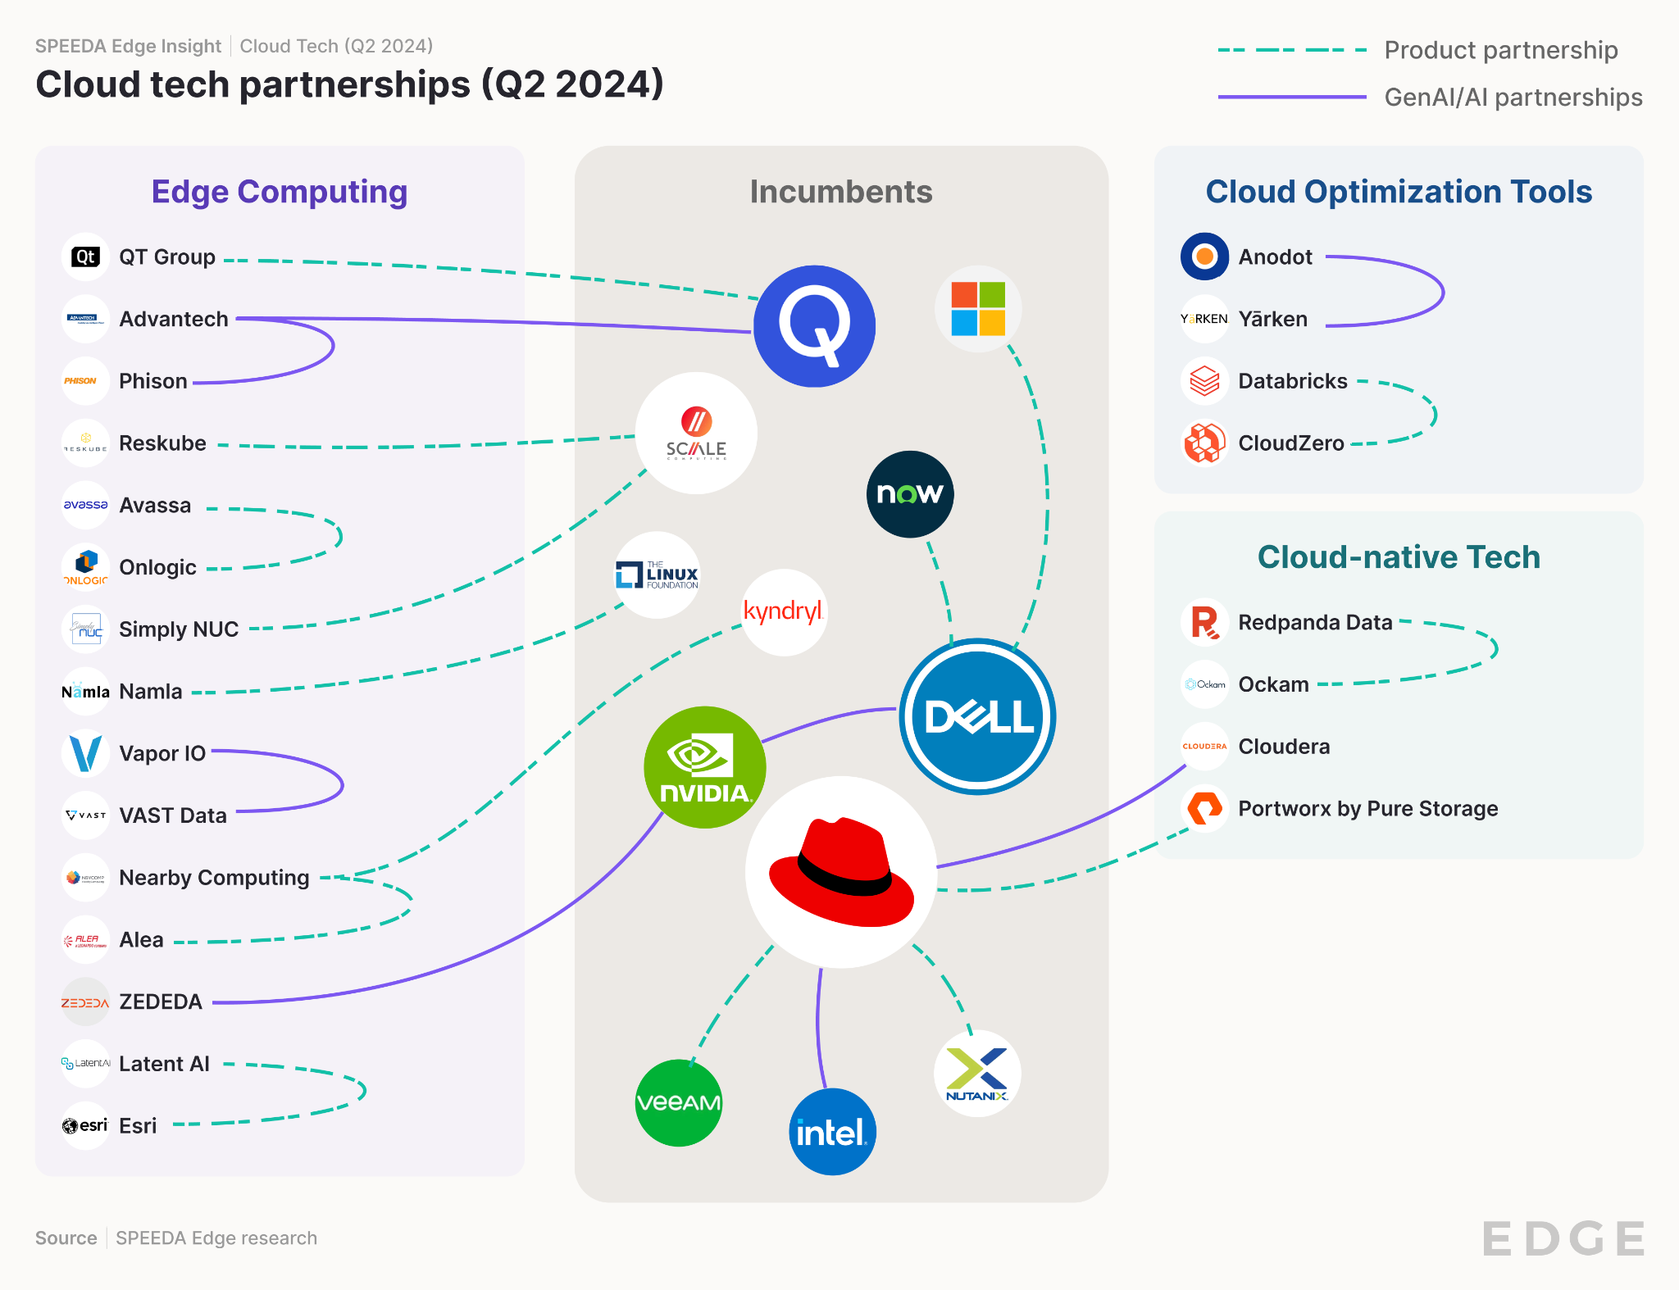Note: Refer to Appendix 2 for the full list of notable partnerships in cloud tech

**Cloud-native Tech and Cloud Optimization Tools**

* Cloud-native Tech dominated activity as Red Hat enhanced AI and cloud capabilities through partnerships with Intel, Cloudera, and others
  + **Red Hat** [**partnered**](https://sp-edge.com/updates/29309) **with Intel** to enhance enterprise **AI applications** through the product, Red Hat OpenShift AI, leveraging various Intel processor technologies.
  + **Red Hat** [**partnered**](https://sp-edge.com/updates/29311) **with Cloudera** to address the growing demand for **AI workloads** by enhancing cloud infrastructure security and robustness. Additionally, Cloudera is transitioning its public cloud infrastructure to Red Hat's newly unveiled RHEL AI platform.
  + The [partnership](https://sp-edge.com/updates/29347) between **Veeam and Red Hat** aims to provide the necessary tools and support for organizations transitioning to OpenShift virtualization, which involves integrating virtual machines and containers.
  + **Nutanix and Red Hat** expanded their [collaboration](https://www.redhat.com/en/about/press-releases/nutanix-and-red-hat-expand-collaboration-power-next-generation-virtualized-and-cloud-native-workloads) to use Red Hat Enterprise Linux as the foundation for Nutanix's cloud platform, providing enterprise-ready Linux capabilities.
* Other notable partnerships included the following:
  + **Redpanda’s** [**partnership**](https://sp-edge.com/updates/29962) **with Ockam** to launch Redpanda Connect with Ockam, a zero-trust streaming data platform developed for large-scale enterprise use.
  + Meanwhile, in Cloud Optimization Tools, the [partnership](https://sp-edge.com/updates/30567) between **Anodot and YäRKEN** aims to provide a cloud cost management solution that integrates on-premises and cloud environments, leveraging Anodot's AI-based optimization and YäRKEN's platform to align tech spending with business objectives.

**Edge Computing**

* Dell and partners collaborated to streamline Edge Computing and AI deployment
  + **Dell** NativeEdge introduced **Azure** Arc [enablement automation](https://www.dell.com/en-us/blog/dell-nativeedge-accelerates-ai-innovation-at-the-edge/) to improve the Azure customer experience, enhance security at the edge, simplify edge operations, and advance AI capabilities.
  + **Dell** NativeEdge [integrates](https://www.dell.com/en-us/blog/dell-nativeedge-accelerates-ai-innovation-at-the-edge/) with **ServiceNow**'s Now Platform to enable businesses to extend IT operations from the data center to the edge, simplifying edge computing resources' orchestration, management, and workflow.
  + **Dell** NativeEdge became the first edge orchestration platform that [automates](https://www.dell.com/en-us/dt/corporate/newsroom/announcements/detailpage.press-releases~usa~2024~05~20240520-dell-technologies-expands-dell-ai-factory-with-nvidia-to-turbocharge-ai-adoption.htm) the delivery of **NVIDIA** AI Enterprise, enabling the deployment of NVIDIA AI frameworks on Dell NativeEdge Endpoints powered by NVIDIA-accelerated computing.
* Other notable partnerships included the following:
  + The [partnership](https://sp-edge.com/updates/29958) between Namla and NVIDIA, which aims to improve the scalability and management of edge AI deployments across various sectors by integrating NVIDIA's technology into Namla's edge AI platform.
  + **VaporIO** [**partnered**](https://sp-edge.com/updates/29002) **with VAST Data** to simplify AI deployments for organizations, merging Vapor IO's Zero Gap AI and the VAST Data platform into an integrated edge-to-core AI system.
  + **Nearby Computing** [**partnered**](https://sp-edge.com/updates/29819) **with Kyndryl** to provide combined edge computing services to customers. Kyndryl will use Nearby Computing's NearbyOne platform to simplify the deployment of industry-specific business applications at the edge.
  + **Nearby Computing and Alea** [partnered](https://www.nearbycomputing.com/nearby-computing-and-alea-partnership/) to automate and orchestrate Alea's mission-critical communications applications through Nearby Computing's edge computing platform.

**Serverless Computing**

* We observed no noteworthy partnerships in these industries during the quarter.

# M&A: IBM bolsters cloud capabilities with HashiCorp acquisition during steady M&A period

**Analyst Take:** The number of deals during the quarter remained broadly flat (10 vs. 11 in Q1 2024). This was amidst a broader trend where the surge in US M&A activity observed in Q1 2024 experienced a [slowdown](https://www.axios.com/2024/07/01/q2-us-merger-data) during Q2.

IBM’s USD 6.4 billion acquisition of HashiCorp strengthens its hybrid cloud capabilities by potentially integrating HashiCorp's multi-cloud infrastructure automation tools with Red Hat offerings.

Harness continued its M&A growth strategy, acquiring Split Software to enhance its products. This move comes after Harness' competitor, [Octopus Deploy](https://sp-edge.com/companies/1199673), acquired the struggling Kubernetes continuous delivery expert [Codefresh](https://sp-edge.com/updates/27008) in Q1 2024. Moreover, Suse, [Timescale](https://sp-edge.com/companies/514837), [Cloudflare](https://sp-edge.com/companies/28149), [Finout](https://sp-edge.com/companies/1637341), and Vercel enhanced their tech stacks and offerings through acquisitions.

* **IBM acquired HashiCorp for USD 6.4 billion**
  + IBM [acquired](https://sp-edge.com/updates/28730) HashiCorp for USD 35 per share, a significant premium over HashiCorp’s pre-announcement trading price of around USD 25.
  + HashiCorp’s product pillars (Terraform, Vault) align well with Red Hat’s (IBM subsidiary) business and IBM's focus on the hybrid/multi-cloud market.
  + In 2023, HashiCorp changed its business model, including a shift away from open-source licensing, which drew attention and new competitors.
  + The transition to a SaaS-style cloud subscription business was taking longer than planned. The company's gross margins on cloud services were only around 60% (FY 2024), while its traditional support revenue had higher margins at 86%.
* **Harness acquired Split Software**
  + Harness, a cloud-based software delivery platform, entered an agreement to [acquire](https://sp-edge.com/updates/29964) Split Software Inc., a company that specializes in feature flag management and experimentation.
  + The acquisition will allow Harness to provide a more robust software delivery platform, including the ability to run A/B tests and measure the performance of new features.
  + This is Harness' second acquisition in 2024 and its seventh overall. In [January 2024](https://sp-edge.com/updates/25477), the company acquired Armory, a continuous delivery platform company, for USD 7 million. This acquisition announcement comes just weeks after Harness secured a [USD 150 million](https://www.prnewswire.com/news-releases/harness-raises-150-million-in-new-financing-302144095.html) debt financing round, backed by Silicon Valley Bank and Hercules Capital.
* **Cloud-native Tech and Serverless Computing dominate the activity**
  + Swedish investment giant **EQT**[acquired](https://sp-edge.com/updates/29112) API management and identity access management company **WSO2** in a deal valued at more than USD 600 million.
  + **SUSE**, an open-source enterprise provider, [acquired](https://sp-edge.com/updates/30568) **StackState's** full-stack observability platform to integrate its capabilities into Rancher Prime.
  + **Timescale**, a cloud database company, has [acquired](https://www.prnewswire.com/news-releases/timescale-acquires-popsql-to-bring-a-modern-collaborative-sql-gui-to-postgresql-developers-302108558.html) **PopSQL**, an SQL editor and collaboration tool, to offer Timescale customers an intuitive interface for database querying, dashboard creation, and collaborative data analysis.
  + **Redpanda**, a streaming data platform, has [acquired](https://sp-edge.com/updates/29960) **Benthos**, an open-source stream-processing platform, to bolster its end-to-end streaming capabilities for data-intensive applications.
  + **Cloudflare** [acquired](https://blog.cloudflare.com/cloudflare-acquires-baselime-expands-observability-capabilities) **Baselime**, a serverless application observability platform, to expand its capabilities and further enhance the developer experience for building, shipping, and troubleshooting applications on the Cloudflare platform.
  + **Vercel** a provider of a serverless web and app development platform [acquired](https://venturebeat.com/ai/vercel-acquires-modelfusion-launches-ai-sdk-3-1-for-enterprise-ai-development/) **ModelFusion.dev**, expanding the capabilities of its Vercel AI SDK 3.1 to further position the company as a leader in the enterprise AI development space.
  + **OpenAI** has [acquired](https://www.reuters.com/markets/deals/openai-acquires-database-analytics-firm-rockset-2024-06-21/) **Rockset**, a real-time analytics database, to enhance its retrieval infrastructure and enable users, developers, and enterprises to better leverage their data for more helpful AI applications.
  + **Finout**, a cloud cost observability platform provider, [acquired](https://www.prnewswire.com/news-releases/timescale-acquires-popsql-to-bring-a-modern-collaborative-sql-gui-to-postgresql-developers-302108558.html) **Cloudthread**, a cloud analytics platform, to enhance Finout's cloud cost optimization and FinOps capabilities.

# Appendix

## Appendix 1: Cloud tech product updates

| **Industry hub** | **Company** | **Summary - New product/market** | **News link** |
| --- | --- | --- | --- |
| Edge computing | Hailo | Launched the Halio-10 high-performance GenAI accelerator | [Edge](https://sp-edge.com/updates/28101) |
| Cloud-optimization tools | Nerdio | Unveiled major upgrades in Nerdio Manager for Enterprise and Nerdio Manager for MSP, enhancing both platforms | [Press release](https://www.globenewswire.com/news-release/2024/04/02/2856037/0/en/Nerdio-Unveils-Major-Upgrades-in-Nerdio-Manager-for-Enterprise-and-Nerdio-Manager-for-MSP-Enhancing-Both-Platforms.html) |
| Cloud-native tech | OpenStack | Launched OpenStack version 29, Caracal | [Edge](https://sp-edge.com/updates/28216) |
| Edge computing | Cloudflare | Added event notifications and GCS support for R2 | [Press release](https://blog.cloudflare.com/data-anywhere-events-pipelines-durable-execution-workflows) |
| Edge computing | Intel (Altera) | Introduced a series of new chips and FPGAs aimed at expanding AI capabilities to the network edge, including several edge-optimized CPUs and GPUs and the Agilex 5 Series FPGAs | [Edge](https://sp-edge.com/updates/28301) |
| Edge computing | Fastly | Introduced a new tool named "Fastly Bot Management" to protect organizations from automated bot attacks at the network edge | [Edge](https://sp-edge.com/updates/28302) |
| Edge computing | AMD | Expanded its Versal adaptive SoC portfolio with AI Edge Series Gen 2 and Prime Series Gen 2 | [Edge](https://sp-edge.com/updates/28366) |
| Cloud-native tech | Grafana Labs | Announced version updates for Grafana, Loki, and Grafana Alloy | [Edge](https://sp-edge.com/updates/28409) |
| Cloud-native tech | Alphabet | Integrated Google Kubernetes Engine into its Google Distributed Cloud platform, allowing the deployment of IT infrastructure setups on any cloud | [Edge](https://sp-edge.com/updates/28411) |
| Cloud-native tech | Docker | Released Docker Desktop 4.29 | [Press release](https://www.docker.com/blog/docker-desktop-4-29/?utm_campaign=blog&utm_content=1714662302&utm_medium=social&utm_source=twitter#enhancing-security) |
| Cloud-native tech | Kong | Launched the Kong Konnect Dedicated Cloud Gateways on AWS, available exclusively via Kong Konnect | [Edge](https://sp-edge.com/updates/28538) |
| Cloud-native tech | Tetrate | Launched AuthService, an open-source project to simplify the deployment and management of the existing authorization service for the Istio service mesh | [Edge](https://sp-edge.com/updates/28596) |
| Edge computing | Vertiv | Launched SmartRow2, a new edge data center solution for streamlined edge deployments with increased scalability and flexibility | [Edge](https://sp-edge.com/updates/28624) |
| Cloud-native tech | Kubernetes | Introduced the 1.30 update with various feature updates and enhancements to improve resource utilization and scalabilities, fortify security measures, and provide better development support | [Edge](https://sp-edge.com/updates/28625) |
| Cloud-optimization tools | CAST AI | Introduced AI for application portfolio governance and software observability | [Press release](https://www.globenewswire.com/news-release/2024/04/18/2865464/0/en/CAST-brings-artificial-intelligence-AI-to-application-portfolio-governance-and-software-observability.html) |
| Edge computing | Akamai Technologies | Introduced a new media-focused service that uses NVIDIA GPUs on its global edge platform, aiming to increase productivity and reduce costs for companies in the media and entertainment industry | [Edge](https://sp-edge.com/updates/28731) |
| Edge computing | Nokia | Introduced MX Grid to enhance operational technology (OT) responsiveness and decision-making in organizations | [Edge](https://sp-edge.com/updates/28885) |
| Edge computing | ZEDEDA | Launched Edge Sync for air-gapped environment management | [Edge](https://sp-edge.com/updates?industryIds=33) |
| Edge computing | StackPath | Expanded edge computing reach with launch of additional IaaS in Paris | [Edge IR](https://www.edgeir.com/stackpath-expands-edge-computing-reach-with-launch-of-additional-iaas-in-paris-20240430) |
| Cloud-optimization tools | Upbound | Added console to centralize management of Crossplane | [Cloud Native Now](https://cloudnativenow.com/features/upbound-adds-console-to-centralize-management-of-crossplane/) |
| Cloud-native tech | Isovalent | Strengthened cloud-native security via Tetragon enterprise update | [Cloud Native Now](https://cloudnativenow.com/news/isovalent-strengthens-cloud-native-security-via-tetragon-enterprise-update/) |
| Cloud-native tech | HAProxy Technologies | Announced HAProxy Enterprise 2.9 with next-generation web application firewall (WAF) and bot management capabilities | [Press release](https://www.haproxy.com/blog/announcing-haproxy-enterprise-2-9) |
| Cloud-native tech | Redpanda Data | Released Redpanda 24.1 with write caching to improve performance | [Press release](https://redpanda.com/blog/redpanda-24-1-general-availability-write-caching) |
| Cloud-native tech | Riverbed Technology | Introduced AI-powered observability platform | [Edge](https://sp-edge.com/updates/29180) |
| Cloud-native tech | Red Hat | Launched Red Hat Enterprise Linux AI platform | [Edge](https://sp-edge.com/updates/29181) |
| Cloud-native tech | Red Hat | Announces Podman AI Lab | [Press release](https://www.redhat.com/en/about/press-releases/red-hat-announces-podman-ai-lab) |
| Edge computing | Databank | DataBank is developing two new data centers in Orangeburg, New York | [Edge](https://sp-edge.com/updates/29427) |
| Cloud-native tech | Logicmonitor | Introduced LM cost optimization feature to its Envision Platform | [Edge](https://sp-edge.com/updates/29581) |
| Cloud-native tech | Rafay Systems | Launched AI suite and extends PaaS to support GPU workloads | [Edge](https://sp-edge.com/updates/29580) |
| Edge computing | Zenlayer | Unveiled port-based purchasing model | [Edge](https://sp-edge.com/updates/29579) |
| Edge computing | Flexnode | Unveiled new Edge data center | [Edge](https://sp-edge.com/updates/29578) |
| Serverless computing | Pinecone | Released Pinecone Serverless publicly after successful beta phase | [Edge](https://sp-edge.com/updates/29657) |
| Cloud-native tech | Lightbend | Released Akka 24.05 | [Press release](https://www.globenewswire.com/news-release/2024/05/22/2886552/0/en/Lightbend-Launches-Akka-24-05-with-a-Focus-on-Security-Performance-and-Efficiency.html) |
| Edge computing | EdgeCortix | Unveiled SAKURA-II Edge AI Accelerator | [Edge](https://sp-edge.com/updates/29739) |
| Cloud-native tech | Microsoft | Previewed Kubernetes automation service, Automatic, at Build 2024 conference | [Edge](https://sp-edge.com/updates/29738) |
| Cloud-native tech | Nvidia | Unveiled NVIDIA NIM, a service offering inference microservices for deploying GenAI applications, at Computex 2024 | [Edge](https://sp-edge.com/updates/30032) |
| Edge computing | Kneron | Launched new AI chip for on-premise AI applications | [Edge](https://sp-edge.com/updates/30099) |
| Edge computing | Advantech | Launched AIR-520 Edge AI server solution for GenAI | [Edge](https://sp-edge.com/updates/30177) |
| Edge computing | Gcore | Launched inference at the edge for AI applications | [Edge](https://sp-edge.com/updates/30354) |
| Cloud-native tech | Mirantis | Mirantis Releases k0smotron 1.0 to Simplify Kubernetes Cluster Management | [Cloud Native Now](https://cloudnativenow.com/editorial-calendar/kubernetes-security/mirantis-releases-k0smotron-1-0-to-simplify-kubernetes-cluster-management/) |
| Cloud-native tech | SUSE | Announced its AI strategy and SUSE AI solutions, a new vendor- and LLM-agnostic GenAI platform | [Tech Crunch](https://techcrunch.com/2024/06/18/suse-wants-a-piece-of-the-ai-cake-too/) |
| Serverless computing | SurrealDB | Announced the beta launch of Surreal Cloud | [Edge](https://sp-edge.com/updates/30646) |
| Cloud-native tech | SUSE | Announced three significant upgrades to its cloud-native computing software family: Rancher Prime 3.1, NeuVector Prime 5.4, and Harvester 1.3.1 | [Cloud Native Now](https://cloudnativenow.com/editorial-calendar/cloud-native-security/suse-updates-cloud-native-tool-portfolio/) |
| Cloud-optimization tools | FinOps Foundation | Debuted unified billing model for cloud computing | [Edge](https://sp-edge.com/updates/30681) |
| Cloud-native tech | Pure Storage | Added AI features to improve performance and detect attacks | [Edge](https://sp-edge.com/updates/30632) |
| Cloud-optimization tools | FinOps Foundation | FinOps Foundation debuted unified billing model for cloud computing | [Edge](https://sp-edge.com/updates/30681) |
| Cloud-native tech | VMware | Simplified product portfolio around Cloud Foundation and vSphere Foundation | [Edge](https://sp-edge.com/updates/30784) |
| Cloud-native tech | SingleStore | Added Iceberg support and speedier vector search | [Silicon Angle](https://siliconangle.com/2024/06/26/singlestore-adds-iceberg-support-speedier-vector-search/) |
| Cloud-native tech | Datadog | Launched Kubernetes Autoscaling in a public beta | [Edge](https://sp-edge.com/updates/30866) |

## Appendix 2: Cloud tech partnerships

| **Industry hub** | **Company** | **Partner** | **Summary - New product/market** | **News link** |
| --- | --- | --- | --- | --- |
| Edge computing | Avassa | OnLogic | To develop a comprehensive solution that combines hardware and software explicitly designed for industrial Internet-of-Things (IoT) edge environments | [Edge](https://sp-edge.com/updates/28254) |
| Edge computing | Qualcomm | Qt Group | To expedite the development of advanced graphical user interfaces (GUIs) and software quality assurance for industrial IoT devices | [Edge](https://sp-edge.com/updates/28410) |
| Edge computing | Scale Computing | Reskube | To leverage Scale Computing’s infrastructure and Reskube’s resilient solutions to develop edge systems that can operate with minimal disruptions | [Edge](https://sp-edge.com/updates/28622) |
| Edge computing | Advantech | Phison | To develop a new GenAI platform for edge computing and industrial applications | [Edge](https://sp-edge.com/updates/28623) |
| Edge computing | Advantech | Qualcomm | To use its combined expertise in AI to enhance innovation in industrial computing | [Edge](https://sp-edge.com/updates/28732) |
| Edge computing | Vapor IO | VAST Data | To develop a technology solution to simplify AI deployments for organizations, merging Vapor IO's Zero Gap AI and the VAST Data platform into an integrated Edge-to-core AI system | [Edge](https://sp-edge.com/updates/29002) |
| Cloud-native tech | Red Hat | Portworx by Pure Storage | To accelerate modern virtualization adoption across enterprises | [Press release](https://www.redhat.com/en/about/press-releases/pure-storage-and-red-hat-accelerate-modern-virtualization-adoption-across-enterprises) |
| Cloud-native tech | Red Hat | Intel | To enhance enterprise AI applications through their product, Red Hat OpenShift AI, leveraging various Intel processor technologies | [Edge](https://sp-edge.com/updates/29310) |
| Cloud-native tech | Red Hat | Cloudera | To address the growing demand for AI workloads by bolstering cloud infrastructure security and robustness | [Edge](https://sp-edge.com/updates/29311) |
| Cloud-native tech | Red Hat | Veeam | To provide the necessary tools and support for organizations transitioning to OpenShift virtualization, which involves integrating virtual machines and containers | [Edge](https://sp-edge.com/updates/29347) |
| Edge computing | Nearby Computing | Alea | To streamline the deployment of edge management and orchestration (EMO) solutions, lower entry barriers, minimize operational complexities, cut costs, and allow faster application deployment than previous methods | [Edge](https://sp-edge.com/updates/29545) |
| Cloud-native tech | Red Hat | Nutanix | To power the next generation of virtualized and cloud-native workloads | [Press release](https://www.redhat.com/en/about/press-releases/nutanix-and-red-hat-expand-collaboration-power-next-generation-virtualized-and-cloud-native-workloads) |
| Edge computing | Nearby Computing | Kyndryl | To simplify the launch of business applications at the edge for Kyndryl's customers | [Edge](https://sp-edge.com/updates/29819) |
| Edge computing | Dell | Nvidia | To offer optimized AI features | [Edge](https://sp-edge.com/updates/29818) |
| Edge computing | Dell | ServiceNow | To offer automated edge management | [Edge](https://sp-edge.com/updates/29818) |
| Edge computing | Dell | Microsoft | To offer seamless integration of Azure services at the edge | [Edge](https://sp-edge.com/updates/29818) |
| Edge computing | ZEDEDA | Linux Foundation | To develop open standards for interoperability in edge computing | [Edge](https://sp-edge.com/updates/29902) |
| Edge computing | Scale Computing | Simply NUC | To improve computing and management capabilities in edge computing applications by combining Scale Computing's software technologies, with Simply NUC's Onyx PC | [Edge](https://sp-edge.com/updates/29903) |
| Cloud-native tech | Redpanda | Ockam | To launch Redpanda Connect with Ockam, a zero-trust streaming data platform developed for large-scale enterprise use | [Edge](https://sp-edge.com/updates/29961) |
| Edge computing | Namla | Nvidia | To enhance edge AI deployments across various sectors | [Edge](https://sp-edge.com/updates/29958) |
| Cloud-native tech | CloudZero | Databricks | Developed a new in-platform Databricks cost adaptor that helps customers visualize and explore 100% of their Databricks spend | [Press release](https://www.prnewswire.com/news-releases/cloudzero-joins-databricks-partner-program-as-first-and-only-validated-cloud-cost-optimization-partner-302165024.html) |
| Cloud-optimization tools | Anodot | Yārken | To integrate Anodot's AI-based cost management capabilities with Yārken's platform | [Edge](https://sp-edge.com/updates/30567) |
| Edge computing | Latent AI | Esri | To enhance AI capabilities for edge devices | [Press release](https://www.edgeir.com/latent-ai-integrates-leip-with-esris-arcgis-to-enhance-ai-capabilities-for-edge-devices-20240627) |

## 

## 

## 

## 

## 

## Appendix 3: New Cloud tech startups added in Q2 2024

| **Company** | **Description** | **HQ** | **Hub** | **Segment** | **Stage** | **Funding** |
| --- | --- | --- | --- | --- | --- | --- |
| Espresso AI | Specializes in optimizing data warehouse operations, primarily focusing on reducing costs and improving efficiency for Snowflake users | US | Cloud optimization tools | Cost Optimization | Seed | USD 11 million |
| Gcore | Provides edge AI, cloud, network, and security solutions that enable developers and enterprises to build, deploy, and secure applications | Luxemburg | Edge computing | Edge application and other software | Growth | - |
| Nearby Computing | Fully agnostic, cross-domain orchestration across infrastructure, network, and applications, integrating all network tiers | Spain | Edge computing | Edge application and other software | Early | USD 2.4 million |
| Finout | Cloud cost management and observability platform providing businesses visibility into their cloud spend across various providers and services | Israel | Cloud optimization tools | Cost Optimization, Cloud Automation | Early | USD 44.8 million |
| Flexnode | Digital infrastructure company that designs, deploys, and operates modular, high-performance micro data centers | US | Edge computing | Data center | Early | USD 12.5 million |
| Cologix | Network-neutral interconnection and hyperscale edge data center company operating data centers in North America | US | Edge computing | Data center | Growth | USD 500 million |
| PointFive | Cloud cost optimization platform that enables enterprises to achieve continuous cloud cost efficiency through its DeepWaste detection technology | US | Cloud optimization tools | Cost Optimization, Cloud Automation | Seed | USD 16 million |
| EdgeCortix | Fabless semiconductor company specializing in energy-efficient AI processing for edge devices | Japan | Edge computing | On-device hardware components | Early | USD 35.6 million |

## 

## Appendix 4: Cloud tech funding rounds in Q2 2024

| **Company** | **Industry hub(s)** | **Announced date** | **Amount (USD)** | **Type** |
| --- | --- | --- | --- | --- |
| Ory Corp | Cloud-native tech | April 2, 2024 | 5,000,202 | Series A |
| Pomerium | Cloud-native tech | June 20, 2024 | 13,750,000 | Series A |
| Loft Labs | Cloud-native tech | April 16, 2024 | 24,000,000 | Series A |
| Aerospike | Cloud-native tech | April 4, 2024 | 109,000,000 | Series E |
| HarperDB | Edge computing | June 12, 2024 | N/A | Private Equity Round |
| Blaize | Edge computing | April 29, 2024 | 106,000,000 | Series D |
| Hailo | Edge computing | April 2, 2024 | 120,000,000 | Series C |
| SiMa.ai | Edge computing | April 4, 2024 | 70,000,000 | Series C |
| DataBank | Edge computing | April 9, 2024 | 725,000,000 | Debt Financing |
| EdgeConneX | Edge computing | April 11, 2024 | 1,900,000,000 | Debt Financing |
| Yondr | Edge computing | May 30, 2024 | 150,000,000 | Debt Financing |
| SurrealDB | Serverless computing | June 18, 2024 | 20,000,000 | Series A |
| Vercel | Serverless computing | May 16, 2024 | 250,000,000 | Series E |
| RunPod | Serverless computing | May 8, 2024 | 20,000,000 | Seed Round |
| Harness | Cloud optimization tools, Cloud-native tech | May 14, 2024 | 150,000,000 | Debt Financing |

## 

## 