**No-code Software: Overview**



## **Low-cost, accessible application development for the masses**

No-code development platforms (NCDPs) aim to give power to citizen developers to realize their software ideas, without needing any technical skill or know-how, contrasting with low-code platforms, which require a certain level of coding knowledge to operate. To do that, these platforms utilize familiar functions such as drag-and-drop, filters, data queries, and widgets to create software without the need to write a single line of code. NCDPs have so far disrupted several software developments such as business applications, mobile applications, and websites.

NCDPs already include multiple niche segments ranging from web development and game development to data science. The target users vary based on the nature of the solutions, with some catering to users within the business (internal use apps; commonly used by businesses with an adequate number of employees) and others catering to customers (external users; can be used by businesses of all sizes).

### 

### 

### 

### 

### **No-code software targets multiple uses by a broad user group and its niche segments**

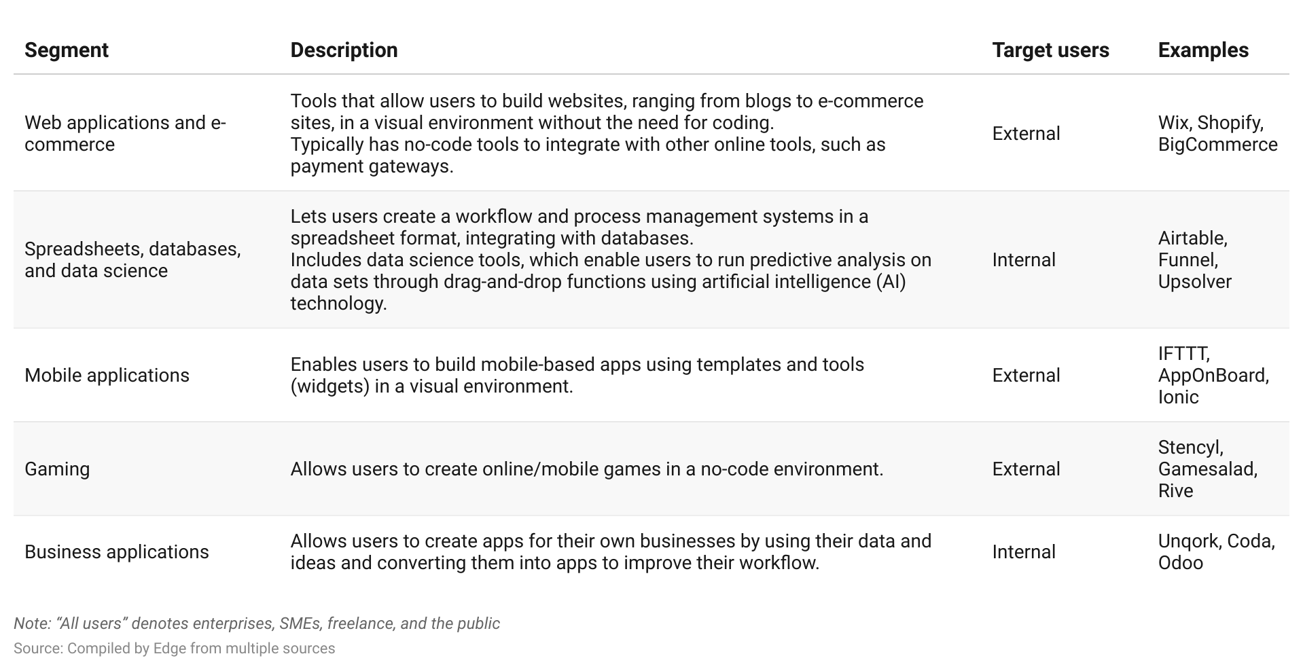

The platforms’ fundamentals for translating simple drag-and-drop functions and human commands into programming codes are similar in most products across the no-code industry’s multiple segments.

The following diagram shows the key components of a working NCDP: a “generator” that converts user directions and a “builder” that represents the user interface.

### 

### 

### 

### 

### 

### 

### 

### 

### 

### **The two main components of an NCDP for websites: the generator and user interface/builder**

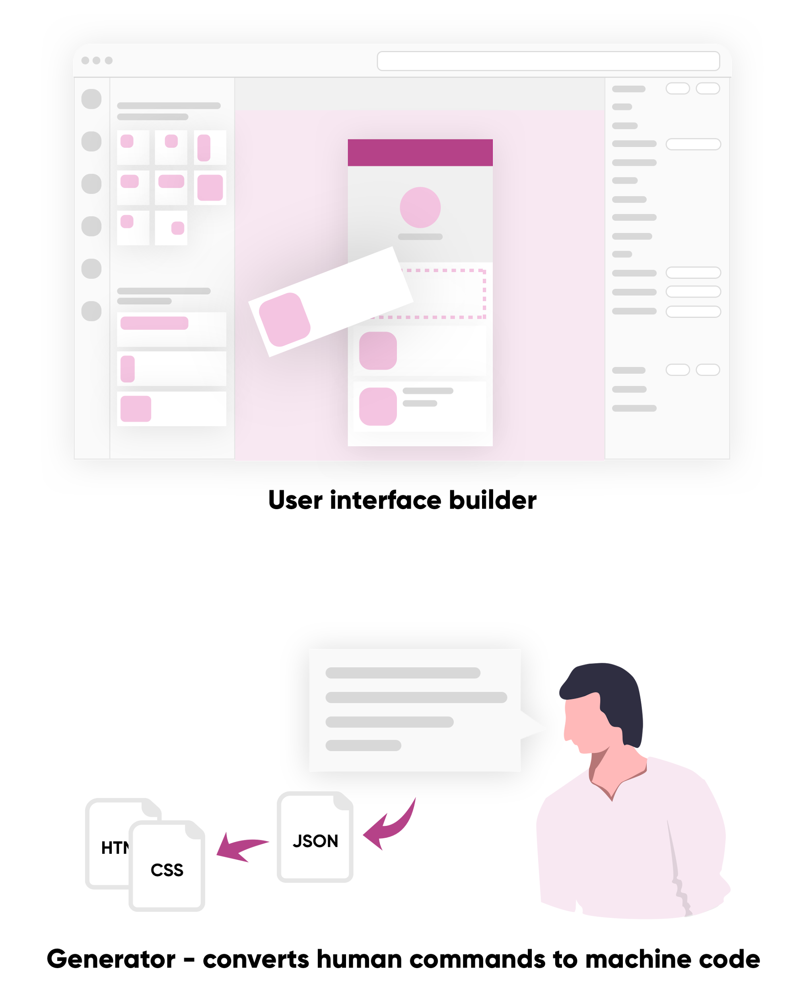

Source: Carrd

The existence of NCDPs can be attributed to the evolution of programming languages, which have increasingly become closer to human languages.

At each stage of the evolution of programming language, new methods have been introduced as “modules” (parts of software that contain routines) and as visual programming that simplifies coding. The current fourth- and fifth-generation programming languages use command statements similar to those in human languages, creating a simpler framework for a greater number of users. Fifth-generation languages use a declarative approach (programming in languages that conform to the mental model of the developer or “no control flow”) rather than an imperative approach (programming with statements that directs a computer on what to execute—“control flow”). NCDPs have similar fundamentals and draw inspiration from several older programming languages. Methods such as drag and drop, commonly used in NCDPs, were first introduced in visual programming developed in third-generation programming languages such as Visual Basic.

### **Programming languages have evolved from machine code to logic languages that use a declarative approach**

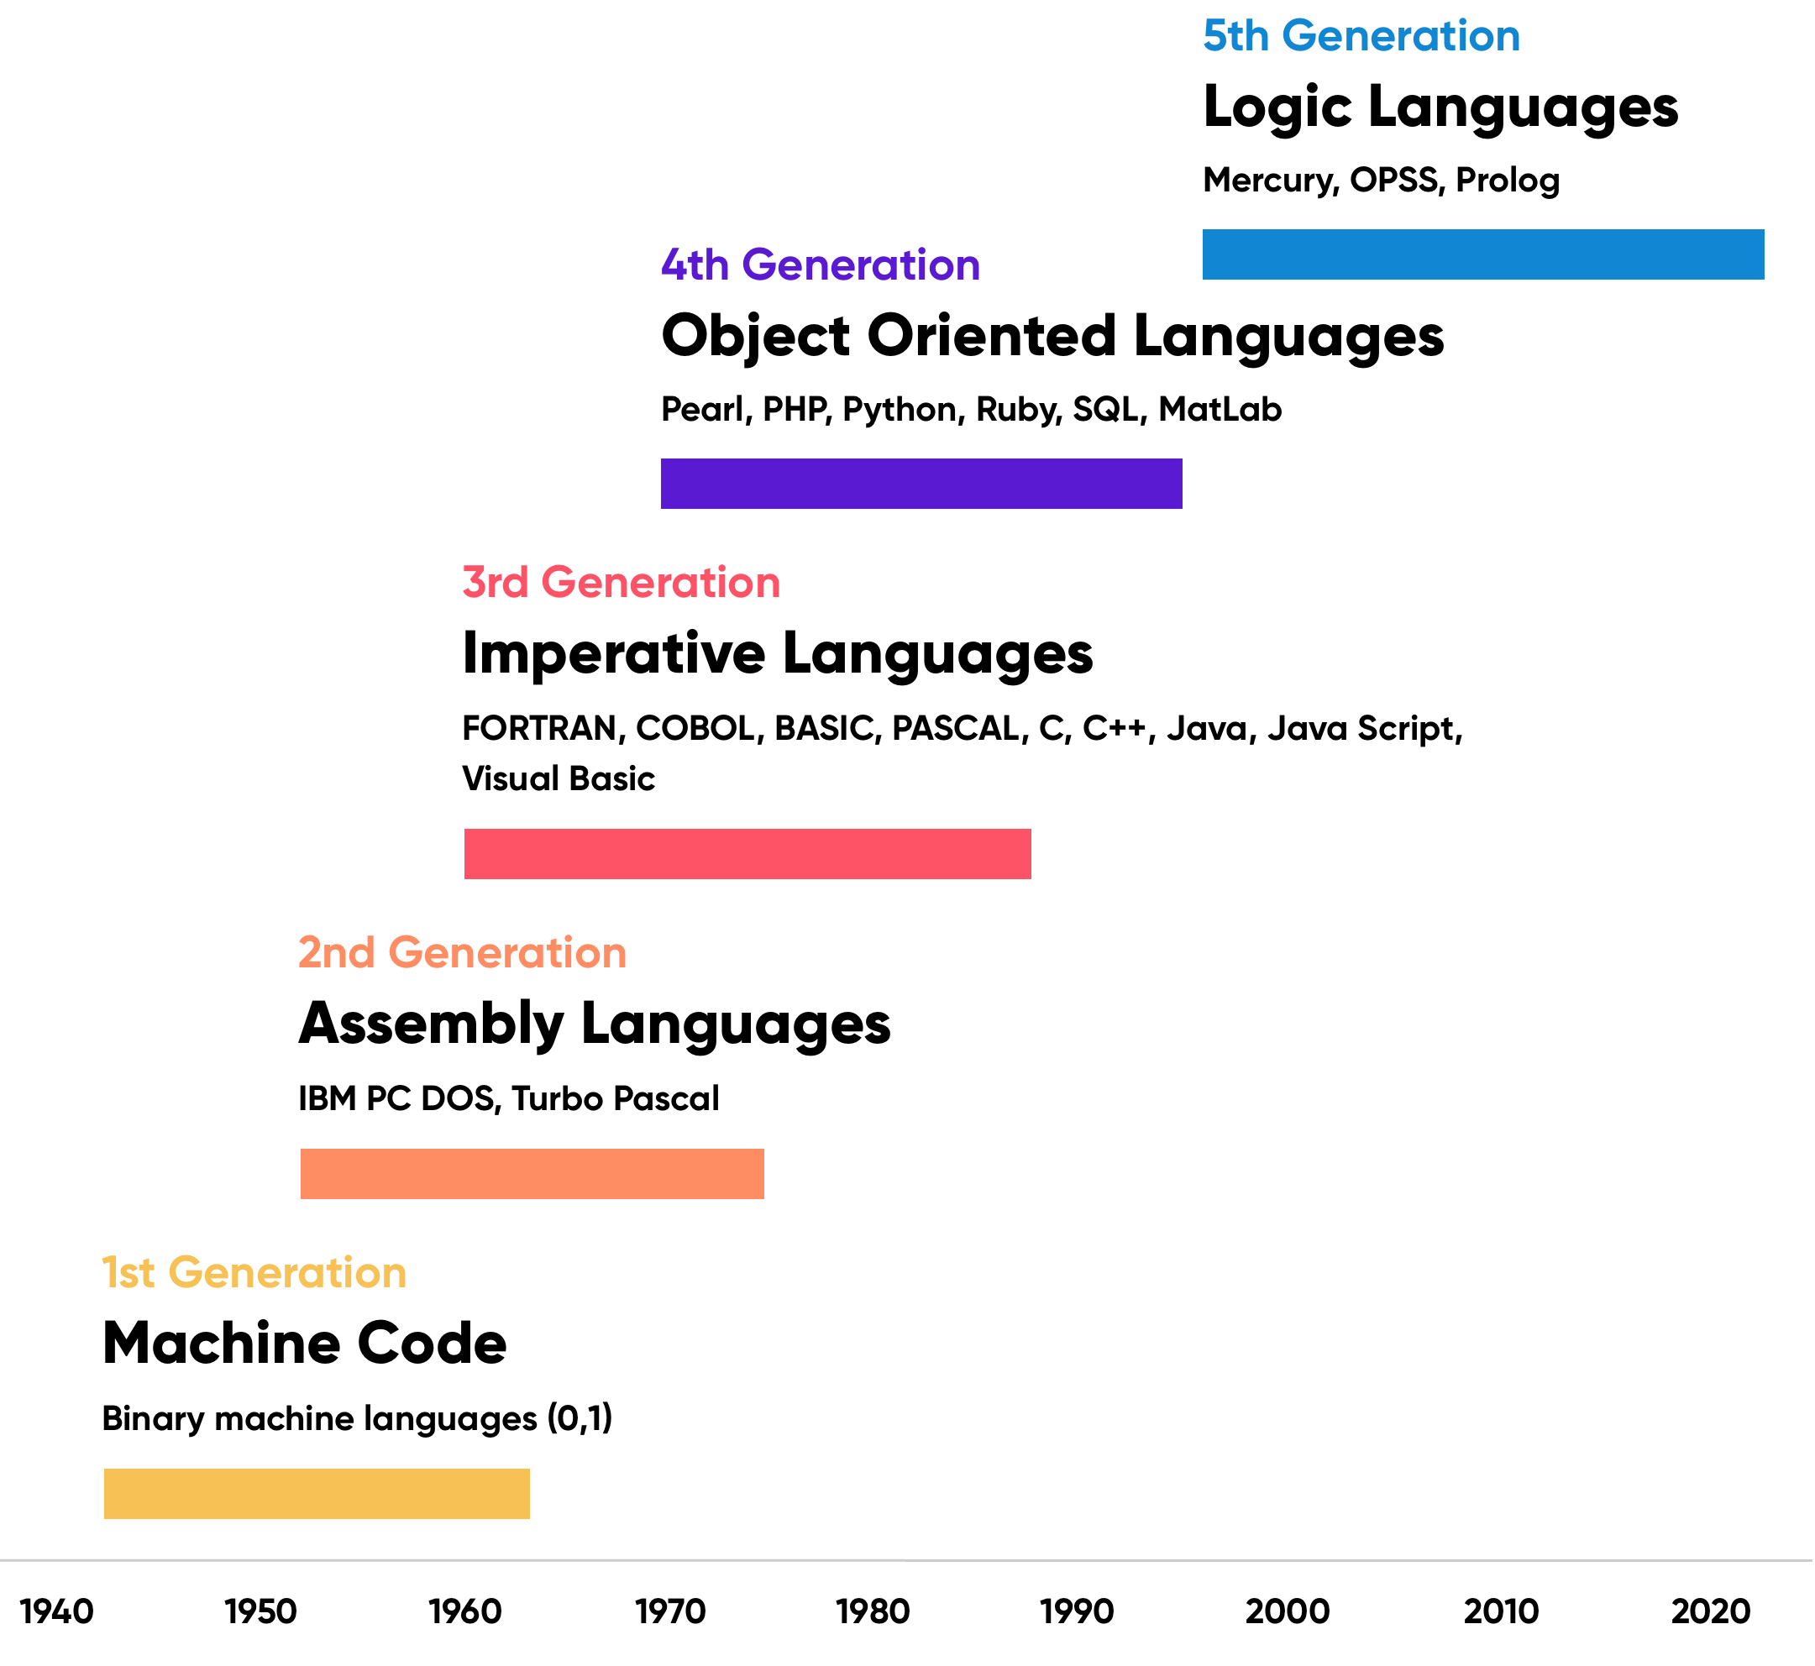

Source: Timetoast

Whenbuilding complete solutions, including fully functional websites or applications through an NCDP, vendors need to leverage end-to-end services that simplify complex processes such as web hosting and online payments. This allows NCDP vendors to focus on their own competencies. A number of tech giants (e.g. Amazon Web Services, Google Cloud, and Microsoft Azure) provide complete cloud computing services. Other companies play a key role in streamlining online payments (e.g. Stripe, Square, and Adyen).

Online payment processing service Stripe, for instance, allows NCDPs to deploy e-commerce applications through just an API. The API bypasses the lengthy process of setting up a merchant account and the need to deal with regulatory fees, compliance standards, and bank and credit card companies while providing payment security.

# **Driving Factors**

## **1. NCDPs are a low-cost alternative for application developers**

The US software industry had a talent shortage of nearly 500,000 personnel, compared with just 108,000 IT graduates joining the workforce annually in 2022. The shortage is expected to widen: estimates from the US Bureau of Labor Statistics indicate 25% job growth in the software development industry for 2022–2032.

NCDPs offer a solution. Application developers’ productivity can increase by as much as 90% when using NCDPs, lowering the need for large application development teams. Application developers’ base salaries have increased over the years as competition sharpened between companies looking to build expertise in areas such as cloud computing, data sciences, and AI. Both the lowest 10% of earnings as well as the median earnings of application developers grew at a 3% compound annual growth rate (CAGR) from 2018 to 2022 in the US.

### 

### 

### 

### 

### **The median earnings of application developers grew at a 3% CAGR over 2018–2022.**

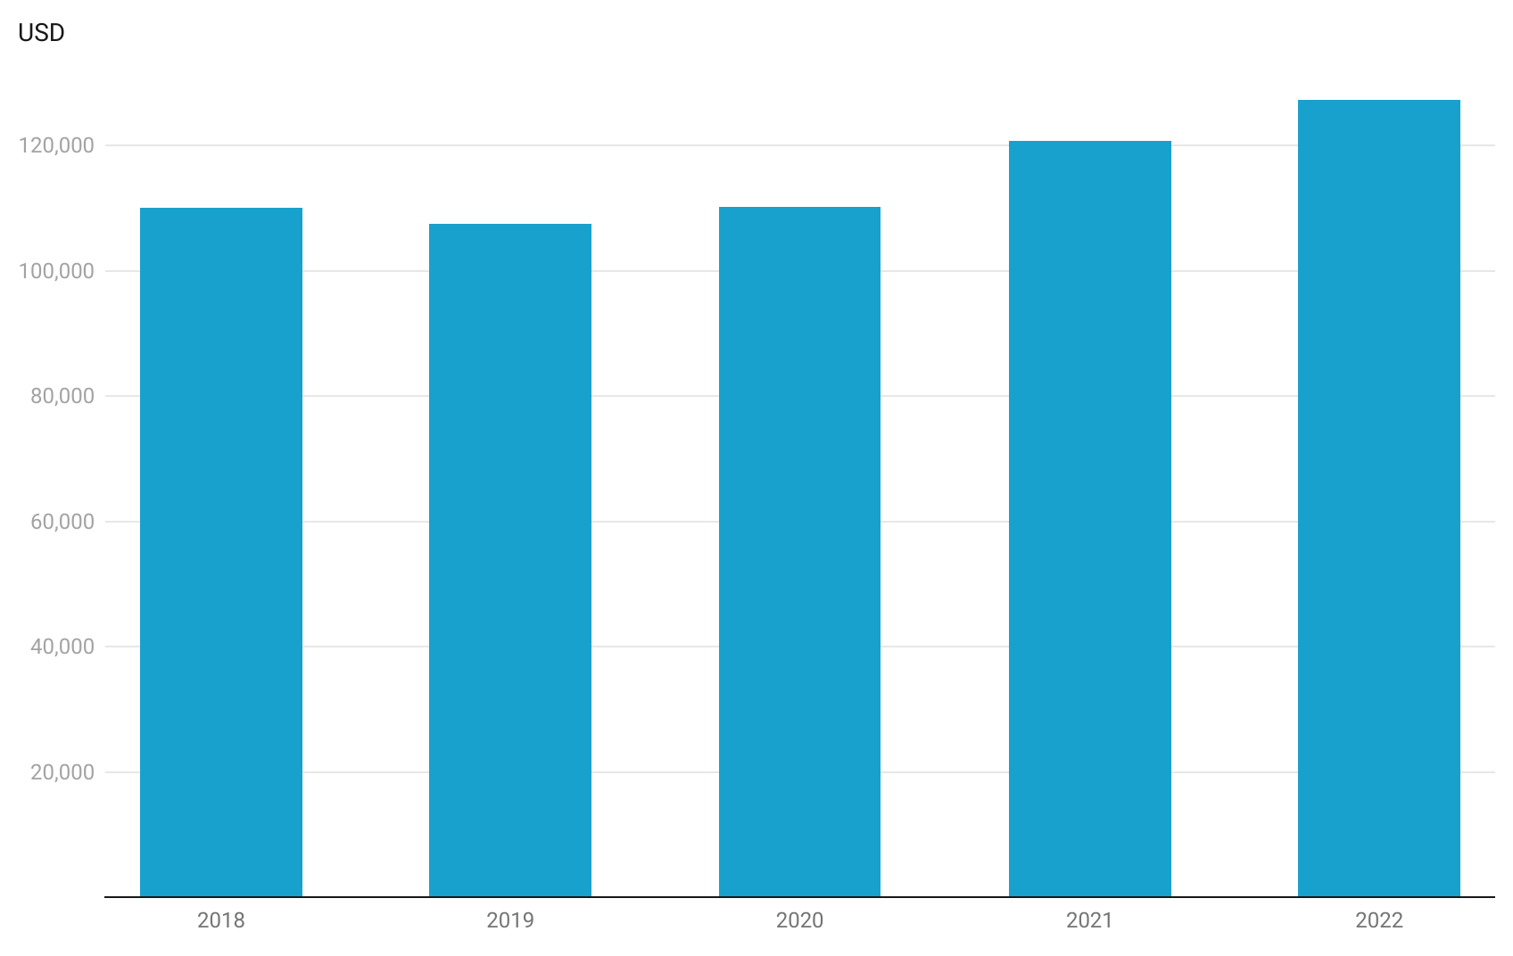

### **2. Under-resourced small businesses leverage NCDPs**

There are a substantial number of micro and small businesses out there, giving rise to a large potential user base for NCDPs. Small businesses with fewer than 20 employees represent around 90% of enterprises in the US (excluding non-employee firms), totaling 5.7 million in 2021, while non-employee firms (entrepreneurs) totaled around 27.1 million in 2019 (latest data available). Furthermore, around 5.5 million new business applications were submitted in 2023.

These businesses would be attracted to NCDPs, given they typically have limited budgets and IT expertise (smaller ratio of IT staff to total employees). As NCDPs can be used to address these constraints, adoption among SMEs has grown over the last few years. This is supported by a 2023 Gartner survey, which found that 41% of businesses have begun citizen development initiatives, with another 20% evaluating implementation. In light of this substantial market, several NCDPs primarily target the SME market, including website-building platforms such as [Shopify](https://sp-edge.com/companies/30109), [Squarespace](https://sp-edge.com/companies/10033), and [GoSite](https://sp-edge.com/companies/459937).

# 

# **Risks to Growth**

* **Low user control over applications raises security risk**

When users of NCDPs have little knowledge of programming and the functionality of the websites/applications they create, product security is limited, leaving these websites/applications open to cyberattacks. With the number of data breaches increasing by 20% YoY in 2023, potential security breaches remain a growing threat to applications and websites built using cloud-based NCDPs.

* **High commitment to early-stage startups a risk for users**

When websites and applications are run on no-code startups’ platforms, their existence is directly linked to those startups’ continued existence. If early-stage startups close operations for reasons such as low funding, users may not be able to recover their websites and applications. For example, companies such as Facet Data, Appdrop, and Dashblock have seemingly shuttered their operations during the last three years.

* **Challenges of building applications via NCDPs**

It is unlikely that NCDPs provide templates and frameworks that match every user’s requirements. Building a website or application without the exact template needed would still require at least basic programming skills. Some complex functions such as backend infrastructure management, performance optimization, and advanced integration are not in the scope of most NCDPs, and therefore users would need to collaborate with various databases and tools (or use a low-code development platform), which requires programming knowledge.

*Last updated: March 2024*

©2024 Uzabase, Inc. All Rights Reserved. The information contained herein: (1) is proprietary to Uzabase Inc. and/or its content providers; (2) may not be copied or distributed; and (3) is not warranted to be accurate, complete or timely. Neither Uzabase Inc. nor its content providers are responsible for any damages or losses arising from any use of this information.