# 

# **Wearable Tech: Overview**

## 

# 

Wearable tech refers to electronic devices that can be worn as accessories to track, analyze, and transmit personal data. Often paired with software, a wearable can take many forms—headbands, wristwatches, waistbands, skin patches, and even clothing. Wearable devices date back to the 1970s when calculator wristwatches by Pulsar and Sony Walkmans were introduced. The early 2000s saw a breakthrough in the market with the introduction of the SPOT smartwatch by Microsoft (even though it was discontinued back in 2008) and a wearable underwater camera by GoPro.

Wearables are equipped with motion sensors and microprocessors that can capture vast amounts of data and sync that information with mobile or other electronic devices for analysis and insights.

These can be broadly grouped as 1) non-implantable, 2) external, and 3) implantable. Most wearables currently in the market fall under the non-implantable category. These devices and external devices mainly use rechargeable batteries, while implantables mostly use non-rechargeable ones.

### **Categorization of wearables**

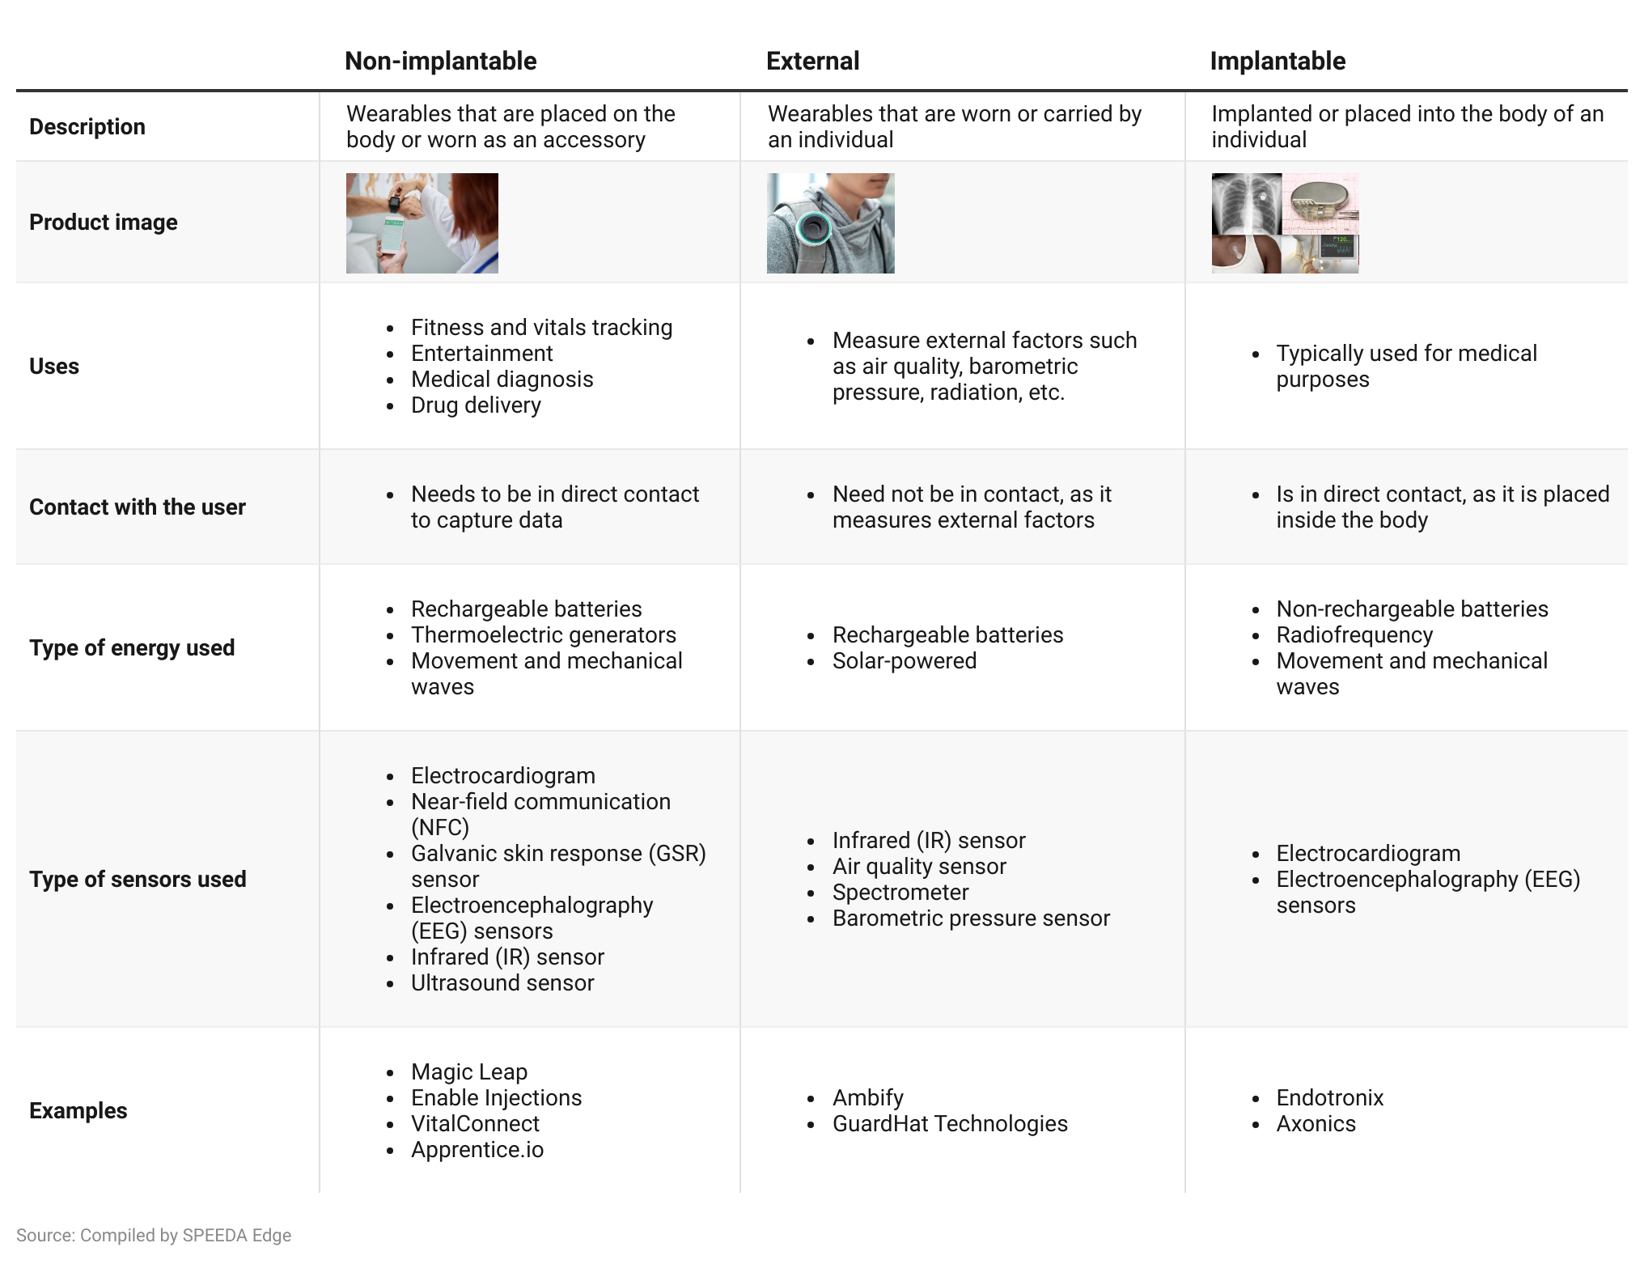

### **Wearable Tech: Key segments**

#### 

#### 

#### 

#### However, we exclude the following areas when selecting companies for this industry:

1. Companies developing AR/VR headsets or displays (covered under [Extended Reality](https://sp-edge.com/industry/65))
2. Apparel and wearable devices exclusively designed to monitor the performance of athletes (covered under [Sports Tech](https://sp-edge.com/industry/126))
3. Pet Tech devices that monitor and enhance the health and well-being of pets (covered under [Pet Care Tech](https://sp-edge.com/industry/7))

## **What are their use cases?**

Wearable devices are most commonly used as fitness trackers. Fitbit, the most renowned of these, came into the market in 2009 and saw multiple upgrades before it was acquired by [Alphabet](https://sp-edge.com/companies/314571) in 2021. Alphabet has also been working with Samsung to jointly develop wearable tech to beat smartwatch market leader [Apple](https://sp-edge.com/companies/1658), which surpassed 100 million users in June 2021.

However, the same technologies are now being tested or at the early stage for more advanced applications ranging from diagnosing chronic diseases to delivering treatments. Listed below is a complete map of the available major use cases of wearable devices.

* **Vitals tracking and at-home monitoring:** This refers to using wearable devices to track health information such as cardiac and respiratory monitoring, blood level information (glucose, oxygen, alcohol, and metabolized drug levels in the body), energy expenditure, etc. These devices are often used for remote monitoring of patients, especially during Covid-19. Some wearables even allow users to establish two-way voice connections with a designated response partner in case of an emergency. This includes wearable devices used to monitor post-surgery and elderly pets.
* **Treatments/drug delivery:** This involves using data collected from wearables to diagnose and formulate medications while delivering treatments and drugs through bodyworn devices. The most common are nerve stimulation wearables for better sleep as well as to provoke positivity and treat depression. Wearables are also used for rehabilitation after surgeries, accidents, strokes, etc. to support recovery. It also helps improve sight and other eye-related disorders like dry eye syndrome and glaucoma. These wearables often require regulatory approvals.
* **Wellness:** As previously mentioned, wearables are mostly used for wellness purposes, which include tracking fitness-related parameters (steps walked, calories burned, movements, postures, etc.). This includes devices that offer heart rate monitoring, sleep quality monitoring, and oxygen saturation on a medically insignificant level as well as maternity-related uses such as wearable breast pumps and fetal monitoring devices.
* **Industrial uses:** Some of its popular industrial uses include training workers, workflow guidance, remote monitoring and assistance, worker augmentation, reducing injuries, and improving efficiency. Here are some major use cases by type of device:
  + **Wearable headsets/smart glasses:** Combined with augmented reality (AR) technology, this is widely used in manufacturing environments to train, provide workflow instructions, and remotely monitor field workers.
  + **Wearable exoskeletons:** Used to augment the strength of users and protect workers’ core and lower back during repetitive and prolonged activities (e.g., Ekso Bionics, Sarcos).
  + **Smart fabric:** Used to augment the strength of users and protect workers’ core and lower back during repetitive and prolonged activities (e.g., [Seismic](https://sp-edge.com/companies/443629)).
  + **Waistbands and gloves:** Used to limit workplace injuries (e.g., [Kinetic](https://sp-edge.com/companies/269025)) and improve efficiency (e.g., proGlove).
* **Entertainment:** Wearables are used for entertainment purposes like gaming, music, and photography. Incumbents [Meta](https://sp-edge.com/companies/5), [Bose](https://sp-edge.com/companies/38014), and GoPro cater to this market while a few startups like [Magic Leap](https://sp-edge.com/companies/176239), Narrative, and Razer also offer wearables for entertainment.

## **What are the factors driving demand for wearables?**

* **The convenience of home healthcare:** Wearables are now being developed to manage chronic illnesses such as diabetes, cancer, lung disease, heart failure, etc. through continuous monitoring. Remote care using telehealth picked up during the pandemic, which also fuelled the demand for wearable devices that monitor vitals. In 2020, due to the pandemic, customer interest was renewed. A survey revealed that 46% of US respondents started using wearables for a new purpose. The most popular reasons were managing a health condition (66%), fitness tracking (34%), and staying active (32%).
* **Increasing adoption of technologically advanced products and the rise of preventive culture:** Demand for wearables has been driven by the increased connectivity and usage of data-driven analytics and tech in everyday life. Millennials and Gen-Zers, accounting for more than half of the US population, are no longer interested in traditional visits to physicians, triaging health issues as they arise. Instead, they now prioritize preventive healthcare methods with a focus on maintaining mental and physical health, while demanding more convenient and accessible healthcare experiences. This suits the wearable devices market, as it aims to assist preventive health measures while providing the digital interactions that Millennials and Gen-Zers are looking for.
* **Increasing functionality and style of wearables:** Just a decade ago, wearable devices were only used for basics like counting steps and calories. However, with advances in sensor technology, they are now seeing exciting new uses. Wearables are also being presented in new and more convenient forms like skin patches. Meanwhile, the advent of smart jewelry has fused functionality and style, with fashion brands like Fossil and Kate Spade partnering to release its smartwatch and Bellabeat offering wellness trackers in the forms of pendants and bracelets.
* **Some wearables are becoming more affordable:** Though most advanced devices are still relatively expensive, mainstream wearables (fitness trackers and smartwatches) have gradually become more affordable. This is mainly because competition has intensified, with new entrants offering similar features for the same price. Even lower-priced smartwatches offer features like oxygen and heart rate monitoring, improving their usability, boosting demand, and keeping prices competitive.

## **What are the growth risks?**

* **Short battery life:** Even though there have been many breakthroughs in battery solutions (body energy harvesting, wireless charging, etc.), short battery life is still a major issue for wearable manufacturers and users. The inverse relationship between battery life and functionality adds to this problem.
* **Data inaccuracies reported:** The data used and displayed on wearables may not be 100% accurate, which could be critical to health monitoring. When used for functions like ECG monitoring, wearables can misdiagnose, fail to identify when medical assistance is needed, or flag heart irregularities that do not require attention. This has been somewhat addressed with FDA clearance being given to devices. However, the difficulties in obtaining approval and the lower demand for uncleared (but potentially accurate) products could hinder market growth. A survey in 2020 revealed that only around 10% of US physicians integrated data from wearables into their electronic health record (EHR) systems due to fear of inaccurate data being recorded. There is also an ongoing debate on racial bias in wearable devices. It has been claimed that data collected by wearables from people of color could be inaccurate due to the use of photoplethysmographic (PPG) green light signaling technology, which is susceptible to being absorbed by melanin.
* **Collection of personal information:** The collection of personal information is a core function of wearables. It is regulated by various laws including the General Data Protection Regulation (GDPR) in Europe and the California Consumer Privacy Act (CCPA) in the US, restricting the collection and processing of data without the owner’s explicit consent. Medical information collected by healthcare providers is also regulated under the Health Insurance Portability and Accountability Act (HIPAA). Furthermore, cyberattacks pose another risk to collected data as experienced last September, when an unsecured database containing over 61 million Apple and Fitbit users belonging to GetHealth was exposed.

*Last updated: September 2023*

©2024 Uzabase, Inc. All Rights Reserved. The information contained herein: (1) is proprietary to Uzabase Inc. and/or its content providers; (2) may not be copied or distributed; and (3) is not warranted to be accurate, complete or timely. Neither Uzabase Inc. nor its content providers are responsible for any damages or losses arising from any use of this information.