# **EdTech: K-12: Overview**

## 

## **The era of mass migration to online learning**

Online learning programs range from entirely digital school schedules, where students receive a complete basic education, to supplemental online courses, where students take one or more courses from an online provider to enhance face-to-face learning.

E-learning goes well beyond recreating the physical classroom to enhance the learning experience by using collaboration tools and engagement methods that promote a sensory virtual learning experience.

In the US, EdTech is largely driven by federal initiatives and funding, with each state governing its own EdTech policy. Several startups have partnered with states and district administrations to drive online learning.

### 

### 

### 

### 

### 

### 

### 

### **High internet penetration and technological advances enable the expansion of online learning**

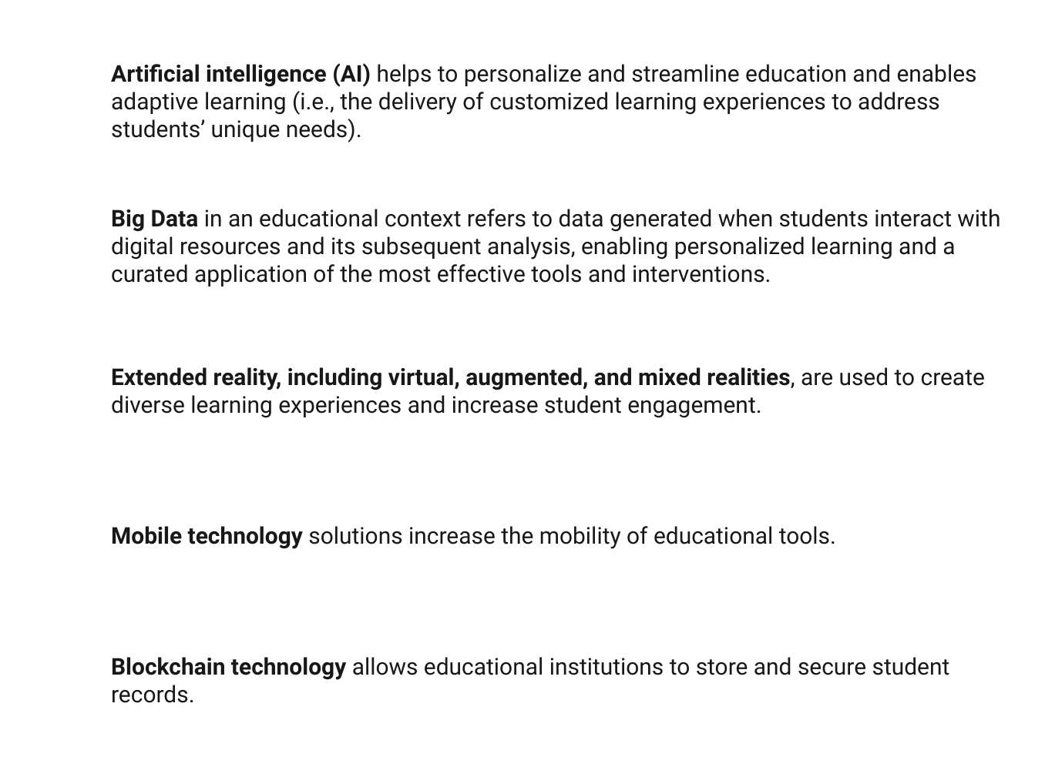

**Service and content providers supply large volumes of online educational content, boosting e-learning**

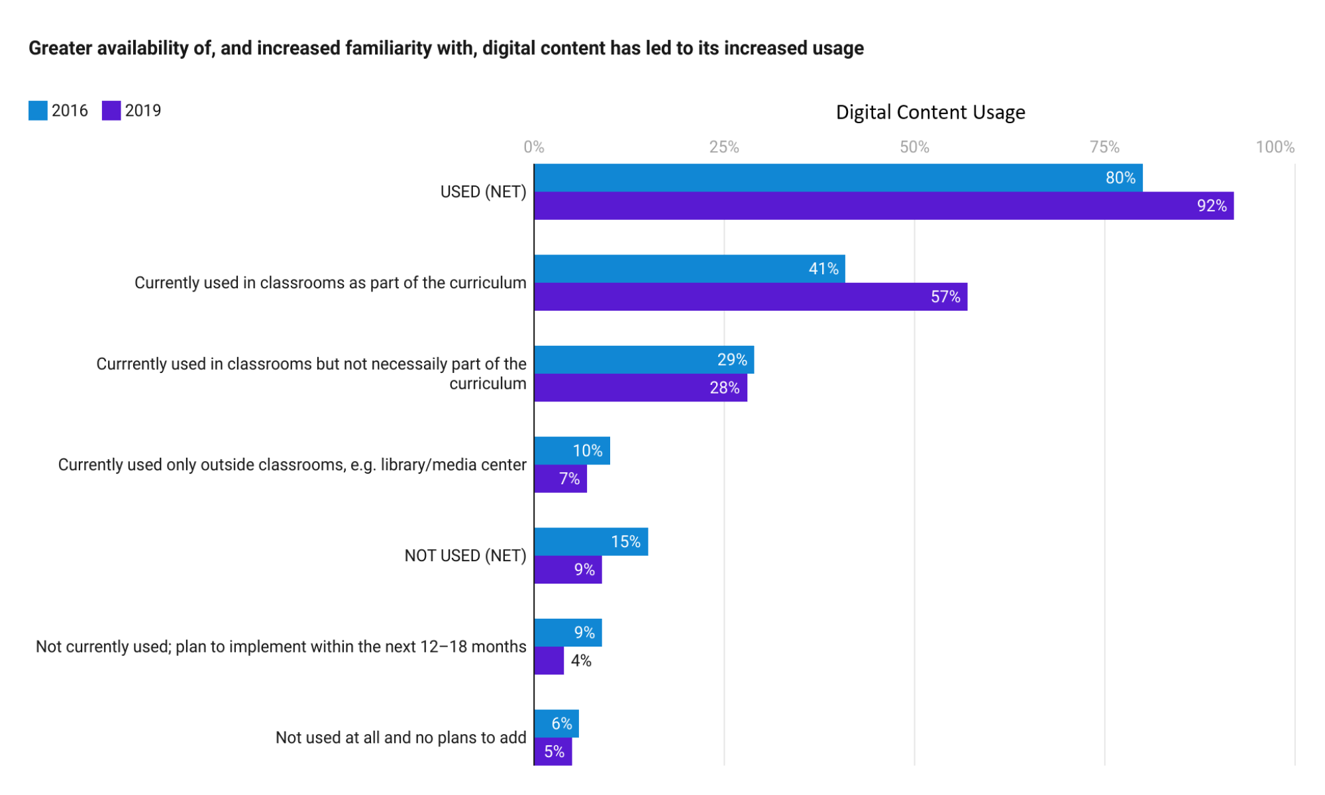

Source: 2019 K–12 Digital Content Report, based on a survey co-sponsored by the Association for Supervision and Curriculum Development (ASCD) and OverDrive Education

Various vendors provide numerous products and services, making the market highly competitive, with participants competing on price and solutions.

# 

# **Driving Factors**

## **1. Greater access and efficiency for students, teachers, and families**

With the adaptability and improved access afforded by EdTech, enrollment in publicly-funded K-12 virtual schools has been on the rise.

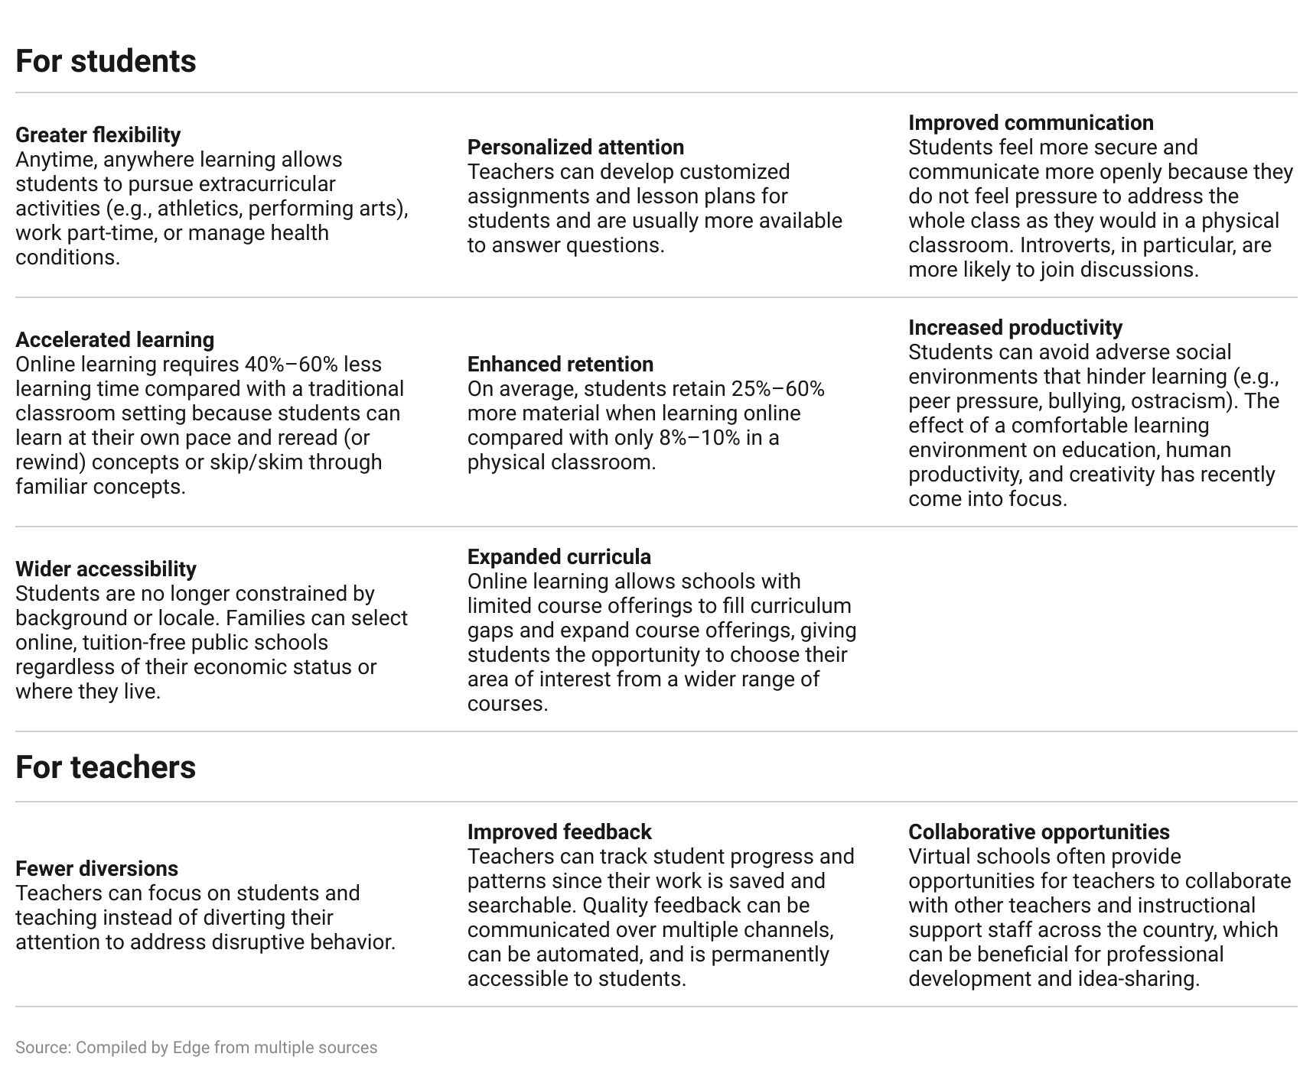

### 

### 

### 

### 

### 

### **Decline in full-time virtual school enrollment due to reduced impact of the pandemic**

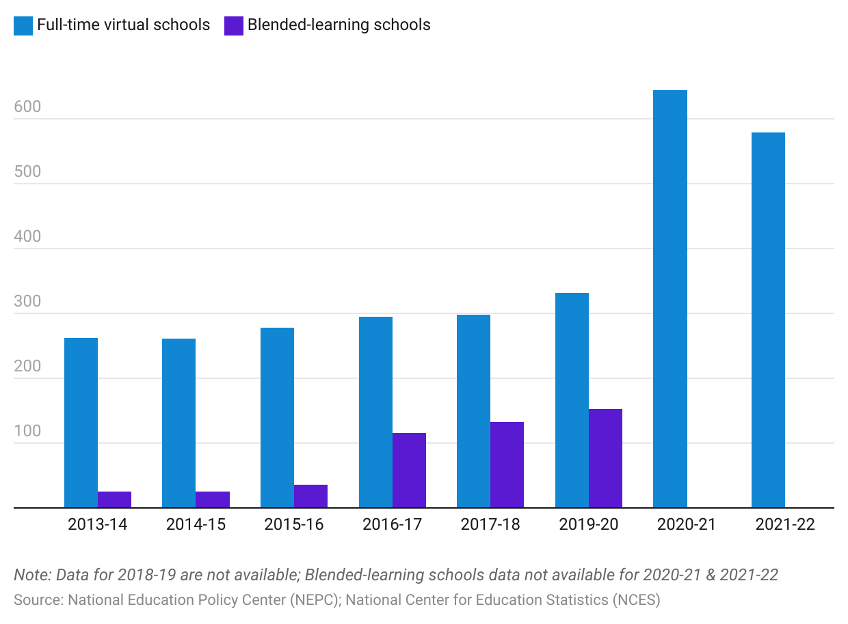

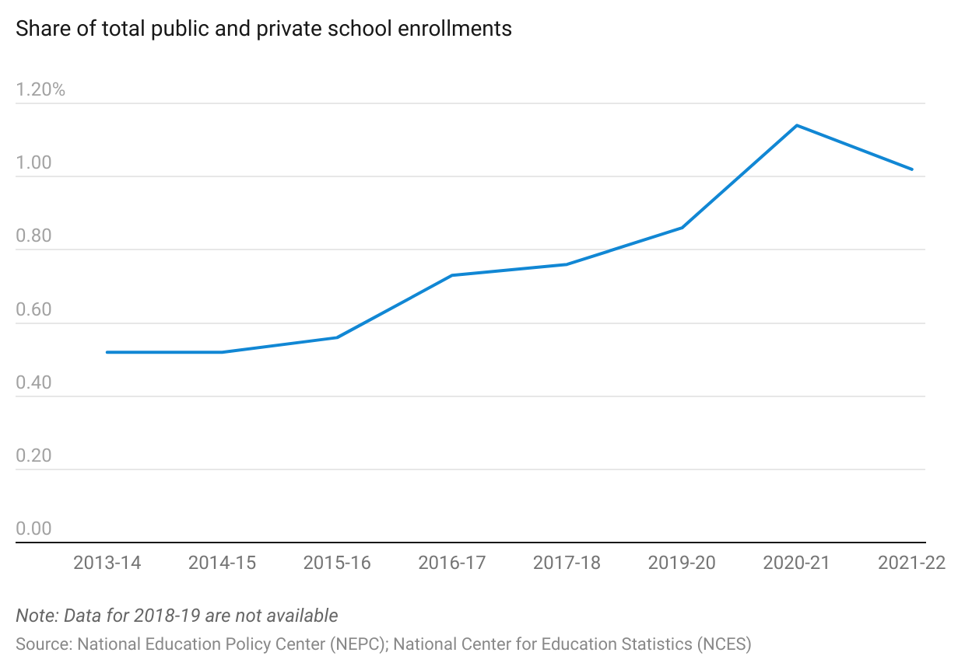

## 

## **2. Shortage of qualified teachers**

The shortage of teachers from preschool to high school in the US, which has worsened during the 2017–2018 academic year compared to the previous year, is projected to almost double by 2025. According to a 2023 survey, nearly nine in 10 public school districts struggled to hire teachers for the start of the school year. The shortage is attributed to several factors, including pay, work conditions, lack of support, lack of autonomy, and changing curriculum requirements.

### 

### 

### 

### 

### 

### 

### **Growing shortage of teachers nationwide**

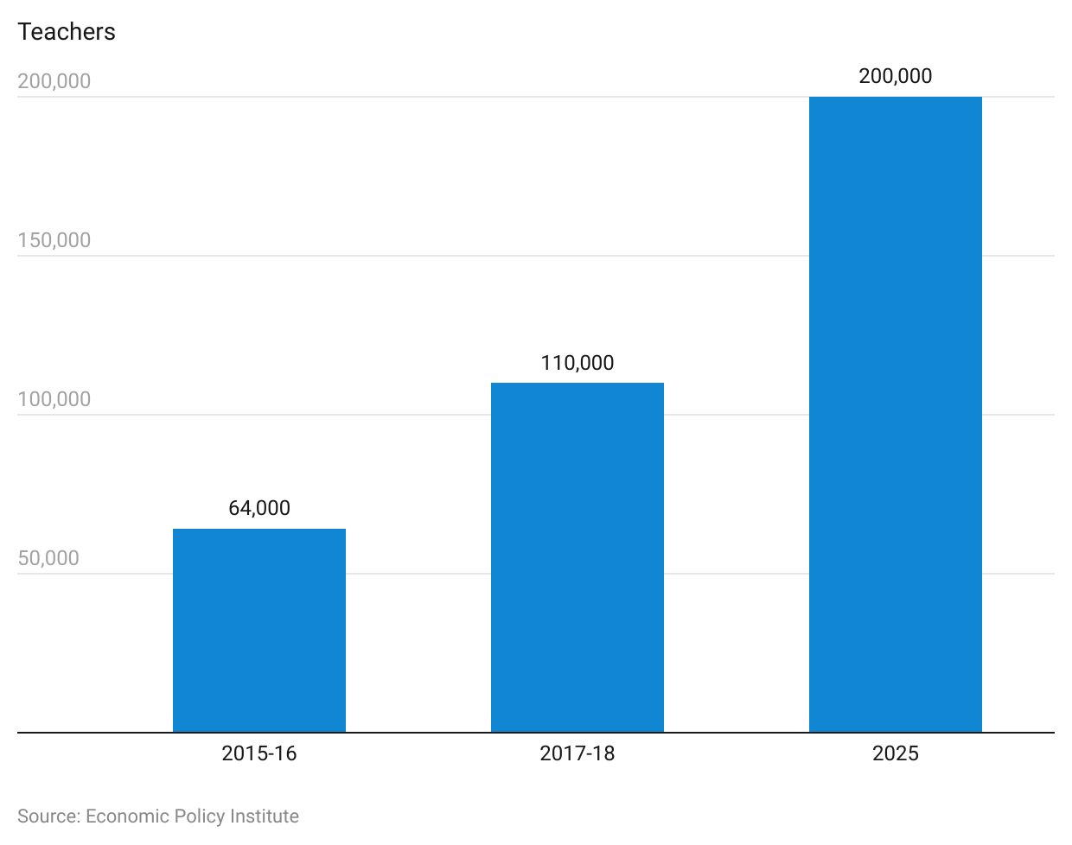

The student-teacher ratio in online schools is 1.65x that of public schools.

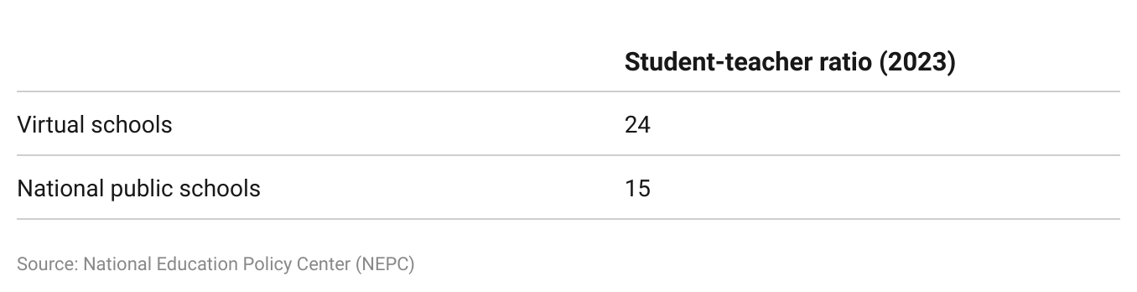

## **3. Need for cost-effective education**

Online learning promises to improve productivity and lower the cost of education. In 2023, the national average spend per student was USD 15,908. By incorporating online learning into the curriculum, schools will incur initial and ongoing technology investment costs (on infrastructure, hardware, and software), but these may be offset by savings from reduced teaching staff. A 2019 survey conducted by the National Education Policy Center (NEPC) found that full-time virtual schools spent an average of USD 6,400 per student, compared to an average of USD 10,000 per student for traditional brick-and-mortar schools. This represents a cost savings of 36% for virtual schools compared to traditional schools.

# **Risks to Growth**

K-12 online learning faces several challenges that pose a risk to market growth.

## **1. Disparate access to reliable internet and/or technology**

The US has a significant gap between populations and student bodies from privileged and disadvantaged backgrounds. An estimated average of 15% of American residents in the 10 worst states for broadband will not be able to afford broadband internet in December 2023. The highest concentration of communities without internet access tends to be in states with

large rural populations.

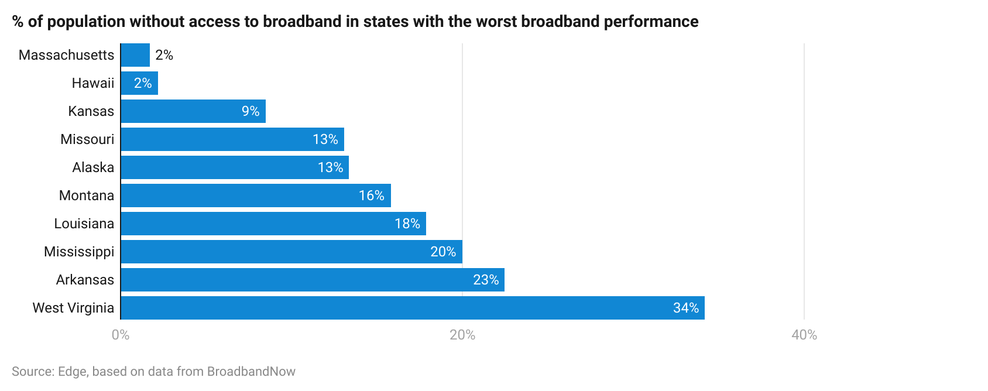

## **2. Performance in virtual and blended schools still lags behind traditional schools**

Despite online schooling’s advantages and increasing enrollment, on-time graduation rates (a key school performance measure) for full-time virtual and blended schools were lower than the national average. The National Education Policy Center (NEPC) recommends addressing this poorer performance before raising the number of virtual or blended schools. One method to close the gap is by reducing the student-teacher ratio to a more optimal level.

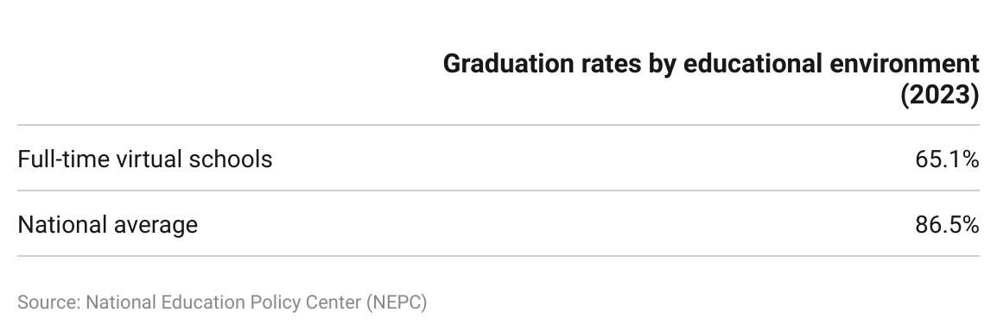

## **3. Teachers require training for digital learning**

## 

Teachers and teacher unions need to be open to change and willing to learn. Teachers also need opportunities to collaborate with and learn from peers.

Following school closures due to the Covid-19 pandemic, less than half of American K-12 teachers believed they were sufficiently trained for online learning, although the majority thought moving to online learning was a step in the right direction.

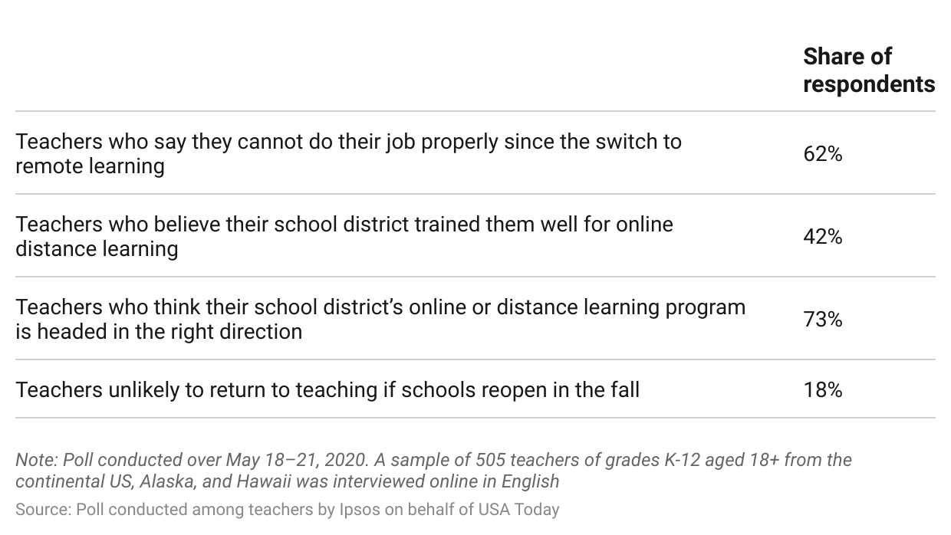

Although parents feel teachers have stepped up to the recent challenge, they believe more training is required.

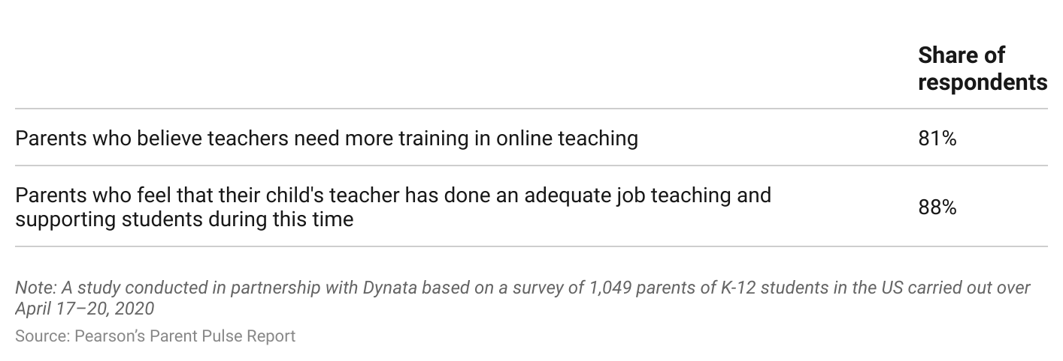

## 

## **4. Online student safety and security**

E-learning tools must incorporate security features and protocols to prevent access and the distribution of students’ sensitive personal information. Stronger regulations should also be enacted at the district level covering baseline security measures with which districts and vendors must comply.

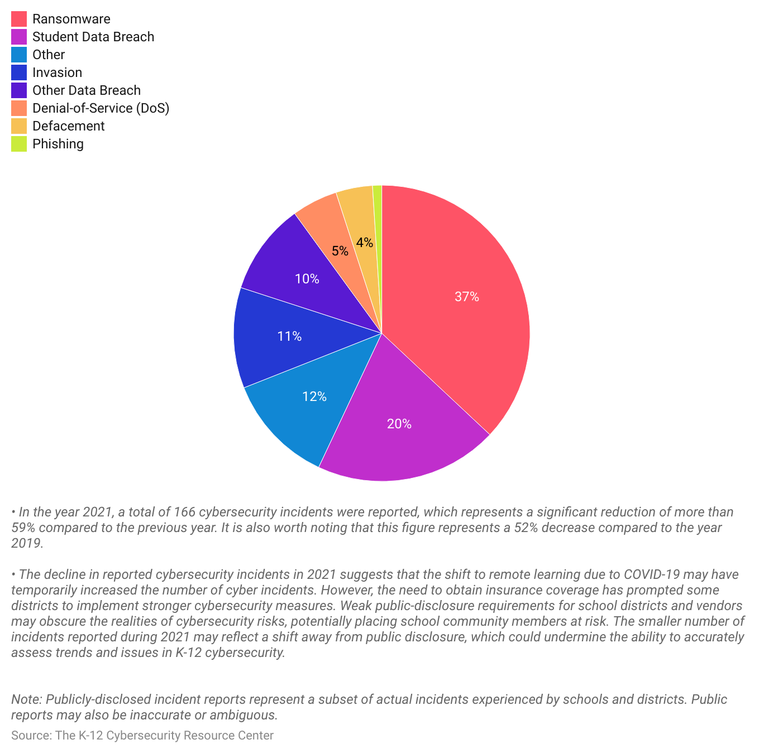

* The lack of federal regulations requiring specific cybersecurity measures in K-12 schools has resulted in inconsistent levels of cybersecurity across schools and districts. This situation is made more challenging by the fact that schools are diverting IT resources to enable hybrid or remote learning due to and following Covid-19. As a result, the focus on cybersecurity has waned and reporting of incidents has slowed, leaving some schools vulnerable to cyberattacks.
* The increased use of cloud apps could result in more frequent incidents; however, these are going unreported as existing security tools focus more on network security rather than on cloud security monitoring.

## 

## **5. Schools re-evaluate EdTech spending**

The Jefferson Education Exchange estimated that of the 7,000 different EdTech tools schools invest in each year at a cost of USD 13 billion, 85% are either a poor fit for the school or implemented incorrectly. Another survey showed that 67%—in some instances, as much as 90%—go unused. A separate study evaluating EdTech purchases reported that the lack of pricing transparency means prices for the same product could vary by 20%–40% depending on the district.

The Covid-19 pandemic may further contribute to the increased scrutiny surrounding spending. Schools already had to shoulder pandemic-related costs prior to reopening, and those dependent on state funding face budget cuts as the pandemic hurt state revenues. Although the use of online tools should continue to increase post pandemic, schools may now be compelled to re-evaluate their licenses and retain only those tools that are effective, easy to access, use, and integrate.

### **Only 15% of EdTech spend went to appropriate and correctly implemented tools**

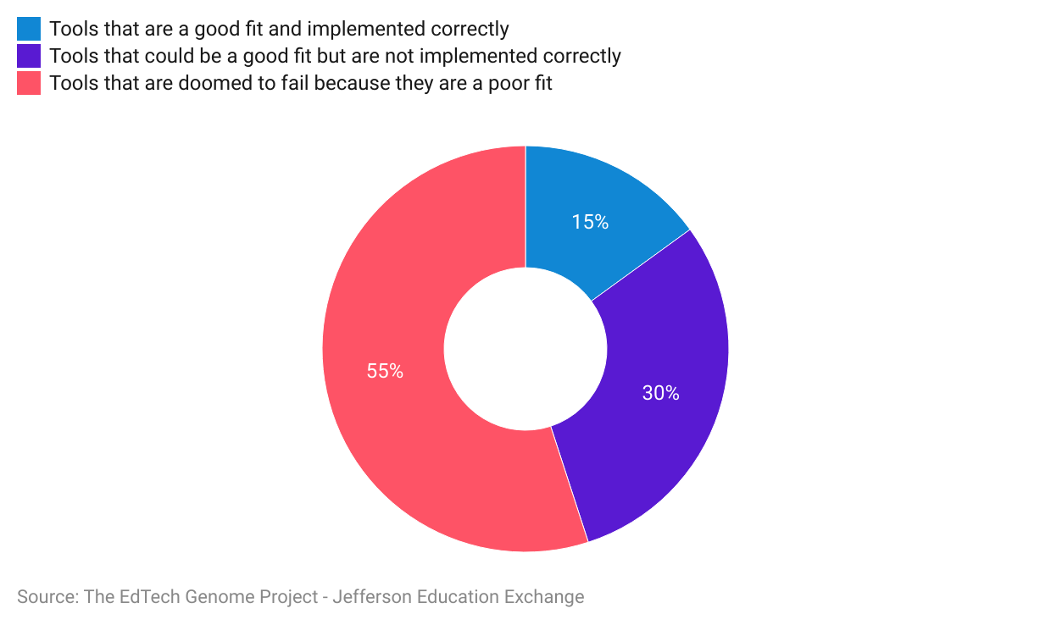

## **6. Proliferation of free content**

As more content providers offer free content in an effort to make education more accessible, those who charge for services will need to differentiate themselves to stay competitive.

## **7. Stigma associated with online learning and lack of social interaction**

Unlike homeschooling, students learning online can interact with teachers and classmates in digital classrooms and are accountable for their work and performance. The lack of daily face-to-face interaction with peers and teachers, however, could impact students’ social skills and development.

*Last updated: March 2024*

©2024 Uzabase, Inc. All Rights Reserved. The information contained herein: (1) is proprietary to Uzabase Inc. and/or its content providers; (2) may not be copied or distributed; and (3) is not warranted to be accurate, complete or timely. Neither Uzabase Inc. nor its content providers are responsible for any damages or losses arising from any use of this information.