Foundation Models: Overview


What are foundation models?
Foundation models are AI models that have been trained on historical training data and have grown in complexity to reach billions of parameters, enabling them to approach tasks with greater skill and accuracy than their smaller counterparts and predecessors. These models tend to be tens of gigabytes (GB) in size and are trained on vast amounts of data—sometimes at the petabyte (PB) scale.

What makes a foundation model a “large” AI model is its number of parameters. Parameters are values or “settings” in machine-learning (ML) algorithms (i.e., the weights and coefficients that the model extracts and estimates from training data and uses to develop outputs). For example, language models train by adjusting parameters, blanking out words, and comparing their predictions with reality. As such, parameters represent the part of the model that has learned from historical training data.

Generally, the more parameters a model has, the more information it can digest from its training data, the more accurate its predictions, and hence, the more sophisticated the model. Some large AI models may even be described as “neural networks” in terms of how they try to mimic the human brain through a set of deep-learning algorithms. For example, OpenAI’s GPT-3 (175 billion parameters) was the largest in the current generation of LLMs when it first emerged in 2020, but its successor—GPT-4, which was released in March 2023—is reportedly 10x larger, at 1.8 trillion parameters.

Foundation models parameters of major model developers over time
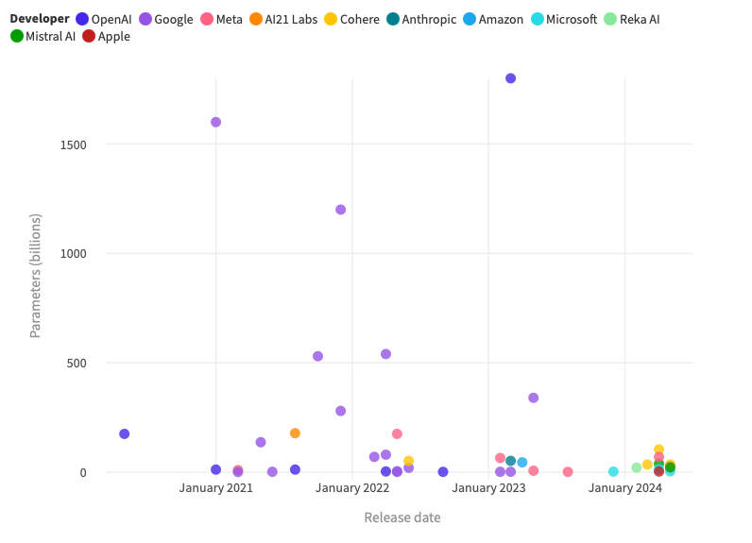
Source: SPEEDA Edge research, designed using Flourish • 1) This visual only includes models for which parameters are available. 2) It excludes Meta’s Facebook DLRM (since this model is an outlier at 12 trillion parameters and has no comparable equivalents).

Additionally, while most foundation models tend to have billions of parameters, a higher number of parameters does not necessarily lead to better performance outcomes, especially if models are undertrained. Google’s Chinchilla, a 70 billion-parameter model, is a case in point. Although 4x smaller than Google’s Gopher, it was trained on 4x more data. Researchers found that Chinchilla outperforms Gopher, GPT-3, Jurassic-1, and Megatron-Turing NLG across several language benchmarks.

Difference between foundation models and traditional machine learning models

Criteria | Foundation models | Traditional machine-learning models
Versatility and flexibility | High: Can be fine-tuned for various tasks with minimal additional training | Low: Typically specialized in a single task; e.g., a model trained for image classification might not be able to handle text processing without significant modifications
Requirement for data labeling | Low: Typically involves unsupervised learning, where the training data does not have explicit labels or pre-defined targets | High: Often requires data labeled for supervised learning, where input-output pairs are provided to train the model
Cross-domain applications | High: Integrates multiple data types; e.g., can handle unstructured data types including text, images, video, and audio | Low: Typically limited to specific data types; e.g., numerical data, categorical data, time-series data, and text
Cost | High: Cost of training models is relatively high | Low: Requires relatively less amount of resources for training
Processing techniques | Uses neural network techniques like transformers, generative adversarial networks (GANs), and variational autoencoders (VAEs) | Consists of rules programmed to perform specific tasks
Source: SPEEDA Edge research

Foundation models segmentation
Currently, foundation models broadly exist in either the textual (language, code), visual (images, videos), and sound (speech and music) domains or the overlap between these modalities (multimodal). Among these, LLMs were the most prevalent model types initially—with the launch of GPT-3 by OpenAI—however, companies are now moving toward multimodal models due to their ability to receive and generate a wide variety of data types, as seen by Google’s Gemini and GPT-4 by OpenAI. Companies have also developed SLMs optimized for domain-specific tasks and trained on more focused but smaller datasets.

Also, there are many companies that have emerged to create new content including artwork, videos, and articles by building atop foundation models. (These startups are covered in Generative AI Applications and Content Creation Tools industry hubs).

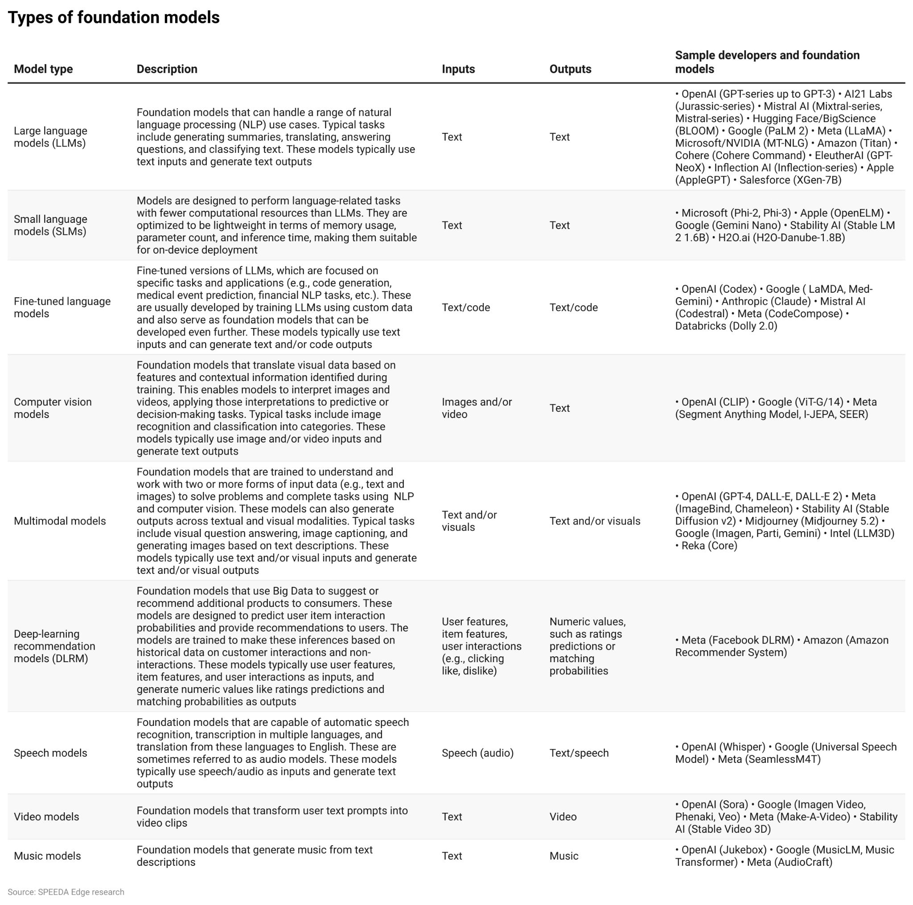

How did these models evolve?
It took until 2020 for the current generation of large foundation models to emerge. It is worth noting, however, that this scaling in size, complexity, and performance did not happen overnight. The ideas, deep-learning algorithms, and artificial neural networks at the core of these large AI models have been propagating since the 1960s. However, interest in AI and ML only truly rocketed in the late 80s and early 90s, when neural networks were found capable of problem-solving by accepting raw input data and building up hierarchical representations to perform predictive tasks.

However, at the time, complex problem-solving was limited by available computational power. For a while, computers could only handle simple, small-scale problems, such as MNIST (a handwritten digit classification problem). It wasn’t until the tail end of the 2000s—after two more decades of computational performance improvements driven by Moore’s Law—that computers finally became powerful enough to train large neural networks.

Overall, four key developments have guided the evolution of the current class of large AI models.

1. The rise of Big Data
Big Data and AI work together. ML (the subset of AI that accounts for how computers become smart) solves tasks by learning from data and making predictions. The explosion of data over the past decade has been instrumental to the emergence of large AI models. In 2012, IBM estimated that over 90% of the world’s data had been created in the preceding two years alone. At the time, the global data supply stood at an estimated 12.8 zettabytes (ZB) or 12.8 trillion GB. By 2020, the estimated total amount of data created, captured, copied, and consumed in the world stood at 59 ZB—the equivalent of 59 trillion GB. By 2025, this is predicted to reach 175 ZB.

The intersection of Big Data and AI is central to mining value from information. OpenAI’s GPT-4 was reportedly trained with a diverse dataset of around one PB of information, including web texts, books, news articles, code snippets, social media posts, and more. Meanwhile, Google’s PaLM 2 had a pre-training corpus larger than that of PaLM 1 (780 billion tokens) across web documents, code, mathematics, conversational data, and books.

2. AI/ML advances and the deep-learning revolution
Over the past decade, there has been a clear spike in research output in the field of ML and its applications. Arxiv, the open-access e-print repository for scholarly articles, has logged over 32x as many ML-related papers in 2018 as in 2009 (doubling every two years). On a daily basis, over 100 ML-related papers are posted to Arxiv, with no indication of slowing down. These leaps in research are also evident through performance improvements in ML-based computer vision models. Consider the ImageNet challenge—a large-scale visual recognition challenge where contestants are provided a training set of one million color images across 1,000 categories and must train models in image classification and object recognition. Before the use of deep-learning approaches in this contest, winning entrants used hand-engineered computer vision features, with the top five error rate being above 25%. From 2011 to 2017, the use of deep-learning approaches and neural networks resulted in the winning ImageNet error rate plummeting to 2.3% (2017), a pronounced improvement.

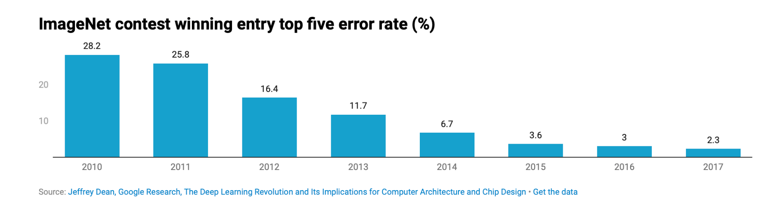

3. Growth in compute
During the pre-deep-learning era (1952–2010), the amount of compute used in AI training runs (simplified to computing performance) grew in line with Moore’s Law, doubling around every 18–20 months. After the advent of deep learning in the early 2010s, the scaling of training compute accelerated, doubling approximately every six months for regular-scale models. In 2015/16, the first large-scale models emerged, starting with models like Google’s AlphaGo (the first computer program to defeat a professional human Go player). These large-scale models display a 10-month doubling time. Improvements in compute represent a key component of AI progress. As long as this trend of scaling continues, AI systems have the potential to evolve significantly beyond today’s capabilities.

Growth in compute is supported by the continuous improvements in processing infrastructure made by players like NVIDIA, Intel, AMD, and Qualcomm. For example, NVIDIA introduced the NVIDIA Blackwell platform in March 2024, which is capable of running real-time GenAI on trillion-parameter LLMs at up to 25x less cost and energy consumption than its predecessor.

4. Development of transformer neural network architecture
Neural networks and, more specifically, artificial neural networks (ANNs) mimic the human brain through a set of deep-learning algorithms. These networks are a key approach for language-understanding tasks, including language modeling, machine translation, and question answering. In 2017, Google invented and open-sourced a new neural network architecture, called “transformer,” based on a self-attention mechanism that mimics cognitive attention. In simple terms, the self-attention mechanism enabled large AI models to focus only on certain parts of the input and more effectively reason the most relevant data based on the context. The Google team claimed that the transformer architecture worked better than previous leading approaches, such as recurrent neural networks (RNN) and convolutional neural networks (CNN). Currently, most of the large AI models are transformer-based (except for Meta’s SEER, which is CNN-based).

What is driving demand for foundation models?

1. Rise of creator economy and demand for AI content creation
A Goldman Sachs report valued the creator economy at USD 250 billion in 2023. By 2027, the market is expected to reach ~USD 480 billion, driven by spending on influencer marketing and the monetization of short-form video platforms via advertising. LLMs like OpenAI’s GPT-series and AI21 Labs’ Jurassic-series represent the starting point for GenAI applications that catalyze content creation, transforming the process from ideation to social media engagement to personalization. An estimated ~95% of content creators used AI for at least one task, including editing content (21%), generating images and videos (20.9%), and generating text and captions for accessibility (19%) in 2023.

2. Growing importance of digital customer experiences
Consumers have increasingly moved toward online channels, a trend accelerated by the pandemic. By 2025, some estimates suggest that “messaging” will be the number one B2C communication channel, making up ~61% of total interactions with a brand. The demand for efficient customer service responses has also escalated. According to Salesforce, 83% of customers expect to interact with someone immediately upon contact and 73% of customers expect companies to understand their unique needs and expectations. Meanwhile, Tidio reports that ~62% of customers would rather talk to a chatbot than wait 15 minutes to speak with a human agent.

As customers increasingly engage with enterprises on a digital basis, companies are doubling down on conversational AI investments that can provide 24/7 availability and personalized, context-driven interactions. Foundation models enable new functionalities and applications that were previously difficult or impossible, such as understanding the context of a conversation, providing more accurate and relevant responses, handling multi-turn conversations, maintaining context over extended interactions, supporting multiple languages and dialects, and offering more personalized responses by understanding user preferences, tone, and style.

3. Demand for automation and autonomy
Growing demand for automation and autonomy across sectors will continue to fuel demand for the underlying foundation models that enable machines to mimic human capabilities and function alongside humans. By 2024, Gartner predicts that AI and associated technologies will replace almost 69% of the manager’s workload of transactional or routine tasks, freeing up time for higher order activities like learning, performance management, and goal setting. Within fields like graphic design, the need to save time and automate repetitive tasks, such as basic image editing, has led to a rise in co-creation with AI using models like DALL-E, Midjourney, and Stable Diffusion.

Limitations

1. Cost of training and running large foundation models
All large foundation models have steep development costs. According to Wired, developing GPT-4 required training the model on trillions of words of text with thousands of powerful computer chips, costing over USD 100 million.

The cost burden goes beyond the financial. The GPUs that AI models are trained on draw more power than traditional CPUs. Based on a lifecycle assessment for training several common large AI models, researchers at the University of Massachusetts Amherst discovered that the process can emit over 626,000 lbs of carbon dioxide equivalent. In effect, training a single large AI model generates nearly 5x the lifetime carbon emissions of the average American car (including its manufacturer). For example, training OpenAI’s GPT-3 model has emitted ~1.1 million lbs of carbon dioxide equivalent. Without a switch to 100% renewable energy sources, AI progress may come at the expense of carbon neutrality.

2. Time- and memory-intensive training processes
Training large AI models is challenging for many reasons beyond cost. For starters, the parameters of these models do not fit into the memory of even the largest GPUs. Moreover, the large number of compute operations needed to refine these models can also result in long training times, unless the algorithms, software, and hardware are optimized together. Training Microsoft’s 530 billion-parameter MT-NLG model in a reasonable timeframe required the convergence of NVIDIA A100 Tensor Core GPUs and HDR InfiniBand networking, state-of-the-art supercomputing clusters, such as the NVIDIA Selene, and Microsoft Azure NDv4.

3. Ethical and social risks
The ethical and social risks of foundation models are areas of ongoing investigation and regulatory concern. In 2021, AI ethicist and former Google executive Timnit Gebru detailed the challenges associated with LLMs in a notable paper on the “dangers of stochastic parrots.” DeepMind has also outlined the six specific risks of LLMs in particular, including the risks of discrimination and representational and material harm by perpetuating stereotypes and social biases. These challenges are not limited to LLMs. OpenAI has also noted that image-generating multimodal AI models like DALL-E can similarly pick up on the biases and toxicities embedded in training images from the web. Aside from these risks of bias, the dangers of intentional misuse are also a significant concern, given the vulnerabilities of LLMs to attacks ranging from prompt injections to data poisoning. There is also the risk that foundation models may be weaponized to create polymorphic malware, more sophisticated phishing campaigns, and problematic deepfakes.

4. Regulatory hurdles
When OpenAI released GPT-4 in March 2023, the company opted for secrecy over disclosure with respect to the model’s architecture, citing competitive and safety considerations. Moving forward, however, this will not be an option for foundation model providers. With the advent of AI legislation, players will increasingly be called to provide detailed technical documentation. For instance, the EU AI Act, approved in March 2024, requires foundation model providers to undertake transparency measures, assess and mitigate risks, comply with design, information, and environmental requirements, and register within the EU database. Providers of generative foundation models also have to comply with additional transparency requirements, including disclosing that content was AI-generated, ensuring that model design prevents the generation of illegal content, and publishing summaries of copyrighted data used for training.

What can these models do?

Appendix: Examples of what foundation models can do

Provided below are some memorable “snapshots” of how select foundation models perform.
LLMs like AI21 Labs’ Jurassic-1 can be used for a wide variety of functions, including question answering, text generation, text classification, and text summarization.

Snapshot: Summarization with AI21 Labs’ Jurassic-1
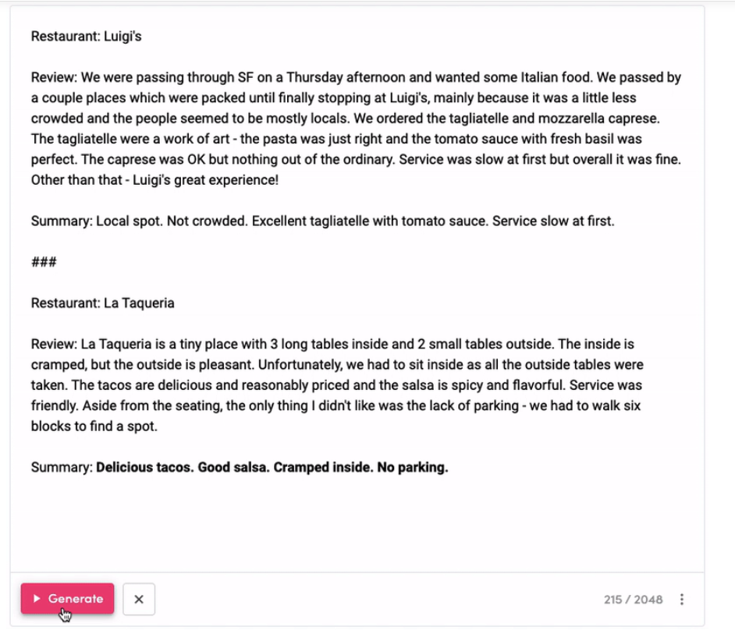
Source: AI21 Labs
Meanwhile, Google’s LLM, PaLM 2, lends itself well to multilingual tasks, such as translation and multilingual question answering. The model was trained on a dataset that included a higher proportion of non-English data than previous LLMs, resulting in multilingual capabilities in language, code generation, and reasoning.

Snapshot: Multilingual translation with Google’s PaLM 2

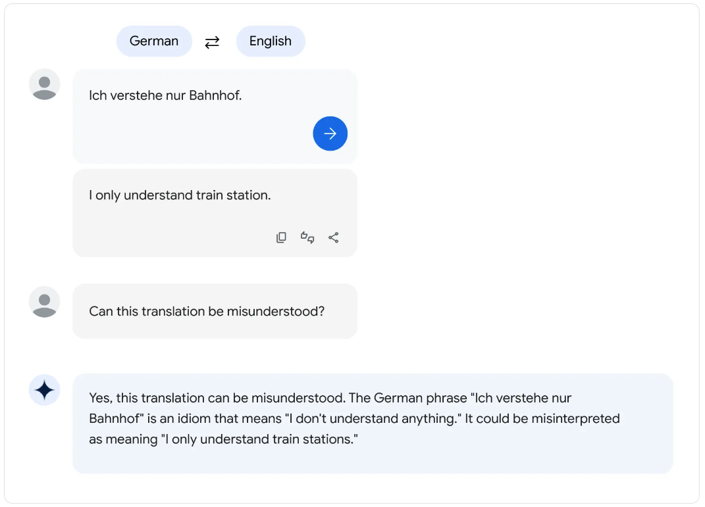
Source: Google
Fine-tuned language models are just as interesting in terms of the possibilities they present. While LLMs can be fine-tuned for a wider range of natural language tasks, fine-tuned models, like OpenAI’s ChatGPT, are best suited for specific conversational tasks, such as AI chatbot applications.

Snapshot: Content generation with OpenAI’s ChatGPT

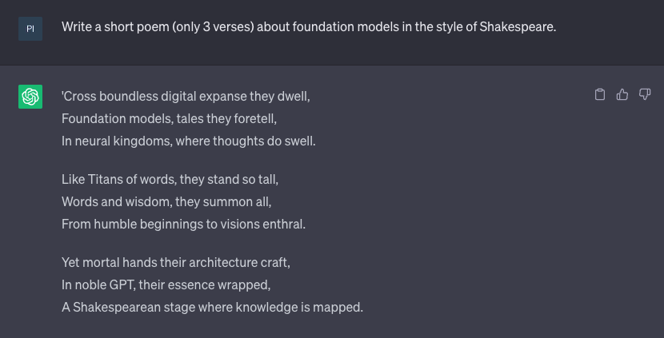
Source: OpenAI
The following snapshot from Amazon’s CodeWhisperer shows how language models can be fine-tuned to generate code and harnessed to reduce the coding burden on software developers. In this instance, the programmer types out instructions in English and CodeWhisperer generates code suggestions in real-time to improve developer productivity. CodeWhisperer provides AI–powered code suggestions across several programming languages, including Python, Java, JavaScript, TypeScript, Rust, PHP, Ruby, SQL, and Scala.

Snapshot: Coding with Amazon CodeWhisperer

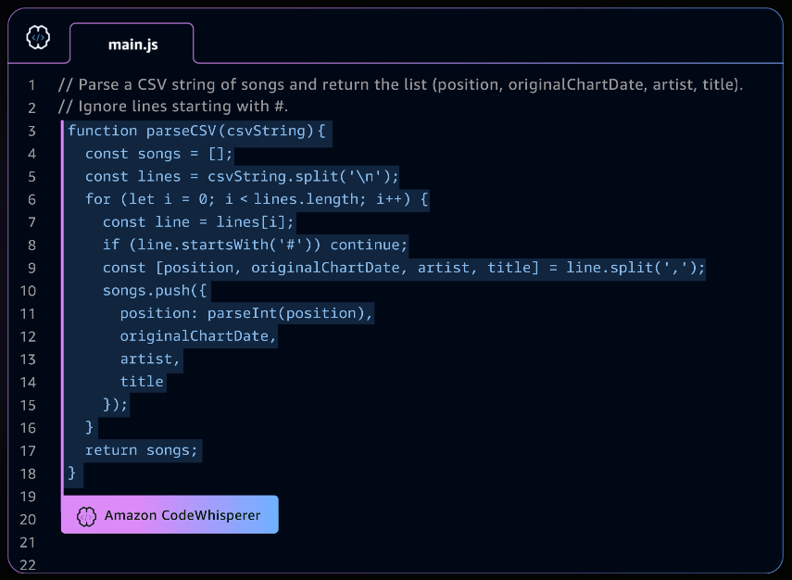
Source: Amazon
Computer vision models are adept at tasks like image recognition and object identification within images. Meta’s Segment Anything Model (SAM), for instance, is a promptable segmentation system that can “cut out” any object in an image with a single click.

Snapshot: Image recognition with Meta’s Segment Anything (SAM) Model

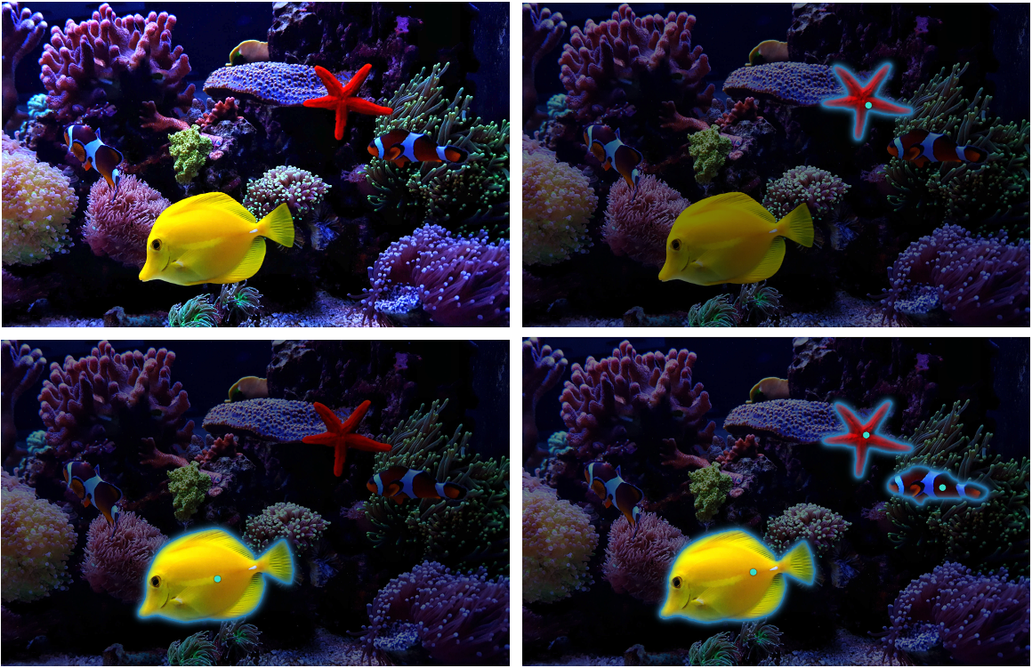
Source: Meta
Multimodal models focused on text-to-image generation are built on the intersection of textual and visual capabilities and hold exciting possibilities for design, image prototyping, and other fields. The snapshot below is a visual created by Stable Diffusion’s model in response to the following text prompt: “Documentary-style photography of a bustling marketplace with spices and textiles in Marrakech.”

Snapshot: Generating images from text with Stable Diffusion


Source: Eduard Arnautu, Created with Stable Diffusion
Other multimodal models like Midjourney, DALL-E, DALL-E 2, Parti, and Imagen similarly operate with a deep level of language understanding and a variety of stylistic capabilities, including photorealistic image generation. They are only limited by the human imagination in terms of the variety of potential visual representations available.
Unlike its predecessors, OpenAI’s GPT-4 is also a large multimodal model, capable of receiving image and textual inputs. However, GPT-4 differs from multimodal models like Stable Diffusion, in that it is strictly a multimodal language model, returning only natural language responses.

Snapshot: Image and text perception with OpenAI’s GPT-4


Source: OpenAI
New multimodal models like Meta’s ImageBind also present a novel opportunity to bind data from several modalities at once, creating an entire sensory experience. Specifically, ImageBind can recognize six modalities, including image, video, audio, text, depth, thermal, and inertial measurement units (IMUs). As such, the model lends itself to a variety of permutations in capabilities. For example, if presented with an image of a beach, ImageBind can enhance it with an associated audio clip like the sound of waves. Alternatively, if presented with an audio recording of a bird, the model can generate images of what the bird might look like.

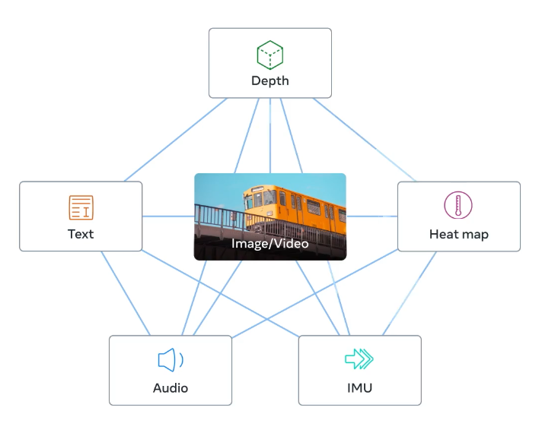
Source: Meta
Google’s Phenaki is a video model that can generate realistic videos of variable lengths from a sequence of textual prompts. Similar models include Meta’s Make-A-Video, which also enables users to add motion to images, fill in motion between two images, and create variations of videos based on the original.

Snapshot: Generating videos from text with Google’s Phenaki

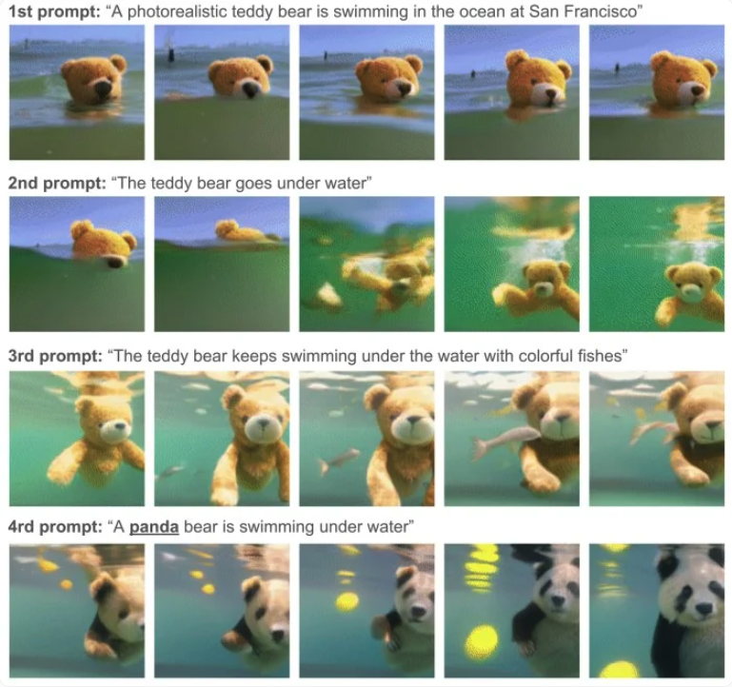
Source: Google

Last updated: June 2024

©2024 Uzabase, Inc. All Rights Reserved. The information contained herein: (1) is proprietary to Uzabase Inc. and/or its content providers; (2) may not be copied or distributed; and (3) is not warranted to be accurate, complete or timely. Neither Uzabase Inc. nor its content providers are responsible for any damages or losses arising from any use of this information.

