# **Content Creation Tools: Overview**

## 

# **Creating affordable content for the digital age**

With target audiences steadily moving online, firms have turned to digital media channels to build brand awareness, credibility, and trust while educating and engaging with stakeholders. Whether it’s infographics on a company’s performance, stop motion animated recruitment videos, or podcasts and blogs featuring a company’s CEO, a host of new mediums have made their way into the mainstream. To create this engagement, firms need content (and a lot of it!), with [60% of marketers](https://neilpatel.com/blog/38-content-marketing-stats-that-every-marketer-needs-to-know/) creating at least one piece of content each day. However, herein lies the problem—44% of marketers identify the [content production process as the biggest challenge](https://www.inc.com/sujan-patel/10-statistics-about-content-marketing-in-2016-you-won-t-believe.html). Solutions like outsourcing content creation to external design agencies are expensive and time-consuming, while traditional design software has a steep learning curve and a hefty price tag.

Enter, content curation tools. These provide non-technical, affordable solutions geared toward producing content at scale for the digital age.

Content creation tools are platforms and tools for discovering, creating, and managing digital content across a multitude of digital media. The proliferation of new digital forms of communications has enabled the creation of platforms that provide affordable solutions, allowing users to create professional content specialized for digital channels, without technical expertise. A number of these solutions also leverage AI to automate and streamline the content creation process, allowing more content to be created at scale.

### 

### **The content creation process**

### 

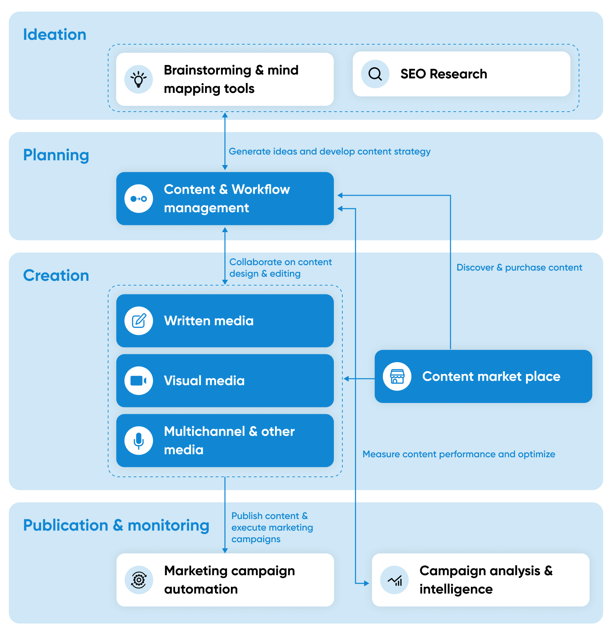

***Source: SPEEDA Edge, based on various sources***

These tools are primarily used by advertising and marketing, media and communication, and customer engagement teams for content marketing and other customer communication requirements. Most of these solutions are free to use with subscription options for premium features, making them more accessible to firms of all sizes.

### 

### 

### 

### 

### **Key segments of content creation tools**

## 

## **However, we exclude the following areas when selecting companies for this industry:**

1. Tools used in the:

* Ideation stage of the content creation process, including search engine optimization (SEO).
* Publishing and monitoring stage, including social media management and other marketing campaign automation tools.
* Monitoring and analysis stage, including content consumption and customer journey analytics.

(The above are covered under [Marketing Automation](https://sp-edge.com/industry/62)).

1. Tools and platforms primarily geared toward solopreneurs and other individual creators like writers, journalists, freelance designers, and social media influencers (covered under [Creator Economy](https://sp-edge.com/industry/42)).
2. Companies that provide professional content creation services or platforms for discovering and outsourcing to freelance content creators. While several firms include professional content creation and advisory services as a supplementary offering, we exclude firms that exclusively provide such services, as they do not support in-house content creation.
3. Tools and platforms used for website creation, communication platforms, and content management systems (CMS) have been excluded, as the application of these solutions is part of the underlying infrastructure for a firm's customer interactions.

## **What's different about modern content creation tools?**

## 

Popular graphic design software, such as Adobe’s Photoshop and CorelDRAW, has been around since the 90s. Most of these traditional tools, while powerful and highly flexible, are typically designed with professional content designers in mind. They come with steep learning curves and hefty price tags.

In contrast, modern content curation tools provide non-technical solutions that are accessible to beginners and specialize in creating content for new and emerging digital media channels. Most of these solutions are free to use with subscription options for premium features, making them more accessible for firms of all sizes.

### 

### 

### 

### 

### 

### 

### 

### 

### 

### **Traditional vs. modern content creation tools**

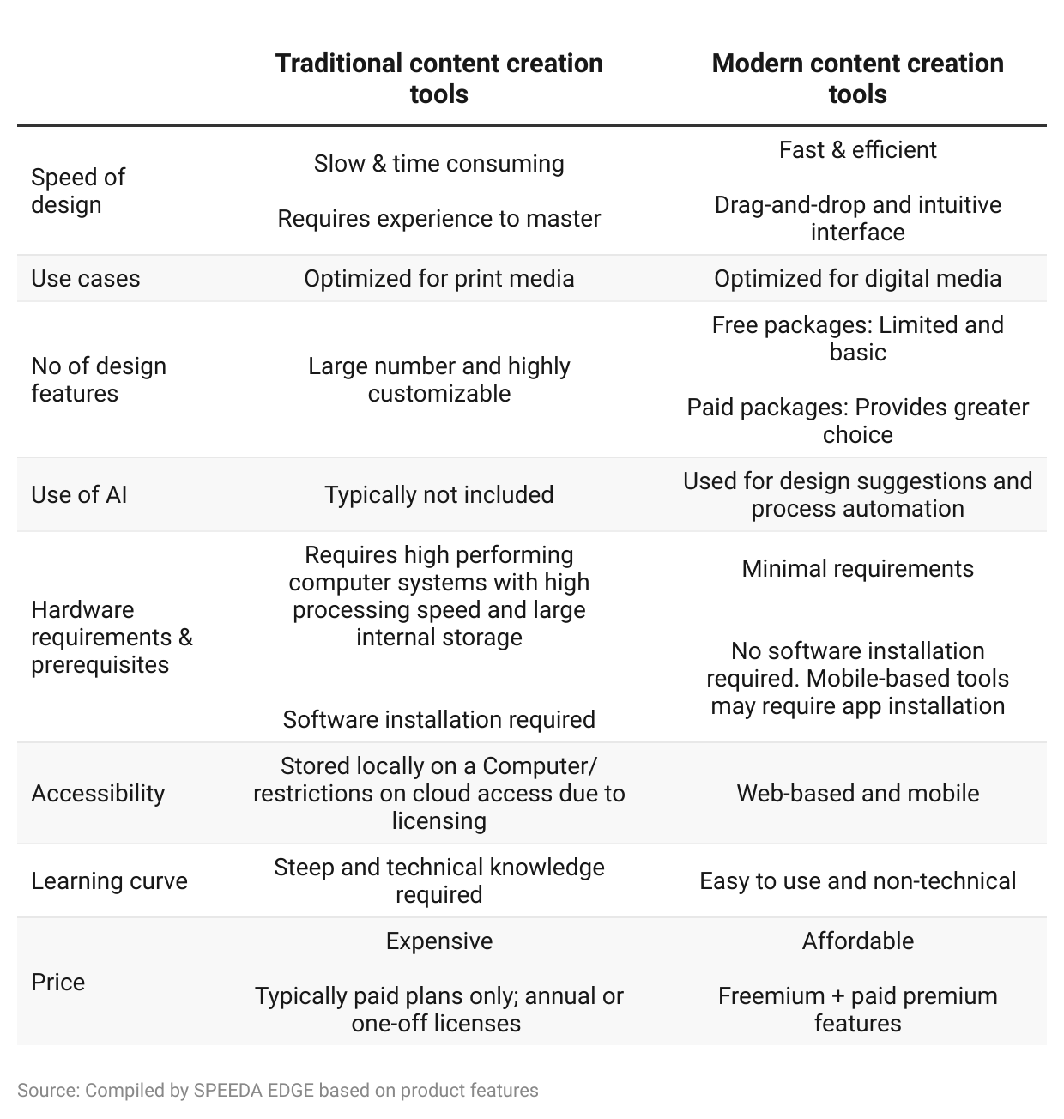

Users of modern content creation tools have reported many benefits including saving on content development costs, speeding up development and content publication, and increasing content engagement and revenue.

### 

### 

### 

### 

### **Summary of benefits claimed**

|  |  |  |  |
| --- | --- | --- | --- |
| **Company** | **Segment** | **User** | **Benefits claimed** |
| Three Kit | Visual media Creation | Custom fantasy rings  (Sports rings manufacturer) | Eliminated 100% of photography costs |
| Ink | Written media creation |  | Content creation is 5x faster due to AI which can instantly rephrase content |
| Turtl | Multi-channel & other media creation |  | 73% increase in content engagement |
| Lumen 5 | Visual media creation/ Content Marketplace | Siemens  (Industrial manufacturer) | 98.3% faster turnaround times  25x cheaper than using an agency |
| Tiled | Multi-channel & other media creation | Paycor  (HR management platform) | 300+ hours of development time saved  $115,000 savings in development costs |
| Relayto | Written media creation | Amadeus  (Travel Tech) | 30x faster development time |
| ContentCal | Content & workflow management | Boutique Workplace Company  (Co-working spaces) | GBP 500,000 increase in revenue from organic content    4,700 new social media followers |
| Chili Publish | Content & workflow management | Precision marketing  (Real estate eCommerce solution) | 80% reduction in content cration time  Time for executing email marketing reduced from 2 days to 2 hours |
| Creator | Integrated offering | Godiva  (Luxury confectionery brand) | 50% time saved in creating and publishing content    380% increase in creative output |

### 

### **What is driving demand for content curation tools?**

### 

### **Growth in content marketing**

Content marketing is a foundational approach to marketing, harnessing a firm’s content to engage with customers and complementing other digital marketing strategies such as email, social media, or influencer-led marketing—all of which rely on some degree of content. According to the [Content Management Institute](https://contentmarketinginstitute.com/about/mediaroom/latest-press-releases/business-to-business-b2b-marketers-confidence-in-content-marketing-continues-to-grow-usage-rates-up/) (CMI), 91% of B2B marketers use content marketing and reportedly allocate close to 40% of their marketing budget for it.

In the digital age, content marketing has been the leading approach to marketing, bringing in [3x as many marketing leads](https://www.demandmetric.com/content/content-marketing-infographic) and costing 62% less than traditional methods. The need for content marketing is only set to grow, with surveys showing that more than 66% of marketers [expect their 2022 content marketing budgets to increase](https://blog.hubspot.com/marketing/state-of-content-marketing-infographic).

The top challenges marketers face with content marketing relate to content production. These include coming up with new content and creating content that generates leads and receives high online engagement. Hence, firms have been devoting an increasing share of their content marketing budget to content creation.

### 

### **Marketers focus more on content creation**

### 

### 

### **High cost of outsourcing content creation**

### 

Firms have traditionally turned to outside agencies or freelance designers and writers for content creation in the absence of in-house experts. However, depending on the type of content and the experience of the design team or individuals, the cost per project could be substantial.

While outsourcing content creation frees up time for a firm’s marketing team, it does require some additional time commitments for getting the content right. This includes time spent on back-and-forth communication for edits and rewrites as well as ensuring that content meets the firm’s brand requirements and intent.

### 

### **Cost of outsourced content creation (USD per project)**

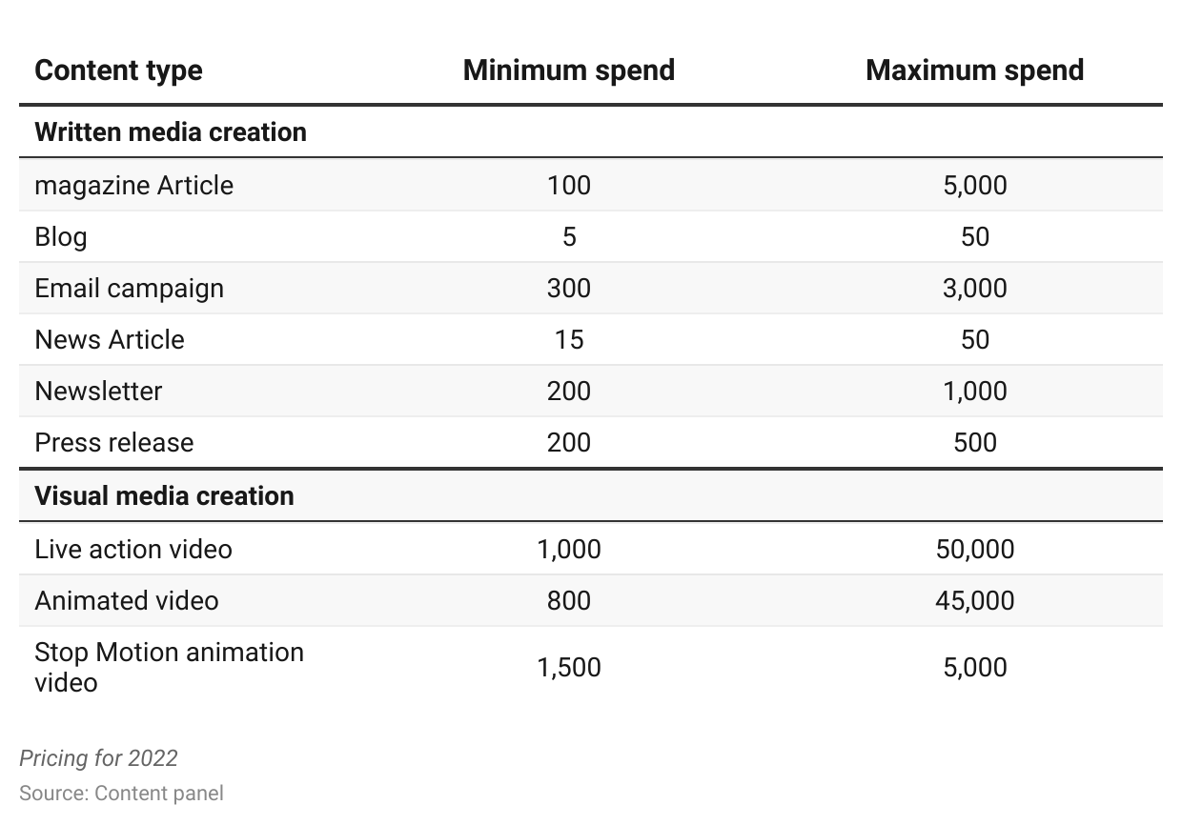We expect that outsourcing will continue to have a role, particularly in terms of 1) consultancy services, providing design ideas and content strategy, and 2) more specialized activities such as SEO and paid search marketing. However, the availability of these tools has pushed firms toward in-house content creation.

### **In-house content creation becoming more popular**

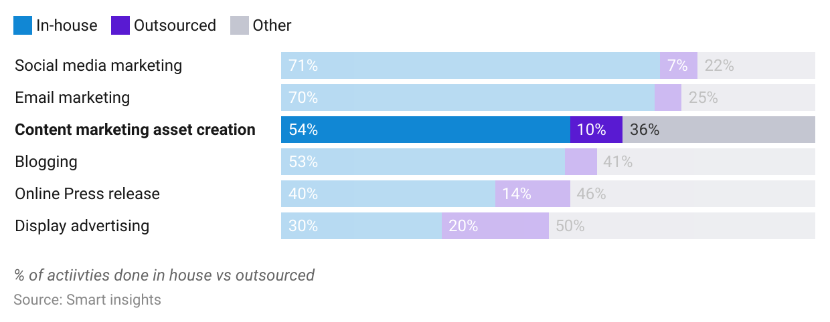

### **Rise of the socially conscious consumer**

The modern consumer is well-informed and aware of global social and political issues. They are vocal and opinionated, expressing themselves openly through varied digital media. As a result, consumers expect the brands they consume to demonstrate the same level of engagement. Two-thirds of consumers expect [firms to weigh in and take a stand](https://sproutsocial.com/insights/data/championing-change-in-the-age-of-social-media/) on varied issues, particularly those affecting a firm's consumers, employees, and business operations. Consumers are also becoming savvy to marketing messages, making efforts to visit a company's website and social media channels to learn about its actions on social issues and to gauge its authenticity. Consumers are ready to reward brands that are perceived as socially conscious while expressing their dissatisfaction and punishing those that are slow to respond or get it wrong ([Pepsi’s Kendall Jenner ad](https://www.wired.com/2017/04/pepsi-ad-internet-response/)).

Delivering such messages, which are needed more frequently and consistently, is no easy feat. Marketing teams can expect to spend upwards of [70 hours per month](https://www.rickwhittington.com/blog/content-marketing-strategy-how-much-time) in developing and executing a content marketing strategy, with content creation accounting for much of it.

Modern content curation tools with their drag-and-drop interfaces, custom templates, and AI-powered services, speed up the content creation process, enabling marketing teams to put out suitable on-brand content in a timely manner.

### **Time spent creating a single piece of content (hours)**

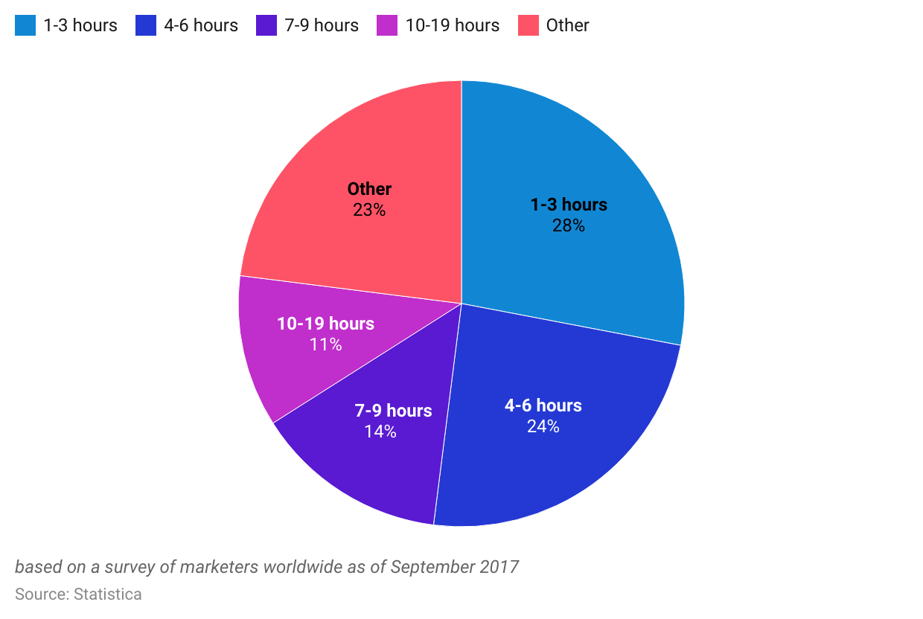

### **Consumers snacking on content anywhere and anytime**

### 

Over the past decade, consumers have increasingly been turning to digital channels to meet their entertainment needs, with an average US adult spending close to [12.5 hours per day consuming content](https://heidicohen.com/infographic-how-we-consume-content-now-what-it-means-for-your-marketing/). US consumers spend most of their time consuming digital media over traditional mediums, and with digital media providing many new consumer touchpoints, content consumption habits have been changing.

### **Time spent consuming content (hours per day)**

### 

### 

Multi-input content consumption and information “snacking” are two emerging trends. The former refers to when consumers engage with content on multiple devices—using a mobile phone while watching television or listening to a podcast while working out. Information “snacking” consumption is when consumers, whether it’s reading an article or listening to a podcast, consume the content in bite-sized chunks throughout the day across different mediums.

As a result, it's increasingly important for content creators to design engaging, attention-grabbing, and skimmable content available across multiple channels. Several startups, such as **Issuu,** specialize in repurposing and distributing content across multiple digital media channels.

### **Risks to growth**

### **Data loss and fraud**

Most modern content curation tools store content on the cloud. Therefore, firms are exposed to risks associated with data hacking and online fraud. A case in point is **Canva**, which in January 2020 was subject to a [significant data breach](https://www.canva.com/help/article/incident-may24/) where ~4 million accounts were hacked and 139 million user details including username, email addresses, and passwords were stolen.

Given the numerous tools available, many of which are free, users may suddenly find that a startup providing a popular tool has gone bust, along with all the content a firm spent hours on preparing.

1. **Compatibility issues and switching costs**

Many startups offering content curation tools tend to focus on specific types of media, such as written, visual, or audio media, and specialize in a niche part of the content creation process. Users may therefore make use of multiple tools to create a single piece of content. At the same time, consumers are looking to engage with their brands across multiple mediums ranging from social media posts and podcasts to blog posts, ensuring consistent messaging across multiple platforms.

This could pose a challenge for content curators. Incompatibility between numerous content creation tools could limit the number of tools used and lead to stickiness. Switching from one platform to another could also lead to a loss of data. However, many popular content curation tools have a range of integrations with social media channels as well as digital asset management and other content curation tools, allowing creators to work across multiple tools and platforms.

### 

### **What’s Next for content creation tools?**

### 

Smartphone growth over the last decade has meant that consumers have gotten used to consuming their digital content anytime, anywhere. As new digital customer touchpoints like smartwatches, virtual reality and augmented reality headsets, and in-vehicle infotainment systems gain popularity, more opportunities open up for firms to deliver content across several new mediums.

Additionally, the growth in online shopping and the preference for direct-to-consumer (D2C) brands has led to new forms of sales and marketing strategies such as social commerce and influencer-led marketing. Delivering personalized content at scale across all digital media channels has become critical for converting passive viewers into active consumers.

All-in-all, these factors highlight the potential for content curation tools to cater to emerging digital channels and trends.

## 

*Last updated: April 2022*

©2024 Uzabase, Inc. All Rights Reserved. The information contained herein: (1) is proprietary to Uzabase Inc. and/or its content providers; (2) may not be copied or distributed; and (3) is not warranted to be accurate, complete or timely. Neither Uzabase Inc. nor its content providers are responsible for any damages or losses arising from any use of this information.