# 

# **What is Sustainable Finance?**

Sustainable finance broadly refers to considering ESG factors when making financial and investment decisions, with the ultimate goal of creating more long-term investments in sustainable economic activities and projects. Sustainable finance also promotes transparency when assessing ESG risk factors and the impact of these risks on the financial system.

### **Key considerations in sustainable finance**

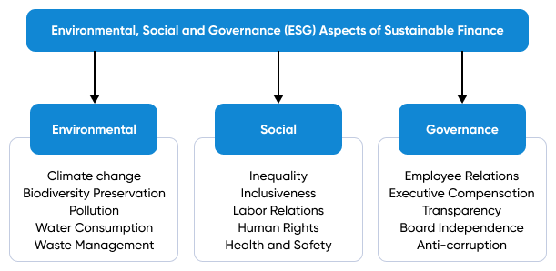

*The list of factors is not exhaustive*

Source: Created by SPEEDA Edge based on various sources

Traditionally, the financial world was thought of as being solely profit-oriented at the expense of the environment and social welfare. Sustainable finance has worked toward shifting this paradigm by urging the financial ecosystem to take on a holistic approach when carrying out financial activities; meaning, including a view that’s more than just about maximizing returns, and shifting the focus from shareholders to stakeholders, pushing to adopt strategies that evaluate the long-term impacts of financial decisions, as opposed to short-term ones that look to make quick profits.

Sustainable finance, as a concept, can be categorized into several forms, which include, but are not limited to, sustainable funds, green bonds, impact investing, microfinance, and credits for sustainable projects and development. All of these categories, however, broadly fall within some form of equity investments or debt instruments.

### 

### **Sustainable finance in a nutshell**

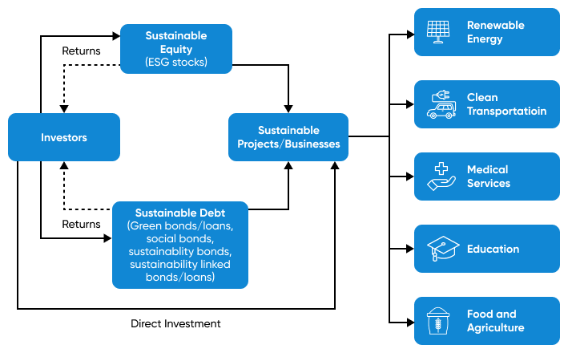

Source: Created by SPEEDA Edge based on various sources

### **Key segments across sustainable finance**

**However, we exclude the following areas when selecting companies for this industry:**

1. Platforms that automate investments on shares and ETFs without a specific focus on ESG considerations (covered under [Retail Trading Infrastructure](https://sp-edge.com/industry/28))
2. Fully digital banks for businesses and consumers that offer banking services without a specific focus on ESG considerations (covered under [Neo Banks](https://sp-edge.com/industry/59))
3. B2B and B2C carbon intelligence tools that help businesses (relating to internal operations and supply chains) and consumers (via lifestyle surveys) track their carbon footprint (covered under [Carbon Management Software](https://sp-edge.com/industry/49))

## **Why now?**

#### 

#### **Regulations**

The importance of sustainable finance has been further emphasized by the Sustainable Development Goals set by the United Nations in 2015, which faces an annual financing shortfall of around USD 2–4 trillion.

To this end, regulatory and financial bodies have announced various initiatives, promoting sustainable practices in the financial ecosystem. For instance, in January 2021, the US Federal Reserve and European Central Bank announced that climate considerations be a central part of finance. Both bodies stated that they intended to analyze the extent to which climate change would affect the stability of banks as well as the broader financial ecosystem. More recently in November 2021, it was announced at the COP26 climate conference in Glasgow that the UK will force financial firms to outline their plans and intentions to decarbonize their operations to achieve Net Zero, stating the nation’s aim to become the world’s first Net Zero-aligned financial center.

Various initiatives have been developed on global, regional, and national levels to support the sustainable finance approach through policies; in addition, initiatives have also offered financing and assistance to sustainable projects. A few key policies and initiatives have been outlined below.

### **Key policies and initiatives that address sustainable finance**

#### **Consumers**

Like governments have increased the pressure on the finance sector to incorporate sustainability practices into its operations, there is pressure from consumers on industries to align their practices with sustainability-focused goals.

The conscious consumer is aware of the adverse effects and doesn’t align themselves with practices that are not sustainable; moreover, they are increasingly directing their funds toward environmentally-friendly companies or projects. According to a recent survey by Morgan Stanley, 85% of customers stated that they would more likely select a bank that had a positive social and environmental impact on their banking needs. Younger demographics, in particular, are becoming increasingly concerned about how the organizations they interact with are contributing toward creating a more sustainable future.

In response to increased pressure from regulatory bodies and consumers, many incumbents, such as in the banking sector, have started to incorporate sustainability into their financial practices, offer access to ESG funds, and have outlined long-term targets associated with reaching these said goals. For instance, European asset manager Amundi has stated that it intends to incorporate ESG into 100% of its investments by the end of 2021, while BlackRock, one of the largest asset managers in the world, aims to increase its sustainable AUM to USD 1 trillion by 2029 (from USD 90 billion in 2019).

### 

### **Comparison between levels of interest in sustainable investing**

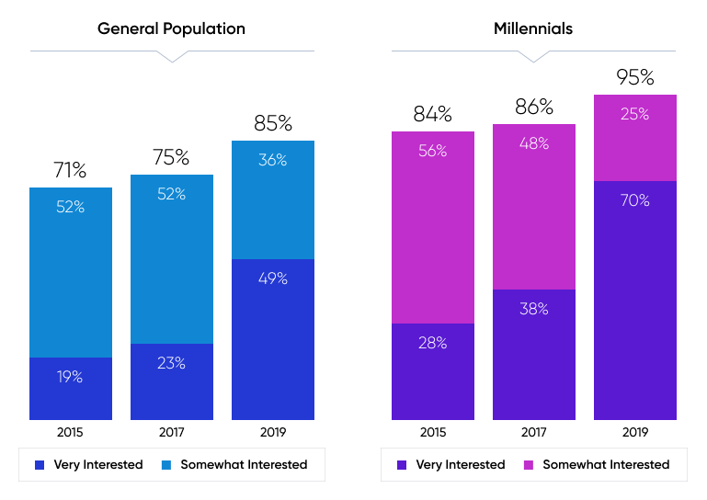

Source: Morgan Stanley

## **What are the methods available?**

#### 

#### **Sustainable equity investments**

Sustainable equity investing mainly involves making equity investments in companies whose activities align with ESG considerations and contribute toward sustainable development goals (SDGs). As such, it excludes investments into industries deemed unsustainable or unethical, such as plastic and tobacco. So, sustainable equity includes mutual funds, index funds, and exchange-traded funds (ETFs), which invest in stocks of ESG principle-abiding companies in addition to direct investments made in companies that operate in the sustainability space, such as renewable energy.

The number of sustainability-focused equity funds has grown rapidly over the past decade, reaching a total of 3,987 funds as of June 2020, from just 1,304 in 2010, with around half of all sustainability-focused funds being launched during the past five years. In line with this, the total AUM of sustainability-focused funds has also surged, nearly doubling between 2019 and mid-2020 alone to reach USD 1.7 trillion, following growth at a CAGR of 22.9% over 2013–2019.

### **Total AUM of global sustainability equity funds**

According to available data from UNCTAD, out of 800 sustainable equity funds, 27% of total assets have been directed toward funding eight key sectors (as of June 2020), out of which, the health sector (covering areas such as medical services, pharmaceuticals, and medical devices) was identified as the single, largest sector for these funds, followed by renewable energy, food and agriculture, and water and sanitation. Other sectors include transport infrastructure, telecommunication infrastructure, education, and ecosystem diversity.

Moreover, 48% of sustainable funds outperformed their respective benchmarks over the period of three years, while 52% underperformed them. The slim difference in performance suggests that these funds don’t typically suffer financial disadvantages due to their investment strategies.

#### 

#### **Sustainable debt**

Sustainable debt is mainly about issuing debt instruments such as bonds and loans to fund specific projects or activities that are aligned with ESG standards. For example, sustainable debt includes green bonds and loans that are issued to support environmental activities, such as the renewable energy capacity installations and social bonds, which are mainly issued by government agencies and supranational bodies for healthcare and other relief purposes.

### **Main types of sustainable debt**

The sustainable debt market has had immense growth over the past few years, growing at a CAGR of 60.7% during 2013–2020, outpacing the growth of the sustainable equity market. Over one-third of sustainable debt issued between 2013–2020 was issued during 2020 alone. The growth has, in part, been supported by the changing landscape of the sustainable debt market.

At its early stages, the sustainable debt market was almost entirely made up of green bonds and green loans; its development was spurred by a growing need for alternative financial instruments that offered more environmentally-friendly results. Issuing green bonds has created more awareness of climate change, its associated challenges, and the need to funnel more funds to overcome these challenges.

Over the past few years, the landscape has shifted to cater to broader ESG initiatives than just green projects alone, allowing financial institutions to issue a much wider range of sustainability-focused debt instruments, such as sustainability-linked bonds and social bonds. For instance, the growth in sustainable debt in 2020 was primarily driven by the higher issuance of social bonds (up nearly 8x YoY) from governments and supranational bodies, such as the EU, to raise funds for pandemic healthcare and relief efforts. From a consumer standpoint, high credit ratings of social bonds have also added to their appeal. For instance, the EU’s first social bond, issued in October, was 14 times oversubscribed.

### **Global sustainable debt issuance growth**

## **How are sustainable funds performing?**

There’s been debate over the inherent risk and the associated returns of investing in ESG funds. On the risk front, many argue that investing in ESG funds alone may be more risky, given that they are less diversified and don’t include large index constituents such as oil and mining stocks. On the other hand, some say that investing in ESG funds may be less of a risk to investors, given that incorporating ESG risks into investment strategies could shield investors from negative publicity over issues related to unethical working practices or other ESG factors.

Although many believe that investing in sustainable funds may compromise their returns, data, however, shows that ESG funds have been outperforming non-ESG funds over the latter half of the last decade. The reasons for ESG fund performance are also up for debate; however, ESG funds’ long-term focus, as opposed to traditional funds’ short-term gains outlook, has been attributed as a key reason for its success.

### **Global ESG fund outperformance relative to non-ESG funds**

## **Like any new practice, sustainable finance has its challenges**

Although sustainable finance practices have been received positively, for the most part, there may be certain challenges associated with incorporating sustainability into day-to-day financial practices. A few key challenges to the future development and growth of sustainable finance are outlined below.

* **Perception of being a niche market:** Although sustainability has become a hot topic in the finance space, sustainable funds still account for a negligent share (3.3% in 2020) of the global fund market. If this persists, there is a risk that sustainable funds may be simply seen as just another segment designed to meet the market need for products aligned with sustainability, making it challenging to embed sustainable practices as an integral part of the investment landscape.
* **Geographic reach:** Product development within the sustainable finance space has largely been concentrated and limited to developed markets, while the concept remains nascent in less developed markets. For instance, developing countries contribute just 5% to total sustainable funds by number and 3% by assets. If the concept of sustainable finance aims to succeed at a global level, more awareness of the benefits and necessities may need to be created.
* **Lack of regulatory disclosure:** Although the idea of sustainable finance calls for greater transparency and disclosure, regulatory mandates on disclosing information on initiatives still remain limited, with disclosures mainly done on a voluntary basis. Hence, the progress made toward achieving sustainable goals may be misrepresented. In October 2019, the World Resources Institute reported that half of the world’s largest 50 banks had made sustainable finance commitments, out of which 57% didn’t publicly disclose their accounting methodology, while one-third had no plans to disclose the progress of their sustainable commitments. Unclear disclosure standards may make it difficult for investors to compare securities on a consistent basis, thereby limiting the credibility of sustainable finance initiatives and hindering their growth.

## 

## **Outlook**

As corporate initiatives increasingly embed sustainability goals into their business models, sustainable practices are likely to become a core focus. Approximately 33% of global assets under management are expected to have ESG mandates by 2025. Adding to this, sustainable investments are expected to increase by 433% between 2018–36, to reach total assets worth USD 160 trillion globally. The growth in sustainable investments will be influenced by a combination of factors, which includes higher demand for sustainable investment options from investors, and the increased need for companies to achieve their sustainability targets.

Moreover, implementing policies and initiatives at global, regional, and national levels should increase the inflow of funds to ESG initiatives. For instance, The International Finance Corporation expects nearly USD 23 trillion worth of investment opportunities to open up in emerging markets by 2030, as a result of the Paris Agreement.

The need to respond to global threats (climate and social) and develop sustainable solutions to minimize associated adversities continues to grow. Developing sustainable solutions, however, requires significant levels of funding, and is hence not feasible, unless capital is directly funneled toward economic activities and projects that deliver the targeted outcomes. Although not yet conclusive, the spike in funds going into sustainable initiatives is directional, and one thing’s for sure: making the world a better place is not just a mantra or a catchphrase anymore; the world is willing to put money on it!

©2024 Uzabase, Inc. All Rights Reserved. The information contained herein: (1) is proprietary to Uzabase Inc. and/or its content providers; (2) may not be copied or distributed; and (3) is not warranted to be accurate, complete or timely. Neither Uzabase Inc. nor its content providers are responsible for any damages or losses arising from any use of this information.