# 

# **Supply Chain Tech: Overview**

## 

# 

# **Unlocking supply chain excellence through technology**

Supply chain technology focuses on solutions that help organizations address supply chain disruptions and build resilient supply chains. These solutions gained notable traction during the Covid-19 pandemic, as organizations accelerated the adoption of novel technologies to future-proof their supply chains. Although the aftermath of the pandemic is easing, disruptions caused by economic and geopolitical turmoil continue to emphasize the importance of adopting these technologies to manage supply chain operations.

Supply chain technologies offer solutions that streamline and optimize supply chain operations. This includes technological solutions that can be applied from raw material sourcing to order fulfillment. We have categorized the available solutions into five segments.

### **Principal supply chain technologies**

## **Multiple tech advancements unlocking advanced supply chain capabilities, led by AI, RFID, RPA, and digital twins**

A survey conducted by Gartner in December 2021 found that out of the 211 supply chain professionals who participated in the survey, [34%](https://www.gartner.com/en/newsroom/press-releases/2022-06-08-gartner-reveals-the-top-supply-chain-technology-themes-in-2022) thought that adapting to new technology is the most important strategic change that supply chain organizations will face in five years. In 2022, Gartner highlighted hyperautomation 2.0 (use of multiple technologies such as AI and ML to identify, vet, and automate business and IT processes), next-generation robots, autonomous things, digital supply chain twin, analytics everywhere, security mesh, ecosystem collaboration, and sustainability tools as the top supply chain technology themes that were emerging.

Looking at several sources, we have identified seven technologies that are powering these next-generation supply chain solutions.

1. **AI and ML:** Within the supply chain, AI is enabling autonomous systems by providing the intelligence needed for machines to perceive, interpret, and respond to their environment without human intervention. When coupled with other technologies such as IoT and RFID (mentioned below), these AI-powered systems provide the means for advanced visibility, demand and supply planning, route optimization, predictive maintenance, etc., enhancing control over supply chain operations. In addition, AI aids organizations in analyzing historical and real-time data to identify trends, forecast demand, and optimize supply chain operations, allowing organizations to identify and proactively respond to any potential disruptions in the supply chain.

### **AI adoption rate in supply chains globally**

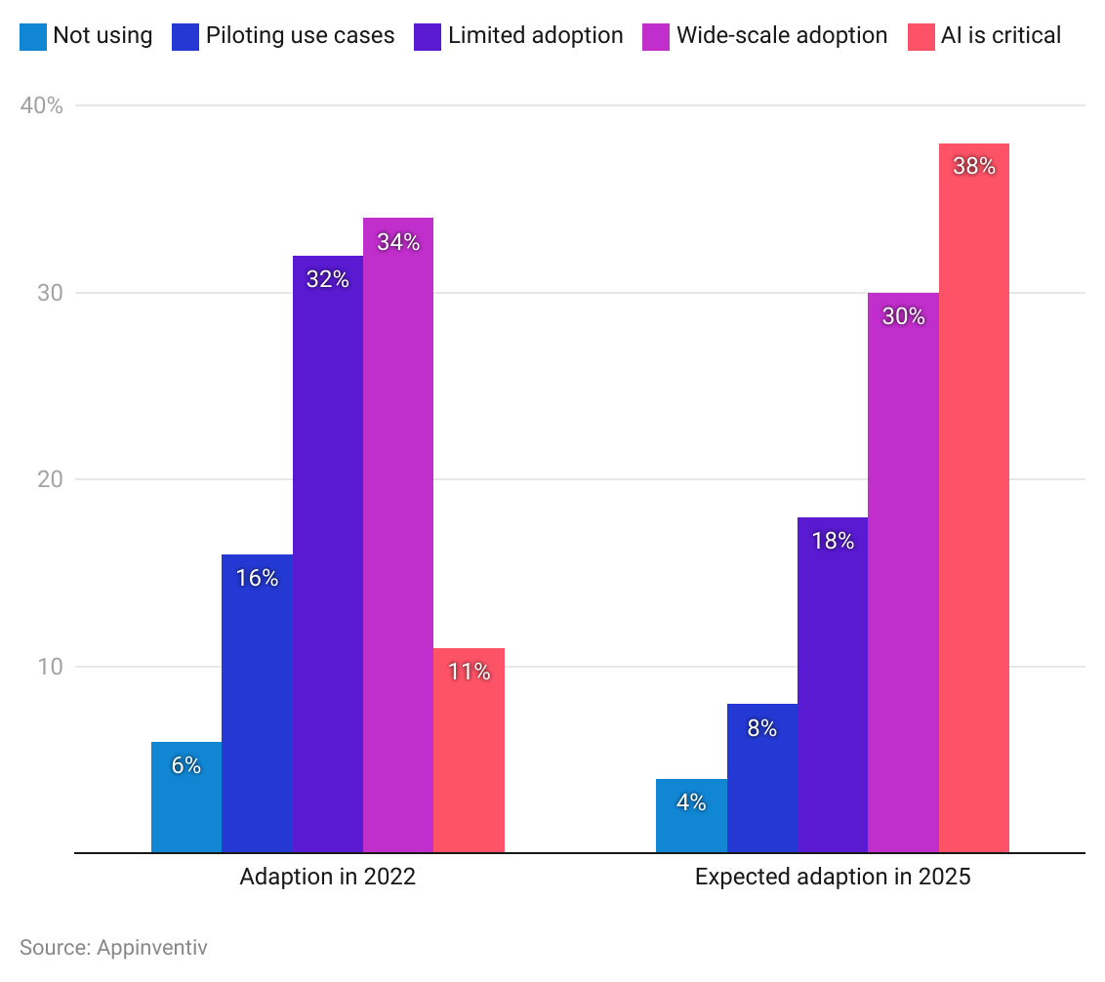

2. **RFID:** Radio-frequency identification (RFID) is widely used for managing supply chain operations by enabling supply chain visibility and asset tracking. The technology uses electronic devices that are attached to or embedded in the items that need to be tracked. When close to an RFID reader, these devices transmit unique identification information that can be used to track the location and status of the asset as it moves through the supply chain.

The real-time visibility offered by tracking technologies such as GPS and RFID enables organizations to monitor the progress of goods throughout the entire supply chain from source to consumer. In addition, these technologies provide insight into the physical conditions of the item, including temperature/humidity, acceleration, pressure, tampering, and light, allowing organizations to make informed decisions and mitigate risks associated with the safety of goods in transit, including spoilage of food, drug safety, counterfeiting, and theft.

3. **Robotics and process automation:** Supply chain operations involve coordination among multiple stakeholders, often with time-consuming and routine manual tasks. However, robotics and process automation are streamlining these processes, making them more efficient and cost-effective, allowing supply chain professionals to focus more on strategic and innovation activities. Common areas of automation include demand forecasting and planning, order processing, supplier management, and inventory management.

4. **Digital twins:** Digital twin technology provides a replica that simulates real-world processes, enabling risk-free testing of new strategies. In supply chain management, digital twins are used to model supplier relationships and procurement lifecycles. They allow for scenario simulations that refine sourcing strategies, optimizing supplier selections and negotiation approaches. The technology is also coupled with sensors, IoT devices, and other sources to provide predictive analytics. This enables organizations to anticipate issues such as equipment failures, maintenance needs, and potential disruptions in the supply chain.

5. **IoT**: Internet of Things (IoT) uses devices, including sensors and connected devices, to provide real-time data on the location, condition, and status of goods in transit. The information transmitted through these devices enhances visibility and control over assets being transported.

6. **Blockchain:** Blockchain technology is employed for secure and transparent record-keeping, enabling end-to-end visibility and traceability of products in the supply chain. It is particularly useful in verifying the authenticity and provenance of goods

7. **Cloud computing:** Cloud-based platforms provide scalable and accessible solutions for storing and sharing supply chain data and improving collaboration among stakeholders.

# **Driving factors**

## **1. Global disruption drives the need to establish resilient supply chains**

The Covid-19 pandemic caused mass disruption and exposed the vulnerabilities of traditional supply chains. This was exacerbated by incidents such as the Russia–Ukraine conflict. These disruptions continue to stress the need for more flexible and responsive supply chains, making digitalization a top priority for organizations to build high visibility, agility, and resilience in supply chains.

A 2022 survey conducted by McKinsey, which targeted supply chain leaders across the world, revealed that more than [90%](https://www.mckinsey.com/capabilities/operations/our-insights/taking-the-pulse-of-shifting-supply-chains) of respondents had invested in digital supply chain technology in 2021. In addition, over 80% of respondents were expected to make further investments in 2022 and beyond. In general, these investments have focused on areas such as supply chain visibility, demand and supply planning, and network modeling. With market volatility and disruptions likely to continue, organizations’ priorities are expected to reflect the need for more sophisticated approaches to underpin supply chain resilience.

### **Global supply chain leaders’ agenda for digitalization**

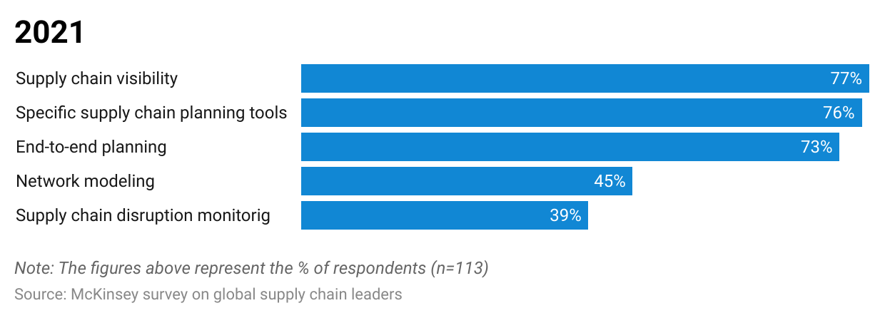

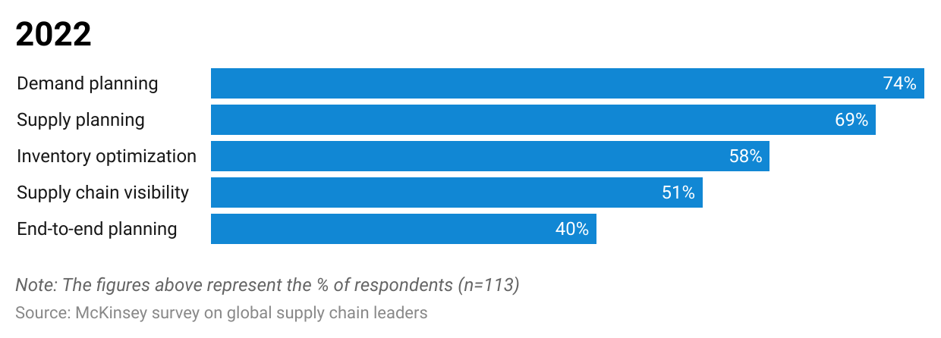

## **2. Growing complexities of supply chains amidst globalization underpin the need for tech-driven solutions**

As supply chains expand across borders, managing these complex networks of multiple suppliers, manufacturers, and distributors in different geographies has become challenging for organizations. Cross-border operations have also exposed organizations to diverse regulatory and compliance regimes, requiring them to implement sophisticated systems to closely monitor operations.

In this context, enhanced visibility of supply networks, real-time tracking of goods, and improved collaboration have become strategic priorities for organizations to remain competitive in a global marketplace. To do so, embracing tech-driven solutions is becoming a strategic imperative for businesses to build more agile and resilient supply chains. AI, for instance, aids in demand forecasting, planning, and enhancing overall supply chain visibility, while technologies like the blockchain—that contribute to increased transparency and traceability—are now becoming crucial elements in ensuring compliance and managing risks across the global supply chain.

### **International trade of goods and commercial services (USD trillion)**

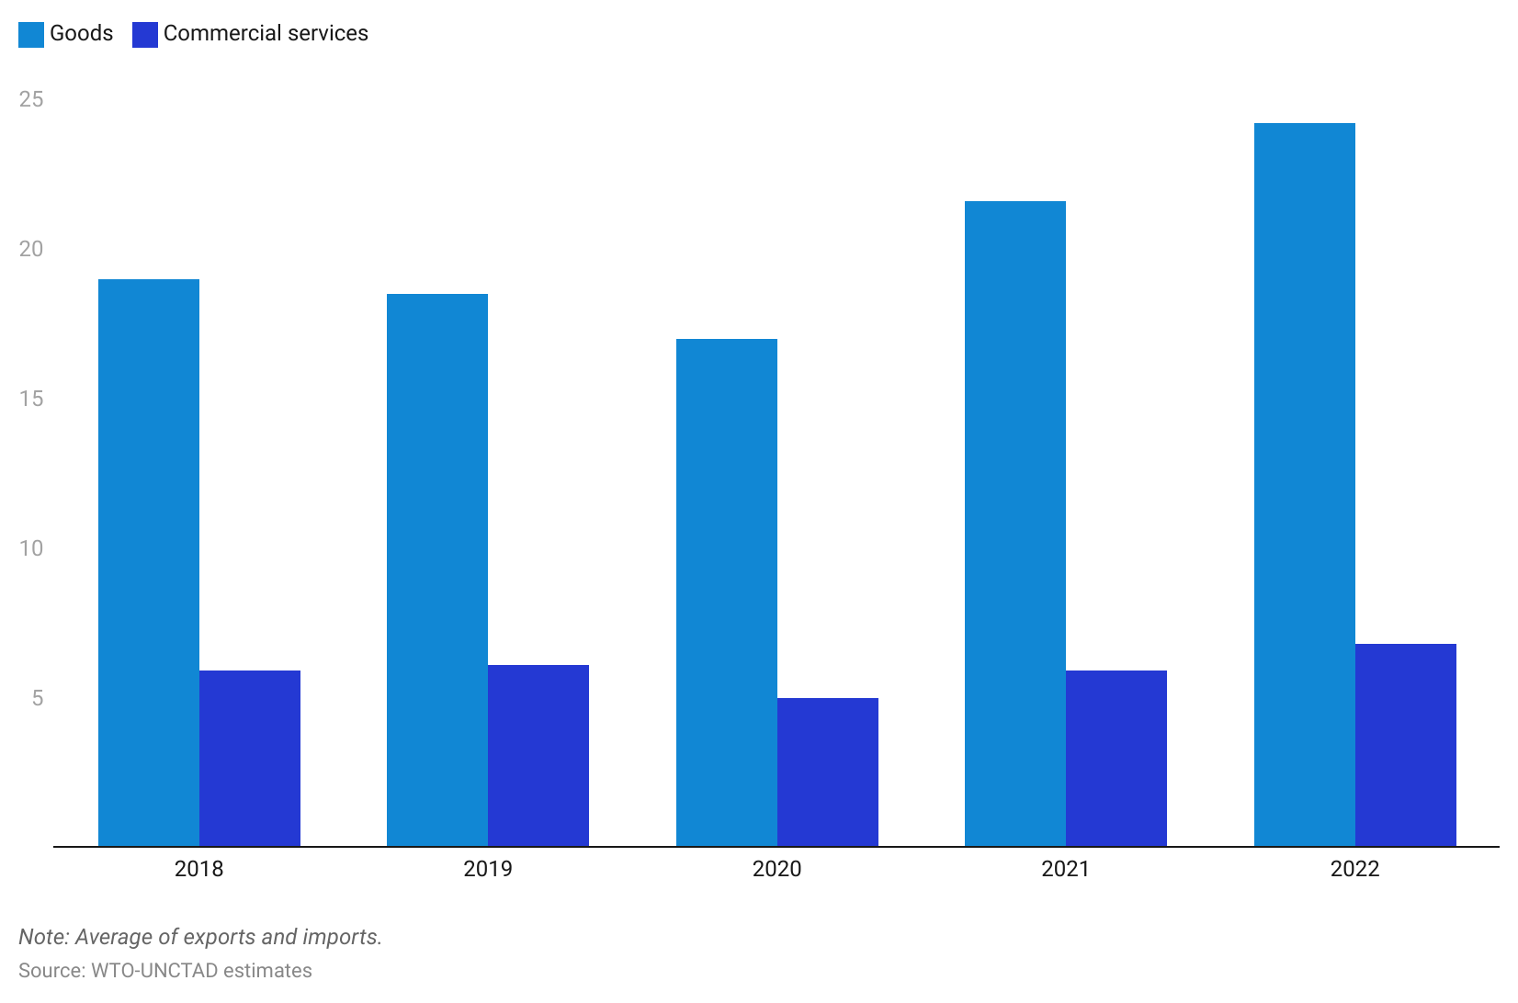

## **3. Increasing consumer demand for ethical sourcing and transparency drives need for traceability solutions**

Customer expectations have evolved beyond cost savings and faster lead times to also consider where their products come from, the conditions under which they are produced, and their environmental impact. In 2021, a study commissioned by OpenText found that [nine out of ten](https://www.opentext.co.uk/about/press-releases?id=5188A6174DE447FCAC930758694BBCB9) global consumers prioritize buying from companies that have a clear commitment to ethical and sustainable sourcing. The survey also revealed that Gen Z and Millennials were driving this change.

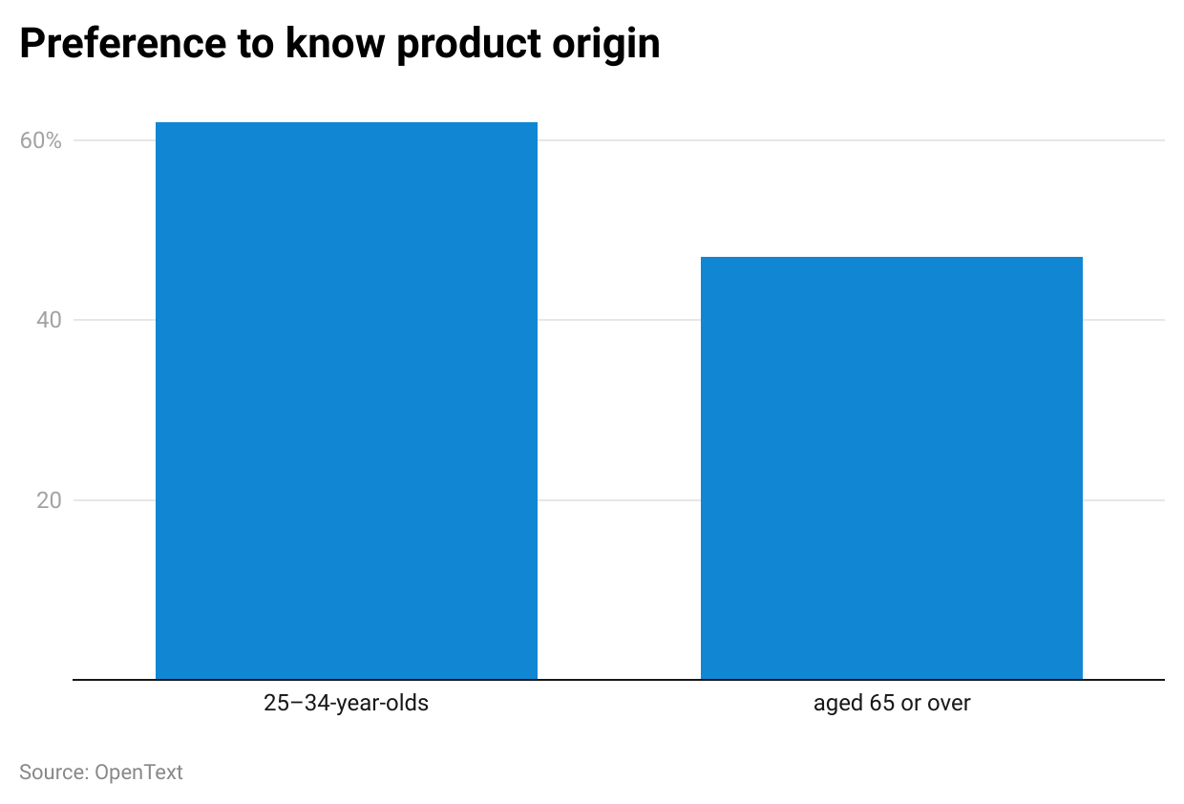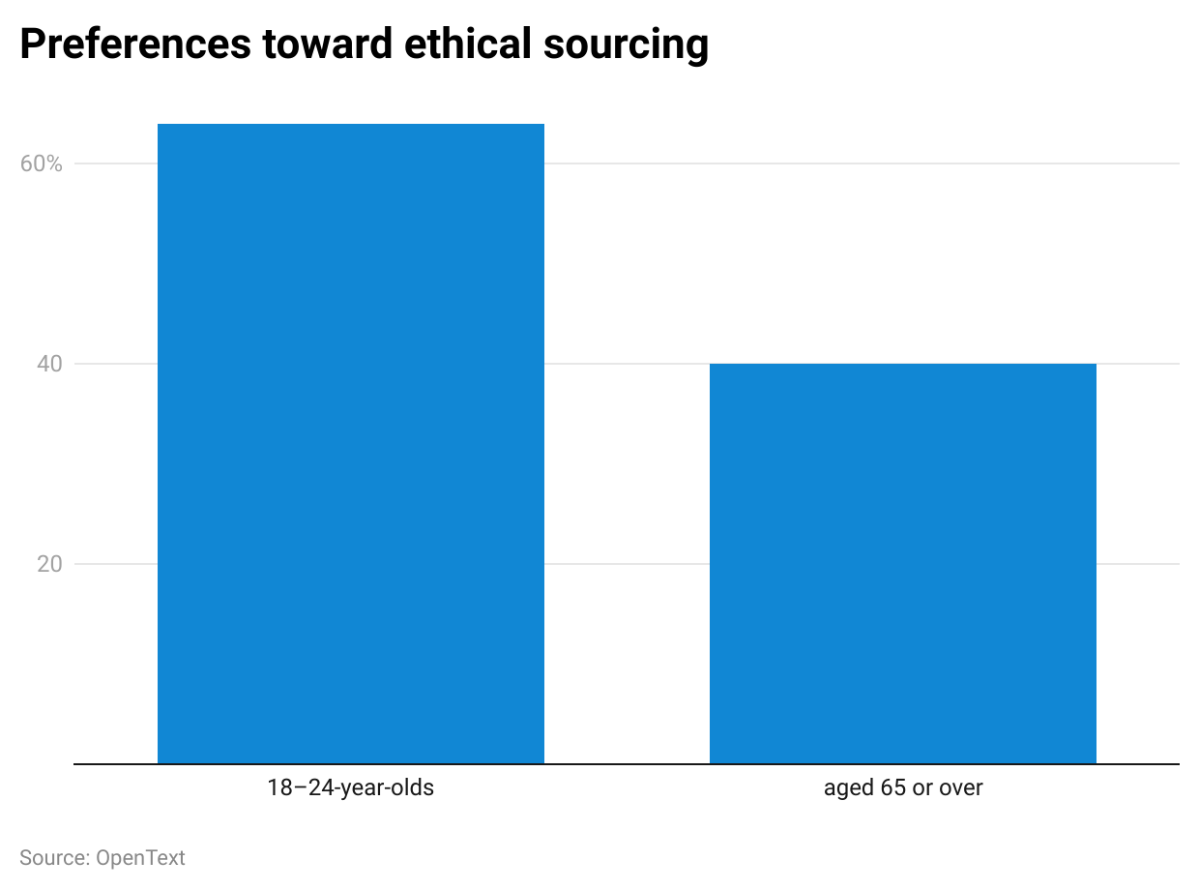

# 

# 

# 

# **Risks to growth**

## **1. Security breaches could disrupt operations and leave company reputation at risk**

The growing reliance on digital systems and data sharing creates pathways for malicious actors to infiltrate internal systems, making them vulnerable to cyberattacks and security breaches. In many instances, cyber-attacks have resulted in devastating outcomes for organizations. For example, in 2017, [Maersk](https://sp-edge.com/companies/187599) was hacked by the NotPetya ransomware attack, causing widespread disruptions to the company’s operations and a revenue loss of ~USD 300 million.

In response to these risks, companies must adopt strong cybersecurity measures that include strong access controls through practices such as multi-factor authentication, investing in robust cybersecurity infrastructure such as firewalls, and devising an incident response plan.

## **2. Data limitations may lead AI systems to generate inaccurate predictions**

Despite the benefits of AI across supply chain tech, the outcomes of AI-based models will depend on the quality and comprehensiveness of the data used to train the models. In this context, data limitations can significantly compromise the effectiveness of AI algorithms, potentially leading to inaccurate or biased outcomes. This limitation becomes particularly pronounced when dealing with rare events or novel situations that were underrepresented in the training data. In such cases, AI models are likely to provide inaccurate predictions, as they lack the necessary information to generalize effectively. In a fully fledged AI-powered environment, such outcomes could have a significant impact on an organization's performance.

*Last updated: December 2023*

©2024 Uzabase, Inc. All Rights Reserved. The information contained herein: (1) is proprietary to Uzabase Inc. and/or its content providers; (2) may not be copied or distributed; and (3) is not warranted to be accurate, complete or timely. Neither Uzabase Inc. nor its content providers are responsible for any damages or losses arising from any use of this information.