# **Edge Computing: Overview**

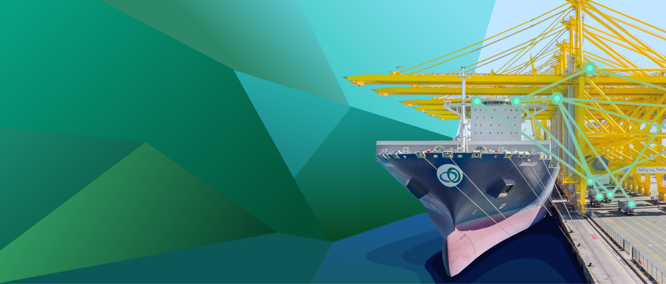

## **Edge computing brings data handling and processing closer to the source**

Edge computing refers to computing that takes place close to the source of data (i.e. the device that generates the data) by decentralizing data storage and processing. In contrast, cloud computing hinges on centralized data storage and processing. Edge computing generally complements cloud computing and is not likely to replace it. This is because not all information generated by devices needs to be processed in a time-sensitive manner, and therefore can continue to use the cloud for data storage so as to reduce the pressure on the edge data center.

An edge data center primarily processes and computes data and is not fundamentally a data gathering mechanism (as it typically gathers, stores, and uses only the most time-sensitive data), which means the cloud continues to play a crucial role in edge computing. The combined use of cloud and edge computing was further highlighted in a 2018 survey of over 500 American companies, of which about 64% had deployed or were planning to deploy combined edge and cloud solutions.

### 

### **Edge computing servers decentralized and closer to the source**

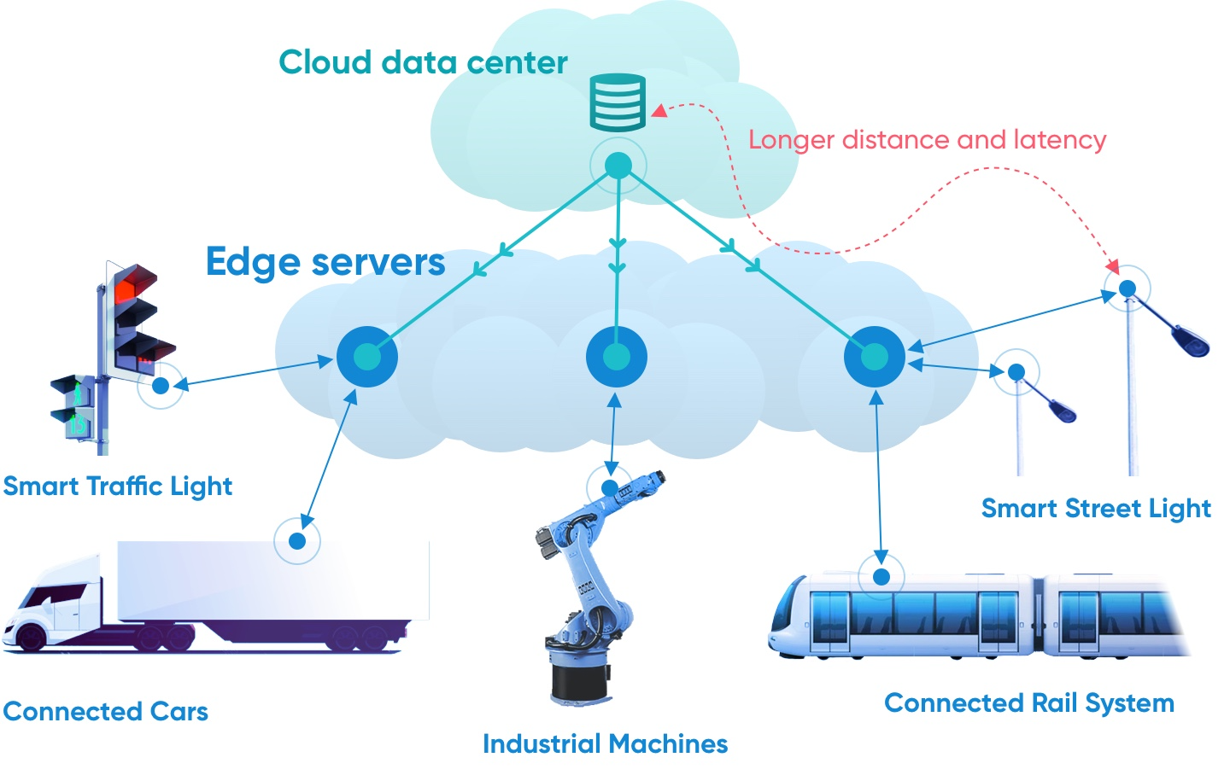

Source: Created by SPEEDA Edge

### **Nearly two-thirds of respondents were inclined to combine edge and cloud computing**

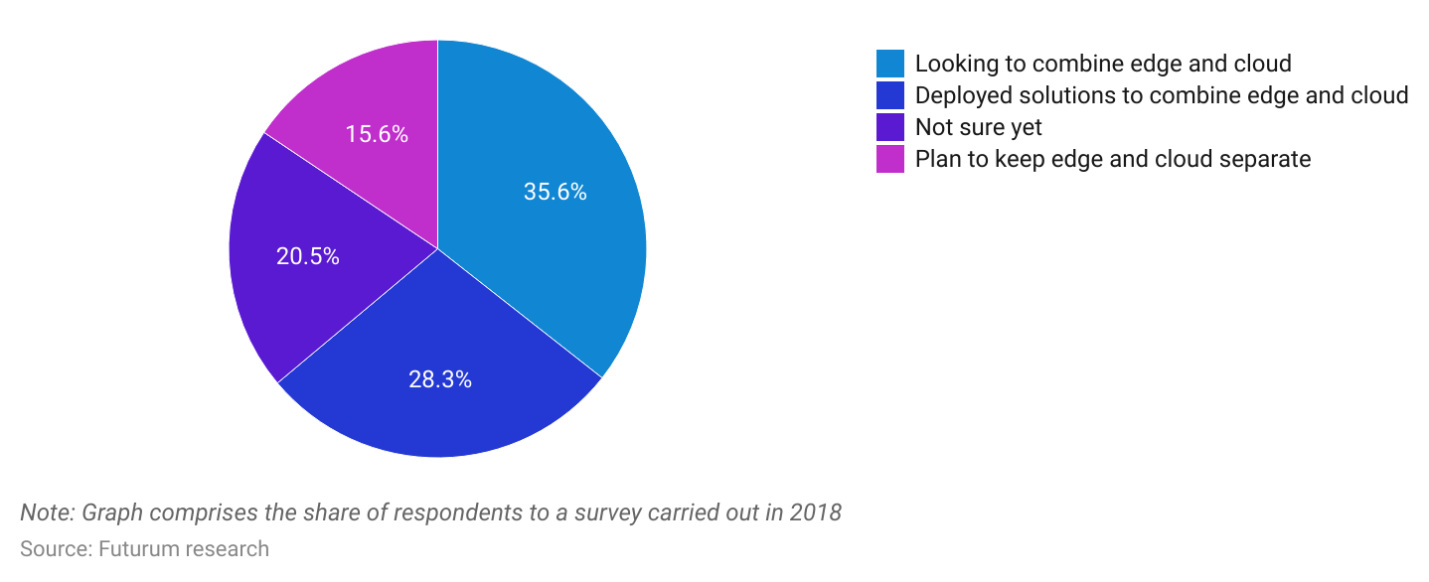

Edge computing must be able to identify the correct data to retain and distinguish it from other data to either move to the cloud or discard. For this function, artificial intelligence (AI) and machine learning (ML) remain central to the development of edge computing.

Since edge computing takes place closer to the source, and is therefore faster than cloud computing, the industry benefits from the concepts of 5G and the Internet of Things (IoT).

* Edge computing technology and 5G technology both process data closer to the source to increase speed. Therefore, while 5G requires edge computing technology, edge computing benefits from 5G networks and infrastructure (such as base stations).
* The concept of IoT hinges on communication between devices, therefore, the emergence of IoT has played a key role in creating the demand to bring edge computing into existence. Likewise, the higher adoption of IoT should continue to expand the demand for edge computing.

The edge computing industry is currently in the growth phase, and it is estimated that around 80% of US firms will have shut down their traditional data centers by 2025; over 51% of IT professionals surveyed in 2022 stated they planned to close all their traditional data centers in the next 24 months.

## **The edge computing ecosystem: hardware, software, and data centers**

Edge computing must fulfill multiple operations to function effectively. These range from software platforms to hardware such as data center components and on-device sensors. This report focuses on three main segments which edge computing firms (which are mostly startups) service.

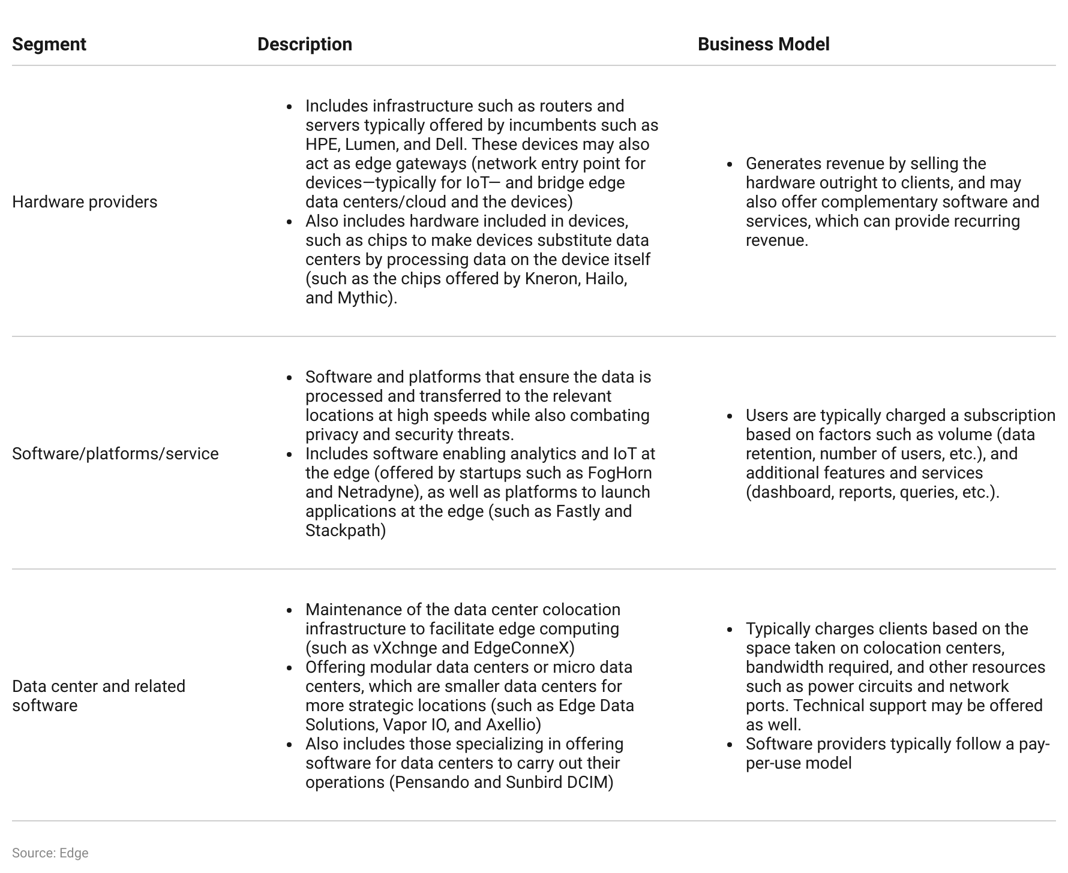

In the US, the edge computing hardware segment (presumably including components such as servers in data centers) remains the largest by value, accounting for around 40% of the market value in 2022.

### **Hardware remains the largest segment in the US edge computing space**

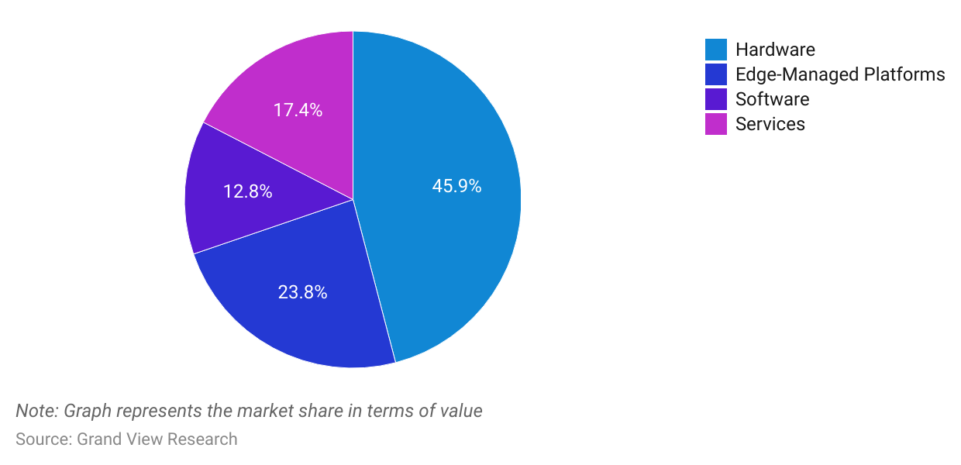

Notably, data centers will remain key for edge adoption as the disparity between data traffic in data centers and the usable data created continues to expand.

### **Disparity between data center traffic and useable data created to reach 4.0x in 2021, from 3.4x in 2017**

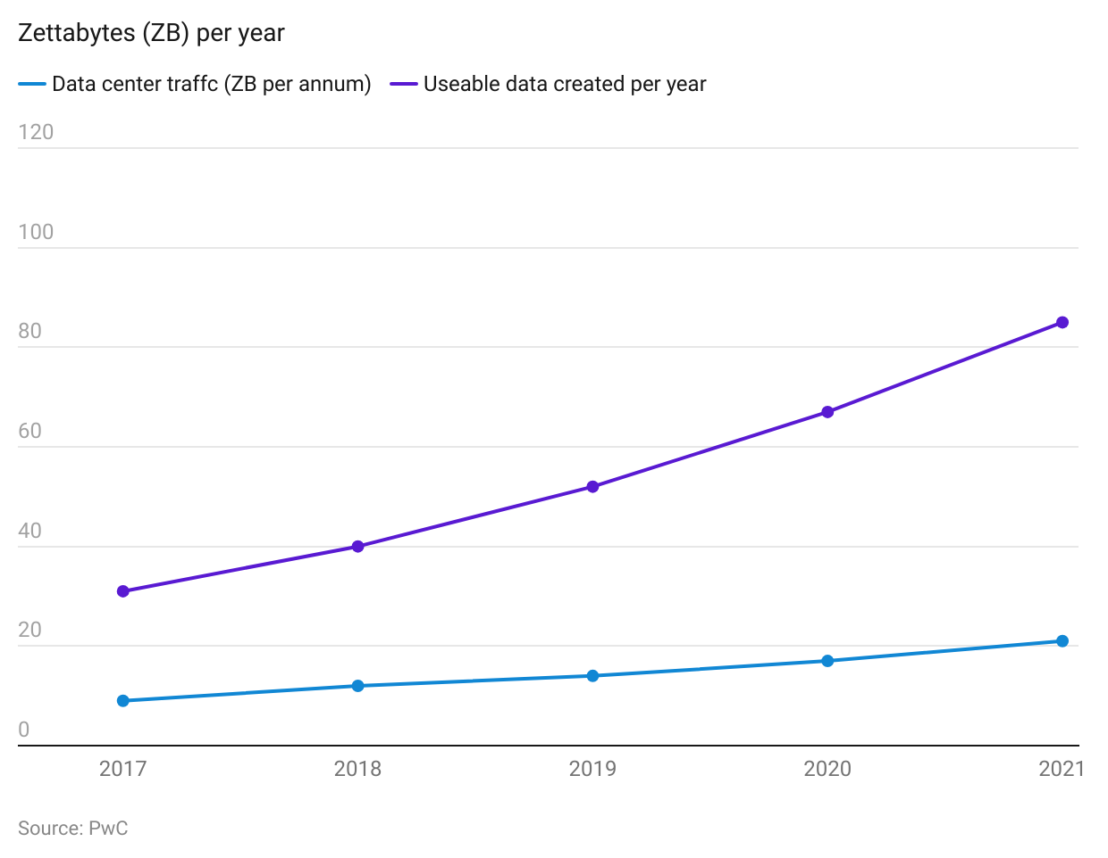

# **Driving Factors**

## **1. Improvements in latency and bandwidth enable emerging tech across industries**

Edge computing benefits a range of end users, with energy and utilities players the largest users globally, followed by industrial, transport, and logistics applications. Its main benefits include the following:

* **Lower latency:** Latency refers to the interval between making a request and its execution. Lower latency is therefore desirable and sometimes vital in certain applications, such as manufacturing and self-driving cars, where small differences in latency can be detrimental. Latency is lower when using edge computing since the data does not have to travel to an origin server and instead can be processed through the edge server itself. Edge computing can reduce latency from about 30 to 75+ milliseconds (ms) to 10 to 20 ms.
* **Lower bandwidth:** Since edge computing focuses on choosing and transferring the most important and necessary data only (as opposed to all data), users experience reduced bandwidth usage. The reduced latency and bandwidth can provide cost savings of about 10%–30% across industries, with an average operational savings of about 10%–20%.
* **Improved privacy and security:** Edge computing may offer privacy and security benefits relative to the cloud since some data can be processed closer to the source, as opposed to the necessity of having all data on the cloud.
* **Greater accessibility:** The cloud requires users to have access to centralized networks. Edge computing, however, caters to more remote locations through the use of mini data centers that are placed closer to users. For instance, startups such as [DC Blox](https://sp-edge.com/companies/230732) focus on offering smaller data centers to underserved markets in the US.

### 

### **Edge computing caters to many verticals (2022)**

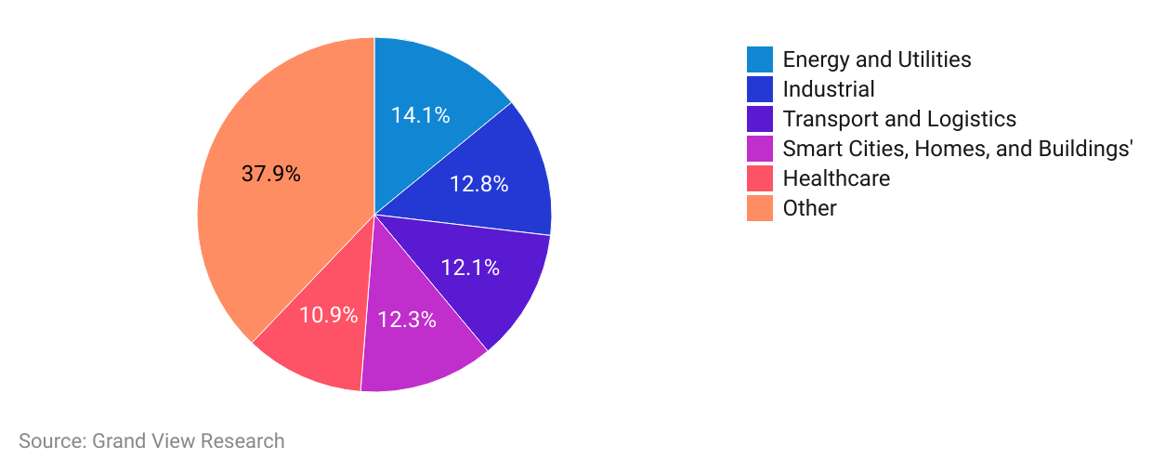

Edge computing also benefits multiple emerging industries, such as industry 4.0, space exploration, autonomous driving, and military drones.

### 

### **Emerging technologies to benefit from edge computing**

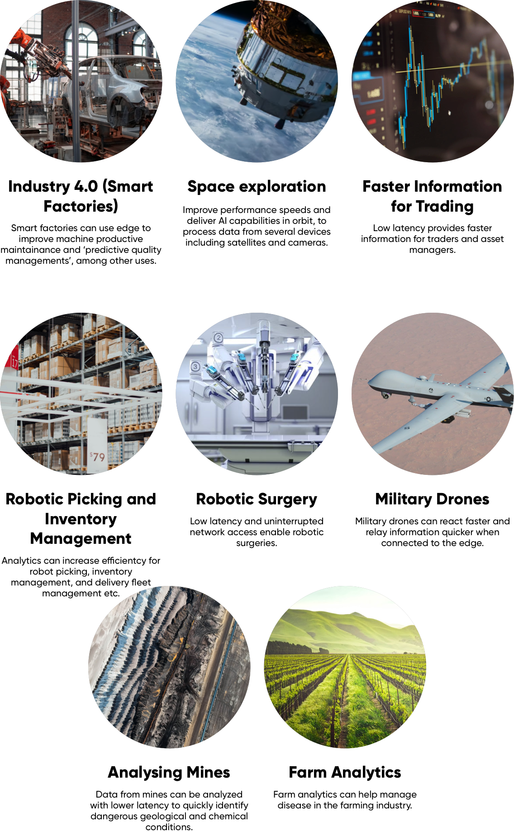

Source: Created by SPEEDA Edge based on data provided by PwC

## **2. Higher adoption 5G and IoT**

As more players adopt 5G, the infrastructure needed for the expansion of edge computing(such as micro data centers in place of hyperscale data centers) is improved, which in turn will also drive higher use of edge computing. Ericsson forecasts that 5G adoption will reach 91% in North America by 2028 (more than 420 million subscriptions) from 35% as of November 2022.

### **5G adoption to reach 91% in North America by 2028**

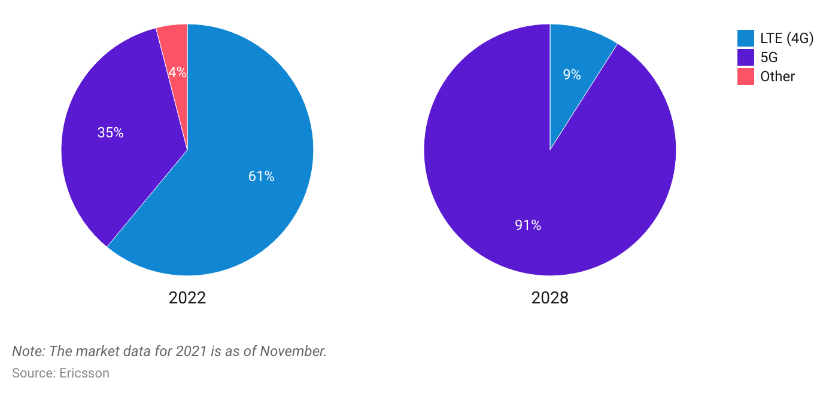

Moreover, businesses are inclined to adopt 5G multi-access edge computing (MEC) platforms. MEC refers to a subset of edge computing where the compute and storage take place at the edge of the service provider’s network (such as radio nodes and aggregation points), rather than in traditional infrastructure such as servers in industrial premises, retail stores, smart homes, etc. Users can benefit through private 5G MECs as they offer more privacy, higher reliability and security, and deliver lower latency. Accordingly, MECs primarily cater to industries that require ultra-low latency, such as remote surgery, autonomous driving, online gaming, and AI/machine learning.

Given MECs deliver substantial benefits and typically hinge on networks, leading edge computing technology providers commonly partner with telcos to deliver MECs to the market. A few such partnerships in 2022 and 2023 include AWS partnering with [British Telecom](https://sp-edge.com/updates/17188), [SK Telecom,](https://sp-edge.com/updates/10968) and [Bell](https://sp-edge.com/updates/9967); Microsoft partnering with [AT&T](https://sp-edge.com/updates/8792) and [Singtel](https://sp-edge.com/updates/8296); and [Dell partnering with SK Telecom](https://sp-edge.com/updates/9396). *For more information on the rollout of MEC, refer to our* [Edge Insight](https://sp-edge.com/insights/7979).

In certain applications, speed is central to the success of IoT, such as in manufacturing, when delays can cause machines to run at less than optimal levels, potentially creating losses for a business. The adoption of IoT continued to increase due to the advent of ML and AI, which should continue to boost edge computing in the future. Researchers suggest the number of connected IoT devices in use (globally) could grow at an estimated 19% compound annual growth rate (CAGR) over 2020–2025 (vs. a 25.7% CAGR over 2015–2020) to reach 27.1 billion devices.

### **Connected devices will continue to show strong growth globally**

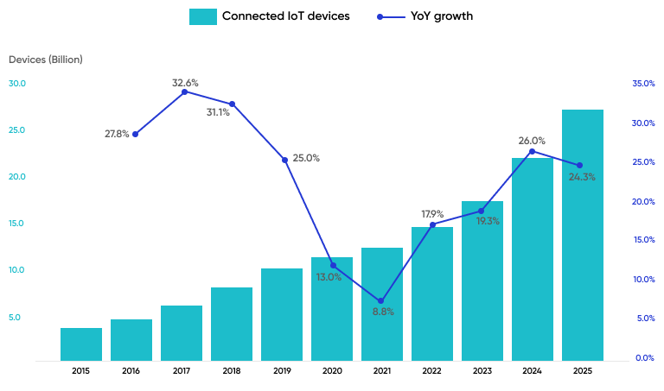

Source: IoT Analytics

# **Risks to Growth**

## **The industry faces security threats due to an increase in the potential targets for hacking.**

Cyber security benefits from edge computing because less data is transferred to the cloud, thus creating less of an opportunity to attack data in transit. However, the potential entry points for hackers increases due to an increase in devices and data processing points.

For instance, during data collection, hackers can manipulate a device to misunderstand the data. This becomes a challenge for edge adoption as enterprises must ensure all edge devices are secure and must go beyond using consumer-grade tech. One study highlighted that two-thirds of IT teams considered edge computing as more of a threat than an opportunity, primarily due to the greater endpoint attack surface.

# **Appendix: Covid-19 Impact**

### **Increasing automation and web traffic inspires further adoption of edge computing**

Overall, we believe Covid-19 will have a positive impact on edge computing. Pre-Covid-19, Gartner forecasted around 80% of enterprises will have shut down their traditional data centers by 2025 compared to around 10% in 2018. An increase in automation and web traffic should benefit an increase in penetration.

* **Increased automation:** The pandemic has exerted pressure on businesses to increase their pace of digital transformation and move toward higher levels of automation in order to protect profitability. This, in turn, enhances the demand for edge computing, primarily through its role in enhancing the Internet of Things (IoT) and usage of devices.
* **Rising web traffic:** The pandemic has led to an increased use of the internet, especially with regards to remote working, video conferencing, and gaming. Internet traffic levels in the US in late March 2020 were about 33% higher than February’s average traffic, which then receded to around 12%-15% above the February 2020 average by April 2020.

The reduction in bandwidth and latency offered by edge computing remains key to seamlessly facilitating the increase in web traffic. The applicability of edge computing is further enhanced by the local nature of most of the data generated through remote working and gaming, which is an added case for the use of local edge centers, as opposed to cloud computing.

Disruptors have also launched products that use edge computing to combat the spread of the pandemic:

* FogHorn launched its “Lightening Health and Safety Suite” in June 2020 to use edge AI to ensure employees adopt necessary safety regulations. By using data from videos and sensors, the platform monitors and derives insights, through which it generates alerts in the case of policy violations.
* SmartCone Technologies introduced Symp2passTM in September 2020, a biometric-based web process that allows users to check themselves for Covid-19 symptoms. The platform uses edge unsupervised AI learning to continually learn and identify patterns within data sets and map and update areas as safe, suspect, or infected. The offering could reduce the spread of Covid-19 in public places such as airports, hospitals, and schools.

In addition to the main driving forces above, it is notable that the digital transformation budgets of most organizations did not declined despite Covid-19 creating pressure on revenue and margins. A survey of IT leaders conducted in September 2020 revealed that over 80% saw their budgets for 2021 increasing or remaining unchanged, although only 33% planned to increase their budgets in 2021 (less than the 44% indicated in the previous year).

*Last updated: April 2023*