# **Brain-computer Interfaces: Overview**

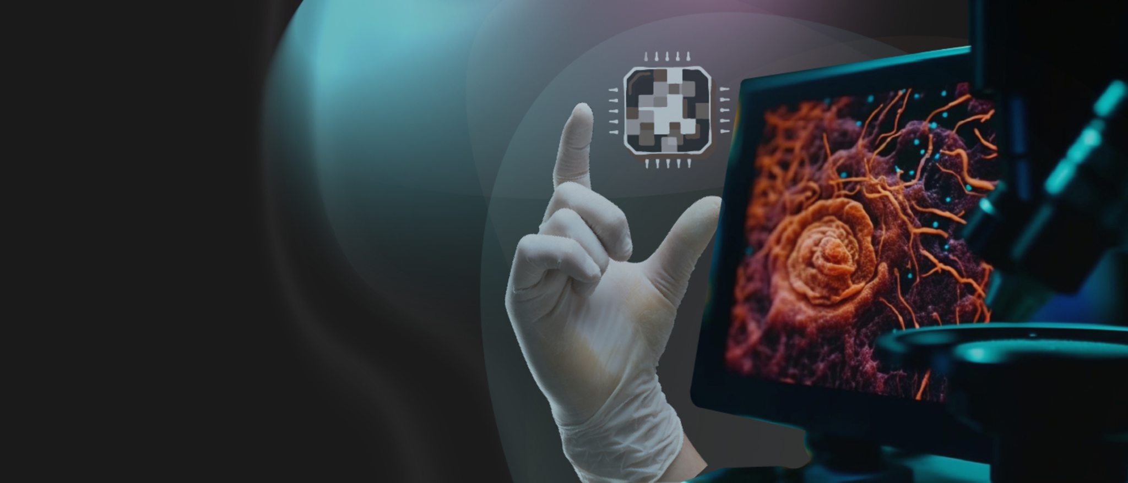

## **Connecting the human brain with technology**

Wouldn’t it be fascinating to control a computer with just your thoughts? Imagine scrolling through your social media or surfing the web just by thinking… wouldn’t it be exciting to play games without lifting a finger? Most importantly, how life-changing would it be if a paralyzed person could communicate, walk, and move using only their thoughts? These ideas have been in human consciousness for a long time, evident in popular science-fiction films from the 1900s, and today, the concept of connecting a human brain to a computer is closer to becoming a reality in the form of brain-computer interfaces (BCI).

Although BCIs have been studied for decades, the technology became the talk of the town after [Neuralink](https://sp-edge.com/companies/467693), Elon Musk’s BCI startup, received FDA approval to conduct human clinical trials in May 2023, having subsequently raised a whopping USD 280 million in Series D funds within three months. The company aims to help paralyzed people take small steps toward regaining control; e.g., moving a cursor or typing on a computer using only their thoughts. Neurological disorders affecting people are rampant today, and BCIs are now emerging as the light at the end of a dark tunnel plaguing human health and well-being.

This Insight explores BCI as a technology, types of BCIs and their applications in the medical sector, industry landscape, key players, demand drivers, challenges to growth, and the potential of the technology in the healthcare sector.

## 

## **What is a BCI?**

A brain-computer interface (BCI), sometimes called a brain-machine interface (BMI), is a direct communication link between the human brain and a computer. It translates the brain's neural signals into commands that can be processed by external devices. This essentially means that neural signals (our commands to act) flow directly into the devices, rather than through our bodies. For example, navigating a cursor does not require manually using a mouse/touchpad; with BCIs, we can directly move the cursor on the screen without an intermediary.

Research on BCIs dates back to the 1970s and has seen remarkable developments since then. Most of these developments have focused on therapeutic applications, specifically on restoring movement and communication for paralyzed or disabled individuals.

In 2015, Chinese researchers unveiled a [brain-controlled car](https://www.businessinsider.com/chinese-researchers-create-mind-control-car-2015-12#:~:text=Chinese%20researchers%20have%20created%20a,signals%20to%20direct%20the%20car.) that allows physically challenged individuals to drive a car without having to move their hands or legs, while companies like [Blackrock Neurotech](https://sp-edge.com/companies/1387720) and research institutes have been conducting various research since 2004 to enable paralyzed patients to communicate and control robotic limbs. However, brain implants have yet to reach the market, although startups are the closest they have ever been. Most recently, in September 2023, [Precision Neuroscience](https://sp-edge.com/companies/1394751) received the FDA’s breakthrough device designation and hopes to receive marketing approval in 2024.

## **How do BCIs work?**

BCIs work similarly to computers, in that the user provides an input that the computer processes to produce an output. The added value here is that instead of typing or clicking, BCIs pull information directly from the user’s brain, work their magic to make sense of it, and then send commands to control things like computers or other devices on the outside.

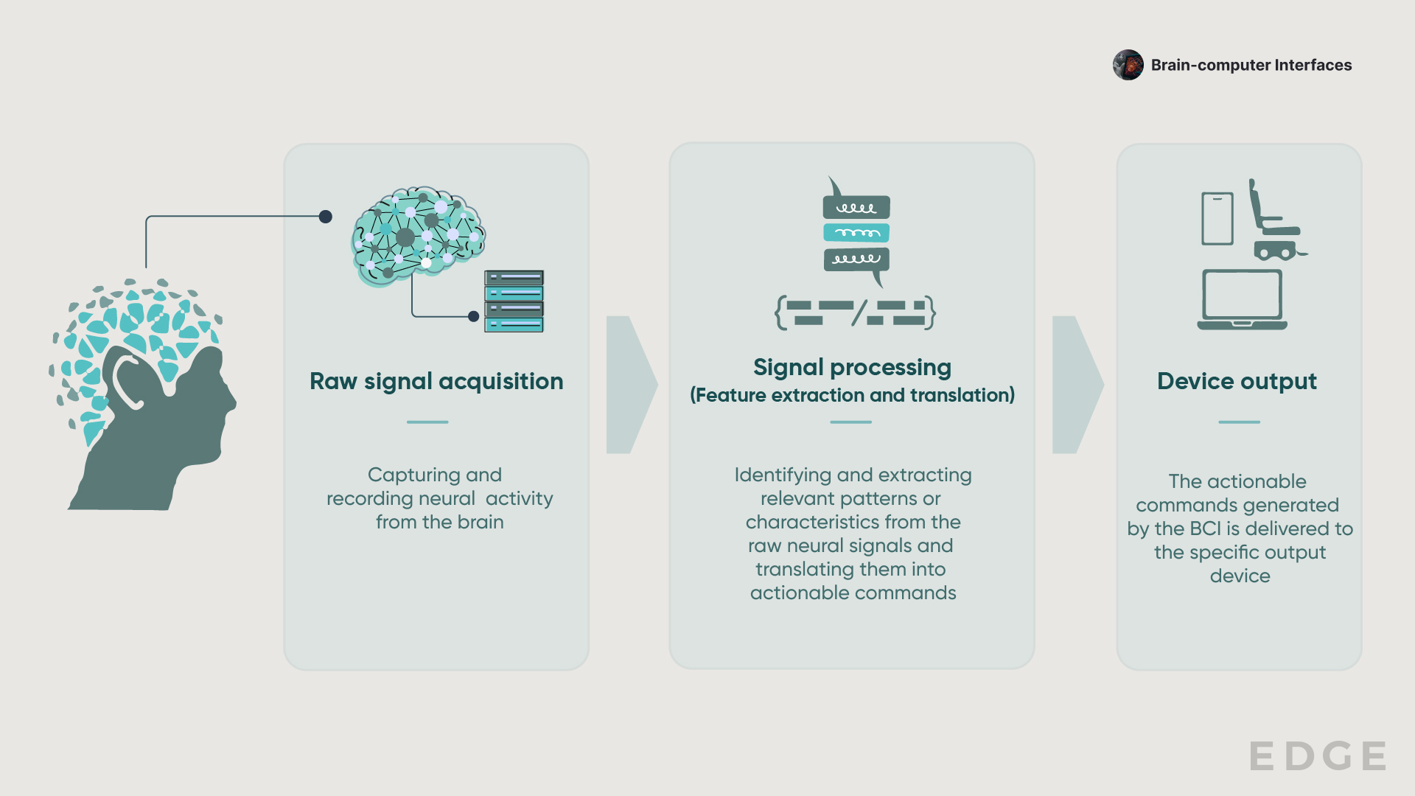

Source: Compiled by SPEEDA Edge

## **Types of BCI**

The different types of BCIs are as follows:

### 

### **Is there a link between BCI and AI?**

The concepts of BCI and AI have been studied separately in the past, but the combination of both technologies has the potential to create significant opportunities in the application of BCIs. This combination of technologies can help us better understand and use the signals from our brains to improve medical treatments—it is like having an exceptionally intelligent assistant who can understand and respond to what our brains are telling us, which can enable more personalized and effective healthcare solutions.

Combining the two technologies can be considered symbiotic, as each technology benefits from the other. As BCIs collect large amounts of neural data from the brain, AI will organize, interpret, and analyze them to identify trends, patterns, and, therefore, effective ways of addressing a condition. The AI will also act as a catalyst to generate the most appropriate responses or commands for the external devices to perform as requested by the brain. Several companies have already integrated AI in their BCIs, including Neuralink, INBRAIN Neuroelectronics, Kernel, and MindMaze.

## **What does the industry landscape look like?**

The BCI market comprises a variety of startup biotech innovators and major tech incumbents who are exploring the technology for healthcare applications. The industry has been segmented based on a mix of the types of BCI identified above and providers of other services, such as user interface software and neuroinformatics solutions.

Most startups in the industry focus on developing non-invasive wearables, such as EEG headsets and electrodes, trending toward developing solutions that are less invasive and more cost-effective while still capturing accurate data. This is largely due to the convenience of these devices, as they can be removed and replaced as needed, are less technologically complex, and are perceived to be safer than invasive BCIs. Most products are also at a seed/pre-seed stage, indicating the long timelines needed to develop and bring BCI products to market. The first non-invasive BCI device, developed by [NeuroLutions](https://yqqqphhcg2hvaaua-test001.pj-initial.net/companies/300666), was [approved by the FDA](https://www.fda.gov/news-events/press-announcements/fda-authorizes-marketing-device-facilitate-muscle-rehabilitation-stroke-patients) (prescription only) in April 2021 for stroke rehabilitation, 14 years after the company’s founding.

The BCI industry is also sought after by Big Tech companies, such as Meta, IBM, and Google, among others, in the form of in-house developments, partnerships, and acquisitions. Greater incumbent interest appears to be in the Non-invasive wearables segment, while investments in invasive technologies are also prevalent, such as Google Ventures’ investment in Neuralink.

#### 

### **Key segments of BCI**

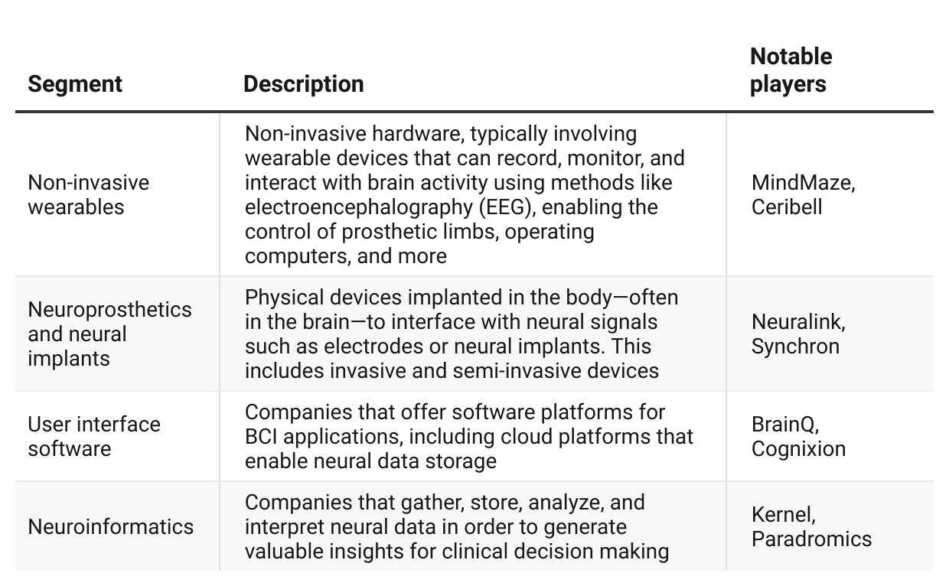

# **What’s driving demand?**

## **1. The prevalence of neurological disorders**

In the US in 2023, around 5.4 million people were living with paralysis (~1.7% of the population), while approximately 3.4 million were epilepsy patients (~1.2% of the population). As the occurrence of neurological disorders rises, there is a growing need for innovative solutions to enhance the quality of life for affected individuals.

Generally, individuals who are unable to move or communicate may consider a brain implant as a viable option to regain control. As a result, the likelihood of patients volunteering to receive BCIs may be high. Reportedly, thousands of paralyzed individuals have already volunteered to get Neuralink’s implant—since it began enrolment in September 2023—although the company will only admit 11 patients in 2024 who are affected by quadriplegia (​​paralysis in all four limbs). At the same time, Synchron enrolled six people with severe motor impairment for its implants.

According to the [Washington Post](https://www.washingtonpost.com/business/2023/03/03/brain-chips-paradromics-synchron/), more than 42 people globally have received BCI implants as of March 2023.

## **2. BCIs have the potential to address a wide range of neurological disorders**

Adopting BCIs to facilitate communication between the brain and external devices could empower individuals suffering from various neurological disorders to regain control of the parts of their bodies that are impaired, including appropriate communication and controlling of muscle movement, such as walking, maintaining posture, or even performing day-to-day tasks.

Below are some of the past successes recorded for selected neurological disorders. Since BCIs are still considered to be an experimental technology, the benefits achieved are limited to simple results currently, rather than a clear-cut cure.

### **BCIs and neurological disorders**

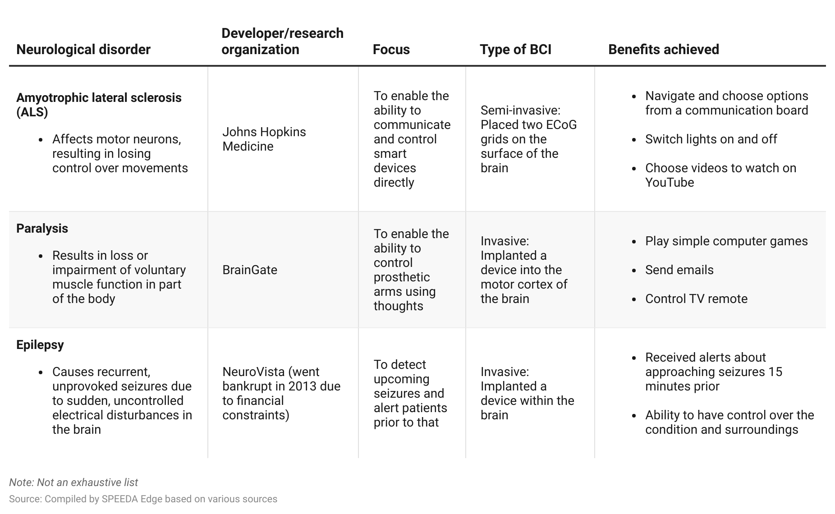

While BCIs are primarily focused on treating the effects of neurological disorders, the technology is also being explored in several other areas, including education, gaming, entertainment, and neuroscience research.

## 

## **What’s the investor interest like?**

Research on BCIs began half a century ago, but private investments did not start until the 2000s. From 2005 to 2014, funding in the area was limited, with an average of only around USD 24 million raised annually across three deals.

The industry gained momentum in 2016 and has since seen multiple mega-rounds (over USD 100 million) in subsequent years. It reached its peak in 2021, raising an impressive USD 750 million across all segments. The largest contribution in 2021 came from [Neuralink](https://sp-edge.com/companies/467693), a neuroprosthetics and neural implant company founded by Elon Musk, which raised USD 205 million in a Series C round. In the same year, other startups that raised significant investments included [Petal](https://sp-edge.com/companies/602294), a user interface software company, [MindMaze](https://sp-edge.com/companies/274434), and [Ceribell](https://sp-edge.com/companies/684095), the latter two being non-invasive wearables companies. It appears that the industry is approaching its 2021 funding record in 2023 after a slight dip in 2022, which was again due to Neuralink's USD 323 million Series D funding round.

Despite having fewer companies, investments in the Neuroprosthetics and neural implants segment were the highest (USD 1.3 billion) between 2015 and 2023—over half of which was accounted for by Neuralink.

#### **BCI investments between 2015 and 2023**

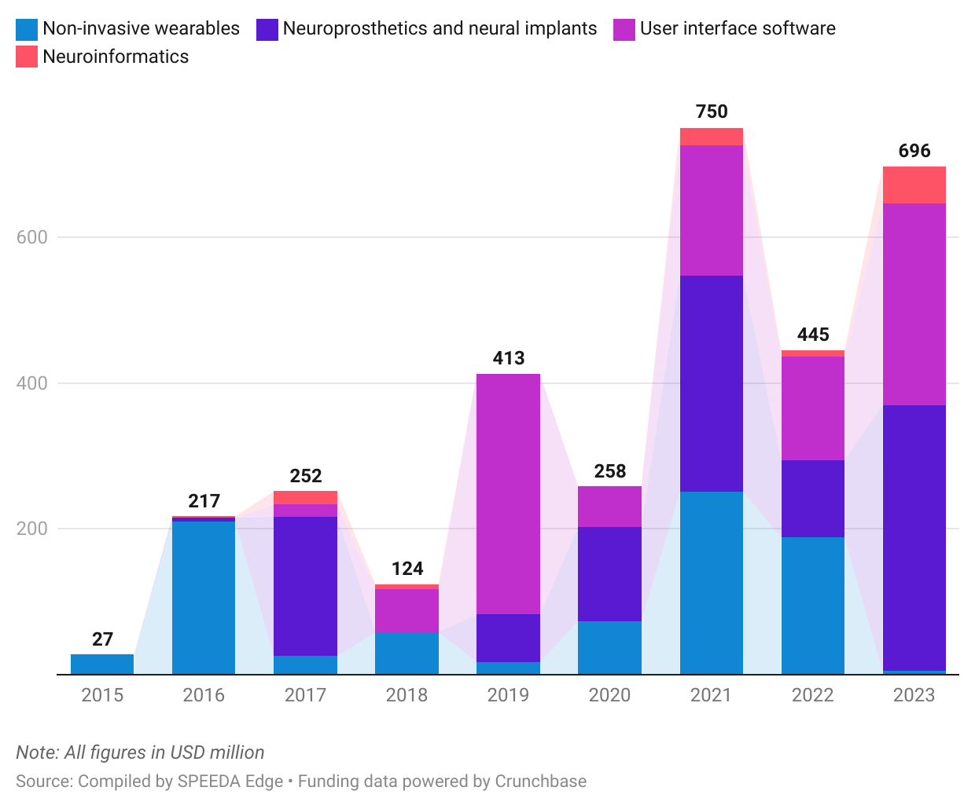

# **What challenges does it face?**

## **1. Invasive brain implantations pose safety risks**

Despite having enormous potential in supporting patients with neurological disorders, safety is a major concern when it comes to using BCIs, especially invasive methods such as implantable devices and electrodes. This is because implantation requires direct intervention into the brain and can pose various risks to the individual, potentially having to face unintended adverse consequences. This includes the risk of infection, bleeding, injury, or damage to the surrounding brain tissues, along with other complications.

Hence, the risk of unintended damage to the brain is still prevalent, even after having access to various advanced surgical technologies at present, such as Neuralink’s surgical robot that enables precise implantation. The existence of electrodes may also result in brain tissue damage in the long run.

## **2. BCIs may bring about ethical and privacy concerns that current regulatory frameworks may not be equipped to handle**

Volunteers who would want a BCI implanted are typically those who struggle or are unable to communicate their thoughts clearly. Some individuals may be able to do so with the help of eye-tracking devices, blinks, or muscle twitches; however, it is challenging to determine the full extent of their consent.

Particularly in the realm of consent, BCIs raise significant ethical concerns (among others), as they involve direct access to individuals' neural signals. While privacy regulations such as the General Data Protection Regulation (GDPR) and the California Privacy Rights Act (CPRA) already exist, the fact that BCIs involve obtaining direct access to neural data and the potential manipulation of cognitive processes, more specific regulations around privacy, informed consent, and responsible development are key while also protecting consumer rights against misuse, unfair practices, and the right to explant the device when necessary.

Finally, BCIs have ethical implications that extend beyond the implantation period, where patients may also be affected after the BCI implant is removed. For instance, an epilepsy patient whose BCI implant was removed without her consent experienced negative effects on her mental health. The implanted BCI was developed by the Australian company NeuroVista, which gave her a signal before a seizure, allowing her to control her daily activities. NeuroVista went bankrupt in 2013 because of insufficient funding, and the BCI was removed as a result.

## 

## **What is the outlook for the industry?**

It’s widely evident that the topic of BCIs has taken over not only within the HealthTech space but also among the general public, as the ideas are familiar with what humans had envisioned for our future. Considering the immense potential that BCI devices hold, the future of the BCI industry looks promising, with several developments already emerging within the past few years. Many neurological disorders do not have a cure at present and people are suffering with lifelong impairments; BCIs hold the power to potentially turn this around.

The [global market](https://www.databridgemarketresearch.com/reports/global-brain-computer-interface-market#:~:text=Brain%20Computer%20Interface%20Market%20Analysis%20and%20Size&text=Data%20Bridge%20Market%20Research%20analyses,15.61%25%20during%20the%20forecast%20period.) for BCIs was valued at USD 1.7 billion in 2022 and is expected to reach USD 5.7 billion by 2030, reflecting a CAGR of 15.6%. This growth is potentially due to the industry's progress toward commercializing neural implants and neuroprosthetic medical devices. Additionally, more people are being enrolled in clinical trials to assess the safety and viability of implantable BCI devices, and the success of these trials will help the industry address health conditions that restrict mobility and communication, instilling hope in patients and their families.

*Last updated: December 2023*

©2024 Uzabase, Inc. All Rights Reserved. The information contained herein: (1) is proprietary to Uzabase Inc. and/or its content providers; (2) may not be copied or distributed; and (3) is not warranted to be accurate, complete or timely. Neither Uzabase Inc. nor its content providers are responsible for any damages or losses arising from any use of this information.