# **Prefab Tech: Overview**

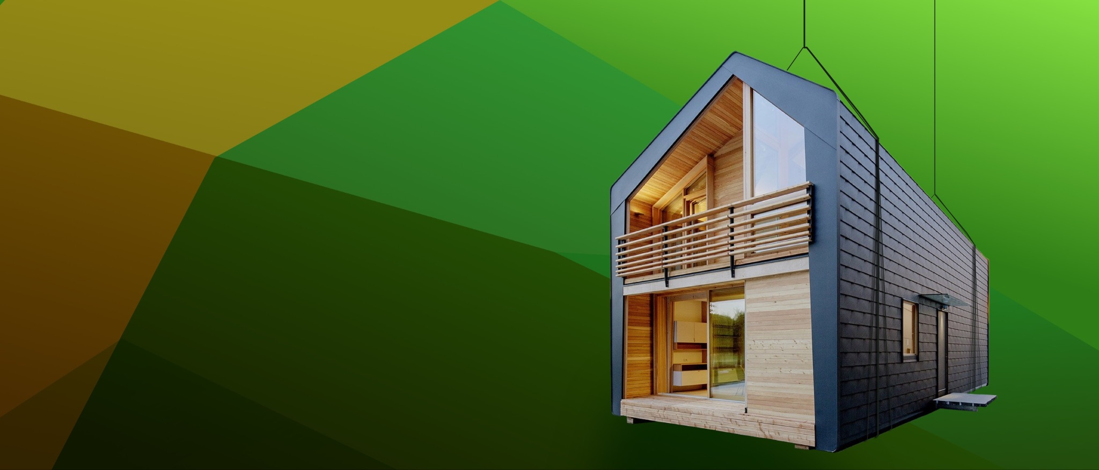

## **Prefab gains ground as a sustainable construction technique**

Prefabricated construction (also known as prefab construction) is the process of manufacturing and assembling building components in an off-site factory and transporting them to the construction site as complete structures or sub-assemblies.

Prefab construction dates back to the late European colonial period when it was used as a low-cost solution to construct buildings in a shorter time frame by compromising on quality. But in recent years, it has gained prominence as a sustainable solution for construction aimed at reducing the environmental impact from construction at a lower cost while achieving quality standards.

The recent popularity of prefab construction is enabled by the advancements in both designing and manufacturing technologies now used in construction, which made high-quality prefab buildings a reality.

* **Designing:** Use of digital designing tools such as building information modeling (BIM), a tool that enables the creation of a digital representation of a building across its lifecycle; and [digital twin](https://sp-edge.com/industry/149), a tool that digitally replicates real-world objects.
* **Manufacturing**: Availability of low-cost yet lightweight and durable material that can easily be transported after assembling, and development in technologies such as [3D printing](https://sp-edge.com/industry/71), lean construction, and the use of robotics in manufacturing.

Broadly, prefab construction can be done in three ways:

**1. Modular construction**: Sections of the building are built as 3D components/structures off-site and transported to the site for assembling. Also known as sectional prefabrication, prefabricated prefinished volumetric construction (PPVC), and unitized systems. The terms “prefabricated construction” and “modular construction” are often used interchangeably.

**2. Panelized construction**: Components are built as 2D panels which are delivered to the site for assembly. Also known as kit homes, pre-cut homes, and flat-pack homes.

**3. Hybrid**: A method that uses a combination of modular and panelized techniques described above.

This technique is environmentally friendly, as most of the construction work happens in a factory, the site disturbance is very low with less earthmoving, and there are fewer disruptions to local flora and fauna. Additionally, most prefab developers are making it more sustainable by embedding advanced features such as sensors that enable ongoing resource (energy, water) monitoring and management as well as preventive maintenance to achieve long-term savings.

### **Traditional construction vs prefab construction**

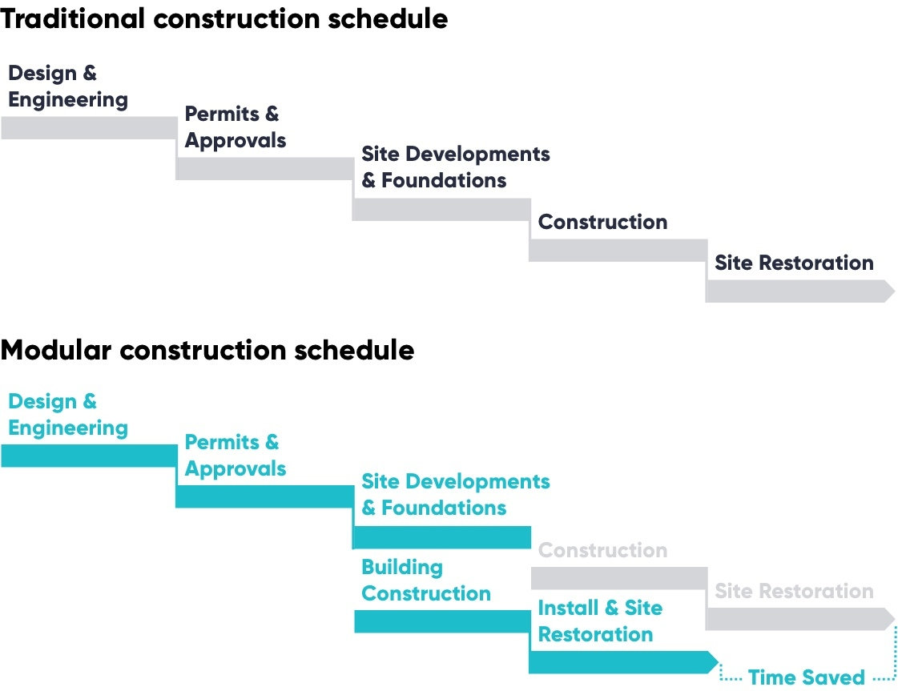

Source: Created by Edge based on various sources

# **Driving factors**

## **1. Prefab houses are built to consume less energy**

In 2022, the average monthly electricity bill for US residential customers rose by 13%, increasing from USD 121 to USD 137, owing to heightened US electricity demand stemming from severe weather conditions affecting heating and cooling, along with increased fuel costs for power plants. This, combined with concerns on environmental impact, has made prefab housing attractive to a new customer group interested in sustainable construction, with 52% respondents to a US [survey](https://www.homeinnovation.com/about/blog/20230524-mf-what-homebuyers_-want-in-2023)willing to pay more for a sustainable home.

Prefab buildings achieve greater energy efficiency by having comparatively tighter seams which help contain heat or air-conditioning. Most prefab developers have been incorporating energy generation solutions such as solar and wind, aiming to achieve net-zero energy generation as well as rainwater harvesting and water recycling systems that help reduce the spending on water. Some prefab makers also provide solutions for continuous resource usage monitoring through sensors embedded in its buildings which help to keep track of water leakages and wastage. For example;

* Prefab housing developer [Mighty Buildings](https://sp-edge.com/companies/574846) targets a 40% reduction in utility costs, with more savings expected for larger multi-family units due to scale.
* Sustainable mobile homes developer [haus.me](https://sp-edge.com/companies/786779)only uses solar energy (solar panels are included as a part of the house).

## **2. A solution to shortage of labor, increasing labor cost and material cost**

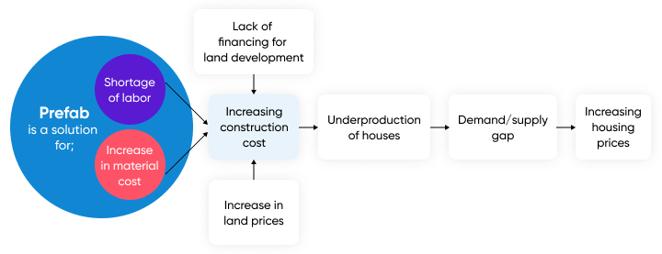

Source: Created by Edge based on Moody’s Analytics

The US housing market indicated a cumulative housing demand-supply gap of 2.3 million units as of December 2022 (increasing from 1.8 million in 2012), considering both single-family and multi-family housing units. This is a result of several factors as the above image indicates, but prefab construction could help resolve two of the major challenges—shortage of labor and increase in material costs.

Around 40% of the US construction workforce (around 3 million) is expected to retire by 2031, with only 807,500 workers projected to enter the construction workforce through 2018–28, indicating a huge labor shortage for construction companies. These shortages are leading to increased basic wages which are eventually passed on to the end consumer. It is also the key reason for the demand-supply gap, as a 2020 survey revealed that 53% construction companies undertake fewer projects due to the labor shortage. Prefabricated buildings address the construction labor shortage by shifting much of the construction process to factories. This method streamlines building tasks, reduces the need for skilled labor on-site, and allows simultaneous site work and assembly. Consequently, it mitigates labor shortages, accelerates construction timelines, and improves efficiency, making it a viable solution for meeting the demand for new construction amidst labor constraints.

Similarly, prefab construction utilizes fewer materials, as it uses standardized materials through all projects and allows precise material budgeting and procurement and better control of inventories, which reduces wastage. For example, prefab housing developer Plant Prefab claims that it can bring down the material loss to almost zero compared to around 40% of materials lost to waste in traditional construction.

### 

### **Cost index of new houses under construction**

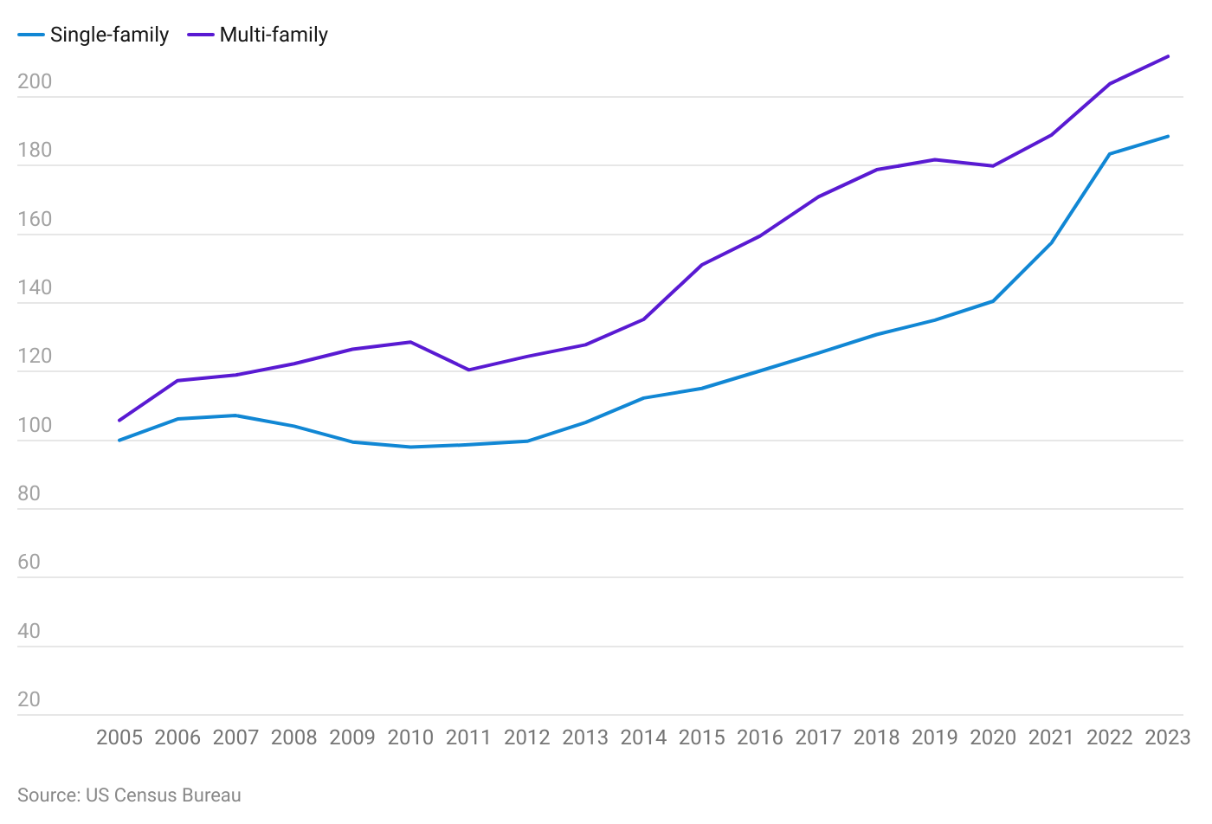

## **3. Faster development time**

While exact times can vary based on the project, prefab construction offers a faster alternative to traditional construction methods. The construction of a prefab building is said to be around 30-50% faster than traditional buildings, benefitting both customers and developers. For example, it can take as little as a month to assemble an entire 3D-printed home, which is far shorter than the six to eight months typically required for constructing a traditional house​.

Faster development is supported by several factors:

1) Weather: Prefab construction is less affected by weather, since much of the work occurs indoors.

2) Simultaneous processes: Site work and building construction can occur at the same time with prefab homes, unlike traditional construction, where site preparation must be completed before building construction can begin.

3) Efficiency: The factory setting of prefab construction allows a more efficient use of materials and labor, further accelerating the process.

# **Risks to growth**

## **1. High capital investment needed for geographical expansion**

Prefab companies are mostly limited to the areas in which the factory/factories are located due to transportation challenges. Geographical expansion will have to be supported with a large investment to set up factories which could restrict growth. Prefab houses will also need to be transported in several truckloads, typically. The added cost of transportation will be determined by the distance from the factory to the site, further increasing final pricing.

## **2. Cost savings might not pass on to the customer**

The reduced cost of a prefab home might not be passed on to the customer, as developers try to take advantage of rising housing prices. For example, prefab house developer Node sold its two-bedroom, one-bath houses in the region of USD 250,000 in 2019, keeping a 50% margin, reflecting an oligopoly in the market. Given the possible high pricing by dominant startups, demand for prefab housing could remain low.

## **3. Limited options for customization**

Prefab houses, mostly modular houses, are offered with fewer options for customization. Companies usually have predesigned floor plans which customers can choose from. This could also result in lower demand.

*Last updated: February 2024*

©2024 Uzabase, Inc. All Rights Reserved. The information contained herein: (1) is proprietary to Uzabase Inc. and/or its content providers; (2) may not be copied or distributed; and (3) is not warranted to be accurate, complete or timely. Neither Uzabase Inc. nor its content providers are responsible for any damages or losses arising from any use of this information.