# **InsurTech: Personal Lines - Overview**



## **Novel insurance models are providing coverage for the connected consumer**

Insurers are offering fully digitized personal line insurance products that are provided entirely through digital channels. These products take advantage of new technologies to provide novel insurance models that feature personalization and convenience.

These new insurance models in the personal lines insurance segment focus greatly on customer experience by providing personalized products that better reflect individual circumstances, allow for on-demand coverage, feature faster claim processing, and are delivered digitally. They seek to address the growing needs for newer policies while overcoming the pain points of traditional insurance where policies are offered based on a one-size-fits-all approach, with customer relationships generally delegated to brokers and agents.

Digital personal line insurance products are enabled through the development of insurance technology (InsurTech), which drives digitalization throughout the insurance value chain. Use cases of these technologies include:

* **Internet of Things (IoT) devices:** Connected equipment such as smart home sensors, fitness trackers, and telematic devices, which collect data that can then be applied to carry out predictive analytics, real-time monitoring, better risk assessment, claims processing, and even incentivize good behavior.
* **Artificial Intelligence (AI) and machine learning:** Automate areas of customer onboarding, underwriting, claim processing, and fraud detection by using data from IoT devices and multiple other data sources such as geospatial imagery and weather information. AI also powers chatbots which users can converse to get personalized offerings or use as an outlet for first notification of losses.

### **Example of new insurance products that take advantage of the above technologies**

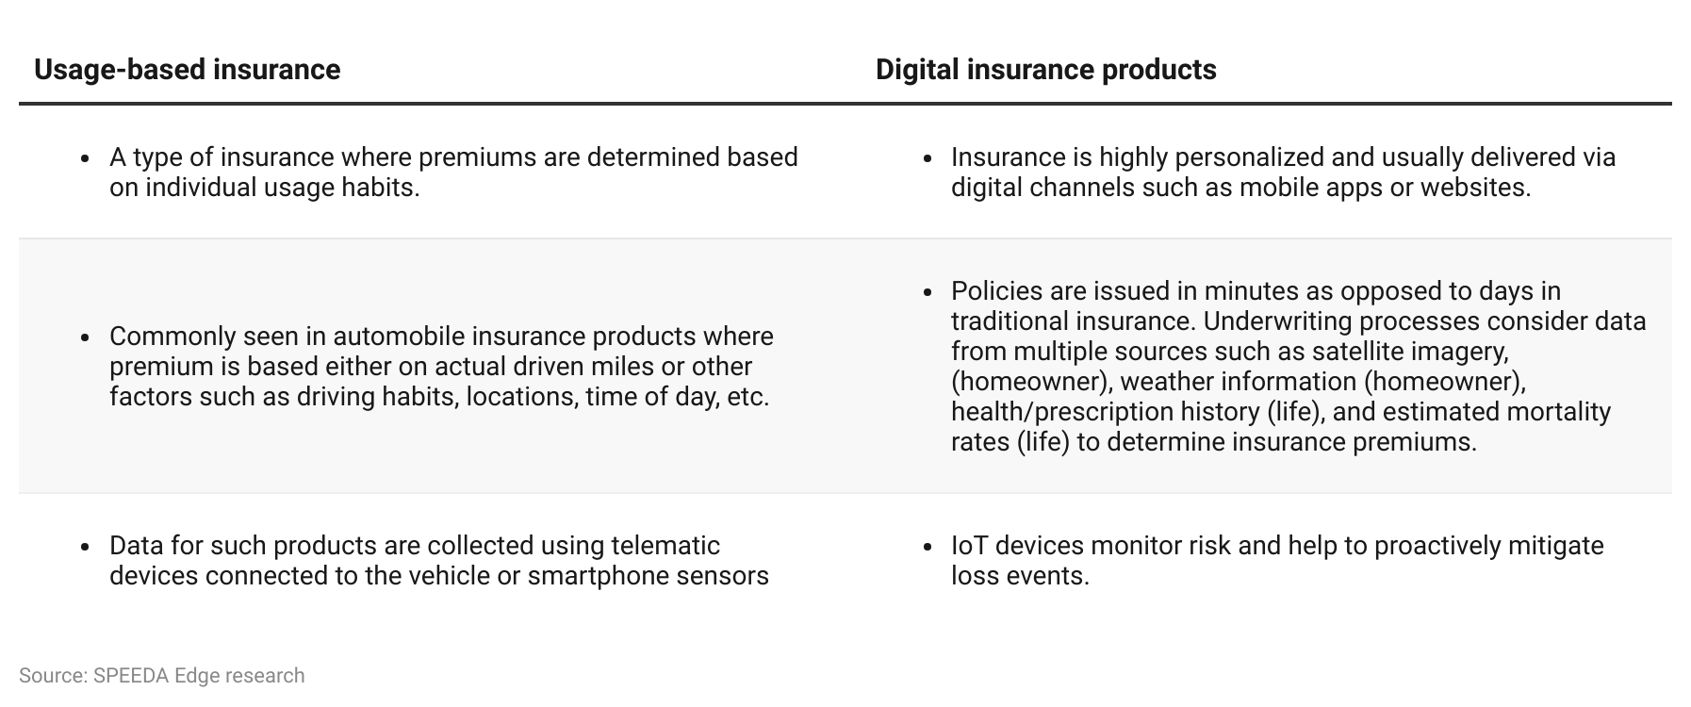

### 

### **Insurance providers are digitally delivering insurance products while solution vendors support digitization across the value chain**

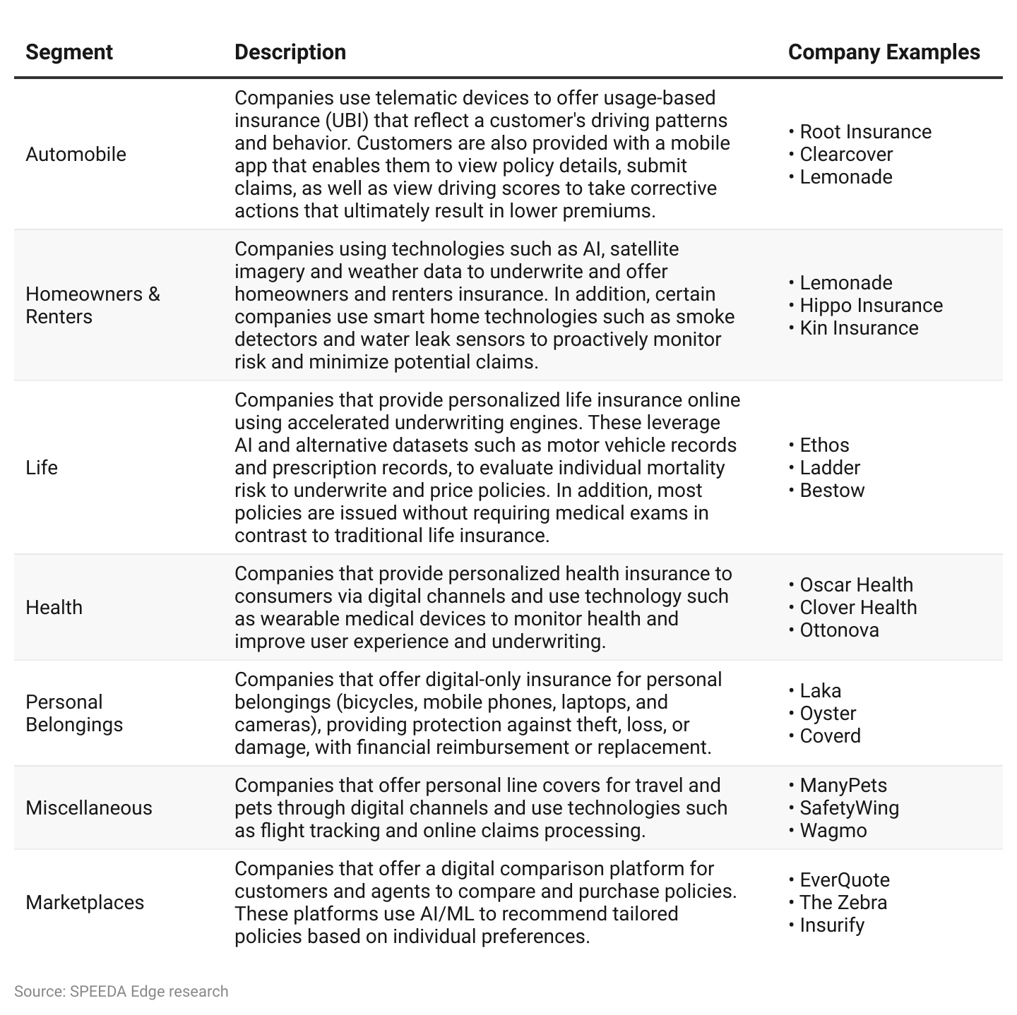

# **Driving Factors**

## **1. Convenience and personalization call for new approaches to insurance**

Customers are increasingly looking for a personalized experience from their insurers, with 80% of these insurance customers wanting product offerings that better suit their needs and preferences. This has resulted in an increase in demand for insurance products based on consumer lifestyle, behavior, micro-events (on demand) and actual use of the asset (usage-based). According to survey conducted by Accenture in 2020, nearly 70% of customers are reported to be willing to share significant data on their health, exercise, and driving habits with their insurers in exchange for lower premiums, which represents an increase of 19% from two years ago, while more than 65% are willing to share data for more personalized services.

### **Customers are demanding more personalized offerings**

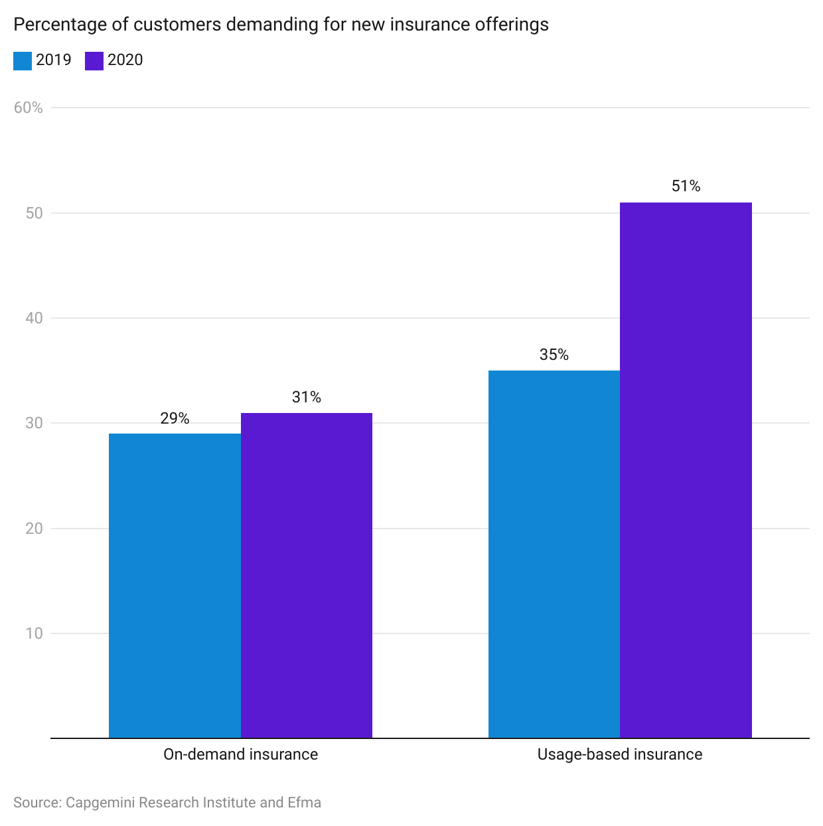

Millennials accounted for 21.9% of the US population in 2020 and represent the largest living adult population. This generation is more likely to prefer speed and convenience compared to the generations that precede them. This segment has an almost 100% internet and 93% smartphone penetration driving demand for insurance distribution through these channels. Startups such as [Lemonade](https://sp-edge.com/companies/3938) provide an end-to-end digital experience from instant on-boarding to faster processing of claims through a mobile app and utilize AI to underwrite policies, while automobile insurance startup, [Root](https://sp-edge.com/companies/416778), leverages smartphone sensors to provide behavior-based car insurance through its app. Online alternatives have also replaced the traditional role of an insurance advisor as online reviews and ratings influenced approximately 60% of insurance purchase decisions as of early 2020.

A combination of personalization and convenience considerations are leading customers to purchase insurance policies from non-traditional players such as BigTech companies or directly from product manufacturers who usually have first-hand access to data on customer behavior. Having access to real-time data also enables insurance companies to deliver greater personalization and value-added services such as advice for good behavior and early detection of issues. Moreover, providing data-driven and personalized insurance products benefits insurers by creating an opportunity to differentiate themselves in a crowded industry. On average, insurers offering personalized coverage enjoy an 81% increase in customer retention, an 89% increase in customer engagement, and a 60% increase in revenue per customer.

### **Customer willingness to purchase insurance from BigTech firms**

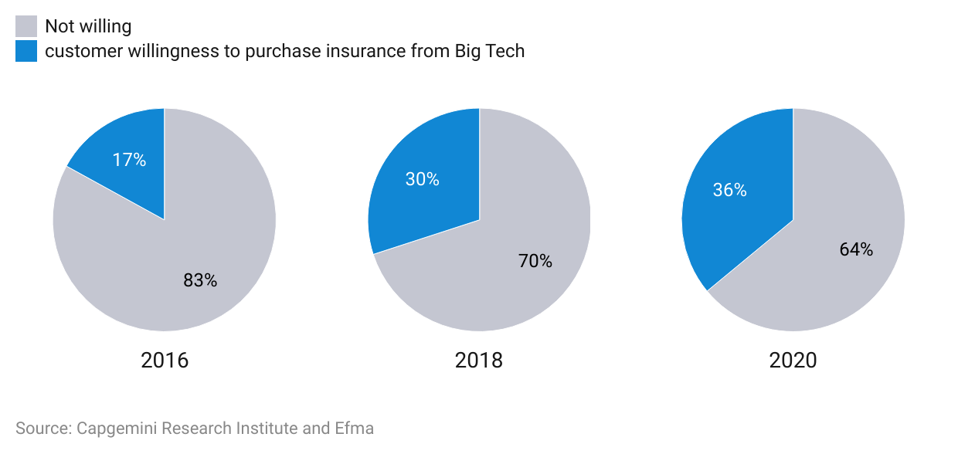

## **2. The Covid-19 pandemic has accelerated demand for personalized and digital personal line insurance cover**

In light of public health guidelines in relation to the Covid-19 pandemic, customers began opting for digital alternatives. As a result, insurance companies expedited the implementation of mobile apps and other process efficiencies, such as touchless claims processing and digital distribution, to meet this growing demand.

Life insurers, in particular, have experienced a direct increase in demand as a result of the pandemic as consumers rush to protect themselves and their family members. In the US, life insurance application activity saw a 3.4% YoY increase in 2021, following 3.9% YoY growth in 2020. These figures mark a significant turnaround from the three consecutive years of decline experienced between 2017 and 2020. Moreover, consumers were increasingly seeking digital life insurance policies that could be conveniently purchased from their homes, without conducting invasive medical exams, which are typically required for traditional life insurance policies. Startups such as [Ethos](https://sp-edge.com/companies/419648) were well-positioned to benefit from this trend, as they utilize AI to analyze personal data along with other public data points, instead of relying on medical exams to underwrite policies.

The Covid-19 pandemic also brought on a change in the lifestyle of consumers such as remote and hybrid working practices leading to less commute. Nearly 30% of consumers who drove before the pandemic claimed that they expect to drive less in the long term than they did before the pandemic, which drives demand for UBI cover that only charges premiums based on the actual usage of the asset.

Positive impacts on select startups owing to the Covid-19 pandemic:

* During 2020, [Lemonade](https://sp-edge.com/companies/3938), a digital homeowners, renters, life, and auto insurance provider, recorded 55.6% customer growth YoY and more than doubled its gross earned premiums during the same period.
* [Root Insurance](https://sp-edge.com/companies/416778), a usage-based automobile insurance provider, saw the number of active policies increased 14.7% YoY during 2020, with direct written premiums growing 36.7% YoY during the same period. Direct loss ratios improved to 82.0% from 99.9% during 2019, as driving fell during the pandemic.
* [Bestow](https://sp-edge.com/companies/497951), a digital term life insurance provider experienced 450% YoY growth in sales during the period from January to October due to surging demand resulting from the pandemic. The company also acquired traditional life insurer Centurion Life in December 2020 to expand its national footprint.
* Germany-based [GetSafe](https://sp-edge.com/companies/290793) grew 20% more than expected during March to May 2020.
* [Policygenius](https://sp-edge.com/companies/96502), an insurance marketplace, introduced three no-medical-exam life insurance options on its platform in 2020, which increased to seven by 2021, as the business segment witnessed 30x volume growth over the past two years, as of March 2022.

## 

## **3. Emerging industries present new risks**

### **Traditional insurance lags to keep up with emerging industries**

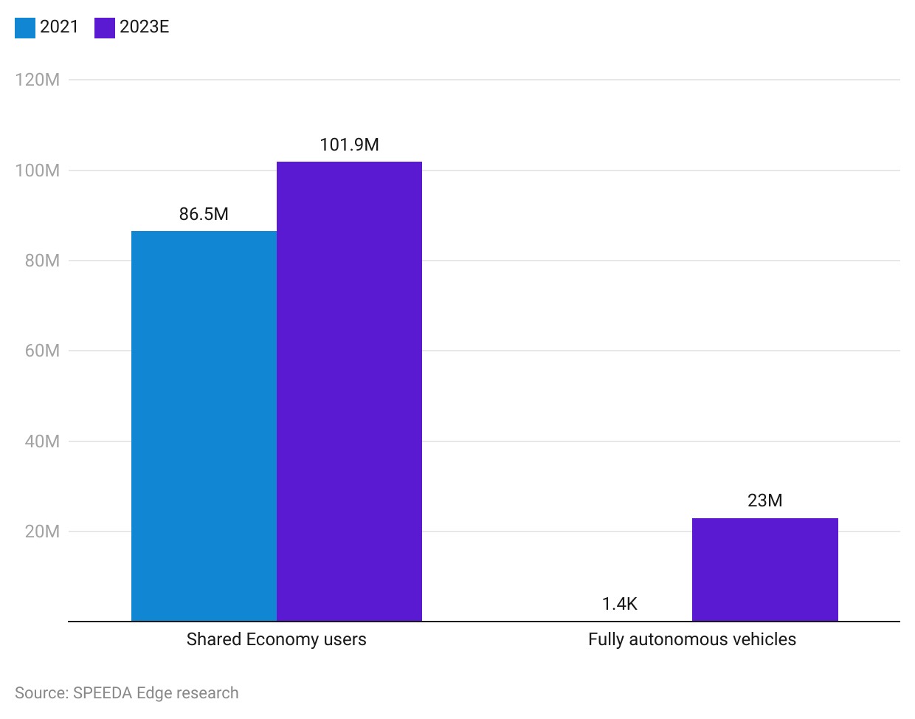

In 2021, approximately 86.5 million consumers were estimated to be engaged in the US sharing economy. Full-fledged commercial insurance is typically not cost effective for those offering their personal assets into the sharing economy, while personal insurance on its own does not cover commercial activity. Startups such as [Buckle](https://sp-edge.com/companies/884699) and [Zego](https://sp-edge.com/companies/500838) meet this need by offering UBI to individuals that provide their personal vehicles for rideshare services.

Fully autonomous vehicles are on track to reduce motor accidents due to human error-which accounted for 94–96% of motor accidents in the US in 2016. While traditional auto insurance policies are purchased by vehicle owners, driverless cars present a paradigm shift for auto insurance as accountability moves from the vehicle owner to the manufacturer and network providers. By 2025, it is expected that roughly 3.5 million autonomous vehicles will be be traversing the roads of the US, with this number projected to increase to around 4.5 million by 2030. It is expected that insurers might lose nearly USD 25 billion in premiums by 2035 resulting from decreased vehicle ownership and overall safer vehicles, approximately 34% of net written premiums of private automobile insurance in 2021.

Given that these are new developments, vehicle manufacturers are leveraging telematics and built-in technologies to roll out their own insurance products, as is the case with Toyota, Tesla and General Motors, or partner with other insurance companies such as BMW’s partnership with Swiss Re.

## 

## **4. Cost-saving opportunities for insurers driving demand for solution vendors**

Implementing AI powered automation across the value chain can result in process efficiencies, which translate to cost savings and improved combined ratios. Its applications across key areas of an insurer’s value chain are as follows:

### **Areas where insurtech can help realize process efficiencies**

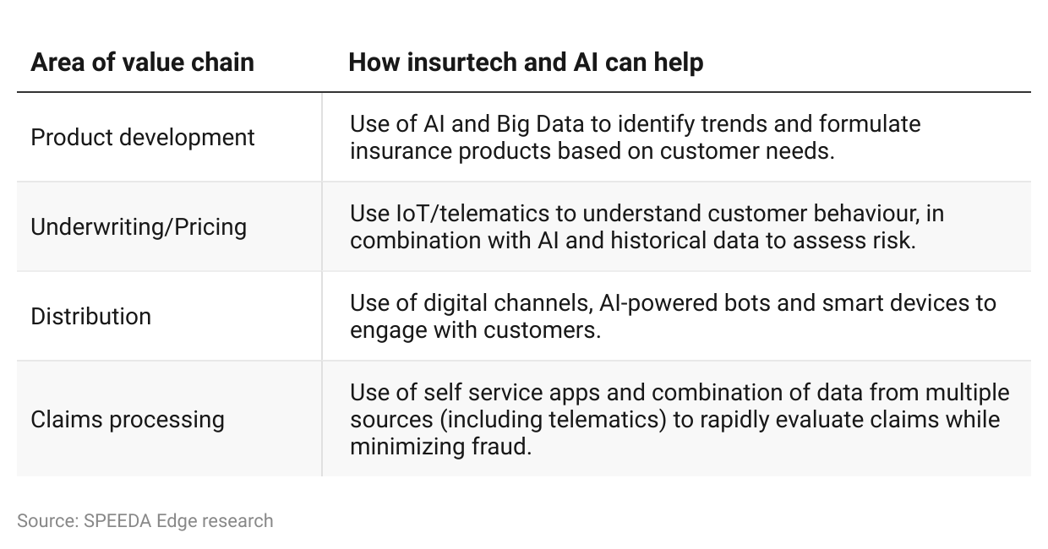

# **Risks to growth**

## **1. Stringent capital requirements**

Full-stack insurance providers have to comply with multiple current and future regulations including, but not limited to, minimum (risk-based) capital and solvency requirements, which in the case of US, vary across different states. Startups typically lack capital reserves compared to traditional insurers. The regulations also include extensive disclosure requirements on controlling investors, which may disincentivize private venture capital investors from future funding rounds. In response to this, some startups in this space are establishing themselves as managing general agents (MGAs) or partnering with other MGAs. MGAs provide critical insurance services such as underwriting, marketing, and policy issuance but do not assume insurance risk. This allows them to innovate and implement new insurance products, without the need to meet large capital requirements.

## 

## **2. Privacy concerns amidst large-scale data collection**

Most new insurance products rely on telematics and user data throughout their value chain and will be subject to existing and upcoming regulations related to the privacy and collection of such data. These regulations have the potential to significantly impair the effectiveness of these technologies.

“Proposition 103” which was passed in 1988 in the state of California is one specific example which prohibits insurance providers from using data collected from telematics into consideration when pricing insurance policies. Root Insurance is in discussions with relevant authorities in California to revise these outdated regulations to allow them to better utilize telematics. Startups in this space will have to consider developments in such regulations and develop processes accordingly.

*Last updated: October 2023*

©2024 Uzabase, Inc. All Rights Reserved. The information contained herein: (1) is proprietary to Uzabase Inc. and/or its content providers; (2) may not be copied or distributed; and (3) is not warranted to be accurate, complete or timely. Neither Uzabase Inc. nor its content providers are responsible for any damages or losses arising from any use of this information.