# **Preventive Healthcare: Overview**



Preventive care delivers personalized prophylactic care to patients and facilitates clinical decision support to practitioners, as opposed to reactive care, which intervenes after health conditions deteriorate. Preventive care technologies track physiological and biometric data through connected devices in real-time and store them in a patient portal that houses electronic health records. This data is analyzed continuously by AI algorithms to predict and warn patients and healthcare providers of potential health issues.

### **The key enablers of new preventive care technologies are wearable device penetration and big data**

### 

### **Wearable device penetration to increase in the US**

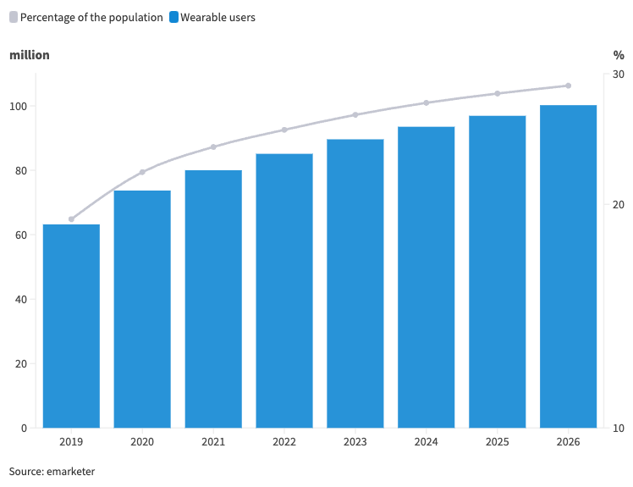

The growing frequency of chronic diseases and the rise in associated costs are a substantial burden to reactive care in the US. Many providers are now offering preventive health solutions for individuals and corporate clients to mitigate the risk of numerous prevalent conditions.

Approximately 2 million (0.6% of the US population) new cancer cases are expected to be diagnosed in the US in 2024, reflecting a 2.2% increase from 2023. In 2023, 9.7% of adults aged 18 and over were diagnosed with some type of cancer in the US. Diabetes affects 11.6% of the US population (2021), and the prevalence of cardiovascular disease (comprising coronary heart disease, heart failure, stroke, and hypertension) in adults 20 years and above is 48.6% overall (2017–2020).

### 

### **The shift from reactive care to preventive care**

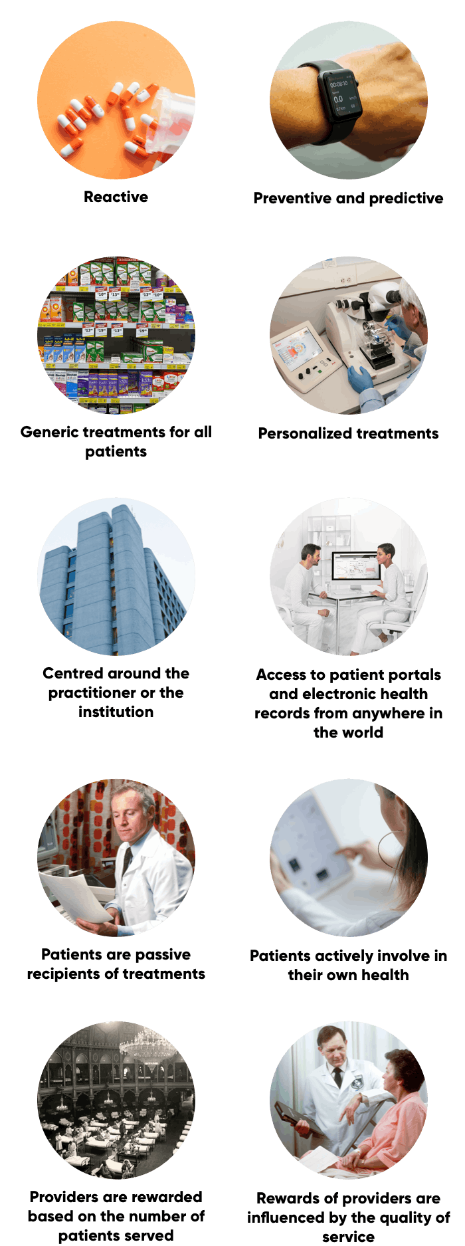

Source: SPEEDA Edge and MaRS Discovery District

## 

## **Subscription-based revenue coupled with a high fixed-cost base are key characteristics of the business model**

Preventive care providers predominantly earn revenue through a subscription-based model supplemented with reimbursements from insurers and customers for services not included in the membership cover.

Amazon One Medical, formerly One Medical, employs a model whereby members are charged a subscription fee for access to its digital health platform, enabling online appointment booking, video visit facilitation, and prescription renewal requests. The subscription does not include the cost of doctor visits or lab tests, which are billed through the insurer or charged to the member. Disruptor preventive care providers Index Clinic, Parsley Health, and Forward cover a number of common health conditions within their subscription fees.

Many cost components of preventive care providers are fixed and often include the cost of care; for instance, Amazon One Medical pays physicians fixed salaries. Preventive care providers increase profitability by onboarding new members or raising subscription fees.

### **Low variation in pricing plan among business-to-consumer disruptors**

### 

# **The Preventive Healthcare landscape**

The Preventive Healthcare industry caters to the evolving needs of patients and healthcare providers. It includes direct primary care providers who offer traditional primary care, along with features like electronic health record (EHR) integration and telehealth for early diagnosis, and companies that provide digital therapeutics to manage chronic conditions. It also includes chronic care management platforms focused on long-term condition management. In addition, it includes providers of diagnostic tools and remote patient monitoring services that support clinical decision-making by collecting and analyzing real-time patient data and providers of population health management tools that help improve outcomes for large patient groups.

### **Key market segments**

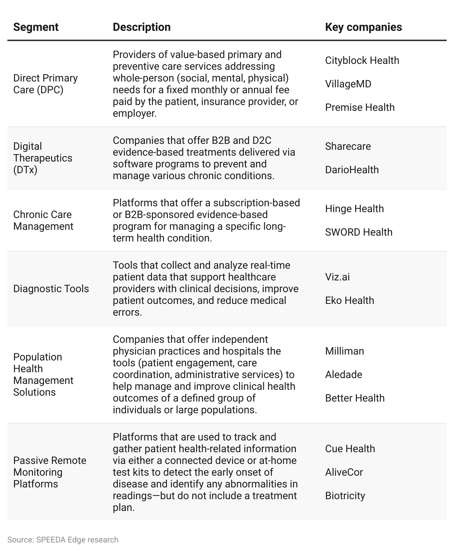

# **Driving Factors**

## **1. Individuals can lower OPP chronic care spending**

As of 2023, around 60% of adult Americans had at least one chronic disease (compared with 50% in 2005), and around 42% had two or more. Chronic diseases account for approximately 90% of aggregate healthcare spend in the US, mainly for hospitalizations and associated long-term care. This is a primary reason for the growth in healthcare expenditure, which rose at a CAGR of 4.87% over 10 years to reach USD 13,493 per capita in 2022, reflecting a 4.1% increase from 2021.

Individuals have been incurring an increasing amount of out-of-pocket (OOP) spending, reaching USD 1,424 per capita or 11% of total healthcare expenditure in 2022 (up from 10.7% in 2021) due to rising healthcare costs, higher deductibles and copays, and soaring prescription drug prices. In addition, the use of healthcare services rebounded in 2021, leading to a 10.4% increase in OOP spending despite a 2.6% drop in 2020 due to limited access to medical goods and services. Average individual deductibles also increased at a CAGR of 5.93% to USD 1,735 between 2012 and 2022.

Much of these hospitalizations were for preventable causes. By preventing avoidable hospitalization, readmission, and emergency room (ER) visits, preventive care could help lower significant OOP costs.

### **Per capita OOP spending continues to increase in line with rising medical costs**

### **US healthcare spending rose at a CAGR of 4.57% between 2013 and 2022**

### **Americans experience high rates of hospitalizations for preventable causes due to fewer physician visits**

### 

### **A 10% reduction in non-emergency ER visits could result in a cost savings of more than USD 100 million for individuals**

## **2. Rising premiums pressure employers to seek medical cost-saving measures**

As healthcare costs rise, insurance premiums paid by corporations have increased significantly. Over 2013–2023, the average annual premium for employer-sponsored health insurance increased to USD 8,435 for single coverage and USD 23,968 for family coverage at CAGRs of 3.7% and 3.9%, respectively.

Consequently, employers have partnered with direct primary care providers, offering preventive care measures, digital therapeutics companies, and specialized chronic care management startups that have proven to reduce total healthcare costs. Through these measures, employers have reported lower spending on downstream care, including emergency care, hospital admissions, prescription medication, specialty care, and surgeries.

### **Total cost savings for employers range between 20% and 40%**

## **3. Reduces the burden of rising healthcare claims for insurers**

Insurers' reactive care burden can be eased through the advancement of preventive care plans. Total hospital and medical expenses paid out by US health insurers increased at a CAGR of 7.2% from 2017 to 2022 to USD 863.1 billion in 2022.

Promoting preventive healthcare plans, through covering monthly subscriptions, for example, can reduce claims significantly in the long term. In addition, partnering with preventive care providers allows insurers to access accurate patient records, facilitating better pricing of policies and premiums and enabling independent claims verification through integrated data platforms.

### **Insurers reduce claims via cost savings from lower hospitalization rates and emergency room visits**

### **Example: Preventive care services in Medicare Advantage support a lower cost of care**

### **Total cost of care for members was 40% lower under Medicare Advantage compared with traditional fee-for-service Medicare in 2021**

# 

# **Risks To Growth**

## **1. Preventive care plans do not eliminate the need for health insurance**

Having a preventive care plan does not replace a health insurance plan, made compulsory for Americans through the Affordable Care Act (ACA). Preventive care plans will not replace all aspects of care such as medical imaging and emergency care, which are covered by traditional health insurance. Hence, many preventive care providers encourage users to have health insurance plans in place. Preventive care subscription services are not covered by health insurance plans, which may discourage users from enrolling in preventive care plans.

## **2. Strong reputation of incumbents poses a challenge for disruptors**

Mayo Clinic, Cleveland Clinic, and Walgreens Boots Alliance benefit from a strong reputation and substantial physical presence in the market. Disruptors are required to forge trust among consumers in order to gain market share, which will likely be a challenge for some players to achieve against healthcare giants.

*Last updated: September 2023*

©2024 Uzabase, Inc. All Rights Reserved. The information contained herein: (1) is proprietary to Uzabase Inc. and/or its content providers; (2) may not be copied or distributed; and (3) is not warranted to be accurate, complete or timely. Neither Uzabase Inc. nor its content providers are responsible for any damages or losses arising from any use of this information.