**Decentralized Finance - Overview**



**Redesigning the traditional financial system using blockchain and lines of code**

Decentralized Finance or DeFi comprises peer-to-peer financial services that use blockchain technology and eliminate intermediaries such as banks that make up the traditional financial system (TradFi). It has several advantages over TradFi, such as faster transactions, greater transparency, and streamlined cross-border transactions, among others.

The Ethereum blockchain is home to the most number of DeFi projects, contributing to nearly 56% of the total value locked (TVL) in DeFi as of March 2024. Developments in blockchain technology have allowed for the creation of decentralized apps using smart contracts, which have, in turn, enabled DeFi. However, a high volume of activity has strained Ethereum, resulting in slower processing times and steep transaction fees. Planned upgrades to the chain, along with new blockchains emerging with innovative processes and interchain compatibility, are set to bring about more efficiencies in the space.

The search for high yields is the primary driving factor for this sector, as investors seek to generate returns that have consistently outperformed traditional investments like treasuries. In addition, a sizable underbanked population and difficulties faced by SMEs in obtaining credit are likely to drive demand for credit through DeFi applications.

**Full view:**

**DeFi moves trust from intermediaries to the blockchain and smart contracts**

Decentralized Finance or DeFi comprises peer-to-peer financial services that use blockchain technologies and eliminate intermediaries such as banks that make up the traditional financial system (TradFi). DeFi moves the source of trust to the blockchain and smart contracts (self-executing code that runs when a condition is met), in contrast to TradFi, where licensed financial institutions act as the trust source.

DeFi is eliminating the pain points seen in TradFi by facilitating faster transactions and driving product innovation through lower barriers of entry, higher transparency, and streamlined cross-border transactions.

**DeFi eliminates intermediaries seen in a typical TradFi setup**

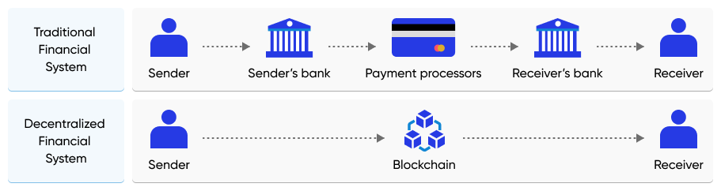

Source: Recreated by SPEEDA Edge based on information from Stably.io

**Binance Smart Chain is home to the most number of DeFi projects**

The Binance Smart Chain (BSC), operated by leading crypto exchange Binance, has overtaken the Ethereum blockchain as home to the most number of DeFi apps (5,000+ as of March 2024)[1]. However, DeFi projects in the Ethereum blockchain accounted for nearly 56% of the USD 102.7 billion total value locked (TVL) in DeFi as of March 2024 compared with only 5% contributed by BSC[2].

**Total value locked in DeFi across major blockchains**

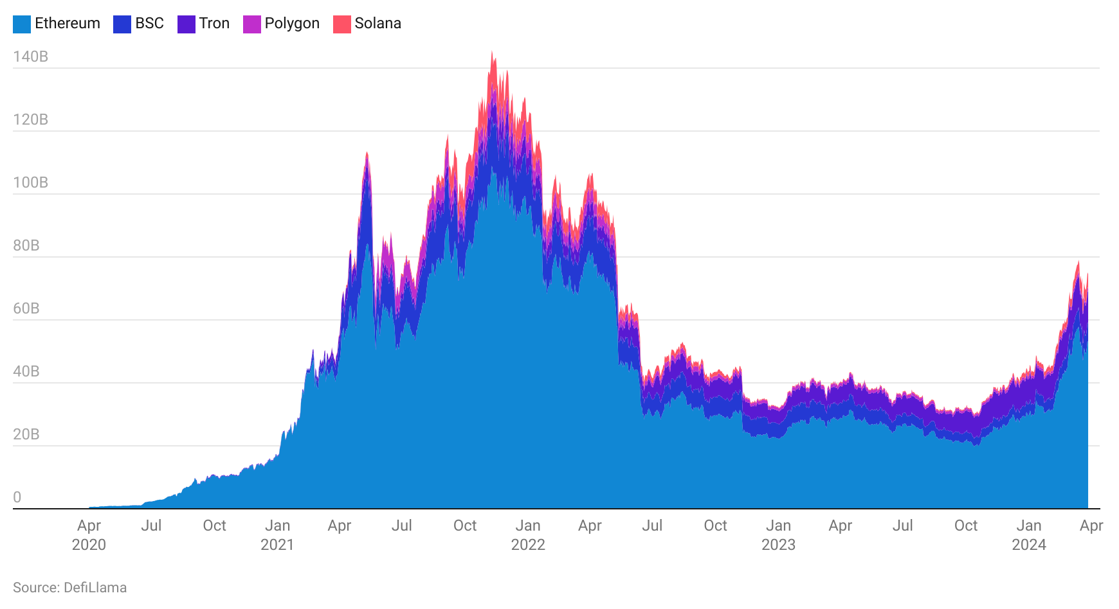

**Developments in blockchain tech enable creation of dApps**

Blockchain technology has come a long way since the pseudonymous creator of Bitcoin Satoshi Nakamoto’s first whitepaper in 2008.[3] It has evolved from just a decentralized record for financial transactions to the distributed supercomputer we see today. This has enabled the development of financial infrastructure, with smart contracts being configured to automate specific actions, such as fund transfers, and act as an escrow, embedding a recourse mechanism at the protocol level.[4]

**The evolution of blockchain to a distributed supercomputer**

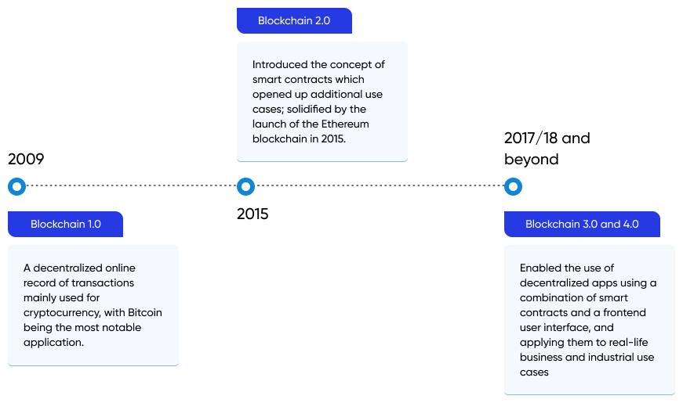

Source: Compiled by SPEEDA Edge based on multiple sources

Commissioning a DeFi project is significantly faster, as these apps are based on blockchains such as Ethereum and Solana, unlike TradFi, which requires additional paperwork (such as applying for licenses) and compliance with risk management measures (such as minimum capital requirements).[5] Most DeFi projects operate under a decentralized autonomous organization (DAO) structure—a non-hierarchical business structure implemented on the blockchain that leverages tokens and smart contracts. Holders of a native token of the project (e.g., MKR for MakerDAO) will be able to vote on operational and strategic decisions of the DAO. The rules of governance are defined in the smart contract, which is immutable and allows the DAO to be governed and run based on predefined rules. *Note: We identify that DAO applications extend to more than just DeFi. Read our* [*Edge Insight*](https://sp-edge.com/sectors/financial-services/insights/5762)*, which explores this phenomenon in more detail.*

**Proof-of-stake blockchain developers look to offer faster speeds**

Ethereum is home to the most number of DeFi apps and records an average of 1.4 million transactions per day[6](as of March 2024). To keep up with the rising transaction volume, the developers behind Ethereum launched the first phases of a planned upgrade in late-2020.[7] While newer blockchains, such as Solana and Polkadot, pioneered the proof-of-stake (PoS) consensus mechanism, along with other efficiencies for faster transaction processing and lower transaction costs, Ethereum also completed the transition of its blockchain to a PoS consensus mechanism from its proof-of-work approach in August 2022.[8] Dubbed “The Merge,” the new consensus mechanism will randomly select validators in proportion to the quantity of Ethereum tokens staked to the network, with a minimum required stake of 32 ETH. The update ends the blockchain’s reliance on mining to validate the network, a process under heavy scrutiny for its excess energy consumption and environmental impact. The Ethereum Foundation claims that the upgrade can potentially reduce the blockchain’s energy consumption by more than 99%.

The upgrade also allows for greater scalability in the future—potentially up to 100,000 transactions per second (TPS)[9], which translates to 8.6 billion transactions per day.[10] Other blockchains like Solana already carry out over 277 million daily transactions (as of March 2024)[11], with the potential of doing over 12x that number. In contrast, traditional payment processors, such as VISA, process around 150 million daily transactions.[12]

Furthermore, while the upgrade does not directly reduce the blockchain’s fees per transaction (known as gas fees), which vary according to the complexity of each transaction, it paves the way for future upgrades that address these issues. In March 2024, Ethereum launched the “Dencun” upgrade, which changed the way data is stored on Ethereum, to make layer 2 transactions cheaper[13]. During the same period, the average fee per transaction for Ethereum was around USD 2.3[14], while Solana’s average was only USD 0.0575.[15]

**Newer blockchain technology set to deliver significantly higher transaction speeds**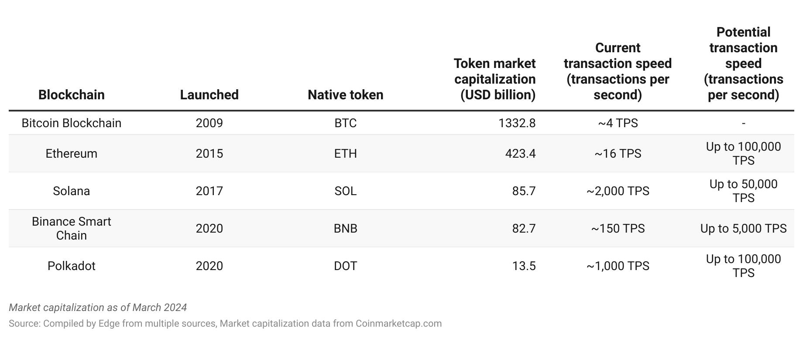

Source: Compiled by SPEEDA Edge based on multiple sources  
*Note - Including layer 2 networks

**Stablecoins help curb price volatility typically associated with cryptocurrencies**

Stablecoins are cryptocurrencies that have their values pegged against fiat currencies, such as the US dollar. Launched in late 2014, Tether was the first successful stablecoin. Its USDT token is backed against a reserve of USD 1 for every unit of USDT issued.[16] Collectively, stablecoins represented a market capitalization of over USD 149 billion as of March 2024.[17] For DeFi applications, stablecoins help overcome the price volatility typically seen with cryptocurrencies and allow participants to reliably generate yields.

**Key segments in the DeFi ecosystem**

The DeFi ecosystem consists of projects (mostly on the Ethereum blockchain) that facilitate borrowing and lending (to the protocol by investors) of crypto assets, along with platforms for participants to access decentralized insurance and tokenized investments.

The landscape also includes projects that are looking at applying NFTs to applications beyond digital art and into financial use cases such as ownership records and documents, supporting products like marketplaces and wallets, and broader infrastructure such as the blockchains required to develop DeFi applications.

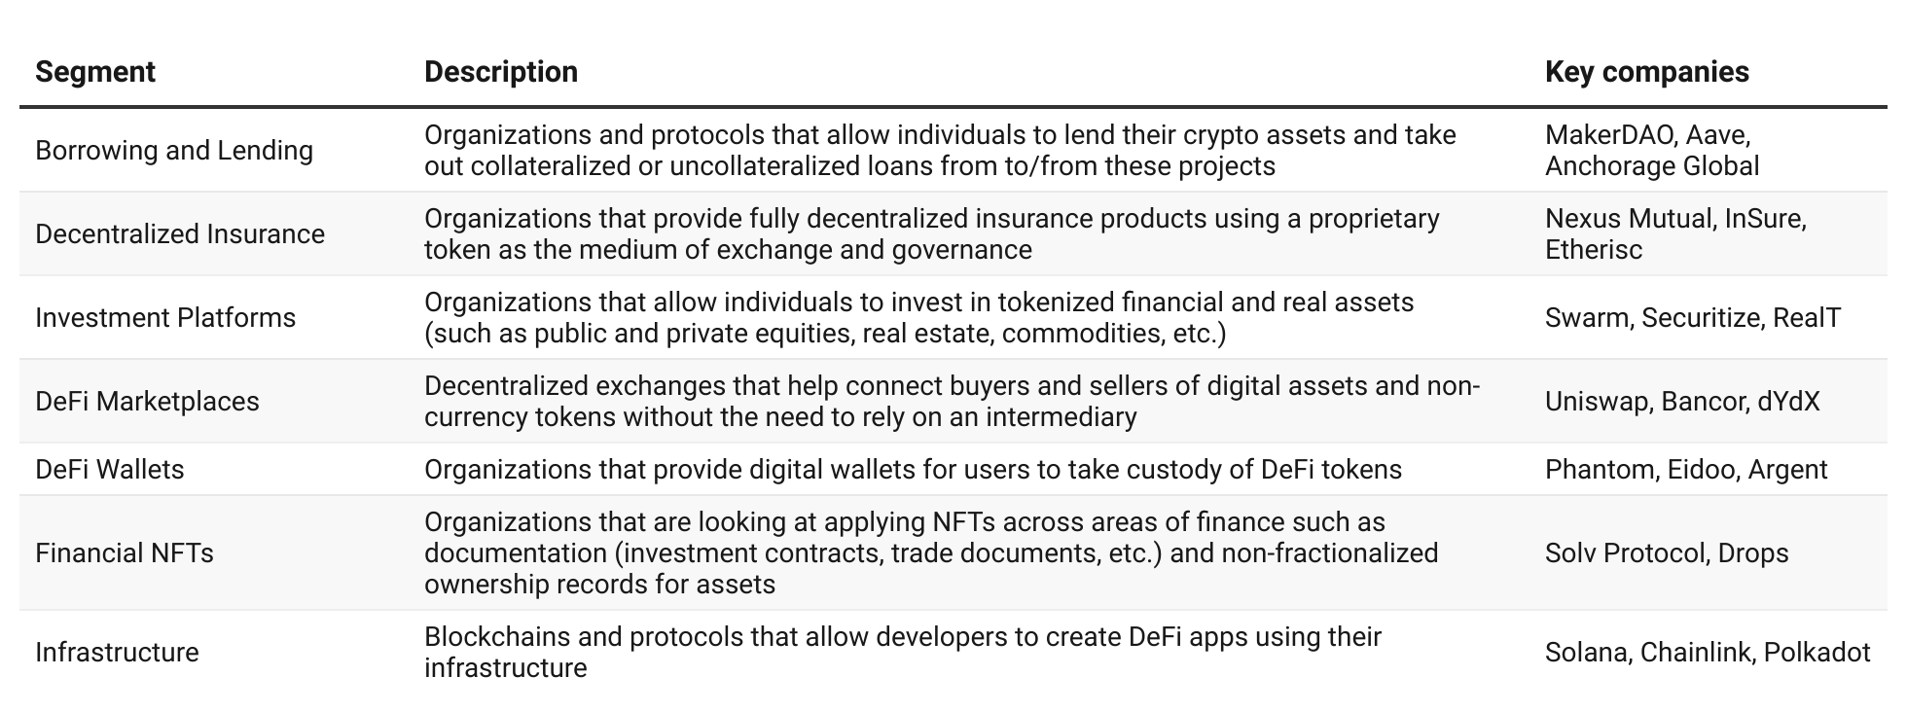

**Driving factors**

1. **Sizeable unbanked population and difficulty for SMEs to raise credit, present significant opportunity**

Around 13% of US adults were underbanked in 2022, with an additional 6% having neither a checking nor a savings account.[18] DeFi, combined with decentralized identity solutions enabled by blockchain, can allow virtually anyone to borrow, lend, and send money or even purchase insurance, by eliminating the bias and bureaucracy that comes with relying on a middleman, such as a bank. For instance, DeFi lending platform Compound does not require any KYC or signing up to access their protocol, allowing users to participate in the ecosystem immediately with their assets without needing approval from a central authority.[19]

While growth in DeFi loans has largely stemmed from individuals[20], the accessibility advantages also extend to small and medium-sized enterprises (SMEs) with lower fees, faster processing times, faster fund transfers[21], the ability to structure bespoke loan products[22], and reduced complexity around cross-border transactions. DeFi-based banking services move away from the traditional models of transactional banking, which involve a relationship manager to establish trust and cross-sell other services. The global shortfall in SME financing in developing countries amounts to around USD 5 trillion, and while banks across the world are finding ways to fill this need, existing frameworks and systems, especially in developing markets, are yet to become more accommodating.[23] DeFi borrowing projects, such as [Obligate](https://sp-edge.com/companies/1254931) and [Kasu](https://sp-edge.com/companies/3406435), are attempting to solve this problem by connecting crypto lenders with traditional SMEs for project or trade finance, backed by real-world assets.

Against this backdrop, total outstanding borrowing across key DeFi protocols has grown since the beginning of 2020, with the TVL of major lending platforms such as Aave and MakerDAO reaching over USD 10.4 billion and USD 9 billion, respectively.

1. **Accessibility benefits extend to traditionally illiquid asset classes through tokenization**

In addition to financial inclusivity, DeFi also helps unlock trillions of dollars locked in private investments, such as equity and real estate, through tokenization. Asset owners can create security tokens that represent fractionalized ownership to generate liquidity on what are typically illiquid assets. By eliminating intermediaries such as brokers, participants can use decentralized exchanges to connect with a wide pool of investors who can invest in assets such as private equities and commercial real estate that have historically been restricted to large institutional investors, while also being entitled to returns from the underlying assets, such as dividends. *For more on this topic, read our* [*Edge Insight,*](https://sp-edge.com/sectors/financial-services/insights/6443) *which explores tokenization in more detail; outlining the process, use cases across key asset classes, and key players in this space.*

**How tokenization works**

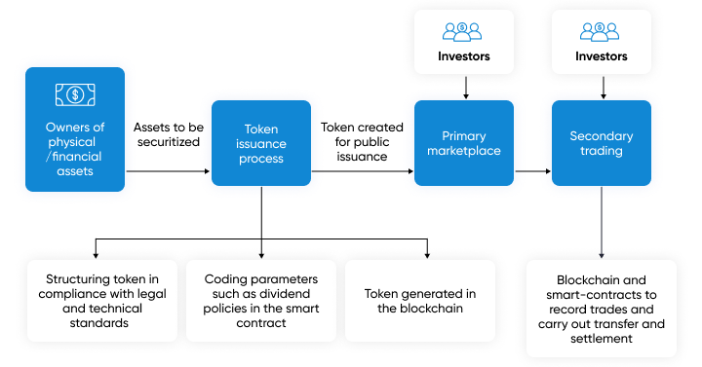

Source: Created by SPEEDA Edge based on multiple sources

1. **NFTs offer use cases beyond just digital collectibles**

Non-fungible tokens (NFTs) are unique tokens created on the blockchain that represent full and irrefutable ownership in one-of-a-kind assets. While NFTs have [dominated the cryptosphere](https://sp-edge.com/sectors/education-and-media/insights/6655) through their application in digital art and collectibles, their use cases go beyond just proving ownership for digital paintings. NFTs are, at their core, digital certificates of authenticity, allowing for verifiable and transferable ownership in the blockchain. In the DeFi space, NFTs can represent real-world documents such as deeds and insurance contracts, documents relating to international trade[24], or even be used for tokenizing assets in situations where fractionalized ownership is not needed.

1. **The hunt for double-digit yields and arbitrage opportunities drive value into DeFi projects**

The concept of “yield farming” refers to the process where investors lock or lend their assets within the DeFi protocols in exchange for interest and lending rewards such as fees and more tokens (which could have the potential to appreciate significantly).[25] Yield farmers also provide the liquidity for the DeFi protocols they invest in, which is used to support the ecosystem of the DeFi project and lend to borrowers. Compound is one such project; also offering its governance token COMP to its users.

Yield farming can also be more lucrative than investing in traditional financial instruments. These can also present opportunities for arbitrage and carry trading across multiple tokens with varying yields, which would otherwise not be possible in a more liquid and developed financial system.[26] As of March 2024, monthly average composite yields for major DeFi projects ranged between 4% and 12%. In contrast, one-year US treasuries had an average market yield of approximately 5% during the same period.[27]

**Composite yields of major DeFi projects**

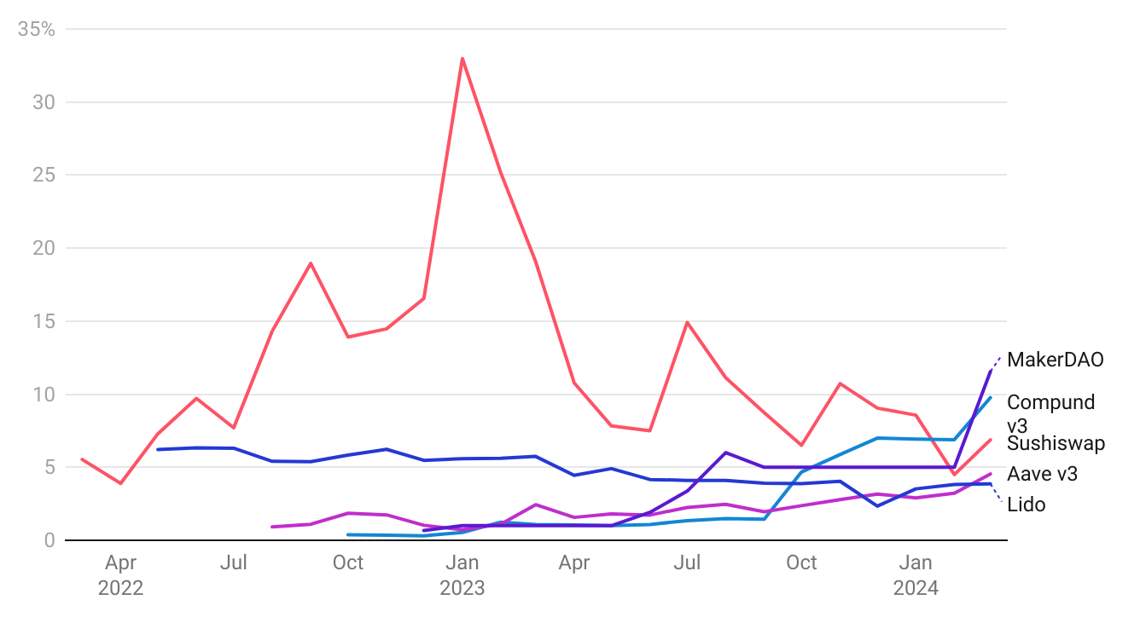

Source: DeFi Pulse

The hunt for high yields has resulted in billions of dollars being invested in these projects. Since the beginning of 2023, TVL for DeFi projects such as MakerDAO and Aave have grown by nearly 12x and 5x, respectively (as of March 2024), with other projects following a similar trajectory.

**TVL of major DeFi protocols**

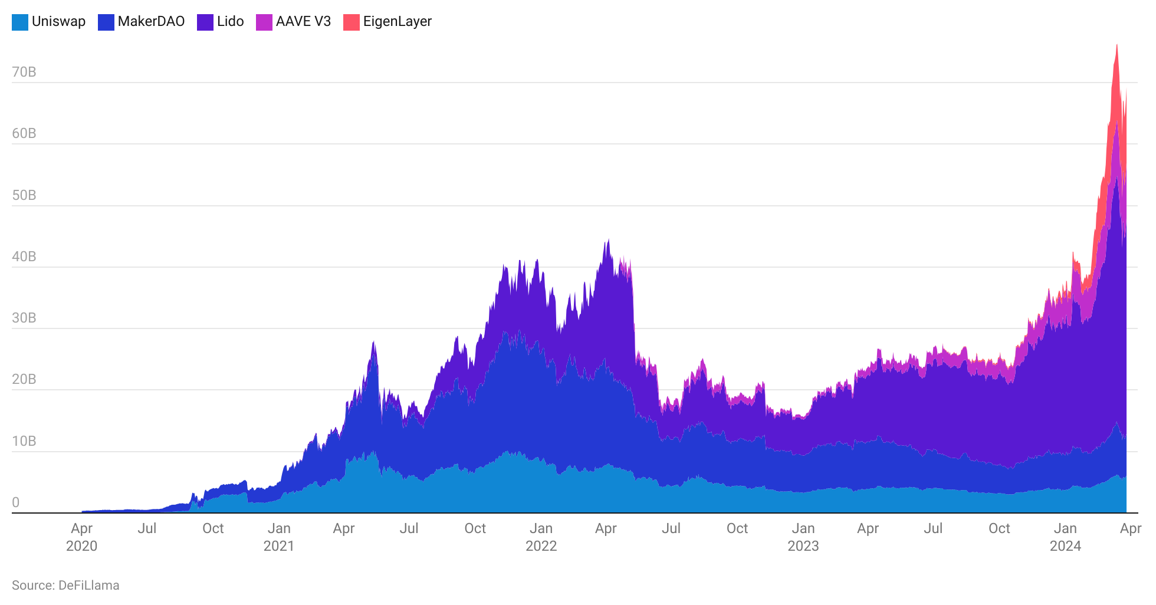

**Risks to growth**

1. **Regulatory void is a key reason for DeFi success; any overreaching regulation could make or break innovation**

Many DeFi products are offered through DAOs, which are unincorporated businesses that operate outside the regulatory frameworks that govern the traditional financial system. The non-hierarchical operating structure of DAOs complicates the distribution of responsibility and accountability for regulatory compliance.[28] While it can be argued that most of DeFi’s success stems from the absence of any regulatory oversight that has led to advantages in terms of speed and accessibility, such an operating environment can also create concerns around consumer protection, alongside the risk of fraud and concerns around money laundering, given the anonymous nature of transactions in the blockchain. Industry groups such as the Bank for International Settlements (BIS) are pushing for regulation in this space, citing high leverage, insufficient liquidity, and the absence of large-scale banks to absorb shocks in the system.[29]

Any overreaching regulatory measures, such as pushing corporate token holders for changes to the protocol or even making any interactions with autonomous protocols illegal, can significantly stifle innovation in this space.[30] Regulators will have to strike a balance to ensure adequate protections are in place to safeguard consumers and prevent abuse while maintaining innovation and “decentralization” within the system.[31][32]

1. **Scalability challenges still remain; further delays to major upgrades could inhibit growth**

The stress on the Ethereum blockchain due to the rise in DeFi activity has pushed transaction fees up. Depending on the complexity of the transactions, this can go well over hundreds of dollars for even small transactions.[33] This is likely to inhibit growth, as most users will not be willing to incur such high transaction costs. While Ethereum's switch to PoS did not directly impact transaction speeds, the change sets the stage for a series of upgrades in 2024 that will increase the throughput of the network and lower transaction fees. However, the transition was delayed multiple times over the last two years[34], so further delays to these planned upgrades could be a major roadblock to mainstream adoption.

1. **Security risks remain, as malicious actors exploit weak spots of smart contracts**

While the blockchain itself is secure due to its decentralized nature, a DeFi project is only as secure as its code. October 2022 became one of the worst months ever with regard to crypto-related theft according to Chainalysis[35], with USD 718 million being stolen from various DeFi protocols. Notable examples include [Bitkeep](https://sp-edge.com/companies/1862619), a DeFi and cryptocurrency wallet, which [lost USD 1 million](https://sp-edge.com/updates/10530), as well as major exchanges [Mango Markets](https://sp-edge.com/companies/1519212) and [Binance](https://sp-edge.com/companies/514390), both [of which lost USD 100 million](https://sp-edge.com/updates/13641). This trend also continued into 2023, with the lending protocol [Euler Finance](https://sp-edge.com/companies/1226721) and blockchain infrastructure provider [Mixin](https://sp-edge.com/companies/653148) losing [USD 200 million](https://sp-edge.com/updates/17045) each in large attacks.

To prevent such exploits, project owners can audit their code, work with experienced developers, and employ techniques such as bug bounty programs to identify errors beforehand to promote user confidence. Providing hackers with token rewards in exchange for returning the stolen funds seems to be a prevailing trend with these protocols, as both Mango Markets and Euler Finance[36] were successful in recovering part of the funds after it offered a bounty.

1. **High returns on DeFi projects and high levels of interdependence within the ecosystem introduce major risks**

Many of the yields offered by DeFi projects are significantly higher than traditional alternatives, making it an attractive stream of passive income for owners of crypto assets. However, this is not without risk. In addition to the risk of losing it all due to hacks, market risks can result in significant movement of the staked cryptocurrency, and it is often volatile. There are also other risks such as rug pulls where DeFi developers siphon all cryptocurrency off a project, rendering the project tokens worthless. For example in March 2023, Kokomo Finance pulled an exit scam stealing USD 4 million from its users.[37]

Furthermore, the interdependence between protocols and centralized exchange providers for liquidity and market-making services creates vulnerabilities that lead to a ripple effect when one platform fails. For example, the collapse of FTX in 2022 due to fraud had a domino effect across the DeFi industry, with many protocols facing issues related to their exposure to the exchange. This list includes [Serum](https://sp-edge.com/companies/1126977), a decentralized crypto-exchange that [ceased operations](https://sp-edge.com/updates/14943), and [Blockfi](https://sp-edge.com/companies/598239), which [filed for bankruptcy](https://sp-edge.com/updates/14928). During that same period, BnkToTheFuture, an online investing platform that had entered an agreement to acquire lending protocol SALT, terminated its plan after the latter froze withdrawals and deposits on the platform due to its unspecified exposure to FTX. Despite the high returns, the risk of potentially losing all their investments will not align with the risk tolerance of most investors, eroding confidence over the long term.[38]

**Appendix: Key terms**

| **Annual percentage yield (APY)** | The annual rate of return earned from lending crypto assets in exchange for interest and governance token incentives. |
| --- | --- |
| **Blockchain** | A shared ledger that records transactions and is duplicated and distributed across an entire network of systems. |
| **Decentralized autonomous organization (DAO)** | A non-hierarchical governance structure where holders of the DeFi project’s native token can vote on strategic and operational matters. |
| **Non-fungible tokens (NFTs)** | Unique tokens created on the blockchain that represent full and irrefutable ownership in one-of-a-kind assets such as digital art, collectibles, and even DeFi applications such as bonds and deeds. These tokens can be bought and sold through marketplaces. |
| **Proof-of-stake (PoS)** | An alternative consensus mechanism that requires network participants to stake their cryptocurrency holdings to validate transactions and add them to the blockchain. Completed transactions result in reward and any malicious activity can lead to the stake being burnt. |
| **Proof-of-work (PoW)** | A consensus mechanism that requires network participants to solve mathematical problems to verify transactions and add them to the blockchain. The participant is rewarded in cryptocurrency for each completed verification. |
| **Smart contract** | A series of self-executing code that runs when a predefined condition is met. |
| **Tokenization** | The process of issuing a token that represents the value of a single or a collection of an actual physical asset. |
| **Total value locked (TVL)** | The sum of the value of assets deposited into a DeFi protocol. TVL is calculated by multiplying the total balance/number of tokens held in smart contracts by their price in USD. |
| **Yield farming** | The process of lending or locking crypto assets into a liquidity pool in exchange for interest and other rewards as well as incentives such as additional native tokens of the underlying project. |

*Last updated: March 2024*

©2024 Uzabase, Inc. All Rights Reserved. The information contained herein: (1) is proprietary to Uzabase Inc. and/or its content providers; (2) may not be copied or distributed; and (3) is not warranted to be accurate, complete or timely. Neither Uzabase Inc. nor its content providers are responsible for any damages or losses arising from any use of this information.

1. https://dappradar.com/rankings/chains
2. <https://defillama.com/>
3. <https://101blockchains.com/history-of-blockchain-timeline/>
4. <https://future.a16z.com/cryptos-fourth-wave-defi-poised-for-breakthrough/>
5. <https://www.theregreview.org/2021/05/10/massari-catalini-defi-disintermediation-regulatory-path-ahead/>
6. <https://ycharts.com/indicators/ethereum_transactions_per_day>
7. <https://medium.datadriveninvestor.com/ethereum-2-0-has-been-launched-successfully-will-the-price-go-up-71d1670ef22a>
8. <https://www.nytimes.com/2022/09/15/technology/ethereum-merge-crypto.html>
9. <https://www.deltecbank.com/2021/10/13/whats-ethereum-2-0-and-what-does-it-mean-for-eth/?locale=en#:~:text=ETH%202.0%20Transactions%20Per%20Second%20Expectations&text=The%20ETH%202.0%20network%20will,claims%20it%20can%20do%2024%2C000>.
10. <https://www.gemini.com/cryptopedia/ethereum-2-0-proof-of-stake-pos-blockchain-serenity>
11. <https://explorer.solana.com/>
12. <https://hackernoon.com/the-blockchain-scalability-problem-the-race-for-visa-like-transaction-speed-5cce48f9d44>
13. <https://www.coindesk.com/consensus-magazine/2024/03/12/what-to-expect-from-ethereums-latest-massive-upgrade-dencun>
14. <https://etherscan.io/gastracker>
15. <https://solanacompass.com/statistics/fees>
16. <https://f.hubspotusercontent00.net/hubfs/5264302/The%20Rise%20of%20Stablecoins.pdf>
17. <https://coinmarketcap.com/view/stablecoin/>
18. <https://www.federalreserve.gov/publications/files/2022-report-economic-well-being-us-households-202305.pdf>
19. <https://coinmarketcap.com/alexandria/article/all-about-compound-flipside-crypto>
20. <https://www.weforum.org/agenda/2021/07/decentralized-finance-transaction-banking-smes/>
21. <https://www.inc.com/tor-constantino/as-banks-lend-less-money-small-businesses-need-more-why-decentralized-finance-could-be-fix.html>
22. <https://www.finextra.com/blogposting/20897/is-defi-the-silver-bullet-to-help-struggling-smes-secure-easier-access-to-finance>
23. https://www.smefinanceforum.org/data-sites/msme-finance-gap
24. <https://www.tradefinanceglobal.com/posts/how-nfts-might-play-a-role-in-international-trade/>
25. <https://www.coindesk.com/learn/what-is-yield-farming-the-rocket-fuel-of-defi-explained/>
26. <https://www.coindesk.com/learn/what-is-yield-farming-the-rocket-fuel-of-defi-explained/>
27. <https://www.federalreserve.gov/releases/h15/>
28. ​​<https://www.paymentsjournal.com/watch-out-defi-the-regulators-are-coming/>
29. <https://www.cnbc.com/2021/12/07/decentralization-illusion-bis-urges-regulation-of-defi.html>
30. <https://techcrunch.com/2021/12/08/how-should-we-regulate-defi/>
31. <https://www.finextra.com/blogposting/20516/defi-and-regulation-the-european-approach>
32. <https://cointelegraph.com/news/putting-a-cap-on-decentralization-how-regulation-impacts-defi-adoption>
33. <https://twitter.com/readDanwrite/status/1443609617586663429?s=20>
34. <https://coinmerce.io/en/news/ethereum-merge-delayed-until-late-2022/>
35. <https://forkast.news/october-biggest-month-biggest-year-crypto-hacking/>
36. <https://cointelegraph.com/news/euler-labs-hacker-returns-all-of-the-recoverable-funds-timeline>
37. <https://twitter.com/certikalert/status/1640118618548568069>
38. <https://www.sec.gov/news/statement/crenshaw-defi-20211109>